**PROJECT MADISON – SPRINT 3**

**SOLUTION DESIGN DOCUMENT**

This document details the requirements for Sprint 3 requirements, the functional and technical solutions developed in NetSuite, the use cases and the test cases.

|  |  |
| --- | --- |
| Date | 10- April -2017 |
| Customer Name | Clorox Renew Life |
| Project Name | Project Madison |
| Project Manager | Suzanne Little |
| Functional Consultants | Raghu Kulkarni, Ali Motiwala, Chinmay Agarwal Devendra Girase, Shashank Pandey |
| Technical Consultants | Janakan Sellaperumal |
| QA Consultants |  |
| Version | 11.0 |

**DOCUMENT VERSION HISTORY**

|  |  |  |  |
| --- | --- | --- | --- |
| Version | Date | Author(s) | Change Summary |
| 1.0 | 10th April 2017 | Muralikrishnan M K Shaurya Aggarwal | 1. Added new requirements. [Req - 01 to Req-12] 2. Added updated Customization list |
| 2.0 | 17th April 2017 | Shashank Pandey | 1. Added new requirements [Req-13 to Req-18] 2. Customization list updated |
| 3.0 | 19th April 2017 | Devendra Girase  Shashank Pandey | 1. Added new requirements [Req-19 to Req-28] |
| 4.0 | 21st April 2017 | Devendra Girase  Shashank Pandey | 1. Added new requirements [Req-29 to Req-39] |
| 5.0 | 24th April 2017 | Devendra Girase  Shashank Pandey | 1. Added new requirements [Req-40 to Req-43] |
| 6.0 | 26th April 2017 | Devendra Girase  Shashank Pandey | * + 1. Added new requirements [Req-44 to Req-45]     2. Added updated Customization list |
| 7.0 | 2nd May 2017 | Chinmay Agarwal | 1. Updated Requirement Req No-46 (Added Fields and List ) |
| 8.0 | 3rd May 2017 | Muralikrishnan M K | 1. Updated Requirement Req No-47 (Added Field) |
| 9.0 | 4th May 2017 | Neeraj Shringi | 1.Added new Requirement Req No.49  2.Updated Req.26 for MEI Reason Code |
| 10.0 | 9th May 2017 | Muralikrishnan MK | 1. Updated Requirement Req No-34 and 44 (Added WF Condition for req-34 and added custom column fields for req-44) |
| 11.0 | 9th May 2017 | Devendra Girase | * + 1. Added new requirement [Req-50]     2. Attached updated customization list |
| 12.0 | 12th May 2017 | Shaurya Aggarwal Saurav Dubey | 1. Added new requirement [Req-51 to Req-53] 2. Updated Customization List |
| 13.0 | 15th May 2017 | Muralikrishnan MK Shaurya Aggarwal | 1. Updated the Requirement [Req-53] (Added custom fields and saved search) 2. Updated the Requirement [Req-19] (Updated as per the new proposed solution) |

TABLE OF CONTENTS

1. Acronyms and Definitions 12

2. Requirements 13

1.1 Req-01: Ability to hold credit review due date 13

1.1.1 ACCEPTANCE CRITERIA 13

1.1.2 USE CASES 13

1.1.3 JEFFERSON IMPACT 13

1.1.4 FUNCTIONAL SOLUTION 13

1.1.5 TECHNICAL SOLUTION 13

1.1.6 CONFIGURATION 14

1.2 Req-02: Ability to hold credit risk category on customer record 16

1.2.1 ACCEPTANCE CRITERIA 16

1.2.2 USE CASES 16

1.2.3 JEFFERSON IMPACT 16

1.2.4 FUNCTIONAL SOLUTION 16

1.2.5 TECHNICAL SOLUTION 16

1.2.6 CONFIGURATION 17

1.3 Req-03: Ability to denote whether or not a customer requires monthly statements on Customer record 19

1.3.1 ACCEPTANCE CRITERIA 19

1.3.2 USE CASES 19

1.3.3 JEFFERSON IMPACT 19

1.3.4 FUNCTIONAL SOLUTION 19

1.3.5 TECHNICAL SOLUTION 19

1.3.6 CONFIGURATION 20

1.4 Req-04: Ability to Hold Payment Method on Customer Record 21

1.4.1 ACCEPTANCE CRITERIA 21

1.4.2 USE CASES 21

1.4.3 JEFFERSON IMPACT 21

1.4.4 FUNCTIONAL SOLUTION 21

1.4.5 TECHNICAL SOLUTION 21

1.4.6 CONFIGURATION 22

1.5 Req-05: Ability to Pull Report to Show Credit Master Data changes 24

1.5.1 ACCEPTANCE CRITERIA 24

1.5.2 USE CASES 24

1.5.3 JEFFERSON IMPACT 24

1.5.4 FUNCTIONAL SOLUTION 24

1.5.5 TECHNICAL SOLUTION 24

1.5.6 CONFIGURATION 25

1.6 Req-06: Ability to report on Defined Credit Management Fields in Master Data By Customer 27

1.6.1 ACCEPTANCE CRITERIA 27

1.6.2 USE CASES 27

1.6.3 JEFFERSON IMPACT 27

1.6.4 FUNCTIONAL SOLUTION 27

1.6.5 TECHNICAL SOLUTION 27

1.6.6 CONFIGURATION 28

1.7 Req-07: Ability to Rename “terms” field to “credit terms" under financial subtab on Customer record. 30

1.7.1 ACCEPTANCE CRITERIA 30

1.7.2 USE CASES 30

1.7.3 JEFFERSON IMPACT 30

1.7.4 FUNCTIONAL SOLUTION 30

1.7.5 TECHNICAL SOLUTION 30

1.7.6 CONFIGURATION 31

1.8 Req-08: Ability to add incoterms under financial subtab on customer record 32

1.8.1 ACCEPTANCE CRITERIA 32

1.8.2 USE CASES 32

1.8.3 JEFFERSON IMPACT 32

1.8.4 FUNCTIONAL SOLUTION 32

1.8.5 TECHNICAL SOLUTION 32

1.8.6 CONFIGURATION 33

1.9 Req-09: Ability to hide create po, create wo and price red 1 to 4 fields from sales order record 35

1.9.1 ACCEPTANCE CRITERIA 35

1.9.2 USE CASES 35

1.9.3 JEFFERSON IMPACT 35

1.9.4 FUNCTIONAL SOLUTION 35

1.9.5 TECHNICAL SOLUTION 35

1.9.6 CONFIGURATION 35

1.10 Req-10: Ability to capture order by ean numbers 37

1.10.1 ACCEPTANCE CRITERIA 37

1.10.2 USE CASES 37

1.10.3 JEFFERSON IMPACT 37

1.10.4 FUNCTIONAL SOLUTION 37

1.10.5 TECHNICAL SOLUTION 37

1.10.6 CONFIGURATION 37

1.11 Req-11: Ability to add new field on sales order to capture the order quantity 37

1.11.1 ACCEPTANCE CRITERIA 37

1.11.2 USE CASES 37

1.11.3 JEFFERSON IMPACT 37

1.11.4 FUNCTIONAL SOLUTION 37

1.11.5 TECHNICAL SOLUTION 37

1.11.6 CONFIGURATION 37

1.12 Req-12: Ability to Identify when a Customer Credit Card is Nearing Expiry 38

1.12.1 ACCEPTANCE CRITERIA 38

1.12.2 USE CASES 38

1.12.3 JEFFERSON IMPACT 38

1.12.4 FUNCTIONAL SOLUTION 38

1.12.5 TECHNICAL SOLUTION 38

1.12.6 CONFIGURATION 38

1.13 Req-13: Need the Ability to Delineate Customer on the Customer Record by Customer Segment 40

1.13.1 ACCEPTANCE CRITERIA 40

1.13.2 USE CASES 40

1.13.3 JEFFERSON IMPACT 40

1.13.4 FUNCTIONAL SOLUTION 40

1.13.5 TECHNICAL SOLUTION 40

1.13.6 CONFIGURATION 42

1.14 Req-14: Ability to Rename “terms” field to “credit terms" under billing subtab and make it view only on Sales order record. 47

1.14.1 ACCEPTANCE CRITERIA 47

1.14.2 USE CASES 47

1.14.3 JEFFERSON IMPACT 47

1.14.4 FUNCTIONAL SOLUTION 47

1.14.5 TECHNICAL SOLUTION 47

1.14.6 CONFIGURATION 47

1.15 Req-15: Ability to Sort Through different Order Segment and Generate a Report to identify ship Dates 50

1.15.1 ACCEPTANCE CRITERIA 50

1.15.2 USE CASES 50

1.15.3 JEFFERSON IMPACT 50

1.15.4 FUNCTIONAL SOLUTION 50

1.15.5 TECHNICAL SOLUTION 50

1.15.6 CONFIGURATION 51

1.16 Req-16: Need the Ability to Capture Unsellable Type on Customer Record 53

1.16.1 ACCEPTANCE CRITERIA 53

1.16.2 USE CASES 53

1.16.3 JEFFERSON IMPACT 53

1.16.4 FUNCTIONAL SOLUTION 53

1.16.5 TECHNICAL SOLUTION 53

1.16.6 CONFIGURATION 53

1.17 Req-17: Ability to Rename “Category” field to “Retailer Type" under Primary Information on Customer record. 56

1.17.1 ACCEPTANCE CRITERIA 56

1.17.2 USE CASES 56

1.17.3 JEFFERSON IMPACT 56

1.17.4 FUNCTIONAL SOLUTION 56

1.17.5 TECHNICAL SOLUTION 56

1.17.6 CONFIGURATION 56

1.18 Req-18: Ability to create and hold 3 Level Customer Hierarchy and Ship to 58

1.18.1 ACCEPTANCE CRITERIA 58

1.18.2 USE CASES 58

1.18.3 JEFFERSON IMPACT 58

1.18.4 FUNCTIONAL SOLUTION 58

1.18.5 TECHNICAL SOLUTION 58

1.18.6 CONFIGURATION 59

1.19 Req-19: Ability to track assembly items inventory by revisions 64

1.19.1 ACCEPTANCE CRITERIA 64

1.19.2 USE CASES 64

1.19.3 JEFFERSON IMPACT 64

1.19.4 FUNCTIONAL SOLUTION 64

1.19.5 TECHNICAL SOLUTION 64

1.19.6 CONFIGURATION 67

1.20 Req-20: Rename FOB Terms to Shipping Terms 74

1.20.1 ACCEPTANCE CRITERIA 74

1.20.2 USE CASES 74

1.20.3 JEFFERSON IMPACT 74

1.20.4 FUNCTIONAL SOLUTION 74

1.20.5 TECHNICAL SOLUTION 74

1.20.6 CONFIGURATION 74

1.21 Req-21: Ability to add Credit Review Date for Customer 75

1.21.1 ACCEPTANCE CRITERIA 75

1.21.2 USE CASES 75

1.21.3 JEFFERSON IMPACT 75

1.21.4 FUNCTIONAL SOLUTION 75

1.21.5 TECHNICAL SOLUTION 75

1.21.6 CONFIGURATION 75

1.22 Req-22: Ability to manage Sales Hierarchy using different Territory levels 76

1.22.1 ACCEPTANCE CRITERIA 76

1.22.2 USE CASES 76

1.22.3 JEFFERSON IMPACT 76

1.22.4 FUNCTIONAL SOLUTION 76

1.22.5 TECHNICAL SOLUTION 76

1.22.6 CONFIGURATION 78

1.23 Req-23: Need the Ability to Categorize code at the Line Item Level 90

1.23.1 ACCEPTANCE CRITERIA 90

1.23.2 USE CASES 90

1.23.3 JEFFERSON IMPACT 90

1.23.4 FUNCTIONAL SOLUTION 90

1.23.5 TECHNICAL SOLUTION 90

1.23.6 CONFIGURATION 90

1.24 Req-24: Need to Create a Field to Designate Customer MEI. 93

1.24.1 ACCEPTANCE CRITERIA 93

1.24.2 USE CASES 93

1.24.3 JEFFERSON IMPACT 93

1.24.4 FUNCTIONAL SOLUTION 93

1.24.5 TECHNICAL SOLUTION 93

1.24.6 CONFIGURATION 94

1.25 Req-25: Ability to perform MEI Integration for vendor 97

1.25.1 ACCEPTANCE CRITERIA 97

1.25.2 USE CASES 97

1.25.3 JEFFERSON IMPACT 97

1.25.4 FUNCTIONAL SOLUTION 97

1.25.5 TECHNICAL SOLUTION 97

1.25.6 CONFIGURATION 97

1.26 Req-26: Ability to perform MEI Integration for Credit Memo and Vendor Bill 99

1.26.1 ACCEPTANCE CRITERIA 99

1.26.2 USE CASES 99

1.26.3 JEFFERSON IMPACT 99

1.26.4 FUNCTIONAL SOLUTION 99

1.26.5 TECHNICAL SOLUTION 99

1.26.6 CONFIGURATION 100

1.27 Req-27: Global Trade Compliance Requirements for Item Master 108

1.27.1 ACCEPTANCE CRITERIA 108

1.27.2 USE CASES 108

1.27.3 JEFFERSON IMPACT 108

1.27.4 FUNCTIONAL SOLUTION 108

1.27.5 TECHNICAL SOLUTION 108

1.27.6 CONFIGURATION 109

1.28 Req-28: Global Trade Compliance Requirements for Customer Master 111

1.28.1 ACCEPTANCE CRITERIA 111

1.28.2 USE CASES 111

1.28.3 JEFFERSON IMPACT 111

1.28.4 FUNCTIONAL SOLUTION 111

1.28.5 TECHNICAL SOLUTION 111

1.28.6 CONFIGURATION 111

1.29 Req-29: Capability to view all sales orders fully filled but pending billing 113

1.29.1 ACCEPTANCE CRITERIA 113

1.29.2 USE CASES 113

1.29.3 JEFFERSON IMPACT 113

1.29.4 FUNCTIONAL SOLUTION 113

1.29.5 TECHNICAL SOLUTION 113

1.29.6 CONFIGURATION 113

1.30 Req-30: Capability to view all open invoices due for this week 116

1.30.1 ACCEPTANCE CRITERIA 116

1.30.2 USE CASES 116

1.30.3 JEFFERSON IMPACT 116

1.30.4 FUNCTIONAL SOLUTION 116

1.30.5 TECHNICAL SOLUTION 116

1.30.6 CONFIGURATION 116

1.31 Req-31: Capability to view all open invoices 118

1.31.1 ACCEPTANCE CRITERIA 118

1.31.2 USE CASES 118

1.31.3 JEFFERSON IMPACT 118

1.31.4 FUNCTIONAL SOLUTION 118

1.31.5 TECHNICAL SOLUTION 118

1.31.6 CONFIGURATION 119

1.32 Req-32: Need the Ability to Reason Code on customer Credit Memo 121

1.32.1 ACCEPTANCE CRITERIA 121

1.32.2 USE CASES 121

1.32.3 JEFFERSON IMPACT 121

1.32.4 FUNCTIONAL SOLUTION 121

1.32.5 TECHNICAL SOLUTION 121

1.32.6 CONFIGURATION 121

1.33 Req-33: Ability to validate requested ship date is captured on sales order 124

1.33.1 ACCEPTANCE CRITERIA 124

1.33.2 USE CASES 124

1.33.3 JEFFERSON IMPACT 124

1.33.4 FUNCTIONAL SOLUTION 124

1.33.5 TECHNICAL SOLUTION 124

1.33.6 CONFIGURATION 125

1.34 Req-34: Ability to Send an email notification to customer when product is shipped 130

1.34.1 ACCEPTANCE CRITERIA 130

1.34.2 USE CASES 130

1.34.3 JEFFERSON IMPACT 130

1.34.4 FUNCTIONAL SOLUTION 130

1.34.5 TECHNICAL SOLUTION 130

1.34.6 CONFIGURATION 131

1.35 Req-35: Ability to approve or reject the invoice 136

1.35.1 ACCEPTANCE CRITERIA 136

1.35.2 USE CASES 136

1.35.3 JEFFERSON IMPACT 136

1.35.4 FUNCTIONAL SOLUTION 136

1.35.5 TECHNICAL SOLUTION 136

1.35.6 CONFIGURATION 137

1.36 Req-36: Report to generate Aging report for customer with sales representative 144

1.36.1 ACCEPTANCE CRITERIA 144

1.36.2 USE CASES 144

1.36.3 JEFFERSON IMPACT 144

1.36.4 FUNCTIONAL SOLUTION 144

1.36.5 TECHNICAL SOLUTION 144

1.36.6 CONFIGURATION 144

1.37 Req-37: Create a new Customized SO Template 146

1.37.1 ACCEPTANCE CRITERIA 146

1.37.2 USE CASES 146

1.37.3 JEFFERSON IMPACT 146

1.37.4 FUNCTIONAL SOLUTION 146

1.37.5 TECHNICAL SOLUTION 146

1.37.6 CONFIGURATION 148

1.38 Req-38: Customized Invoice Template 155

1.38.1 ACCEPTANCE CRITERIA 155

1.38.2 USE CASES 156

1.38.3 JEFFERSON IMPACT 156

1.38.4 FUNCTIONAL SOLUTION 156

1.38.5 TECHNICAL SOLUTION 156

1.38.6 CONFIGURATION 158

1.39 Req-39: Capability to have further attributes on Item Record for price List 166

1.39.1 ACCEPTANCE CRITERIA 166

1.39.2 USE CASES 167

1.39.3 JEFFERSON IMPACT 167

1.39.4 FUNCTIONAL SOLUTION 167

1.39.5 TECHNICAL SOLUTION 167

1.39.6 CONFIGURATION 170

1.40 Req-40: Customized Customer Statement Template 178

1.40.1 ACCEPTANCE CRITERIA 178

1.40.2 USE CASES 178

1.40.3 JEFFERSON IMPACT 178

1.40.4 FUNCTIONAL SOLUTION 178

1.40.5 TECHNICAL SOLUTION 178

1.40.6 CONFIGURATION 179

1.41 Req-41: Ability to propose shipdate on sales order based on preferred Customer sla policy 180

1.41.1 ACCEPTANCE CRITERIA 180

1.41.2 USE CASES 180

1.41.3 JEFFERSON IMPACT 180

1.41.4 FUNCTIONAL SOLUTION 180

1.41.5 TECHNICAL SOLUTION 180

1.41.6 CONFIGURATION 182

1.42 Req-42: Ability to flag a customer active or inactive 186

1.42.1 ACCEPTANCE CRITERIA 186

1.42.2 USE CASES 186

1.42.3 JEFFERSON IMPACT 186

1.42.4 FUNCTIONAL SOLUTION 186

1.42.5 TECHNICAL SOLUTION 186

1.42.6 CONFIGURATION 186

1.43 Req-43: Ability for NetSuite to set up payees as with Planning, Non-Planning (indirect of wholesaler) or Vendor (3rd party) - MEI to include payee type 189

1.43.1 ACCEPTANCE CRITERIA 189

1.43.2 USE CASES 189

1.43.3 JEFFERSON IMPACT 189

1.43.4 FUNCTIONAL SOLUTION 189

1.43.5 TECHNICAL SOLUTION 189

1.43.6 CONFIGURATION 190

1.44 Req-44: Commercial Invoice template for Invoice Record 195

1.44.1 ACCEPTANCE CRITERIA 195

1.44.2 USE CASES 195

1.44.3 JEFFERSON IMPACT 195

1.44.4 FUNCTIONAL SOLUTION 195

1.44.5 TECHNICAL SOLUTION 195

1.44.6 CONFIGURATION 198

1.45 Req-45: Ability to track MEI Transaction on Check Transaction 210

1.45.1 ACCEPTANCE CRITERIA 210

1.45.2 USE CASES 210

1.45.3 JEFFERSON IMPACT 210

1.45.4 FUNCTIONAL SOLUTION 210

1.45.5 TECHNICAL SOLUTION 210

1.45.6 CONFIGURATION 211

1.46 Req-46: Ability to List out all Items with Wholesale Price and Suggested Retail Price. 214

1.46.1 ACCEPTANCE CRITERIA 214

1.46.2 USE CASES 214

1.46.3 JEFFERSON IMPACT 214

1.46.4 FUNCTIONAL SOLUTION 214

1.46.5 TECHNICAL SOLUTION 214

1.46.6 CONFIGURATION 215

1.47 Req-47: Ability to hold suggested retail price on sales order,invoice and cash sale record 219

1.47.1 ACCEPTANCE CRITERIA 219

1.47.2 USE CASES 219

1.47.3 JEFFERSON IMPACT 219

1.47.4 FUNCTIONAL SOLUTION 219

1.47.5 TECHNICAL SOLUTION 219

1.47.6 CONFIGURATION 220

1.48 Req-48: Customized Credit Card Invoice Template 226

1.48.1 ACCEPTANCE CRITERIA 226

1.48.2 USE CASES 226

1.48.3 JEFFERSON IMPACT 226

1.48.4 FUNCTIONAL SOLUTION 226

1.48.5 TECHNICAL SOLUTION 226

1.48.6 CONFIGURATION 228

1.49 Req-49: Ability to create a new Journal Entry form for MEI 236

1.49.1 ACCEPTANCE CRITERIA 236

1.49.2 USE CASES 236

1.49.3 JEFFERSON IMPACT 236

1.49.4 FUNCTIONAL SOLUTION 236

1.49.5 TECHNICAL SOLUTION 236

1.49.6 CONFIGURATION 237

1.50 Req-50: Ability to Group the Locations 240

1.50.1 ACCEPTANCE CRITERIA 240

1.50.2 USE CASES 240

1.50.3 JEFFERSON IMPACT 240

1.50.4 FUNCTIONAL SOLUTION 240

1.50.5 TECHNICAL SOLUTION 240

1.50.6 CONFIGURATION 241

1.51 Req-51: Ability to add Credit Approve Date for Customer 242

1.51.1 ACCEPTANCE CRITERIA 242

1.51.2 USE CASES 242

1.51.3 JEFFERSON IMPACT 242

1.51.4 FUNCTIONAL SOLUTION 242

1.51.5 TECHNICAL SOLUTION 242

1.51.6 CONFIGURATION 242

1.52 Req-52: Ability to add Legacy customer id for Customer 243

1.52.1 ACCEPTANCE CRITERIA 243

1.52.2 USE CASES 243

1.52.3 JEFFERSON IMPACT 243

1.52.4 FUNCTIONAL SOLUTION 243

1.52.5 TECHNICAL SOLUTION 243

1.52.6 CONFIGURATION 243

1.53 Req-53: Ability to display remaining credit available and place a check on Credit Limit and Credit Days Limit 244

1.53.1 ACCEPTANCE CRITERIA 244

1.53.2 USE CASES 244

1.53.3 JEFFERSON IMPACT 244

1.53.4 FUNCTIONAL SOLUTION 244

1.53.5 TECHNICAL SOLUTION 244

1.53.6 CONFIGURATION 248

3. TESTING INSTRUCTIONS & QA TEST CASES 260

4. APPENDIX 260

4.1 Customization list 260

5. ACCEPTANCE 260

Sprint 3 Overview

Below is the list of user stories for Sprint 3.

|  |  |
| --- | --- |
| **Requirement**  **Number** | **Description** |
| Req-01 | Ability to hold credit review due date |
| Req-02 | Ability to hold credit risk category on customer record |
| Req-03 | Ability to denote whether or not a customer requires monthly statements on Customer record |
| Req-04 | Ability to hold Payment Method on customer record |
| Req-05 | Ability to pull report to show credit master data changes |
| Req-06 | Ability to report on defined credit management fields in master data by Customer |
| Req-07 | Ability to rename “Terms” field to “Credit Terms” under financial subtab on customer record |
| Req-08 | Ability to add incoterms under financial subtab on customer record |
| Req-09 | Ability to hide create PO, create WO and price red 1 to 4 fields from sales order record |
| Req-10 | Ability to capture order by EAN numbers |
| Req-11 | Ability to add new field on sales order to capture the order quantity |
| Req-12 | Ability to identify when a customer credit card is approaching expiration |
| Req-13 | Need the Ability to Delineate Customer on the Customer Record by Customer Segment |
| Req-14 | Ability to Rename “terms” field to “credit terms" under billing subtab and make it view only on Sales order record |
| Req-15 | Ability to Sort through different Order Customer Segment and Generate a Report to identify Ship Dates |
| Req-16 | Need the Ability to capture Unsellable Type on Customer Record |
| Req-17 | Ability to Rename “Category” Field to “Retailer Type” under primary information on Customer record |
| Req-18 | Ability to create and hold 3 level Customer Hierarchy and Ship to |
| Req-19 | Ability to track assembly items inventory by Revisions |
| Req-20 | Rename FOB Terms to Shipping Terms |
| Req-21 | Ability to add Credit Review Date for Customer |
| Req-22 | Ability to manage Sales Hierarchy using different Territory levels |
| Req-23 | Need the ability to categorize code at the line item level |
| Req-24 | Need to create a field to designate customer MEI |
| Req-25 | Ability to perform MEI Integration for Vendor |
| Req-26 | Ability to perform MEI Integration for Credit Memo and Vendor Bill |
| Req-27 | Global Trade Compliance requirements for Item Master |
| Req-28 | Global Trade Compliance Requirements for Customer Master |
| Req-29 | Capability to view all sales orders fully filled but pending billing |
| Req-30 | Capability to view all open invoices due for this week |
| Req-31 | Capability to view all open invoices |
| Req-32 | Need the Ability to Reason Code on customer Credit Memo |
| Req-33 | Ability to validate requested ship date is captured on sales order |
| Req-34 | Ability to Send a email notification to customer when product is shipped |
| Req-35 | Ability to approve or reject the invoice |
| Req-36 | Report to generate aging report for customer with sales representative |
| Req-37 | Customized SO Template |
| Req-38 | Customized Invoice Template |
| Req-39 | Capability to have further Attributes in Item Record For Price List |
| Req-40 | Customized Customer Statement Template |
| Req-41 | Ability to propose Ship Date based on Preferred Customer SLA policy days. |
| Req-42 | Ability to flag a customer active or inactive |
| Req-43 | Ability for NetSuite to set up payees as with Planning, Non-Planning (indirect of wholesaler) or Vendor (3rd party) - MEI to include payee type |
| Req-44 | Commercial Invoice template for Invoice Record |
| Req-45 | Ability to Track MEI Transaction on Check Transaction on Check Transaction |
| Req-46 | Ability to List out all Items with Wholesale Price and Suggested Retail Price |
| Req-47 | Ability to hold suggested retail price on sales order, invoice and cash sale record |
| Req-48 | Customized Credit Card Invoice. |
| Req-49 | Ability to create a new Journal Entry form for MEI |
| Req-50 | Ability to Group the Locations |
| Req-51 | Ability to add Credit Approve Date for Customer |
| Req-52 | Ability to add Legacy customer id for Customer |
| Req-53 | Ability to display remaining credit available and place a check on Credit Limit and Credit Days Limit |

# Acronyms and Definitions

The following acronyms and terms have been used throughout this document:

|  |  |
| --- | --- |
| **Acronym or Term** | **Definitions** |
| NS | NetSuite |
|  |  |
|  |  |

# Requirements

## Req-01: Ability to hold credit review due date

Requirement is to hold credit review due date on Customer record.

### ACCEPTANCE CRITERIA

1. “Credit Hold Review Date” field should be available on Customer record.
2. “Credit Hold Review Date” field should be of type date.

### USE CASES

1. Navigate to Lists > Relationship > Customers >New
2. User shall be able to select date value from the “Credit Hold Review Date” field.

### JEFFERSON IMPACT

No impact

### FUNCTIONAL SOLUTION

There is no functional solution for this requirement.

### TECHNICAL SOLUTION

1. A custom field will be created on Customer record.

Details of the custom field are given below:

|  |  |  |  |  |
| --- | --- | --- | --- | --- |
| **Record Type** | **Field** | **Description** | **Type** | **Properties** |
| Customer | Credit hold Review Date | This field will have due date for reviewing credit hold on Customer record | Date | 1. Display Type=Normal 2. Field Type =Date 3. Field will be displayed on Header tab under financial tab. |

### CONFIGURATION

1. Create custom Field using below path

Customization->Lists, Records & Fields >Entity Fields > New

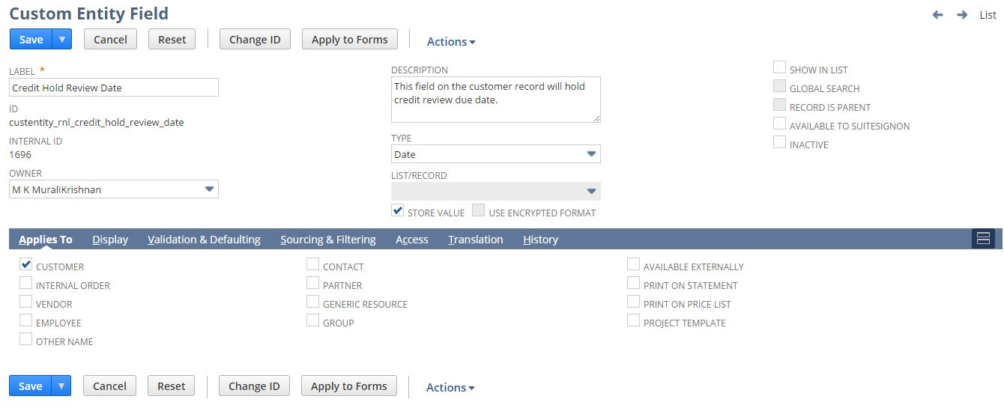

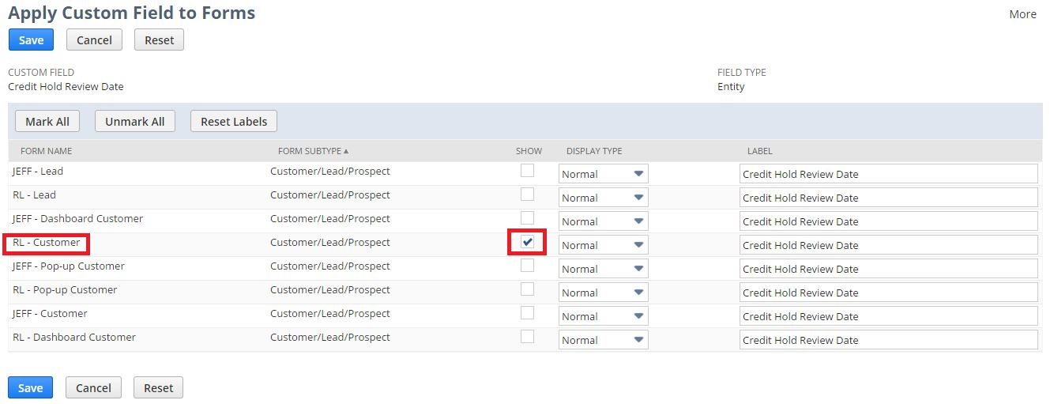

1. Open a Customer using below path

Lists > Relationship > Customers >New

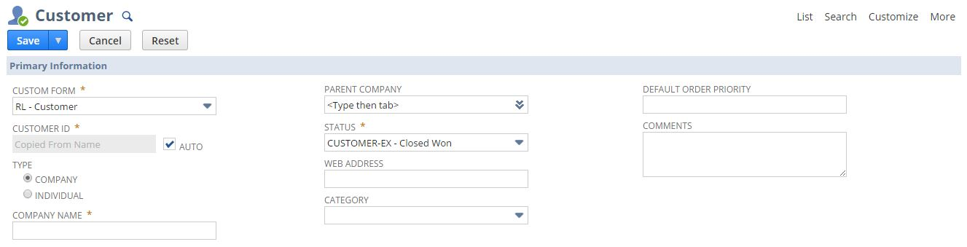

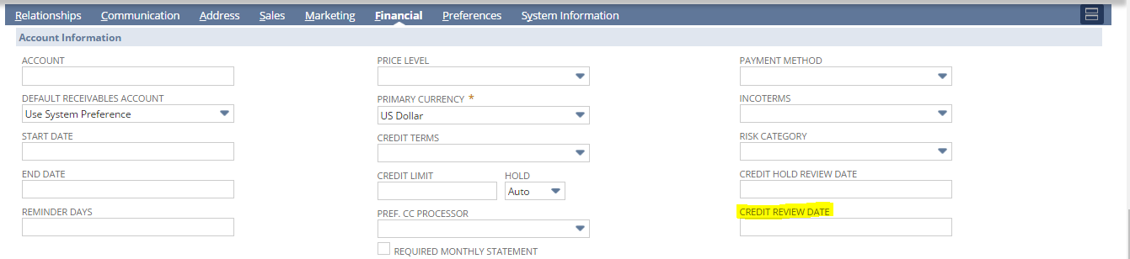

## Req-02: Ability to hold credit risk category on customer record

Requirement is to hold credit risk category on Customer record.

### ACCEPTANCE CRITERIA

1. “Risk Category” field should be available on Customer record.
2. “Risk Category” field should be of type list/record.
3. Availability to select value from drop down on “Risk Category” Field whenever customer is created manually.

### USE CASES

1. Navigate to Lists > Relationship > Customers >New
2. User shall be able to select value from the drop down.

### JEFFERSON IMPACT

No impact

### FUNCTIONAL SOLUTION

There is no functional solution for this requirement.

### TECHNICAL SOLUTION

1. A custom field will be created on Customer record.

Details of the custom field are given below:

|  |  |  |  |  |
| --- | --- | --- | --- | --- |
| **Record Type** | **Field** | **Description** | **Type** | **Properties** |
| Customer | Risk Category | This field on the customer record will hold credit risk category | List/Record | 1. Display Type= Normal 2. Source the custom List "Risk Category List" 3. Field will be displayed on Header tab under Financial Tab. |

1. Custom list needs to be defined to source the values in list field.

Details of the custom list are given below:

|  |  |  |  |
| --- | --- | --- | --- |
| **Name** | **Description** | **Values** | **Properties** |
| Risk Category List | This list contains the list values on Risk Category field on the customer record to hold credit risk category | * Check All Orders * Top Rated - No Credit Check * Over Limit / Past Due * Cash in Advance * Bankruptcy | 1. This list will be available selecting Risk Category on Customer Record |

### CONFIGURATION

1. Create custom list using below path

Customization->Lists, Records & Fields >Lists > New

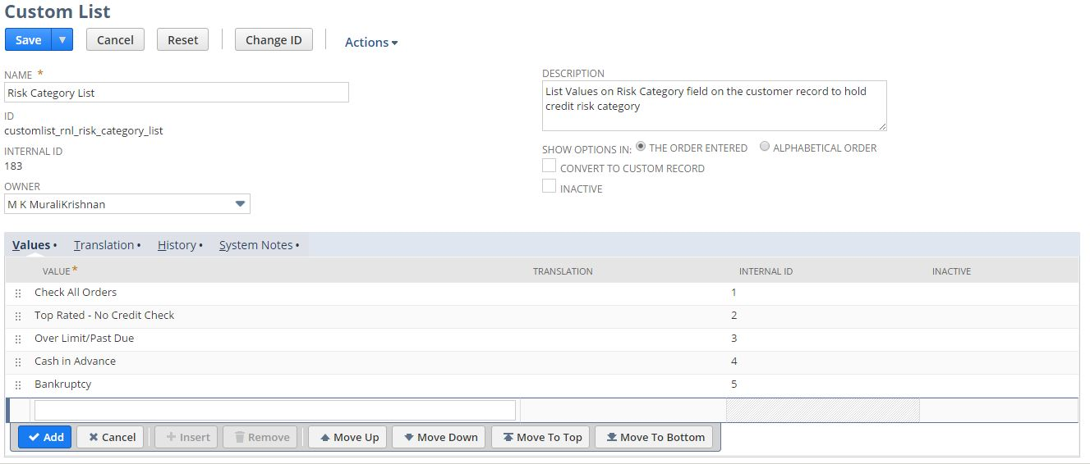

2. Create custom Field using below path

Customization->Lists, Records & Fields >Entity Fields > New

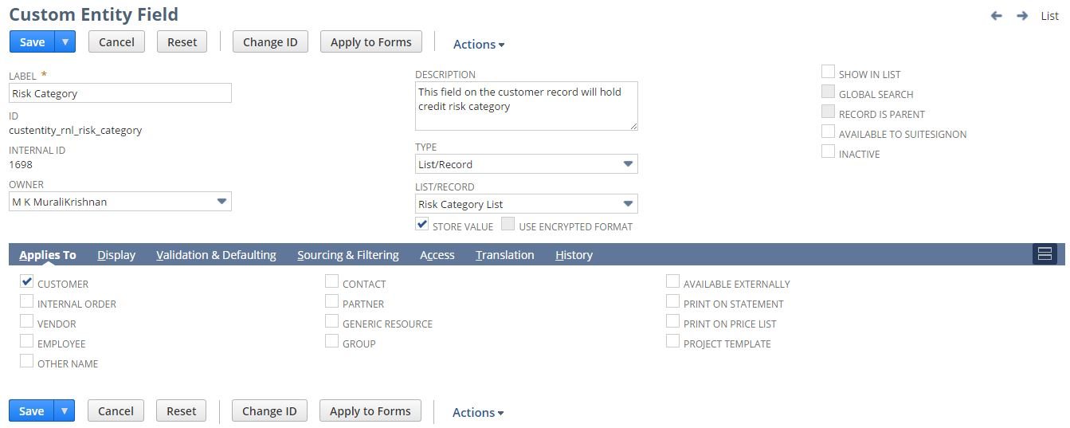

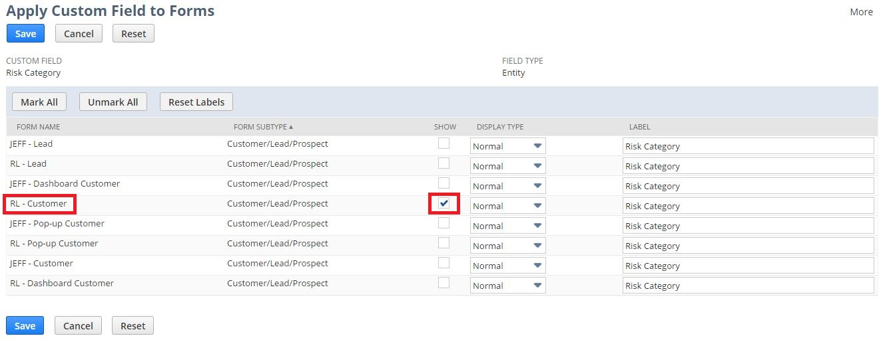

3. Open a Customer using below path

Lists > Relationship > Customers >New



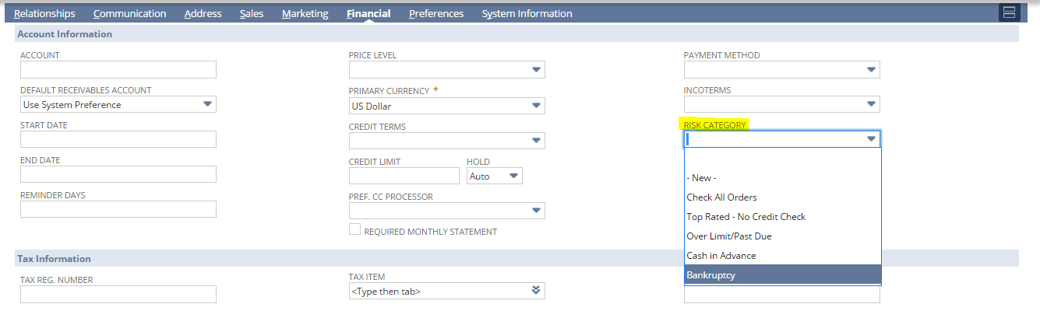

## Req-03: Ability to denote whether or not a customer requires monthly statements on Customer record

Requirement is to denote whether or not a customer requires monthly statements on Customer record.

### ACCEPTANCE CRITERIA

1. “Required Monthly Statement” field should be available on Customer record.
2. “Required Monthly Statement” field should be of type Checkbox.

### USE CASES

1. Navigate to Lists > Relationship > Customers >New
2. User shall be able to mark and unmark the checkbox.

### JEFFERSON IMPACT

No impact

### FUNCTIONAL SOLUTION

There is no functional solution for this requirement.

### TECHNICAL SOLUTION

1. A custom checkbox field will be created on Customer record.

Details of the custom field are given below:

|  |  |  |  |  |
| --- | --- | --- | --- | --- |
| **Record Type** | **Field** | **Description** | **Type** | **Properties** |
| Customer | Required Monthly Statement | This checkbox field on the customer record will denote whether or not a customer requires monthly statements | Checkbox | 1. Display Type = Normal 2. Field will be displayed on financial subtab under Account Information Field group. |

### CONFIGURATION

1. Create custom Field using below path

Customization->Lists, Records & Fields >Entity Fields > New

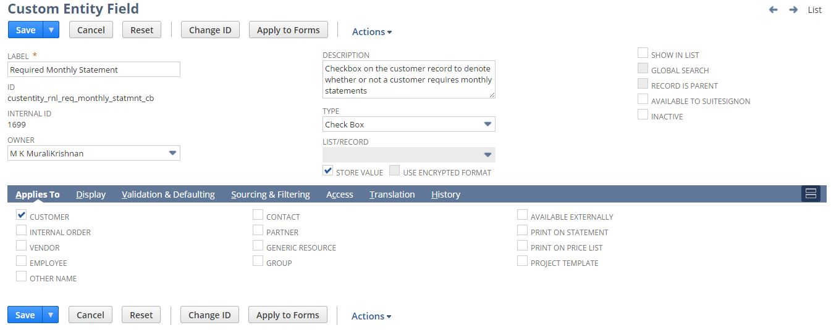

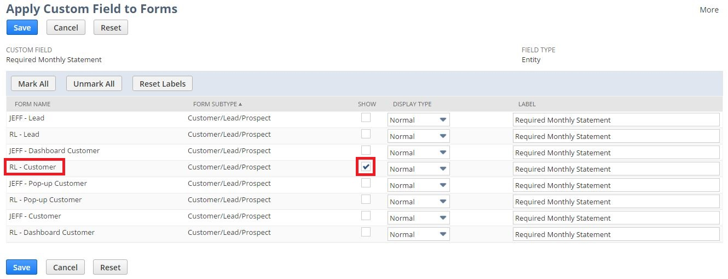

2. Open a Customer using below path

Lists > Relationship > Customers >New



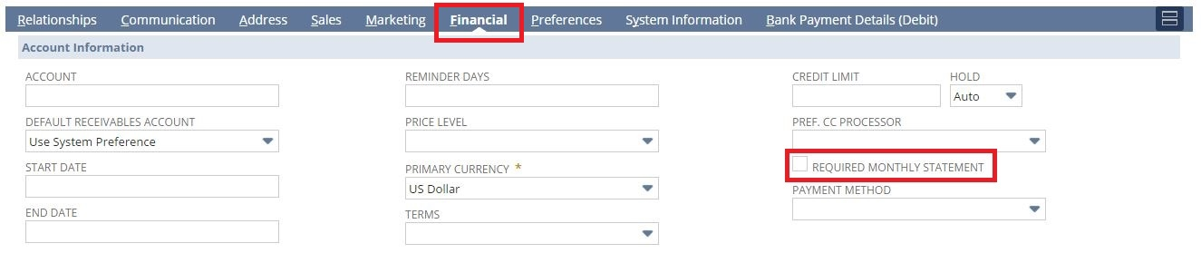

## Req-04: Ability to Hold Payment Method on Customer Record

Requirement is to hold Payment Method on Customer record

### ACCEPTANCE CRITERIA

1. “Payment Method” field should be available on Customer record.
2. “Payment Method” field should be of type List/Record.
3. Availability to select value from drop down on “Payment Method” field whenever customer is created manually.

### USE CASES

1. Navigate to Lists > Relationship > Customers >New
2. User shall be able to select Payment Method.

### JEFFERSON IMPACT

No impact

### FUNCTIONAL SOLUTION

There is no functional solution for this requirement.

### TECHNICAL SOLUTION

1. A custom List/Record field will be created on Customer record.

Details of the custom field are given below:

|  |  |  |  |  |
| --- | --- | --- | --- | --- |
| **Record Type** | **Field** | **Description** | **Type** | **Properties** |
| Customer | Payment Method | This List/Record field on the Customer record will list all the available Payment Methods for the Customer. | List/Record | 1. Display Type = Normal 2. Source the custom List "Payment Method" 3. Field will be displayed on Financial Subtab under Account Information Field group. |

### CONFIGURATION

1. Create a Custom Field by following the path mentioned below

Customization->Lists, Records & Fields >Entity Fields > New

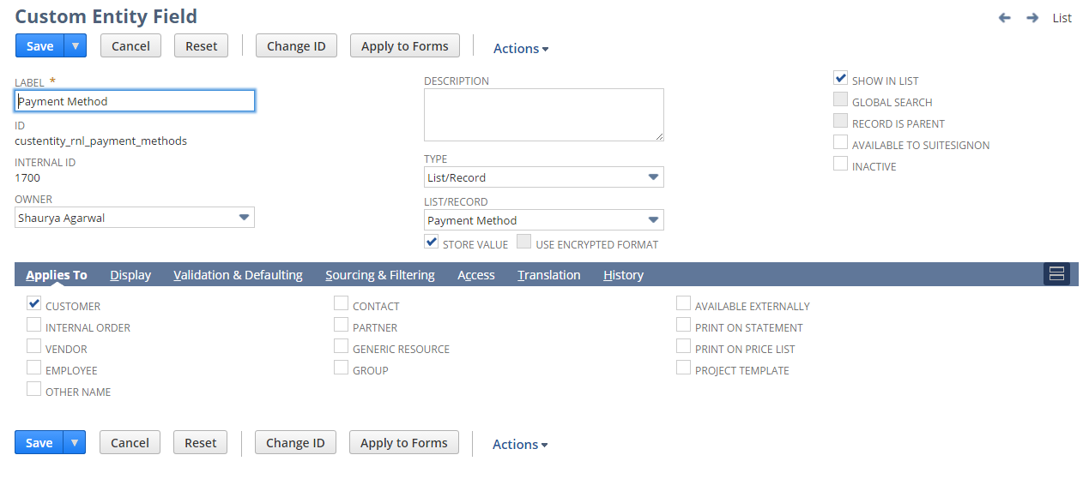

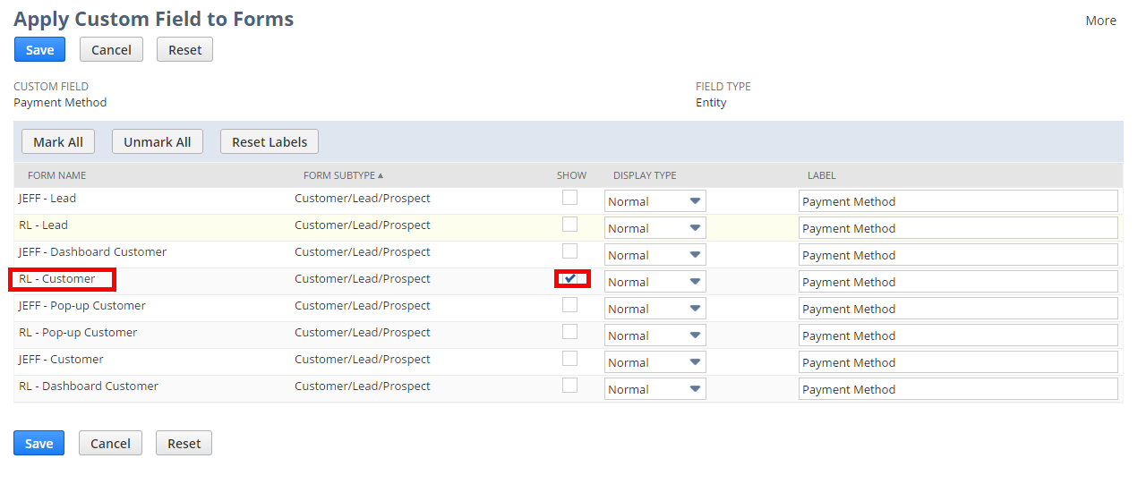

2. Create/Edit a Customer by following the path mentioned below

Lists > Relationship > Customers >New   
Lists > Relationship > Customers (Existing)



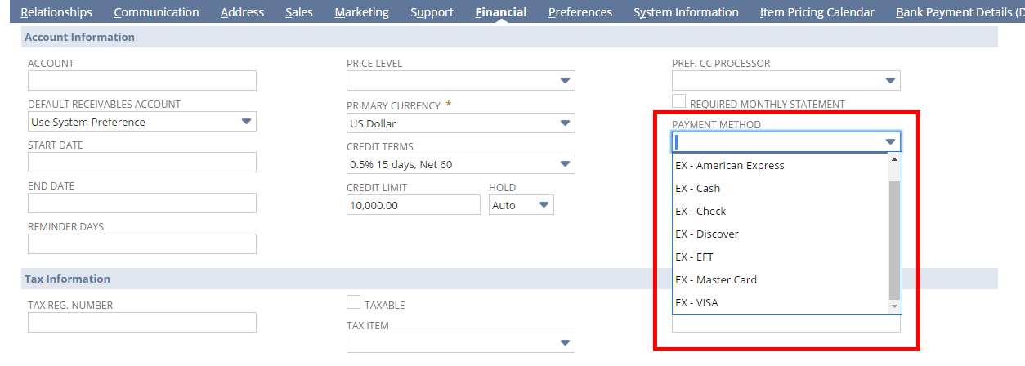

## Req-05: Ability to Pull Report to Show Credit Master Data changes

The requirement is to extract data from ‘RNL Credit Audit Report’ and generate a report of changes made to the Credit Limit, Risk Category and Terms for Customer which are listed under Renew Life Subsidiary in NetSuite.

### ACCEPTANCE CRITERIA

1. All the Customers for which a change in Credit Limit, Risk Category and Terms has happened should be listed along with their respective Set By, Date, Field, Old Value and New Value fields.

### USE CASES

1. User needs to Go to Reports> Saved Searches > RNL Credit Audit Report.
2. User needs to select/run the report.

### JEFFERSON IMPACT

No impact

### FUNCTIONAL SOLUTION

* 1. There is no functional solution for this requirement. We are using NetSuite’s out-of-box functionality of Saved Search to fetch data for reporting.

### TECHNICAL SOLUTION

1. Saved search to be created on Customer record
2. Saved Search type should be report.
3. In the result columns all required fields will be added.  
   Details of the saved search are given in the table below:

|  |  |  |  |  |  |
| --- | --- | --- | --- | --- | --- |
| **Record Type** | **Name** | **Description** | **Filters** | **Columns** | **Properties** |
| Customer | RNL Credit Audit Report | This saved search will fetch the data of the required columns from the ‘RNL Credit Audit Report’. | * Company Code = Renew Life * System Notes = Field: Credit Limit, Risk Category and Terms * Name/ID | * Name * System Notes : Set By * System Notes : Date * System Notes : Field * System Notes : Old Value * System Notes : New Value Price | * Company Code field will be defaulted in criteria for search * System Notes: Date field will be available for user selection as Filter. * Name/ID filter is available for customer name/ID |

### CONFIGURATION

1. To Create Saved Search follow the path mentioned below:

Reports->Saved Search->All Saved Searches->New

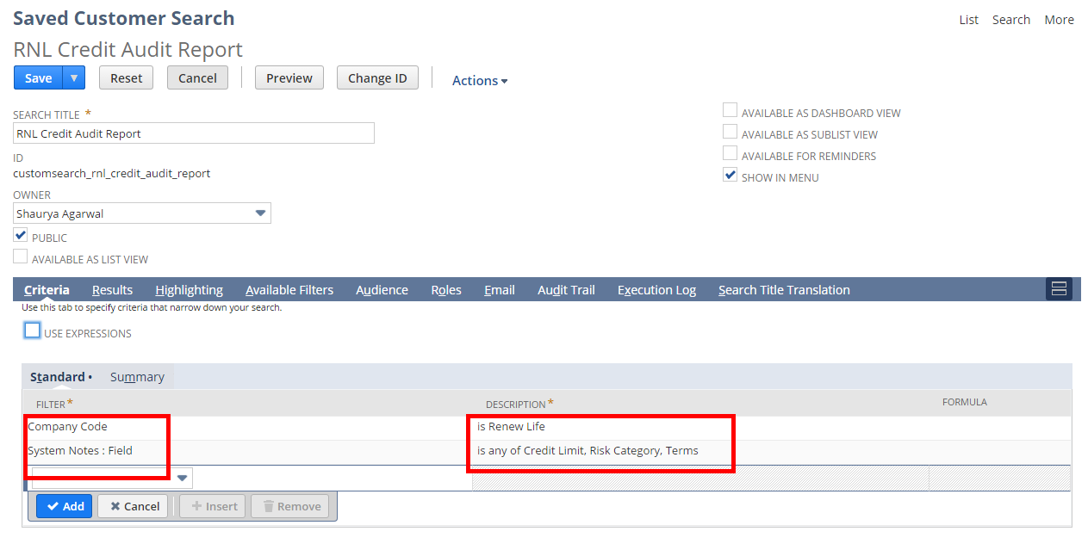

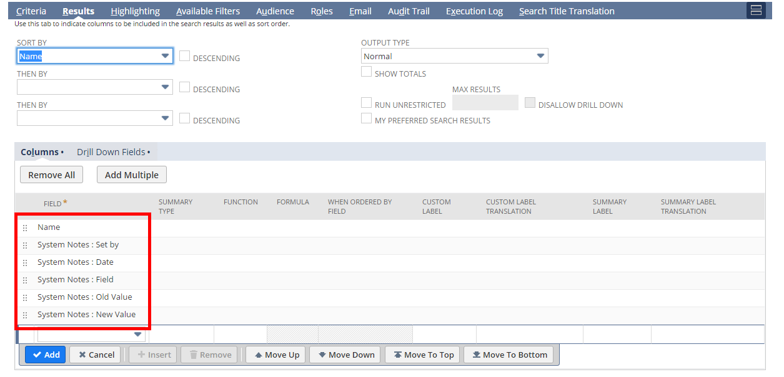

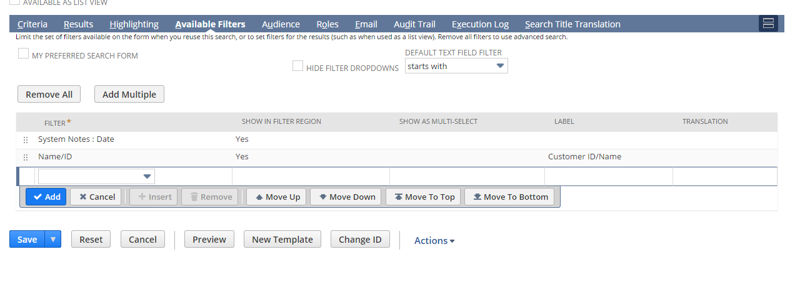

1. To view Saved Search follow the path mentioned below:

Reports->Saved Search->RNL Credit Audit Report

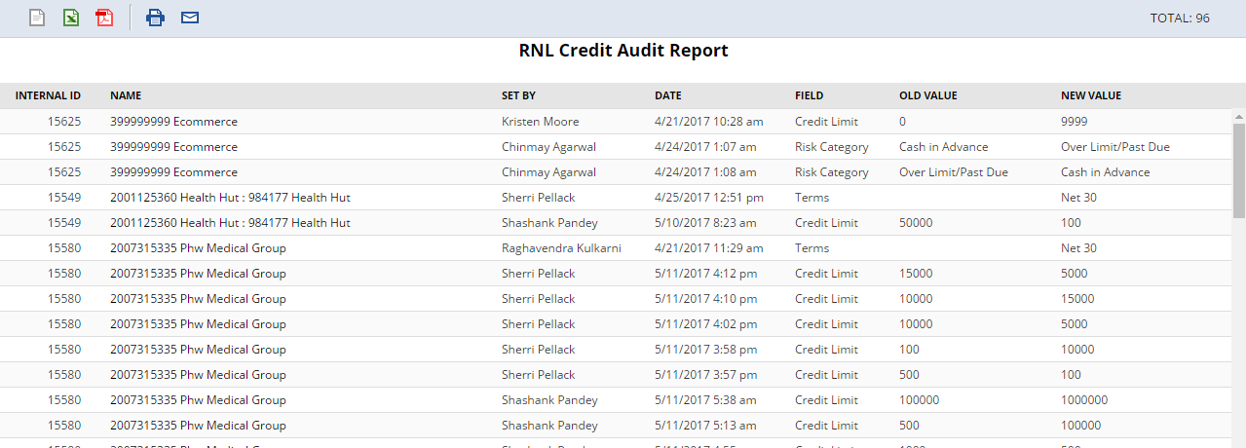

## Req-06: Ability to report on Defined Credit Management Fields in Master Data By Customer

The requirement is to extract data from ‘RNL Credit Management Report’ and generate a report having details for Name, Credit Hold Review Date, Risk Category, Credit Limit, Credit Card Number, Credit Card Type and CC Expiry Date of Customers which are listed under Renew Life Subsidiary in NetSuite.

### ACCEPTANCE CRITERIA

1. All the Customers should be listed along with their respective Name, Credit Hold Review Date, Risk Category, Credit Limit, Credit Card Number, Credit Card Type and CC Expiry Date fields.

### USE CASES

1. User needs to Go to Reports> Saved Searches > RNL Credit Management Report.
2. User needs to select/run the report.

### JEFFERSON IMPACT

No impact

### FUNCTIONAL SOLUTION

1. There is no functional solution for this requirement. We are using NetSuite’s out-of-box functionality of Saved Search to fetch data for reporting.

### TECHNICAL SOLUTION

1. Saved search to be created on Customer record
2. Saved Search type should be report.
3. In the result columns all required fields will be added.  
   Details of the saved search are given in the table below:

|  |  |  |  |  |  |
| --- | --- | --- | --- | --- | --- |
| **Record Type** | **Name** | **Description** | **Filters** | **Columns** | **Properties** |
| Customer | RNL Credit Management Report | This saved search will fetch the data of the required columns from the ‘RNL Credit Management Report’. | * Company Code = Renew Life. | * Name * Credit Hold Review Date * Credit Review Date * Risk Category * Credit Limit * Credit Card Number * Credit Card Type * CC Expire Date * Start date * Credit Terms * Payment Method * Incoterms | * Company Code field will be defaulted in criteria for search * Credit Review Date, Credit Hold Review Date and Name/ID fields will be available for user selection as Filter. |

### CONFIGURATION

1. To Create Saved Search follow the path mentioned below:

Reports->Saved Search->All Saved Searches->New

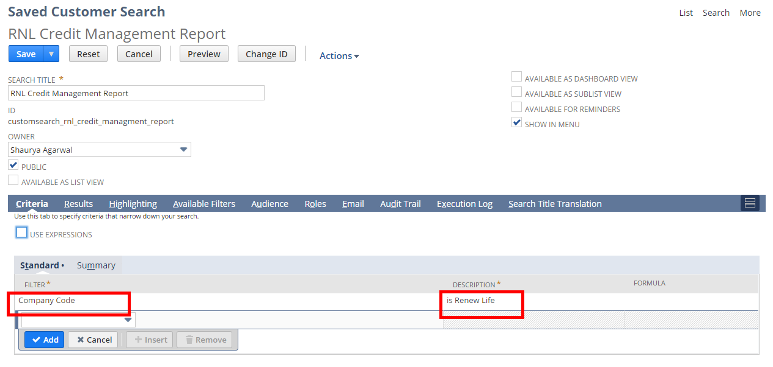

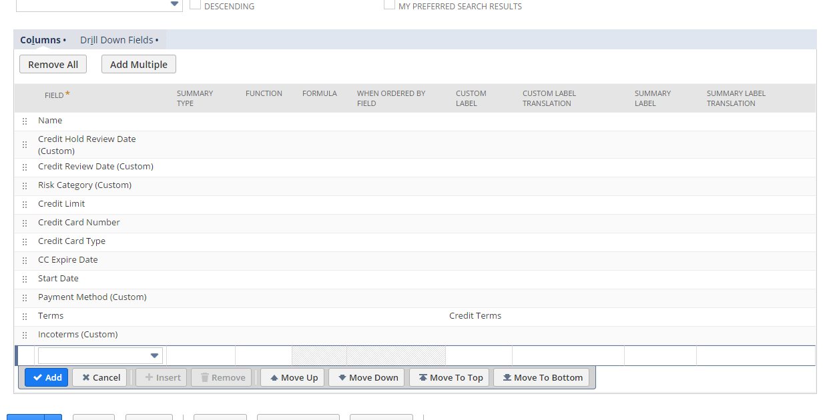

1. To view Saved Search follow the path mentioned below:

Reports->Saved Search->RNL Credit Management Report

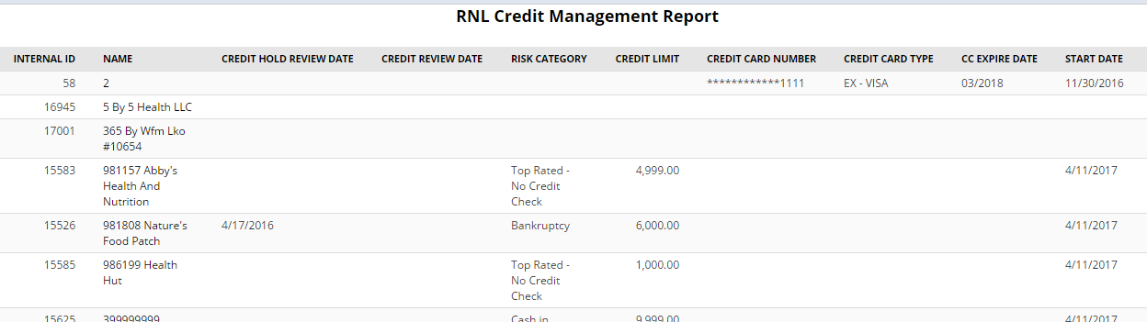

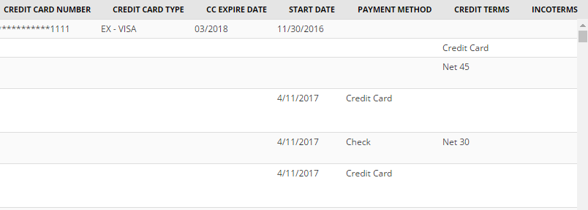

## Req-07: Ability to Rename “terms” field to “credit terms" under financial subtab on Customer record.

Requirement is to rename the “Terms” field to “Credit Terms” under financial subtab on Customer record.

### ACCEPTANCE CRITERIA

1. Terms should be the Standard NetSuite field and we should rename the label as Credit terms.

### USE CASES

1. Navigate to Lists ->Relationship ->Customers ->New
2. User should be able to see the “Credit Terms”.

### JEFFERSON IMPACT

No impact

### FUNCTIONAL SOLUTION

1. Customize the “RL-Customer” form.

2. Go to Screen Fields Tab, under financial subtab and Rename the Terms with “Credit terms”.

3. Save the Form to mark the required changes.

|  |  |  |  |
| --- | --- | --- | --- |
| **Record Type** | **Name** | **Description** | **Properties** |
| Customer | RL-Customer | Form customized to rename the Terms field to "Credit Terms" under financial subtab |  |

### TECHNICAL SOLUTION

There is no technical solution for this requirement.

### CONFIGURATION

1. Edit the RL-Customer Form using below path

Customization -> Forms -> Entry Forms and Edit the form

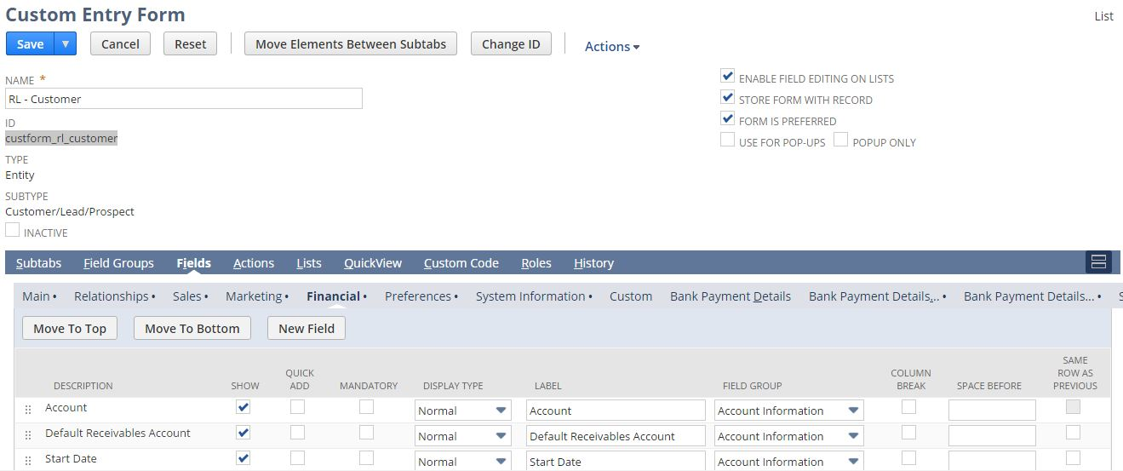

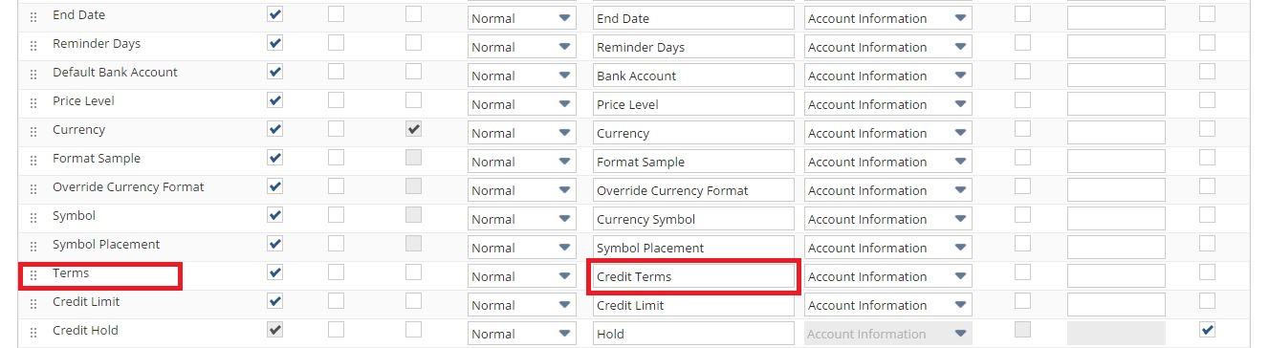

1. View the Customer Using the below Path

List -> Relationships -> Customer -> New



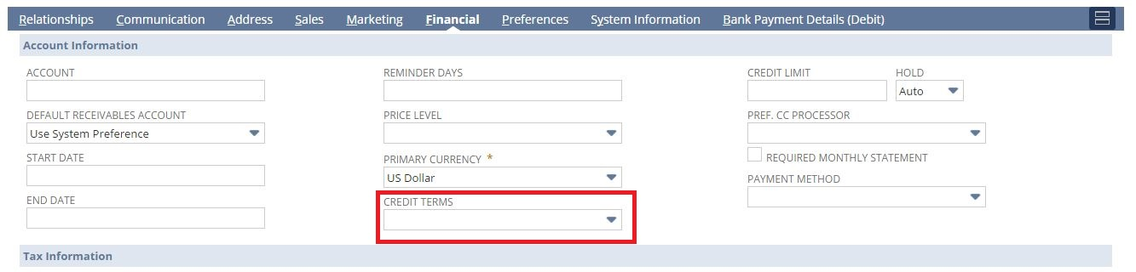

## Req-08: Ability to add incoterms under financial subtab on customer record

Requirement is to add a new list/record field “Incoterms” under financial subtab on customer record.

### ACCEPTANCE CRITERIA

1. “Incoterms” field should be available on Customer record.

2. “Incoterms” field should be of type list/record.

3. Availability to select value from drop down on “Incoterms” Field whenever customer is created manually.

### USE CASES

1. Navigate to Lists > Relationship > Customers >New

2. User shall be able to select value from the drop down.

### JEFFERSON IMPACT

No impact

### FUNCTIONAL SOLUTION

There is no functional solution for this requirement.

### TECHNICAL SOLUTION

1. A custom field will be created on Customer record.

Details of the custom field are given below:

|  |  |  |  |  |
| --- | --- | --- | --- | --- |
| **Record Type** | **Field** | **Description** | **Type** | **Properties** |
| Customer | Incoterms | This field on the customer record will give the list of incoterms | List/Record | 1. Display Type= Normal 2. Source the standard Incoterm List "Incoterms List" 3. Field will be displayed on financial subtab under Account Information Field group. |

### CONFIGURATION

* 1. Create custom Field using below path

Customization->Lists, Records & Fields >Entity Fields > New

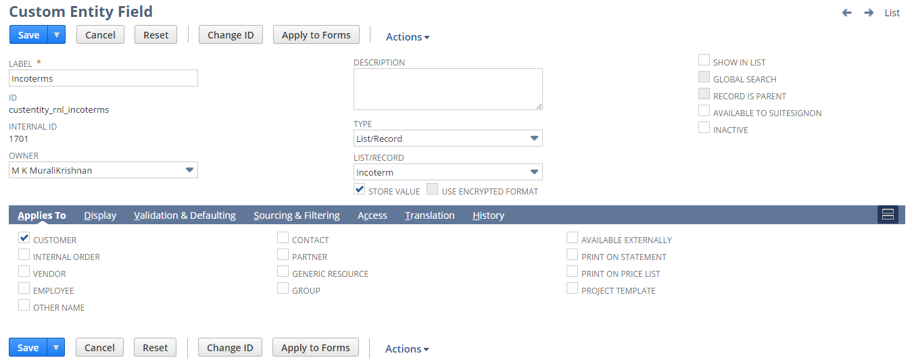

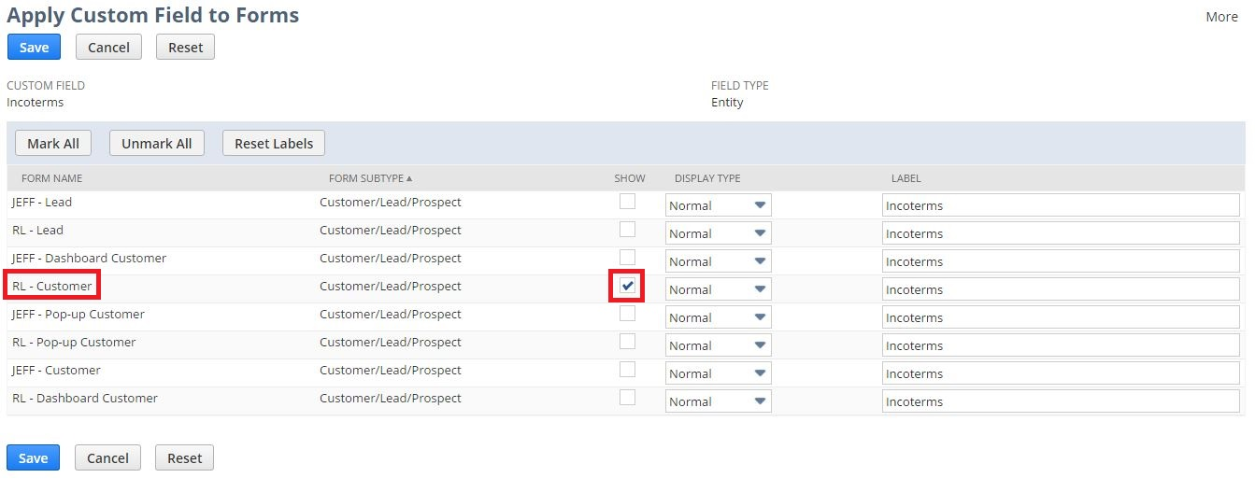

1. Open a Customer using below path

Lists > Relationship > Customers >New



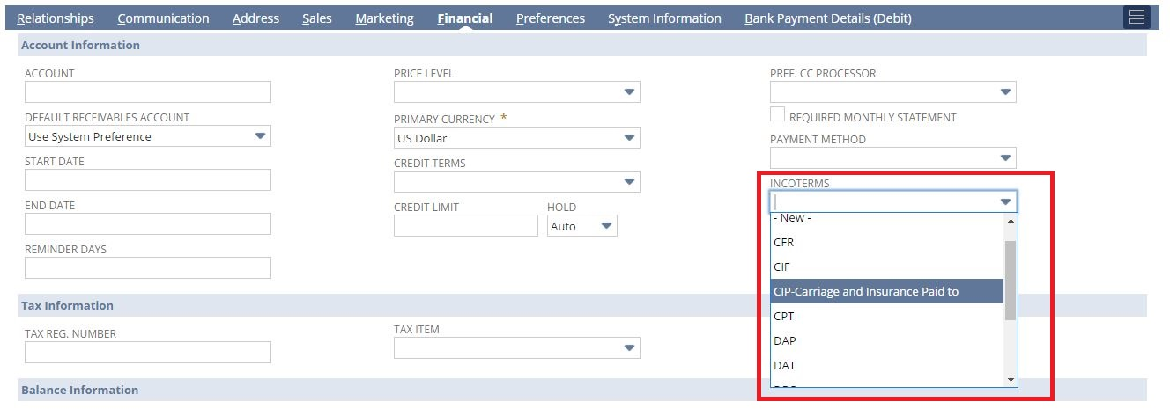

## Req-09: Ability to hide create po, create wo and price red 1 to 4 fields from sales order record

Requirement here is to hide create PO, create WO and price red 1 to 4 fields at line level from sales order record.

### ACCEPTANCE CRITERIA

1. Create PO, create WO and price red 1 to 4 should be disabled from sales order record.

2. User can’t see the create PO, create WO and price red 1 to 4 fields at line level in sales order record

### USE CASES

1. Navigate to Transactions > Sales > Enter Sales Order

### JEFFERSON IMPACT

No impact

### FUNCTIONAL SOLUTION

There is no functional solution for this requirement.

### TECHNICAL SOLUTION

1. Field will be disabled on OA, PO, Receipts, Bills, and RTV forms.

Details are given below:

|  |  |  |  |
| --- | --- | --- | --- |
| **Record Type** | **Name** | **Description** | **Properties** |
| Sales Order | RL – Sales Order | Create PO, Create WO, Price Red 1, Price Red 2, Price Red 3, Price Red 4 fields should be hidden at line level for Sales Order | Show=False |

### CONFIGURATION

1. Edit the RL – Sales Order using below path

Customization -> Forms -> Transaction Forms and Edit the form

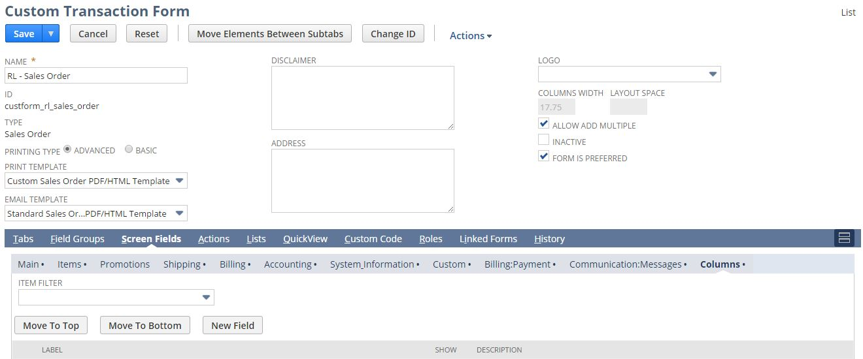

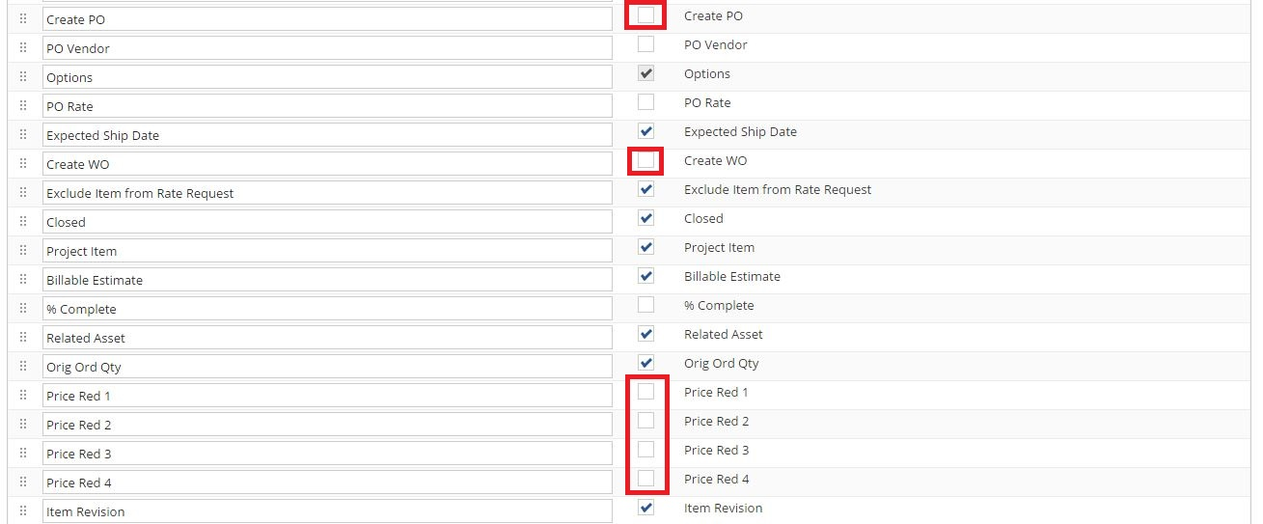

## Req-10: Ability to capture order by ean numbers

Requirement is to create a new custom field “EAN Number” for capturing orders in the main tab on Sales Order record. **(This requirement is not required to be developed.)**

### ACCEPTANCE CRITERIA

### USE CASES

### JEFFERSON IMPACT

### FUNCTIONAL SOLUTION

### TECHNICAL SOLUTION

|  |  |  |  |  |
| --- | --- | --- | --- | --- |
|  |  |  |  |  |
|  |  |  |  |  |

### CONFIGURATION

## Req-11: Ability to add new field on sales order to capture the order quantity

Requirement is to create a new custom field “Order Quantity” on Sales Order for capturing the order quantity which should flow to the invoice and print on the invoice. **(This requirement is not required to be developed.)**

### ACCEPTANCE CRITERIA

### USE CASES

### JEFFERSON IMPACT

### FUNCTIONAL SOLUTION

### TECHNICAL SOLUTION

### CONFIGURATION

## Req-12: Ability to Identify when a Customer Credit Card is Nearing Expiry

The requirement is to extract data from ‘RNL Customer Credit Card Nearing Expiry’ and generate a report of Customers whose credit card is approaching expiration within 60 days and which are listed under Renew Life Subsidiary in NetSuite.

### ACCEPTANCE CRITERIA

1. All the Customers for whom the Credit Card is nearing expiry within 60 days from now should be listed along with their respective Credit Card Number and Expiry date fields.

### USE CASES

1. User needs to Go to Reports> Saved Searches > RNL Customer Credit Card Nearing Expiry.
2. User needs to select/run the report.

### JEFFERSON IMPACT

No impact

### FUNCTIONAL SOLUTION

* 1. There is no functional solution for this requirement. We are using NetSuite’s out-of-box functionality of Saved Search to fetch data for reporting.

### TECHNICAL SOLUTION

1. Saved search to be created on Customer record
2. Saved Search type should be report.
3. In the result columns all required fields will be added.  
   Details of the saved search are given in the table below:

|  |  |  |  |  |  |
| --- | --- | --- | --- | --- | --- |
| **Record Type** | **Name** | **Description** | **Filters** | **Columns** | **Properties** |
| Customer | RNL Customer Credit Card Nearing Expiry | This saved search will fetch the data of the required columns from the ‘RNL Customer Credit Card Nearing Expiry’. | * Company Code = Renew Life * CC Expire Date = Within 60 days from now | * Name * Credit Card Number * CC Expire Date | * Company Code field will be defaulted in criteria for search. |

### CONFIGURATION

1. To Create Saved Search follow the path mentioned below:

Reports->Saved Search->All Saved Searches->New

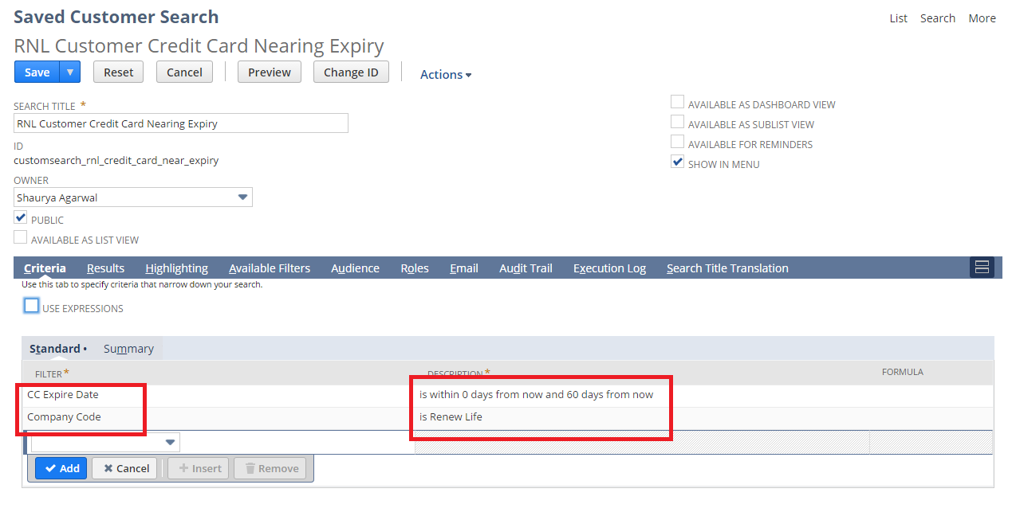

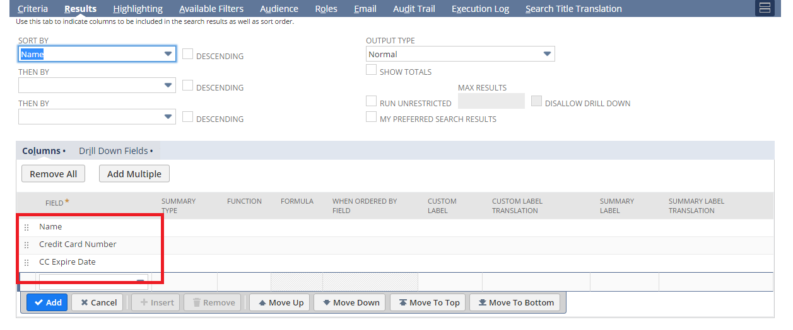

1. To view Saved Search follow the path mentioned below:

Reports->Saved Search-> RNL Customer Credit Card Nearing Expiry

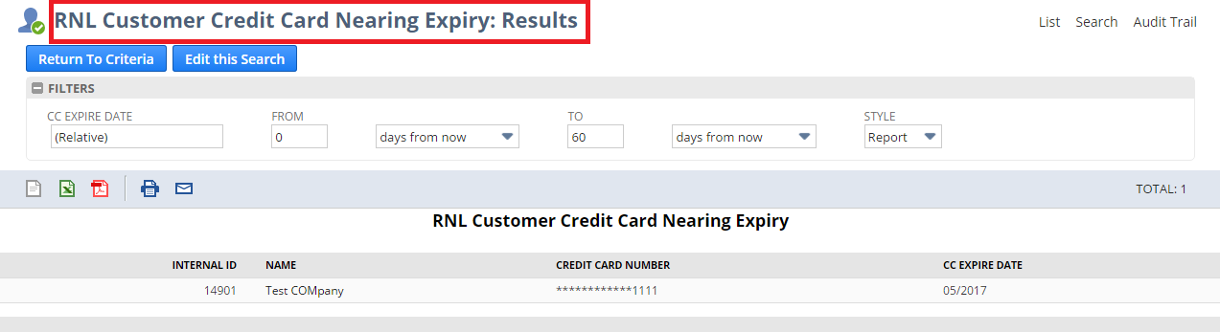

## Req-13: Need the Ability to Delineate Customer on the Customer Record by Customer Segment

Requirement is to manage customer segments and to link the customer with appropriate segments on Customer Form. Create a Saved Search report to show Sales by Customer Segment.

### ACCEPTANCE CRITERIA

1. Customer Segment field should be available for selection which is level 3 segment

2. Customer Segment 1 & Customer Segment 2 fields are to be sourced on selection of Customer Segment

3. All segment fields to be shown under Hierarchy & Segment field groups

4. User should be able to add or delete all 3 levels of segments

### USE CASES

1. Navigate to **…** > Hierarchy, Segment & Territory > Customer Segment > Segment 1 > New

2. Navigate to **…** > Hierarchy, Segment & Territory > Customer Segment > Segment 2 > New

3. Navigate to **…** > Hierarchy, Segment & Territory > Customer Segment > Segment 3 > New

4. Segments to be created in above segment records

5. Navigate to List > Relationship > Customer> New

6. User shall be able to select “Customer Segment”

7. Reports > Saved Search > RNL Sales by Customer Segment

### JEFFERSON IMPACT

No impact

### FUNCTIONAL SOLUTION

There is no functional solution for this requirement.

### TECHNICAL SOLUTION

* 1. 3 Custom records needs to be created

Details of the custom records are given in the table below:

|  |  |  |  |  |  |
| --- | --- | --- | --- | --- | --- |
| **Record Type** | **Name** | **Fields** | **Description** | **Type** | **Properties** |
| Custom Record | Customer Segment 1 | * Name | * The name field will be used for storing the name value of segment 1 | * Free-form Text | 1. Alphanumeric data can be entered |
| Custom Record | Customer Segment 2 | * Name * Customer Segment 1 | * The name field will be used for storing the name value of segment 2. * The Customer Segment 1 field will be used for storing the reference to Customer Segment 1 record | * Free-form Text * List/Record | 1. Alphanumeric data can be entered 2. Select Customer Segment 1 to maintain Hierarchy |
| Custom Record | Customer Segment 3 | * Name * Customer Segment 1 * Customer Segment 2 | * The name field will be used for storing the name value of segment 3. * The Customer Segment 1 field will be used for storing the reference to Customer Segment 1 record. * The Customer Segment 2 field will be used for storing the reference to Customer Segment 2 record | * Free-form Text * List/Record * List/Record | 1. Alphanumeric data can be entered 2. Select customer Segment 2 to maintain Hierarchy 3. Customer Segment 1 will be a disabled field and will be auto sourced from Customer Segment 2 record. 4. We have to populate value for Customer segment 2 field. |

1. A Center Tab will be created.  
   Details of the Center Tab are given in the table below:

|  |  |  |  |
| --- | --- | --- | --- |
| **Center Type** | **Name** | **Description** | **Categories** |
| Classic Center | Hierarchy, Segment & Territory | This Center tab will be available on the Menu under more options (…) | * Customer Segment |

1. A Center Category will be created  
   Details of the Center Category is mentioned below

|  |  |  |  |  |
| --- | --- | --- | --- | --- |
| **Center Tab** | **Name** | **Description** | **Links to Record** | **Label** |
| Hierarchy, Segment & Territory | Customer Segment | This Center Category will contain the links to records of different levels of Customer segments | * Customer Segment 1 * Customer Segment 2 * Customer Segment 3 | * Segment 1 * Segment 2 * Segment 3 |

1. 3 fields will be created on Customer Record.  
   Details of the custom field are given in the table below:

|  |  |  |  |  |
| --- | --- | --- | --- | --- |
| **Record Type** | **Field** | **Description** | **Type** | **Properties** |
| Customer | Customer Segment 3 | This field will be used to select among the different options present under Customer segment 3 | List/Record | 1. Only Customer Segment 3 records will be sourced 2. It will be displayed on Header tab under Hierarchy & Segment field group 3. Mandatory=No |
| Customer | Customer Segment 1 | This field will be used to select among the different options present under Customer segment 1 | List/Record | 1. Only Customer Segment 1 records will be sourced. 2. It will be displayed on Header tab under Hierarchy & Segment field group on selection of Customer Segment 3. 3. Mandatory=No 4. Display Type = Disabled |
| Customer | Customer Segment 2 | This field will be used to select among the different options present under Customer segment 2 | List/Record | 1. Only Customer Segment 2 records will be sourced. 2. It will be displayed on Header tab under Hierarchy & Segment field group on selection of Customer Segment 3. 3. Mandatory=No 4. Display Type = Disabled |

5. Saved search to be created on Transaction (Sales Order).

6. Saved Search type should be report.

7. In the result column all required field will be added

Details of the saved search report are given in the table:

|  |  |  |  |  |  |
| --- | --- | --- | --- | --- | --- |
| **Record Type** | **Name** | **Description** | **Filters** | **Columns** | **Properties** |
| Transaction  (Sales Order) | RNL Sales By Customer Segment | This saved search will fetch the data of the required columns from the Sales Order and customer record. | * Company Code = Renew Life * Type=Sales Order * Main Line=False * Tax Line=False * Customer Segment | * Segment * Name * Document Number * Customer Segment * Customer Segment 1 * Customer Segment 2 * Item * Quantity * Amount | * Company Code field will be defaulted in criteria for search. * Channel & Date will be available as a filter on report. * Customer Segment will be available as multi-select filter. |

### CONFIGURATION

1. To Create a Custom Record follow the path mentioned below:

Customization-> Lists, Records, & Fields ->Record Types-> New

Customer Segment 1:

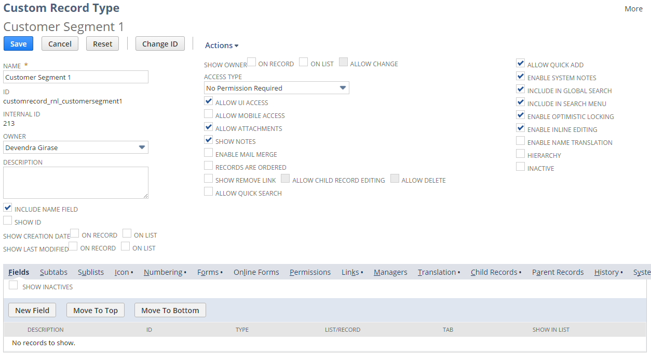

Customer Segment 2:

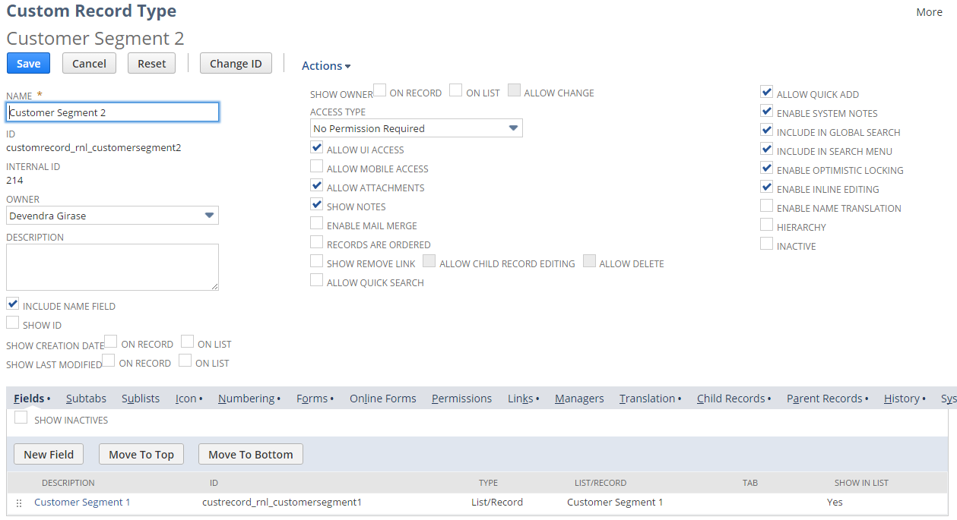

Customer Segment 3:

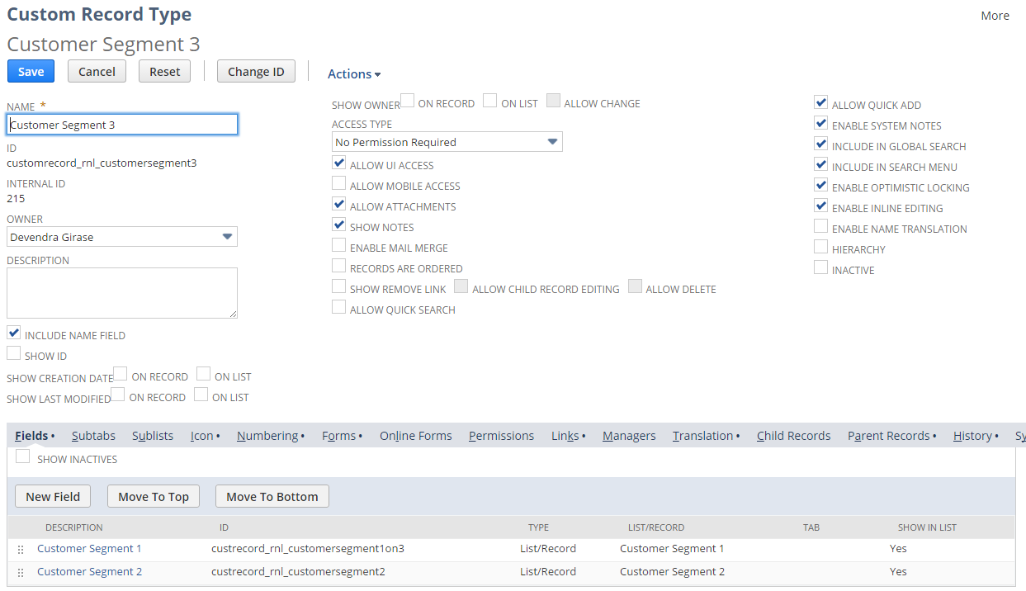

1. Create custom Field using below path

Customization->Lists, Records & Fields >Entity Fields > New

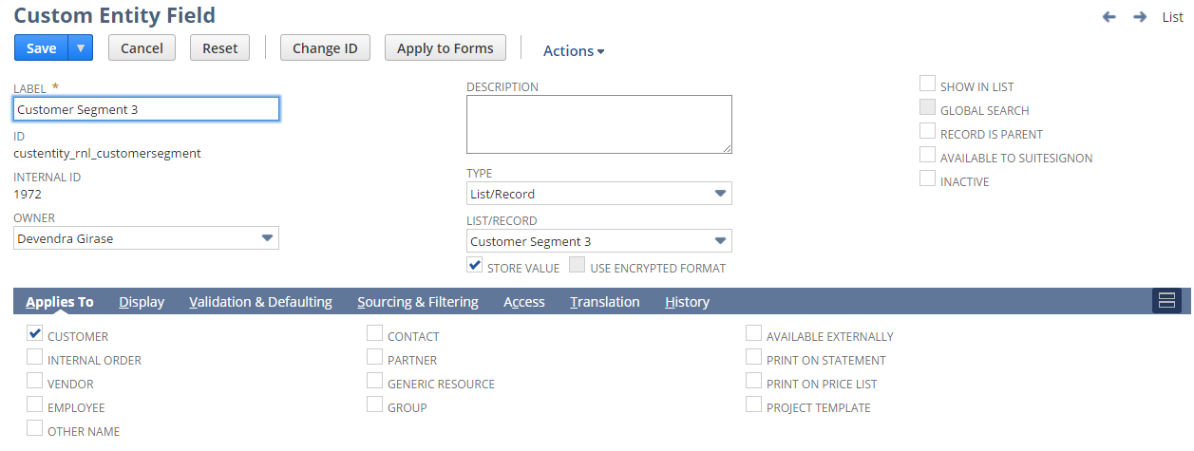

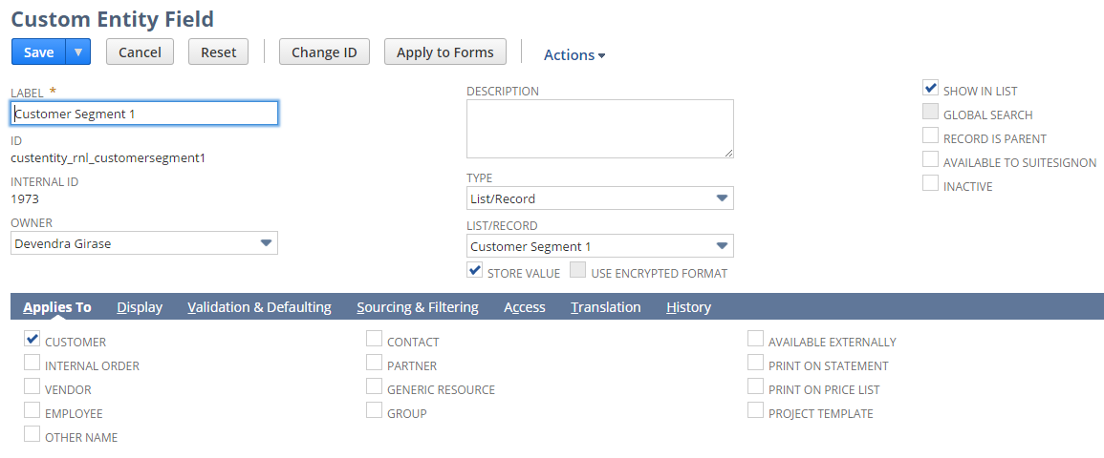

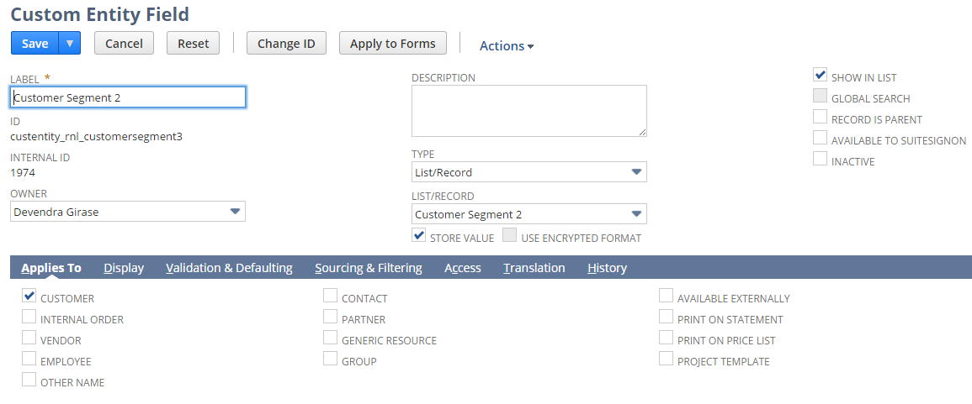

3. To Create Saved Search follow the path mentioned below:

Report > Saved Search > All Saved Search > New

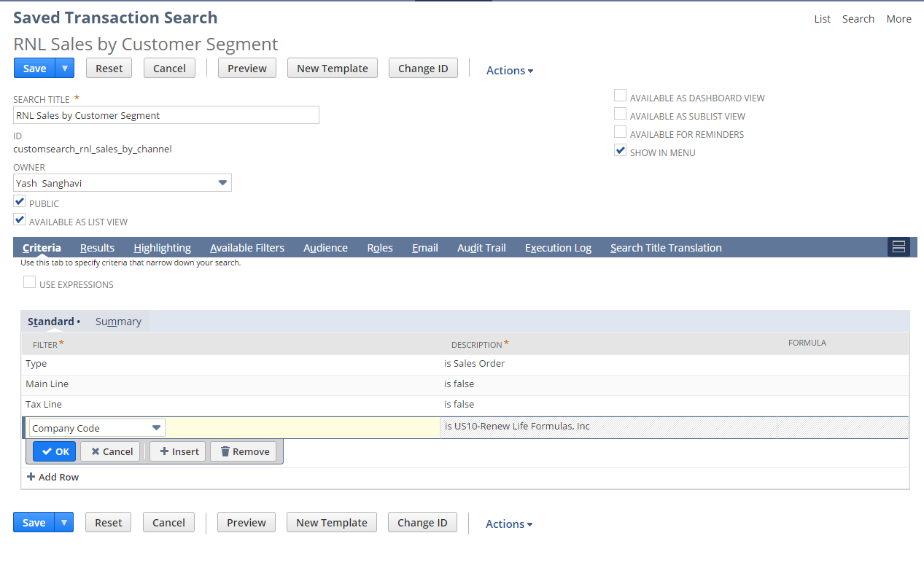

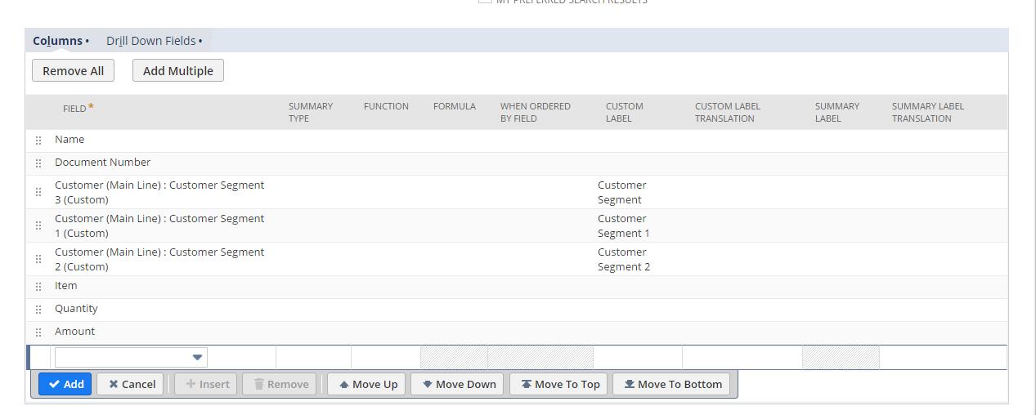

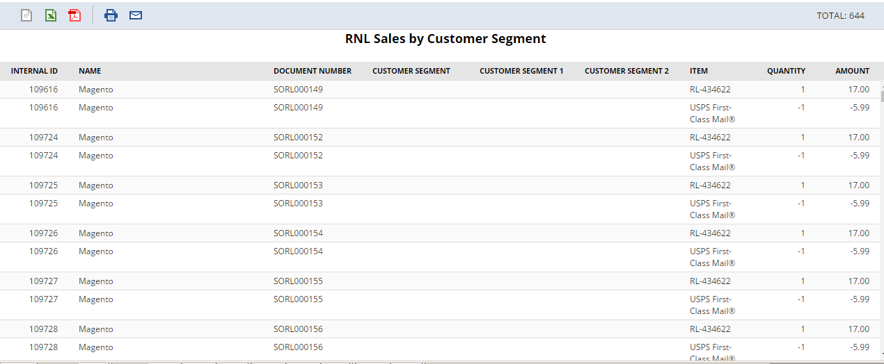

## Req-14: Ability to Rename “terms” field to “credit terms" under billing subtab and make it view only on Sales order record.

Requirement is to rename the “Terms” field to “Credit Terms” under billing subtab and make this field view only on Customer record.

### ACCEPTANCE CRITERIA

1. Terms should be the Standard NetSuite Date and we should rename the label as Credit terms.

2. Credit terms field is disabled under billing subtab.

### USE CASES

1. Navigate to Transactions -> Sales -> Enter Sales Orders

2. User should be able to see the “Credit Terms” field as disabled under billing subtab.

### JEFFERSON IMPACT

No impact

### FUNCTIONAL SOLUTION

1. Customize the “RL-Sales Order” form.

2. Go to Screen Fields Tab, under billing subtab and Rename the Terms with “Credit terms”.

3. Set the display type as disabled.

4. Save the Form to mark the required changes.

|  |  |  |  |
| --- | --- | --- | --- |
| **Record Type** | **Name** | **Description** | **Properties** |
| Sales Order | RL-Sales Order | Form customized to rename the Terms field to "Credit Terms" under billing subtab | * Display type = Disabled |

### TECHNICAL SOLUTION

There is no technical solution for this requirement.

### CONFIGURATION

1. Edit the RL-Sales Order Form using below path

Customization -> Forms -> Transaction Forms and Edit the form

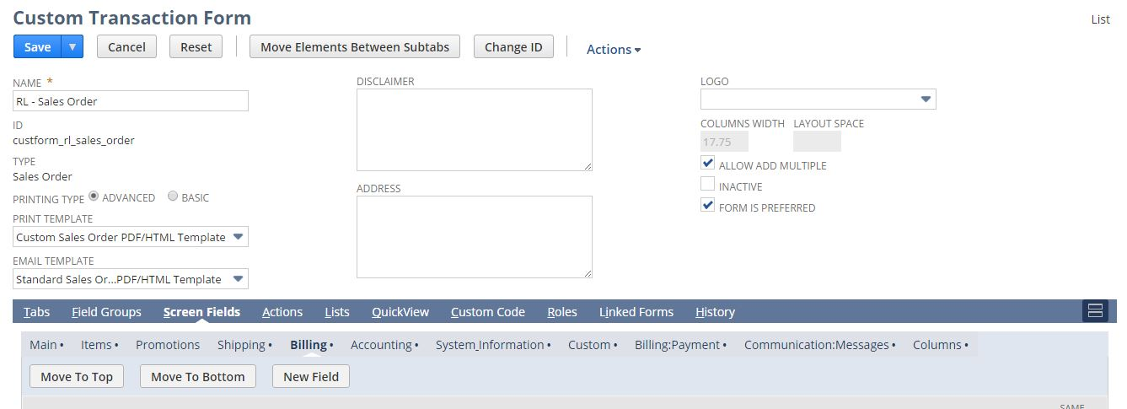

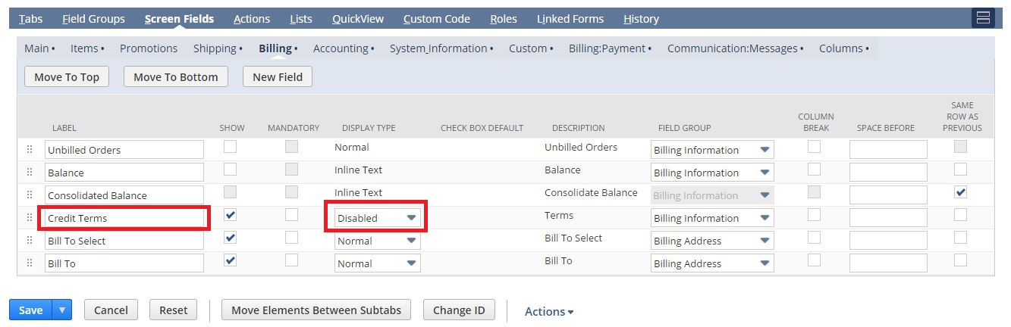

2. Open a Sales Order using below path

Transactions > Sales > Enter Sales Order

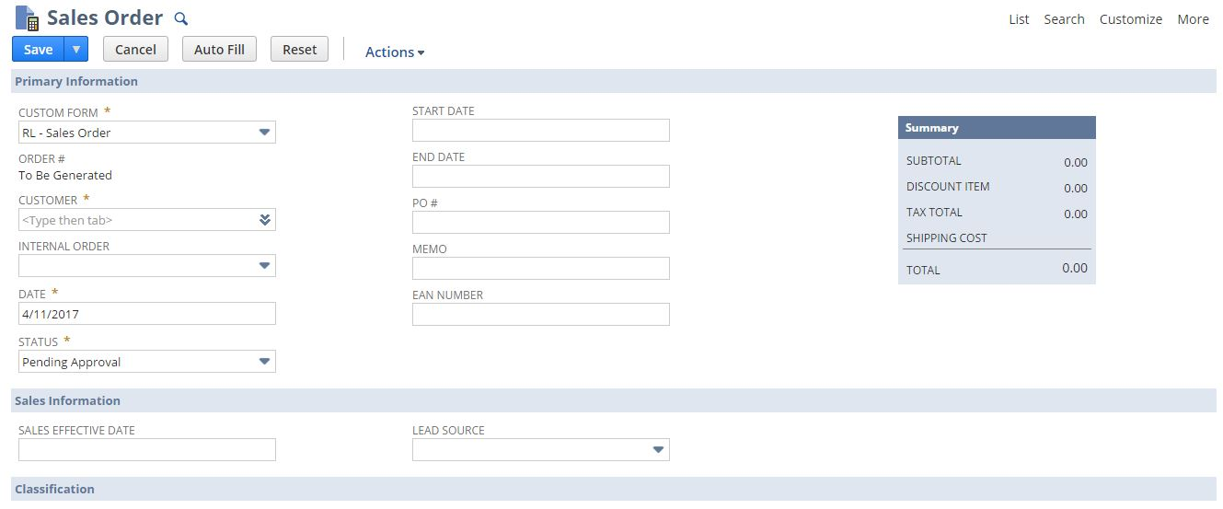

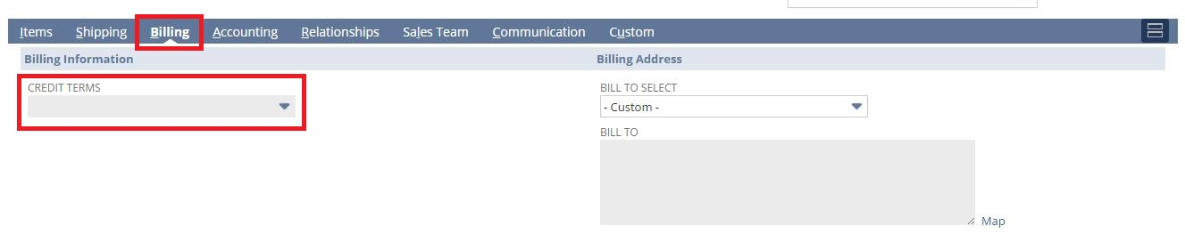

## Req-15: Ability to Sort Through different Order Segment and Generate a Report to identify ship Dates

The requirement is to extract data from ‘RNL Shipment by Segment’ and generate a report of Customers having different order channels to identify Ship Dates and which are listed under Renew Life Subsidiary in NetSuite.

### ACCEPTANCE CRITERIA

1. All the Customers for whom the Shipped Date is not empty should be listed along with their respective Channel, Item, Quantity, Shipping Carrier, Shipped Date and Tracking Number fields.

### USE CASES

1. User needs to Go to Reports> Saved Searches > RNL Shipment by Segment.
2. User needs to select/run the report.

### JEFFERSON IMPACT

No impact

### FUNCTIONAL SOLUTION

1. There is no functional solution for this requirement. We are using NetSuite’s out-of-box functionality of Saved Search to fetch data for reporting.

### TECHNICAL SOLUTION

1. Saved search to be created on Customer record
2. Saved Search type should be report.
3. In the result columns all required fields will be added.  
   Details of the saved search are given in the table below:

|  |  |  |  |  |  |
| --- | --- | --- | --- | --- | --- |
| **Record Type** | **Name** | **Description** | **Filters** | **Columns** | **Properties** |
| Transaction | RNL Shipment By Customer Segment | This saved search will fetch the data of the required columns from the ‘RNL Shipment By Customer Segment’. | * Company Code = Renew Life * Created From = Type: Sales Order * Type = Item Fulfillment * Actual Ship/Receipt Date is not empty | * Name * Segment * Customer Segment * Customer Segment 1 * Customer Segment 2 * Item * Quantity * Shipping Carrier * Actual Ship/Receipt Date * Tracking Numbers | * Company Code field will be defaulted in criteria for search. * Channel filter will be available for User to set * Customer Segment will be available as filter |

### CONFIGURATION

1. To Create Saved Search follow the path mentioned below:

Reports->Saved Search->All Saved Searches->New

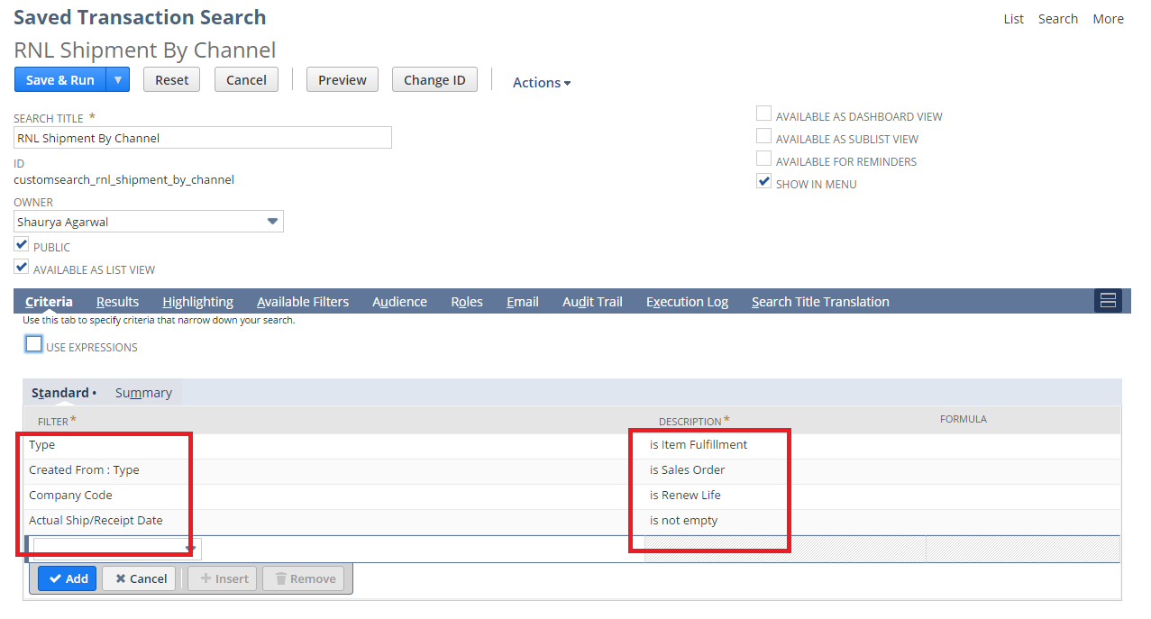

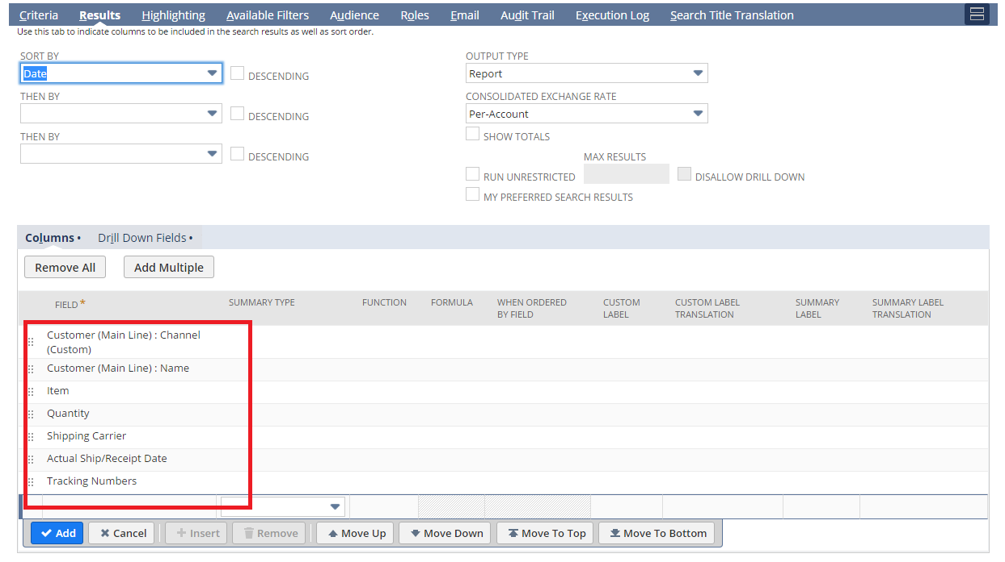

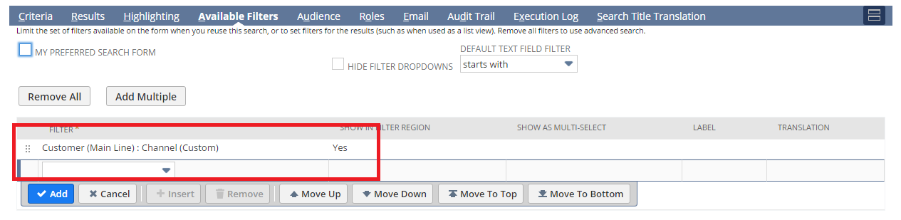

1. To view Saved Search follow the path mentioned below:

Reports->Saved Search-> RNL Shipment By Customer Segment

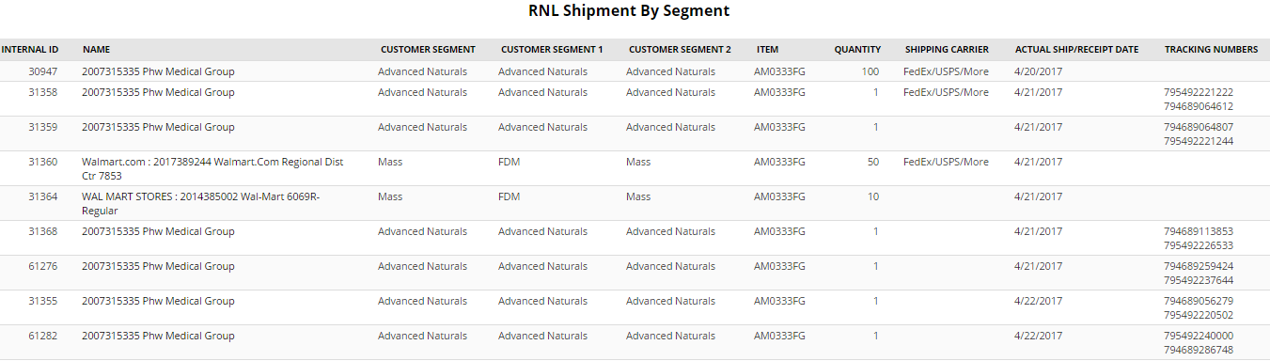

## Req-16: Need the Ability to Capture Unsellable Type on Customer Record

Requirement is to create a new custom field “Unsellable Type” on Customer Form of List type under classification tab.

### ACCEPTANCE CRITERIA

1. “Unsellable Type” field should be available on Sales Order record.

2. “Unsellable” field should be of type list record.

### USE CASES

1. Navigate to List > Relationship > Customer> New

2. User shall be able to select “Unsellable Type”.

### JEFFERSON IMPACT

No impact

### FUNCTIONAL SOLUTION

There is no functional solution for this requirement.

### TECHNICAL SOLUTION

1. A custom field will be created on customer record.

Details of the custom field are given below:

|  |  |  |  |  |
| --- | --- | --- | --- | --- |
| **Record Type** | **Field** | **Description** | **Type** | **Properties** |
| Customer | Unsellable Type | This field will capture unsaleable type for the customer. | List Record | 1. Display Type=Normal 2. Field Type =List Record 3. Field will be displayed on main level under classification tab. |

|  |  |  |  |
| --- | --- | --- | --- |
| **Name** | **Description** | **Values** | **Properties** |
| Unsellable Type | This list contains the list values on unsellable type field on the customer record | * Accrual * Deductions * Off Invoice | 1. This list will be available selecting unsellable type on Customer Record |

### CONFIGURATION

1. Create custom Field using below path

Customization->Lists, Records & Fields >Entity Fields > New

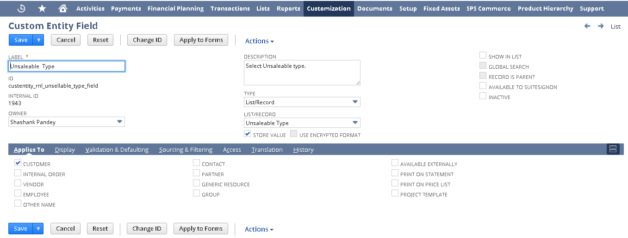

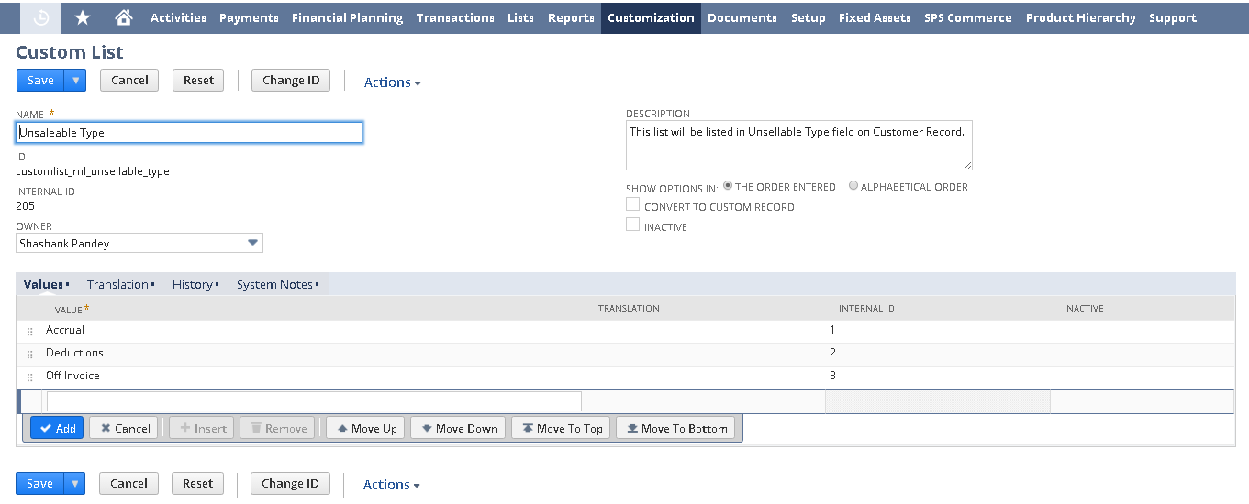

2. Click Save and Apply to forms

Apply the field to RL – Customer.

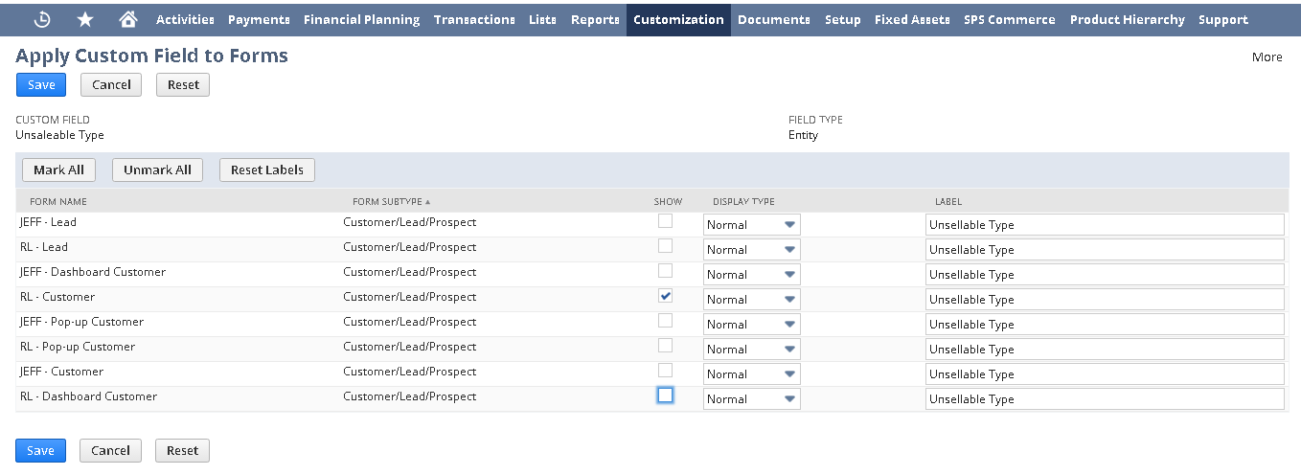

3. Open a Sales Order using below path

List > Relationship > Customer

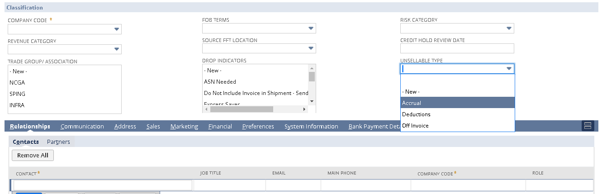

## Req-17: Ability to Rename “Category” field to “Retailer Type" under Primary Information on Customer record.

Requirement is to rename the “Category” field to “Retailer Type” under Primary Information on Customer record.

### ACCEPTANCE CRITERIA

1. Category should be the Standard NetSuite Field and we should rename the label as Retailer Type.

### USE CASES

1. Navigate to Lists ->Relationship ->Customers ->New
2. User should be able to see the “Retailer Type”.

### JEFFERSON IMPACT

No impact

### FUNCTIONAL SOLUTION

1. Customize the “RL-Customer” form.

2. Go to Screen Fields Tab, under Primary Information and Rename the Category with “Retailer Type”.

3. Save the Form to mark the required changes.

|  |  |  |  |
| --- | --- | --- | --- |
| **Record Type** | **Name** | **Description** | **Properties** |
| Customer | RL-Customer | Form customized to rename the Category field to "Retailer Type" under Primary Information |  |

### TECHNICAL SOLUTION

There is no technical solution for this requirement.

### CONFIGURATION

1. Edit the RL-Customer Form using below path

Customization -> Forms -> Entry Forms and Edit the form

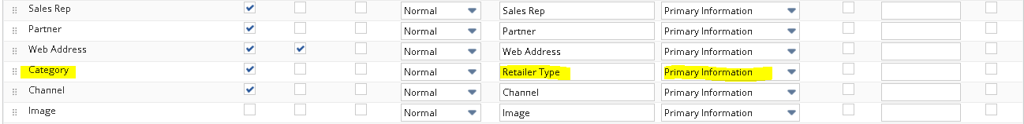

1. View the Customer Using the below Path

List -> Relationships -> Customer -> New

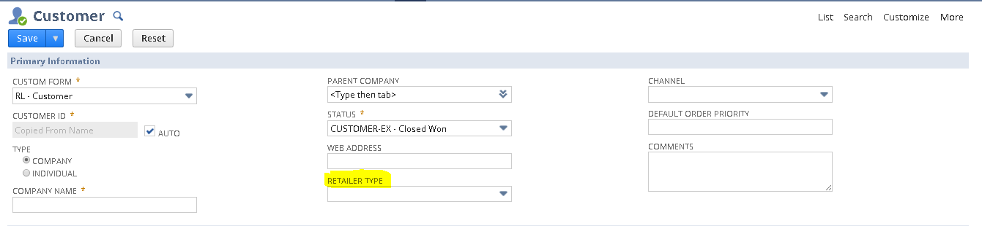

## Req-18: Ability to create and hold 3 Level Customer Hierarchy and Ship to

The requirement is to create and hold 3 levels Customer Hierarchy and Ship to

### ACCEPTANCE CRITERIA

1. The attribute fields will be grouped under Hierarchy & Segment on Customer Record with different levels and a SAP ID for Customer Level 3

### USE CASES

1. User needs to Go to Lists> Relationships > Customers > New.
2. User needs to select from the different level fields available on the record.

### JEFFERSON IMPACT

No impact

### FUNCTIONAL SOLUTION

1. There is no functional solution for this requirement.

### TECHNICAL SOLUTION

1. 3 Custom records needs to be created

Details of the custom records are given in the table below:

|  |  |  |  |  |  |
| --- | --- | --- | --- | --- | --- |
| **Record Type** | **Name** | **Fields** | **Description** | **Type** | **Properties** |
| Custom | Level 1 Customer Hierarchy | * Name | * The name field will be used for storing the name value of level. | * Free-form Text | 1. Alphanumeric data can be entered |
| Custom | Level 2 Customer Hierarchy | * Name * Level 1 | * The name field will be used for storing the name value of level. | * Free-form Text | 1. Alphanumeric data can be entered |
| Custom | Level 3 Customer Hierarchy | * Name * SAP ID * Level 1 * Level 2 | * The name field will be used for storing the name value of level. * SAP ID will be used to store the SAP ID on the Record | * Free-form Text * Free-Form Text * List * List | 1. Alphanumeric data can be entered |

1. A Center Tab will be created.  
   Details of the Center Tab are given in the table below:

|  |  |  |  |
| --- | --- | --- | --- |
| **Center Type** | **Name** | **Description** | **Categories** |
| Classic Center | Hierarchy, Segment & Territory | This Center tab will be available on the Dashboard under more options (…). | * Customer Hierarchy |

1. A Center Category will be created  
   Details of the Center Category is mentioned below

|  |  |  |  |  |
| --- | --- | --- | --- | --- |
| **Center Tab** | **Name** | **Description** | **Links to Record** | **Label** |
| Hierarchy, Segment & Territory | Customer Hierarchy | This Center Category will contain the links to records of different levels of Customer Hierarchy | * Level 1 Customer Hierarchy * Level 2 Customer Hierarchy * Level 3 Customer Hierarchy | * Level 1 * Level 2 * Level 3 |

1. Four fields will be created on Customer Record.  
    Details of the custom field are given in the table below:

|  |  |  |  |  |
| --- | --- | --- | --- | --- |
| **Record Type** | **Field** | **Description** | **Type** | **Properties** |
| Customer | Customer Level 1 | This field will be used to select among the different options present under Level 1 Customer Hierarchy Record | List/Record | 1. Only Level 1 Customer Hierarchy Record will be sourced 2. It will be displayed on Header tab under Customer Hierarchy field group on selection of Customer Level 3 3. Mandatory=No 4. Display Type = Disabled |
| Customer | Customer Level 2 | This field will be used to select among the different options present under Level 2 Customer Hierarchy Record | List/Record | 1. Only Level 2 Customer Hierarchy Record will be sourced 2. It will be displayed on Header tab under Customer Hierarchy field group on selection of Customer Level 3 3. Mandatory=No 4. Display Type = Disabled |
| Customer | Customer Level 3 | This field will be used to select among the different options present under Level 3 Customer Hierarchy Record | List/Record | 1. Only Level 3 Customer Hierarchy Record will be sourced 2. It will be displayed on Header tab under Hierarchy & Segment field group 3. Mandatory=No |
| Customer | Customer Level 3 SAP ID | This field will be used to source the respective SAP ID of the Level 3 Customer Hierarchy Record | Free-Form Text | 1. This will be sourced from the respective Level 3 Customer Hierarchy Record 2. It will be displayed on Header tab under Hierarchy & Segment field group 3. Mandatory=No 4. Display Type = Disabled |

### CONFIGURATION

1. To Create a Custom Record follow the path mentioned below:

Customization-> Lists, Records, & Fields ->Record Types-> New

Level 1 Customer Hierarchy:  
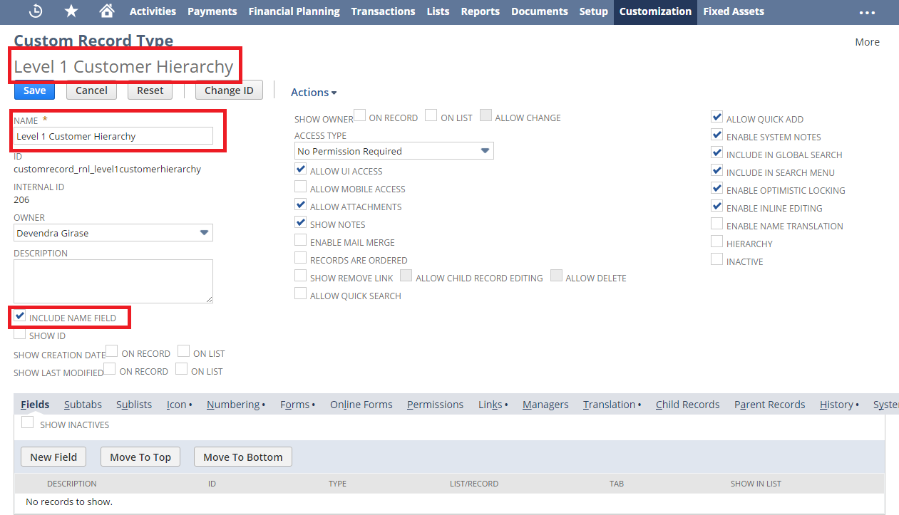

Level 2 Customer Hierarchy:

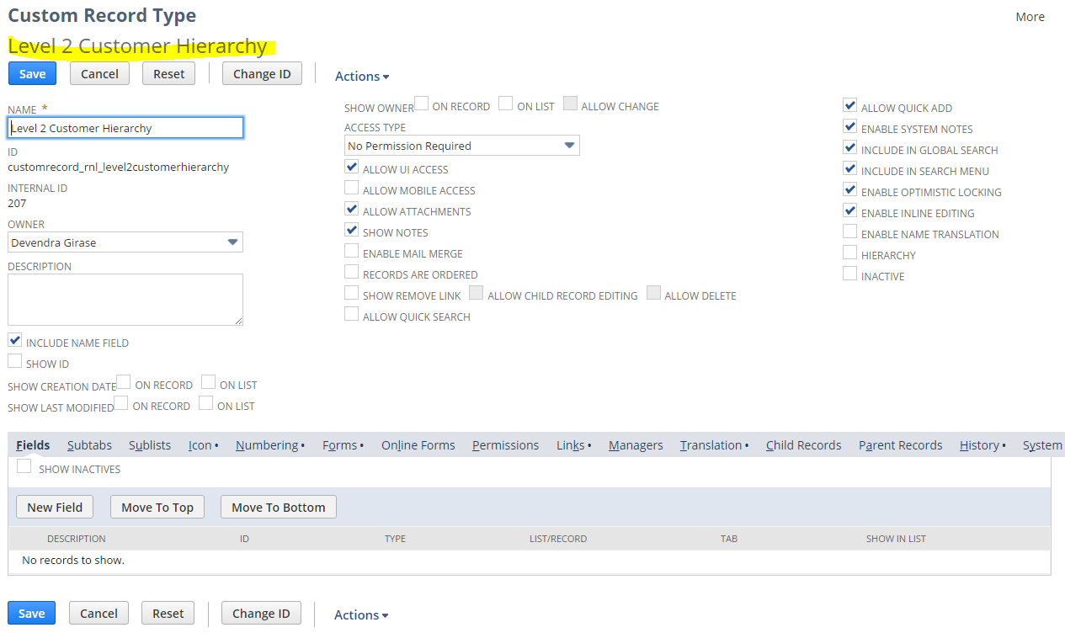

Level 3 Customer Hierarchy:

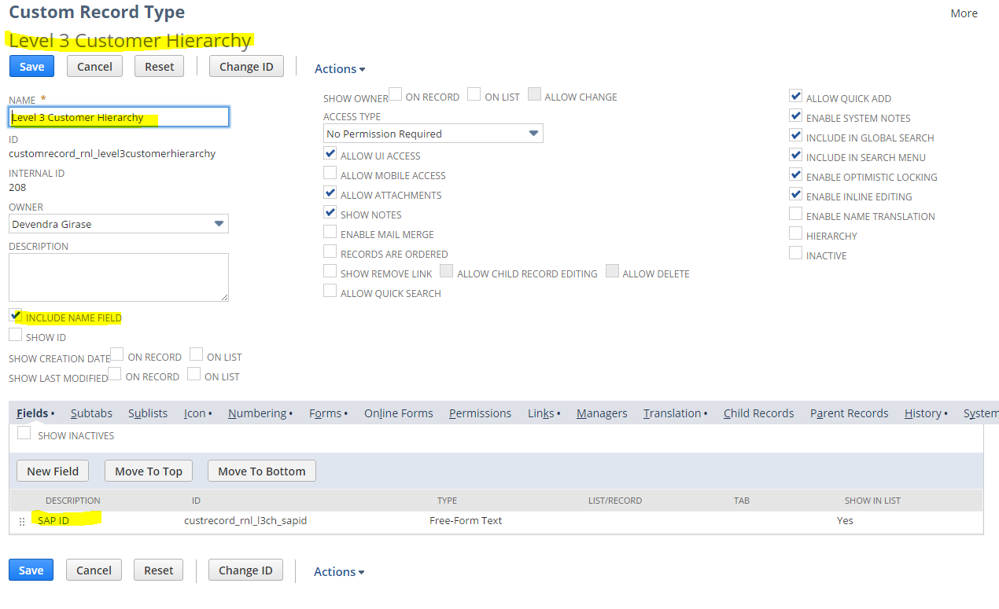

1. To Create a Center Tab follow the path mentioned below:

Customization->Centers and Tabs->Center Tabs->New

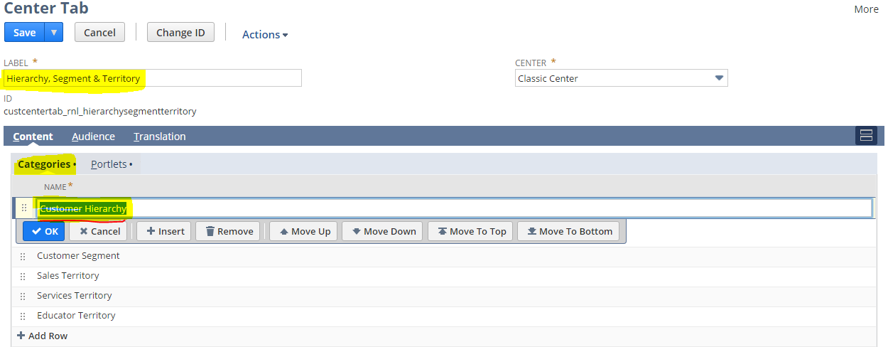

1. To Create a center Category follow the path mentioned below:  
   Customization->Center and Tabs->Center categories->New

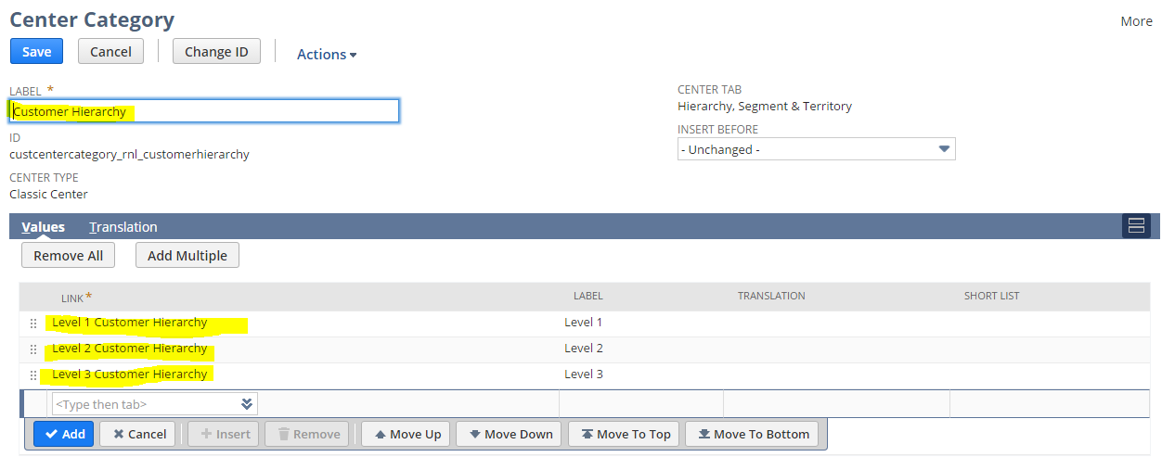

1. To Create a Custom Field follow the path mentioned below:

Customization-> Lists, Records, & Fields ->Entity Field-> New

Customer Level 1:

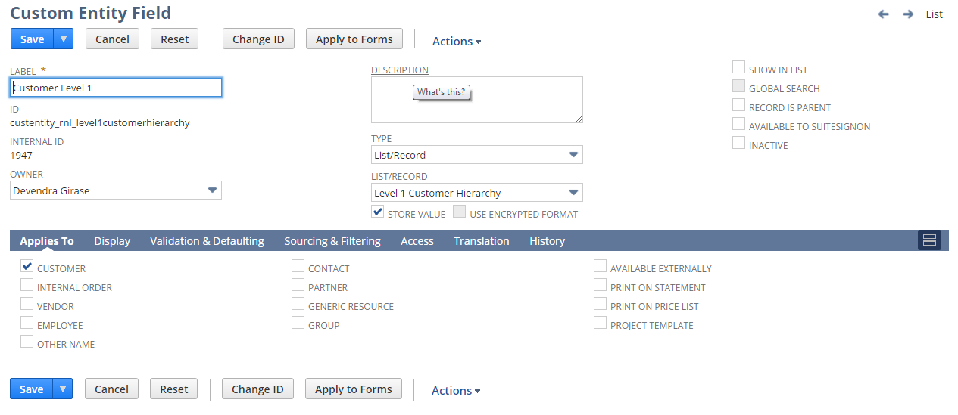

Customer Level 2:

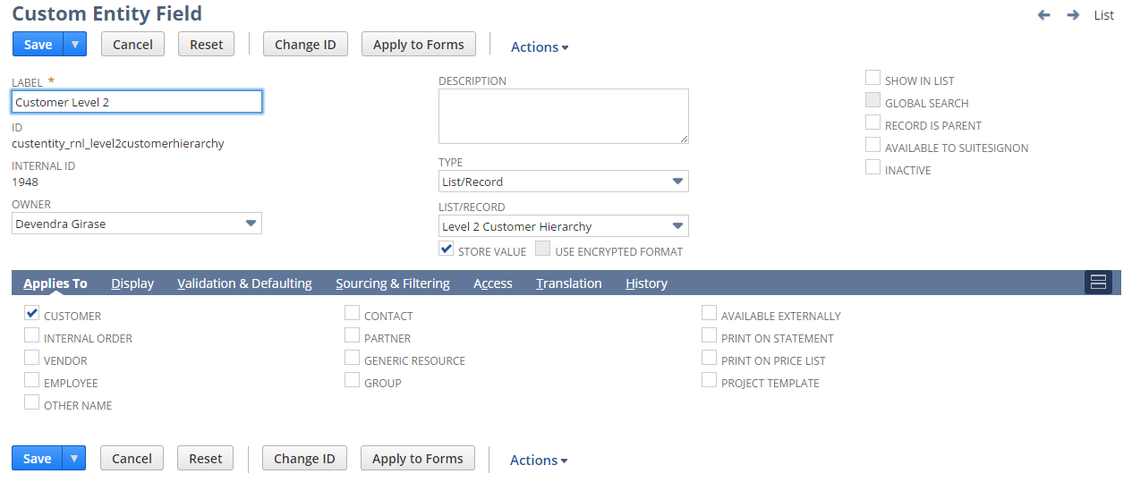

Customer Level 3:

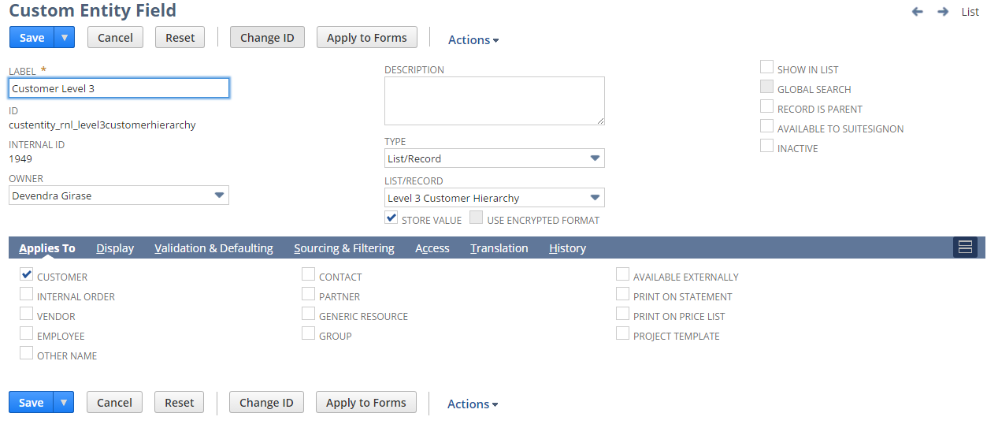

Customer Level 3 Sap ID:

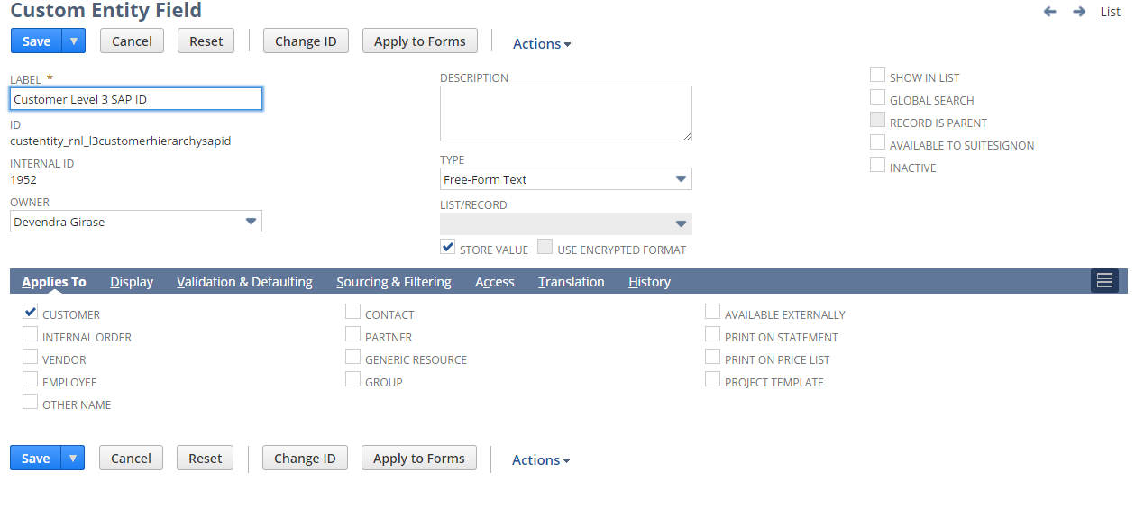

## Req-19: Ability to track assembly items inventory by revisions

The requirement is to capture the Item Revision by lot number for Purchase Order to Item Receipt and Work Order to Assembly Build process flows.

### ACCEPTANCE CRITERIA

1. The Item Revision should be set for all Lot Numbered Items present on the Item Receipt and Assembly Build record.

### USE CASES

#### 1. PO\IR Process flow

#### Purchase orders can be created by UI or through supply plan

#### Default the revision field in PO line based on effective receipt date, if effective receipt date not present will default based on current date

#### On receiving the PO, after saving the Item receipt apply the revision to all lot numbers associated to the IR line item

#### 2. Work Order/Assembly:

#### On successfully saving Assembly Build records, if revision field is maintained in the assembly build record. Update the revision field in Lot Number record with value from the revision field in Assembly build record.

#### 3. Provide an exception report to find any lots that do not have Revision

### JEFFERSON IMPACT

No impact

### FUNCTIONAL SOLUTION

1. There is no functional solution for this requirement.

### TECHNICAL SOLUTION

1. A custom field will be created on Purchase Order Record at line item level.

Details of the custom field are given below:

|  |  |  |  |  |
| --- | --- | --- | --- | --- |
| **Record Type** | **Field** | **Description** | **Type** | **Properties** |
| Purchase Order | Item Revision | This field will have all the available Item Revision record names | List/Record | 1. Display Type=Normal 2. Field Type =List/Record 3. The field will source the values from Item Revision record. 4. Field will be displayed at Line level under Item Sublist. |

1. Custom Scripts will be created on Purchase Order, Item Receipt and Assembly Build.

Details of the custom scripts are given below:

|  |  |  |  |  |
| --- | --- | --- | --- | --- |
| **Name** | **Type** | **Description** | **Logic Overview** | **Properties** |
| RNL PO Item Revision UE | User Event Script | User event script to check and fix Item revisions during save of Purchase order. Applies to both manually created PO and supply plan PO | * Check if the logged in user subsidiary is “RL sub”, if not exit * Triggered on before save event of Purchase Order creation * If supply plan created PO, default item revision based on expected receipt date. If expected receipt date is blank, default item revision based on today’s date. * If manually created PO then check if item revision is empty and then default item revision based on expected receipt date. If expected receipt date is blank default item revision based on today’s date. | 1. The script will be executed on save of Purchase Order.  2. It will fetch the values for Item Revision from the respective Item Revision record  3. A script configuration parameter shall be added which shall provide inputs to the script   * Subsidiary Internal id |
| RNL Item Revision IR UE | User Event Script | User event script to populate the Item revision custom field in Lot number record based on Revision maintained in the corresponding PO. | * Check if the logged in user subsidiary is “RL sub”, if not exit * Triggered on after save event of Item Receipt creation. * For every line item in Item receipt, transaction script shall perform a lookup to get the referenced Purchase order line item and get the Item revision maintained in purchase order line item. Apply the item revision to all lot numbers associated with the Item receipt line item. | 1. The script will be executed on Save of Goods Receipt.  2. It will fetch the values for Item revision from the respective PO line Item.  3. A script configuration parameter shall be added which shall provide inputs to the script   * Subsidiary Internal id |
| RNL Assembly Inventory Revision UE | User Event Script | User event script to populate the Item revision custom field in Lot number record based on Revision maintained assembly build | * Check if the logged in user subsidiary is “RL sub”, if not exit * Triggered on after save event of Assembly Build creation * Script shall read the standard revision field in assembly build transaction and apply the revision to all lot numbers associated with the assembly build | 1. The script will be executed after Save of Assembly Build.  2. It will fetch the values for Item revision for the respective Assembly Item.  3. A script configuration parameter shall be added which shall provide inputs to the script   * Subsidiary Internal id |
| RNL PO Item Revision CE | Client Script | Client script to default the revision for manually created purchase orders | * Check if the logged in user subsidiary is “RL sub”, if not exit * Triggered based on field change events for Expected receipt date field and post Sourcing of Item at PO line item. * Script shall execute only if expected receipt date field is not blank * Script shall search for matching revisions based on expected receipt date and update the Item revision custom field in PO line item | 1. The script will be executed on field change and post sourcing event of Purchase Order.  2. It will fetch the values for Item Revision from the respective Item Revision record  3. A script configuration parameter shall be added which shall provide inputs to the script   * Subsidiary Internal id |

System Change Impacts for Script

|  |  |  |
| --- | --- | --- |
| **#** | **Impact** | **Analysis** |
| 1 | Impact of Adding new subsidiary | 1. Script configuration parameter subsidiary_internal_id shall accept multiple subsidiary ids either separated by “,” OR “|” symbols. So to add a new subsidiary, script configuration parameter shall be extended with new subsidiary ids. Refer to section 1.19.6.3 for details |
| 2 | Impact of NetSuite Product upgrades | 1. No specific maintenance needed during NetSuite upgrades as Script uses stable API’s of NetSuite. 2. A preview testing shall be needed during upgrades, as advised by NetSuite for all custom developments |
| 3 | Post Go Live maintenance | 1. No specific post go live maintenance needed and should be manageable by support organization |

### CONFIGURATION

1.19.6.1 Custom field  
  
To create follow path Customization->Lists, Records & Fields-> Transaction Column Fields->New

Item revision

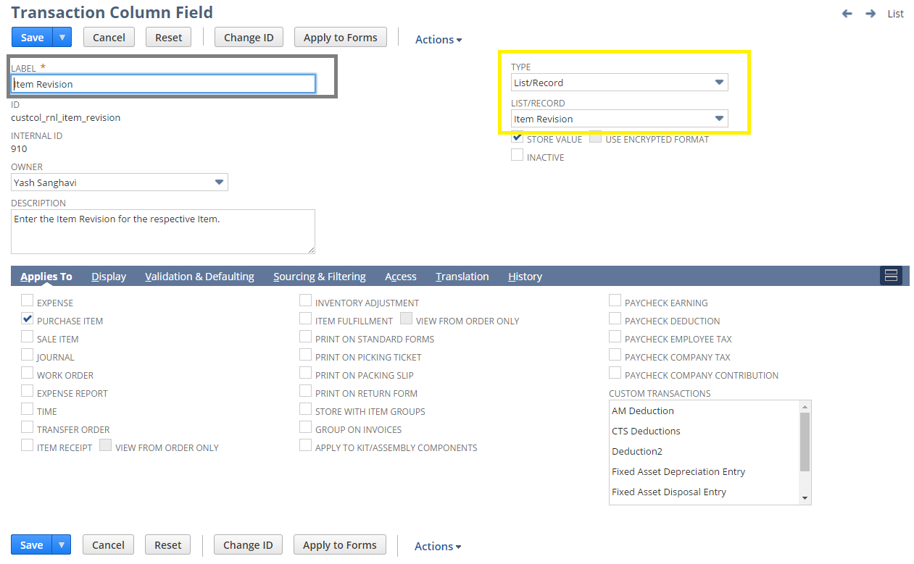

1.19.6.2 Custom Scripts  
  
To create Custom Script follow path Customization->Scripting->Script->New

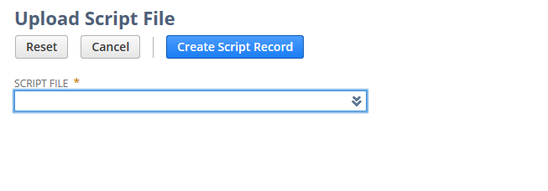

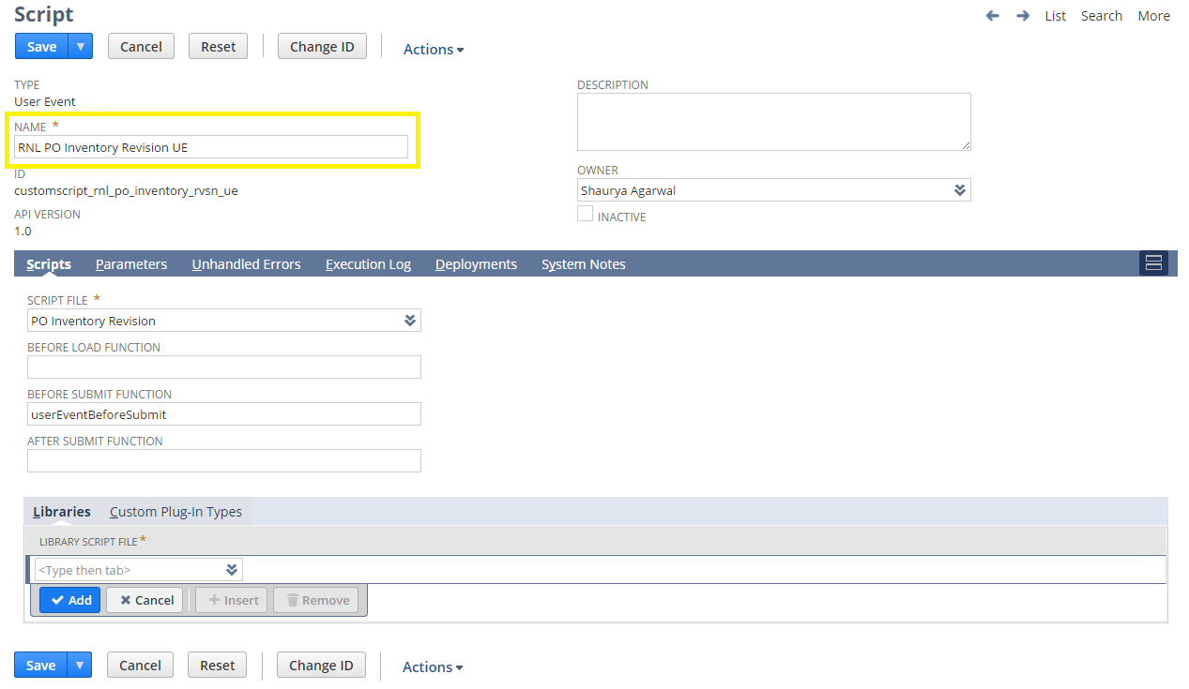

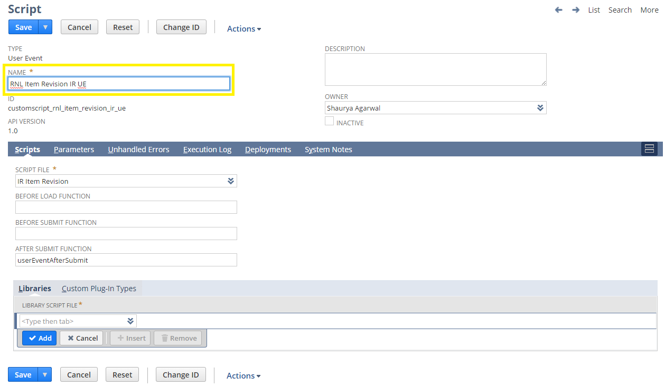

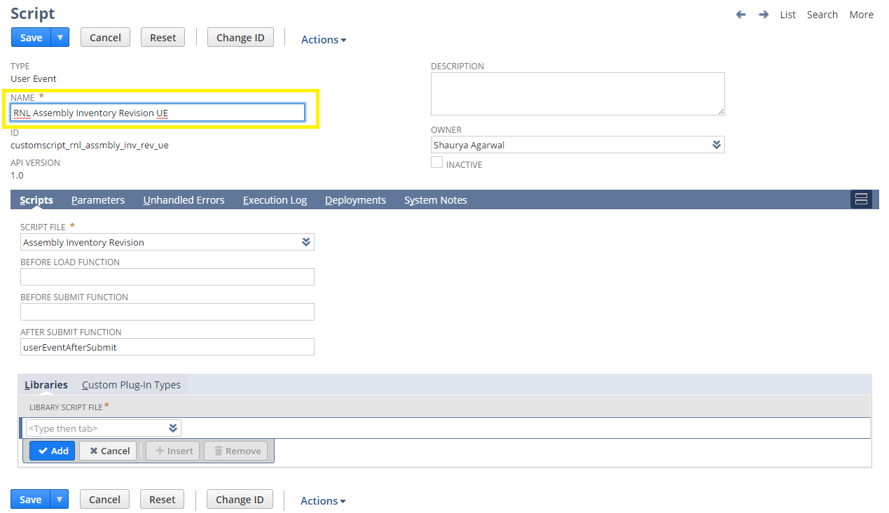

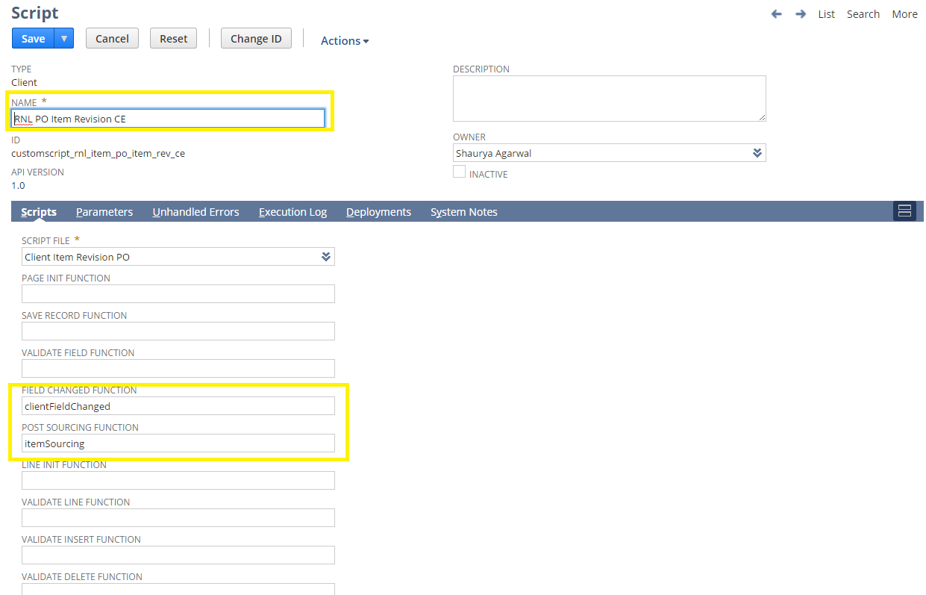

To view Script Deployment follow below path customization->Scripting->Scripts Deployment

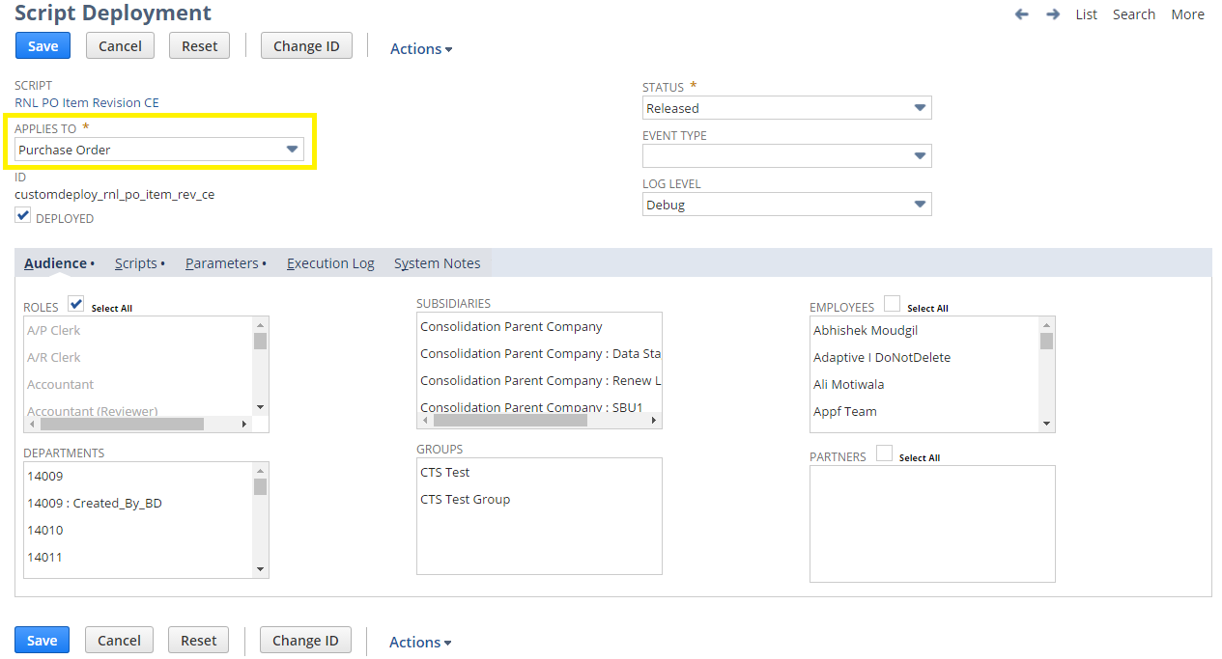

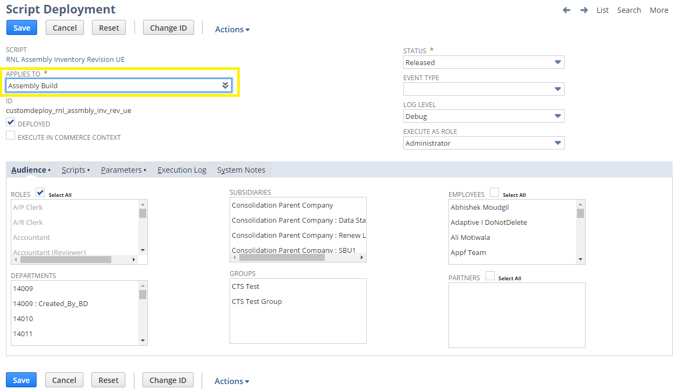

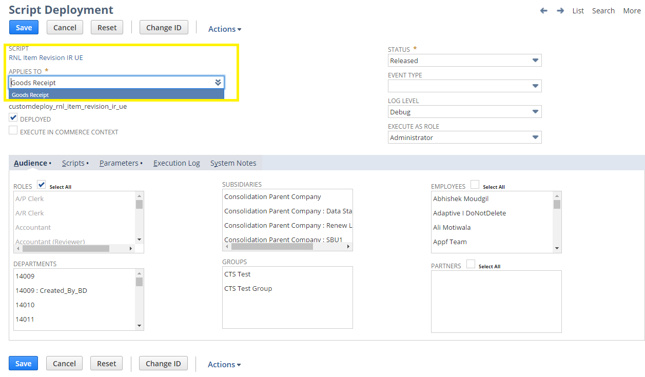

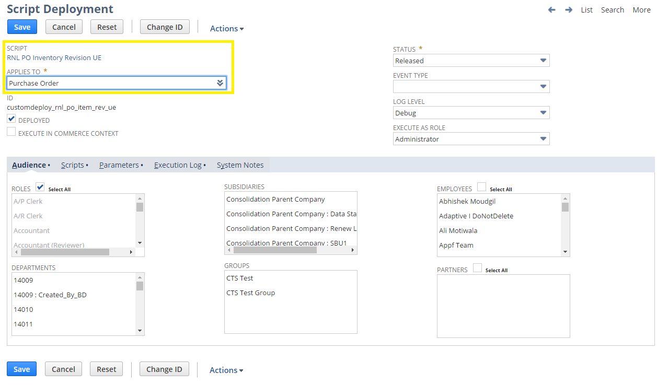

#### 1.19.6.3 Updating Custom scripts for Subsidiary additions\ deletion

#### Below script parameters needs to be updated either with “,” or “|” symbol for any new subsidiary

#### 

#### 

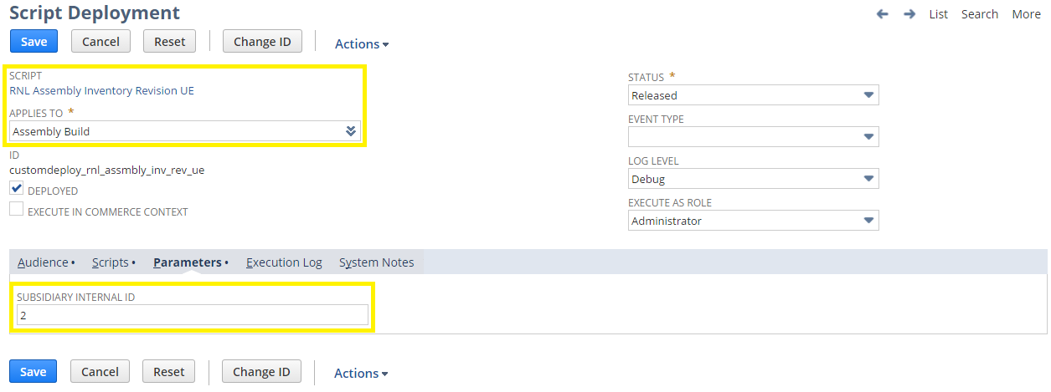

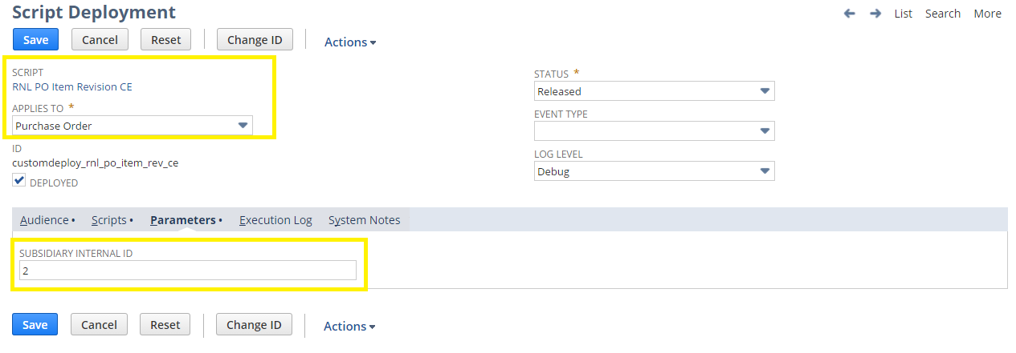

## Req-20: Rename FOB Terms to Shipping Terms

Requirement is to rename the FOB Terms to Shipping Terms in RL-Customer Form.

### ACCEPTANCE CRITERIA

1. FOB Terms to be renamed to Shipping Terms and all Values in the selection list should be same

### USE CASES

1. Navigate to Lists ->Relationship ->Customers ->New
2. User should be able to see the “Shipping Terms”.

### JEFFERSON IMPACT

No impact

### FUNCTIONAL SOLUTION

1. Customize the “RL-Customer” form.

2. Go to Screen Fields Tab, under Classification Main subtab and Rename the FOB Terms with “Shipping Terms”.

3. Save the Form to mark the required changes.

|  |  |  |  |
| --- | --- | --- | --- |
| **Record Type** | **Name** | **Description** | **Properties** |
| Customer | RL-Customer | Form customized to rename the FOB Terms field to "Shipping Terms" |  |

### TECHNICAL SOLUTION

There is no technical solution for this requirement.

### CONFIGURATION

1. Edit the RL-Customer Form using below path

Customization -> Forms -> Entry Forms and Edit the form

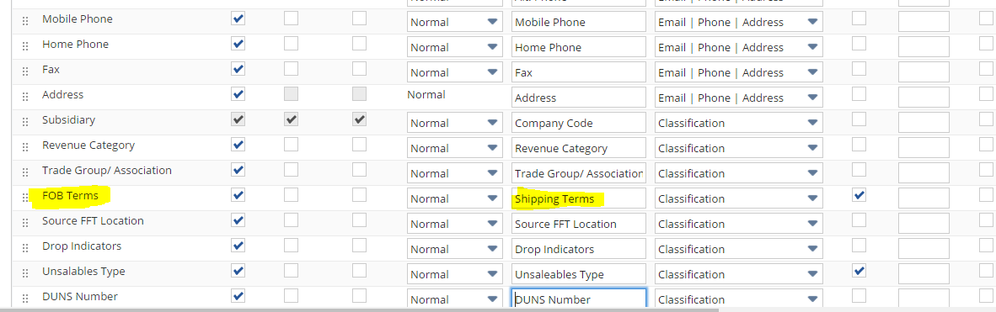

## Req-21: Ability to add Credit Review Date for Customer

Requirement is to hold credit review date on Customer record.

### ACCEPTANCE CRITERIA

1. “Credit Review Date” field should be available on Customer record.
2. “Credit Review Date” field should be of type date.

### USE CASES

1. Navigate to Lists > Relationship > Customers >New
2. User shall be able to select date value from the “Credit Review Date” field.

### JEFFERSON IMPACT

No impact

### FUNCTIONAL SOLUTION

There is no functional solution for this requirement.

### TECHNICAL SOLUTION

1. A custom field will be created on Customer record.

Details of the custom field are given below:

|  |  |  |  |  |
| --- | --- | --- | --- | --- |
| **Record Type** | **Field** | **Description** | **Type** | **Properties** |
| Customer | Credit Review Date | This field will have date for reviewing credit on Customer record | Date | 1. Display Type=Normal 2. Field Type =Date 3. Field will be displayed on financial tab under Account Information Field group. |

### CONFIGURATION

1. Create custom Field using below path

Customization->Lists, Records & Fields >Entity Fields > New

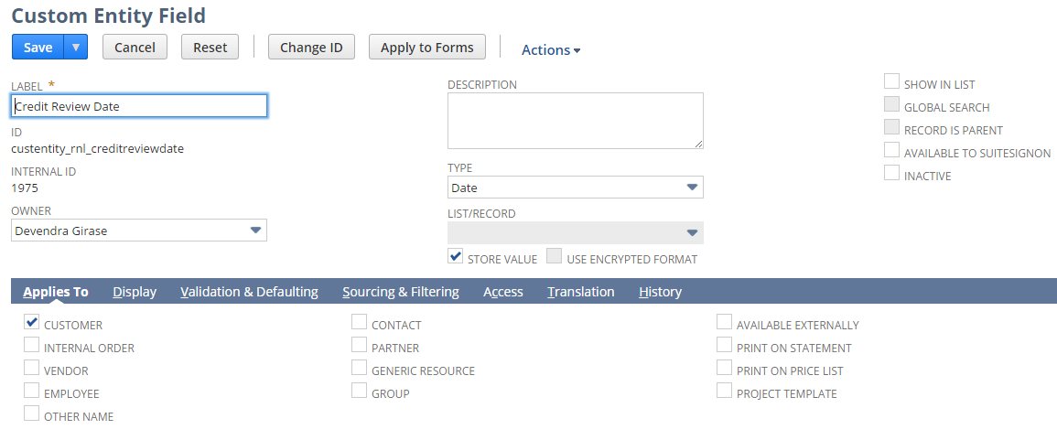

## Req-22: Ability to manage Sales Hierarchy using different Territory levels

The requirement is to create and manage Sales Territory, Service Territory & Educator Territory for the customers using different levels.

### ACCEPTANCE CRITERIA

1. The Territory fields will be grouped on Sales tab under Territory field group
2. 3 Territory fields will be available for selection and on selection of those the related fields would be populated.

### USE CASES

1. User needs to Go to Lists> Relationships > Customers > New.
2. User needs to select from the different territory fields available on the customer record under sales tab

### JEFFERSON IMPACT

No impact

### FUNCTIONAL SOLUTION

There is no functional solution for this requirement.

### TECHNICAL SOLUTION

1. 8 Custom records needs to be created

Details of the custom records are given in the table below:

|  |  |  |  |  |  |
| --- | --- | --- | --- | --- | --- |
| **Record Type** | **Name** | **Fields** | **Description** | **Type** | **Properties** |
| Custom Record | Sales Dept. - Sales Territory | * Name | * The name field will be used for storing the name value of Sales Dept. | * Free-form Text | 1. Alphanumeric data can be entered |
| Custom Record | Sector - Sales Territory | * Name * Sales Dept | * The name field will be used for storing the name value of Sector | * Free-form Text * List | 1. Alphanumeric data can be entered 2. Sales Dept for the Sector needs to be selected |
| Custom Record | Region - Sales Territory | * Name * Sector * Sales Dept | * The name field will be used for storing the name value of Region. | * Free-form Text * List * List | 1. Alphanumeric data can be entered 2. Sector for the Region needs to be selected 3. Sales Dept for the Sector will be populated |
| Custom Record | Sales Territory Hierarchy | * Name * Region * Sector * Sales Dept | * The name field will be used for storing the name value of Sales Territory | * Free-form Text * List * List * List | 1. Alphanumeric data can be entered 2. Region for the Sales Territory needs to be selected 3. Sector & Sales Dept for the Region will be populated |
| Custom Record | Services Rep Name - Services Territory | * Name | * The name field will be used for storing the name value of Service Rep Name | * Free-form Text | 1. Alphanumeric data can be entered |
| Custom Record | Retail Services Specialist Territory | * Name * Retail Service Rep Name | * The name field will be used for storing the name value of Retail Service Territory Name | * Free-form Text * List | 1. Alphanumeric data can be entered 2. Select Service Rep Name for the Service Territory |
| Custom Record | Educator Rep Name - Educator Territory | * Name | * The name field will be used for storing the name value of Educator Rep Name | * Free-form Text | 1. Alphanumeric data can be entered |
| Custom Record | Educator Territory | * Name * List | * The name field will be used for storing the name value of Educator Territory Name | * Free-form Text * List | 1. Alphanumeric data can be entered 2. Select Educator Rep Name for the Educator Territory |

1. A Center Tab will be created.  
   Details of the Center Tab are given in the table below:

|  |  |  |  |
| --- | --- | --- | --- |
| **Center Type** | **Name** | **Description** | **Categories** |
| Classic Center | Hierarchy, Segment & Territory | This Center tab will be available on the Dashboard under more options (…). | * Sales Territory * Services Territory * Educator Territory |

1. A Center Category will be created  
   Details of the Center Category is mentioned below

|  |  |  |  |  |
| --- | --- | --- | --- | --- |
| **Center Tab** | **Name** | **Description** | **Links to Record** | **Label** |
| Hierarchy, Segment & Territory | Sales Territory | This Center Category will contain the links to records of different levels of Sales Territory | * Sales Dept. - Sales Territory * Sector - Sales Territory * Region - Sales Territory * Sales Territory Hierarchy | * Sales Department * Sector * Region * Sales Territory |
| Hierarchy, Segment & Territory | Services Territory | This Center Category will contain the links to records of different levels of Services Territory | * Services Rep Name - Services Territory * Retail Services Specialist Territory | * Retail Services Rep Name * Services Specialist Territory |
| Hierarchy, Segment & Territory | Educator Territory | This Center Category will contain the links to records of different levels of Educator Territory | * Educator Rep Name - Educator Territory * Educator Territory | * Educator Rep Name * Educator Territory |

1. Eight fields will be created on Customer Record.  
    Details of the custom field are given in the table below:

|  |  |  |  |  |
| --- | --- | --- | --- | --- |
| **Record Type** | **Field** | **Description** | **Type** | **Properties** |
| Customer | SALES TERRITORY | Select Sales Territory from Sales Territory Hierarchy record | List/Record | 1. This is a list field sourced from Sales Territory Hierarchy. |
| Customer | REGION | Region will be populated on selection of Sales Territory | List/Record | 1. This is a list field sourced from Region - Sales Territory. |
| Customer | SECTOR | Sector will be populated on selection of Sales Territory | List/Record | 1. This is a list field sourced from Sector - Sales Territory. |
| Customer | SALES DEPT | Sales Dept will be populated on selection of Sales Territory | List/Record | 1. This is a list field sourced from Sales Dept. - Sales Territory |
| Customer | RETAIL SERVICES SPECIALIST TERRITORY | Select Retail Services Specialist Territory | List/Record | 1. This is a list field sourced from Retail Services Specialist Territory |
| Customer | RETAIL SERVICES REP NAME | Retail Service Rep Name will be populated on selection of Retail Services Specialist Territory | List/Record | 1. This is a list field sourced from Servicers Rep name - Services Territory |
| Customer | EDUCATOR TERRITORY | Select Educator Territory for the Customer | List/Record | 1. This is a list field sourced from Educator Territory. |
| Customer | EDUCATOR REP NAME | Educator rep name will be populated on selection of Educator Territory | List/Record | 1. This is a list field sourced from Educator Rep Name – Educator Territory |

### CONFIGURATION

Custom Records

To create a Custom Record follow the path mentioned below:  
Customization > Lists, Records, & Fields >Record Types > New

**Sales Dept. – Sales Territory**

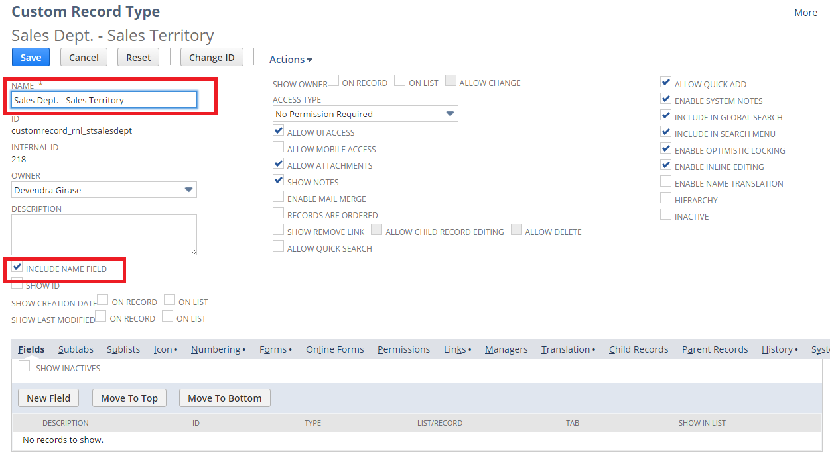

**Sector – Sales Territory**

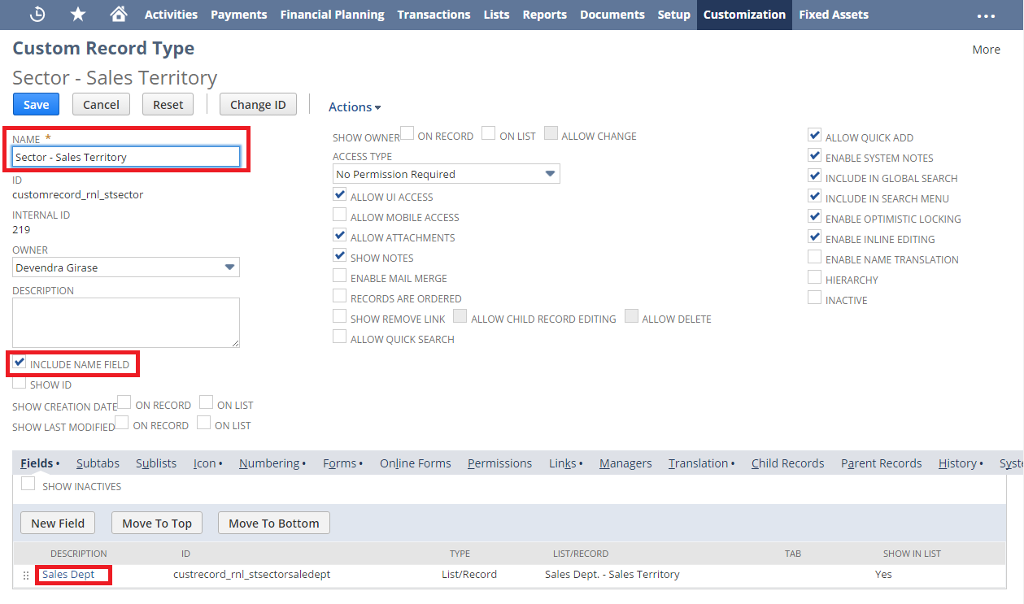

**Region – Sales Territory**

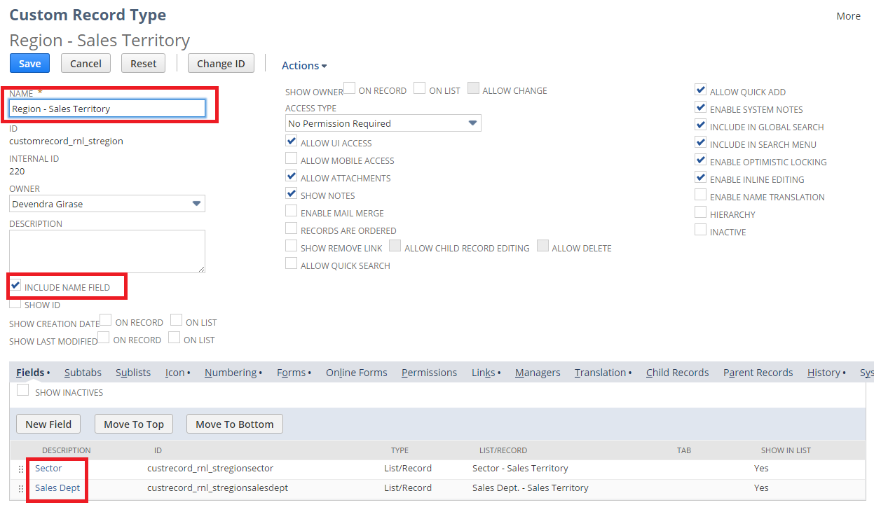**Sales Territory Hierarchy**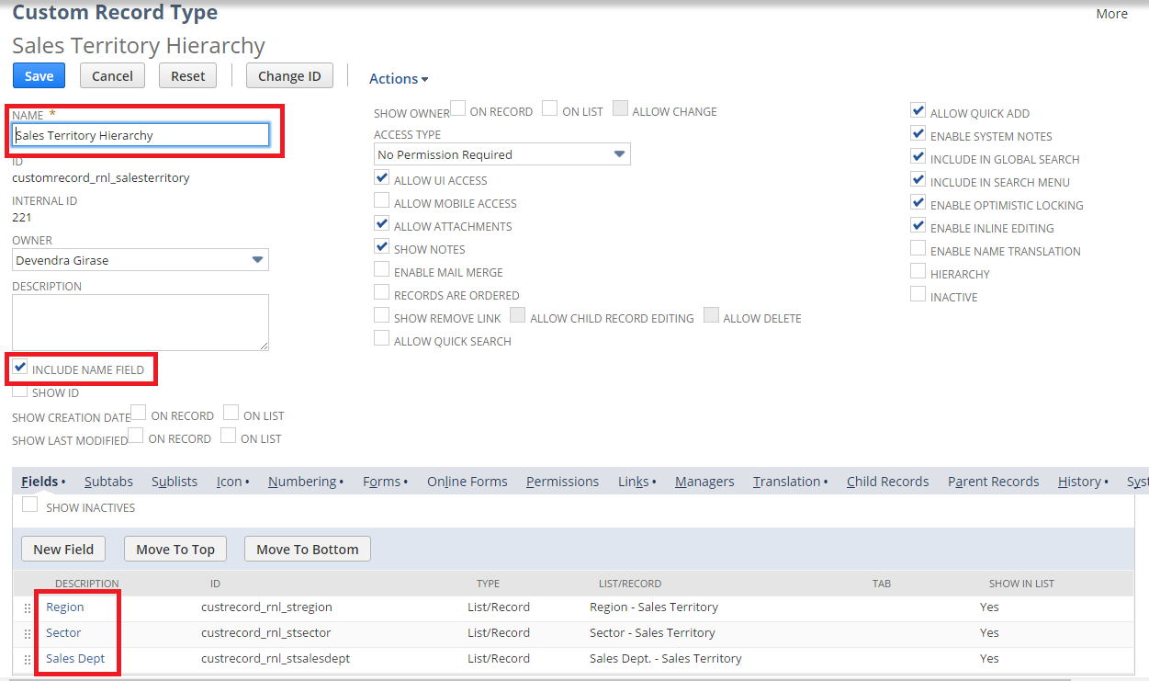

Services Rep Name – Services Territory

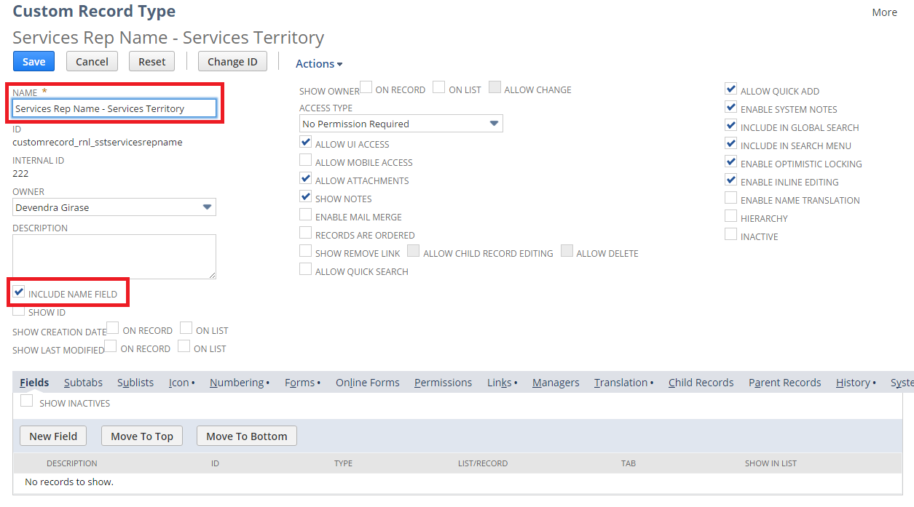

Retail Services Specialist Territory

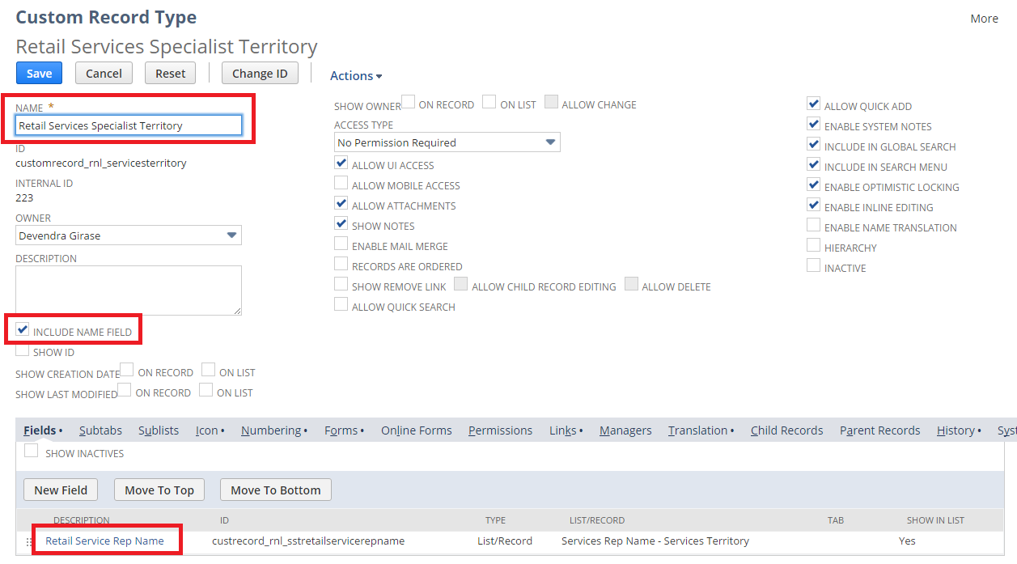

Educator Rep Name – Educator Territory

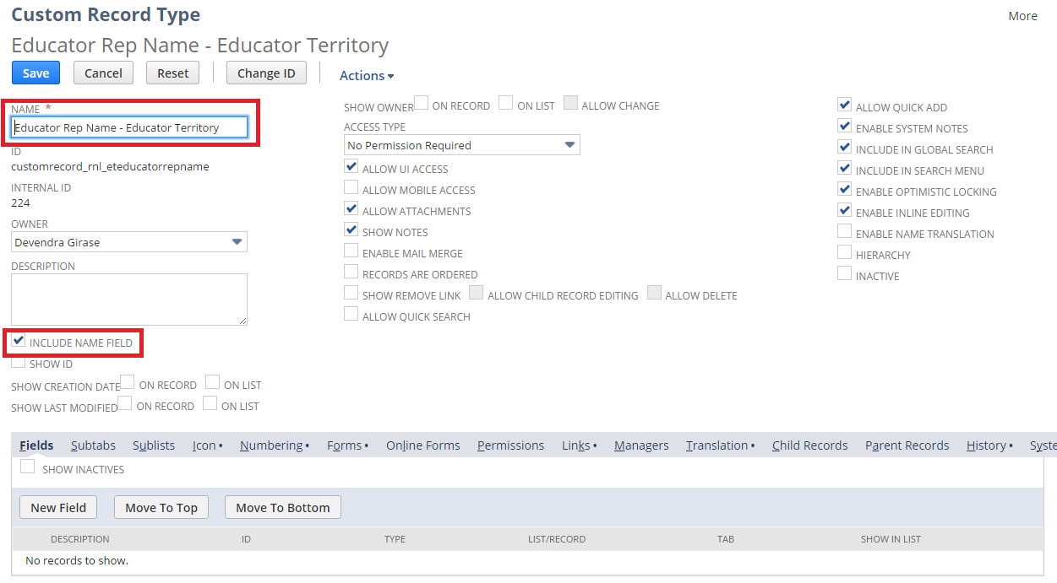

Educator Territory

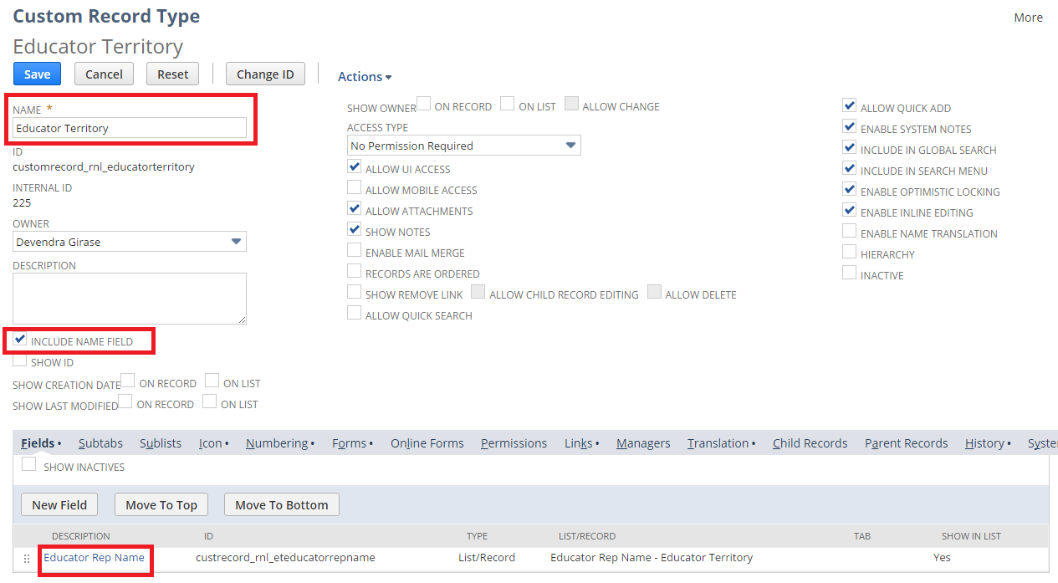

Custom Fields

To create a Custom Record follow the path mentioned below:  
Customization > Lists, Records, & Fields > Entity Fields > New

Sales Territory  
  
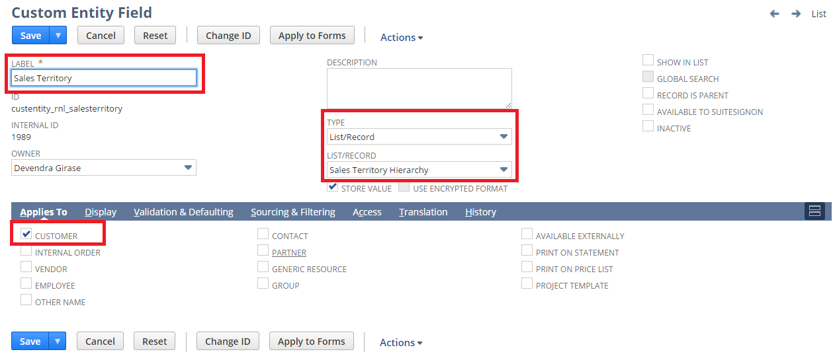

Sales Dept  
  
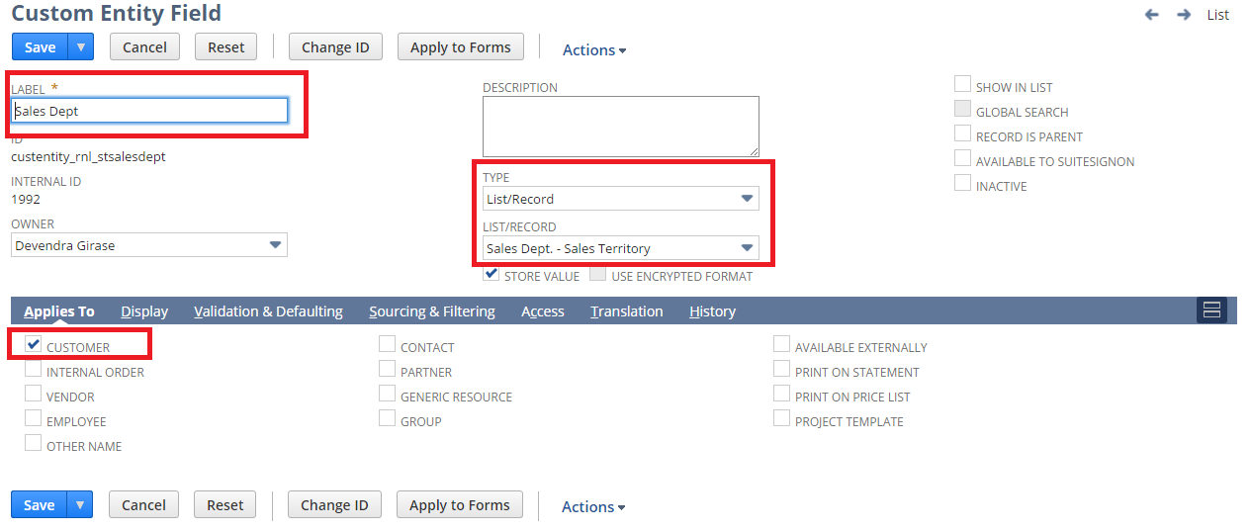

Sector

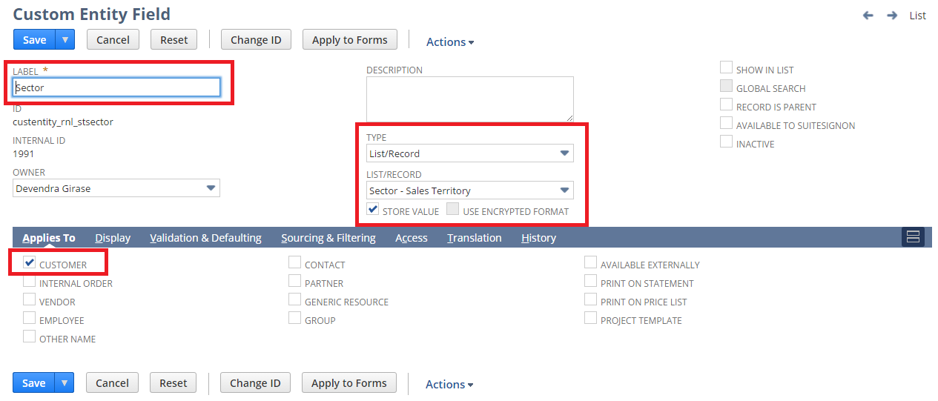

Region

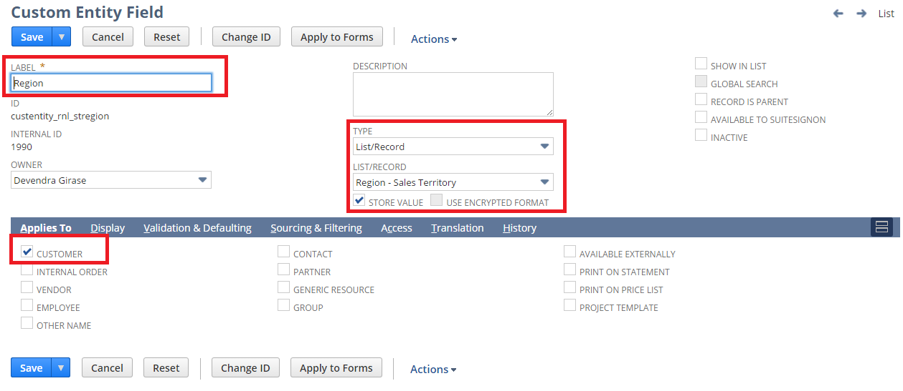

Retail Services Rep Name

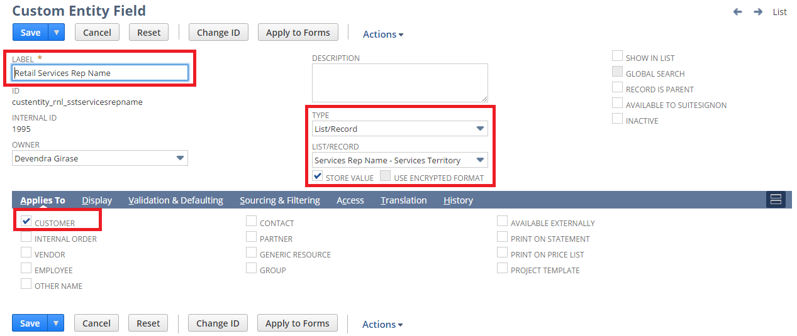

Retail Services Specialist Territory

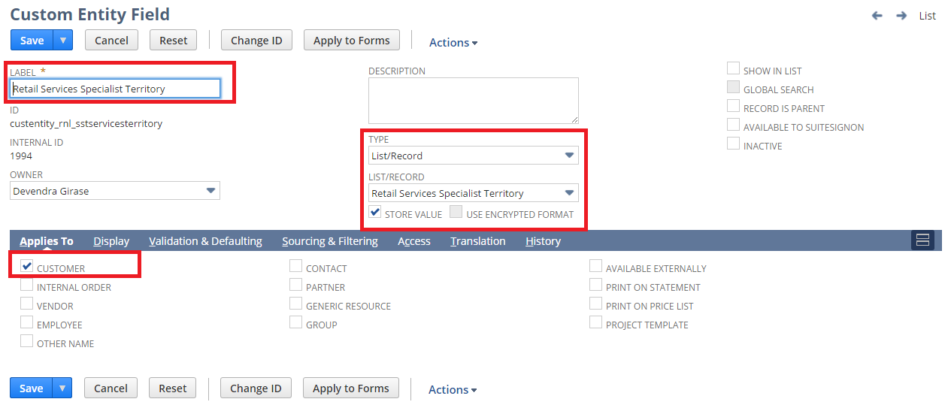

Educator Rep Name

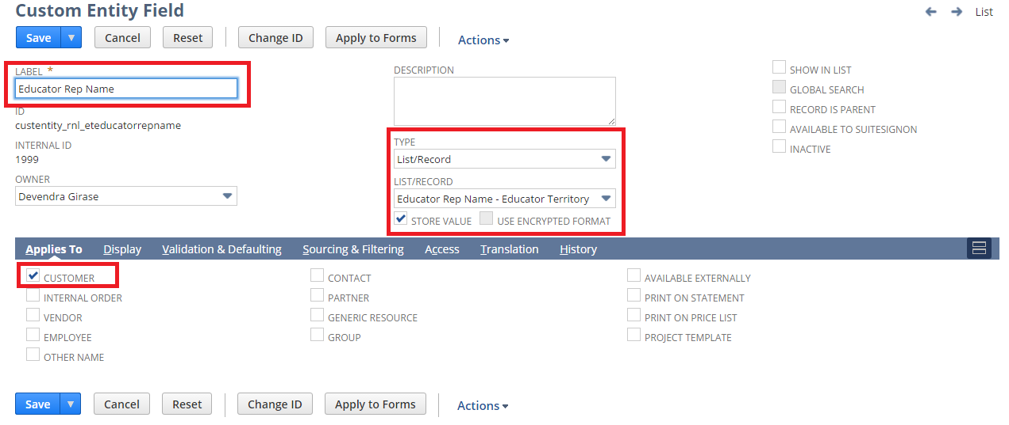

Educator Territory

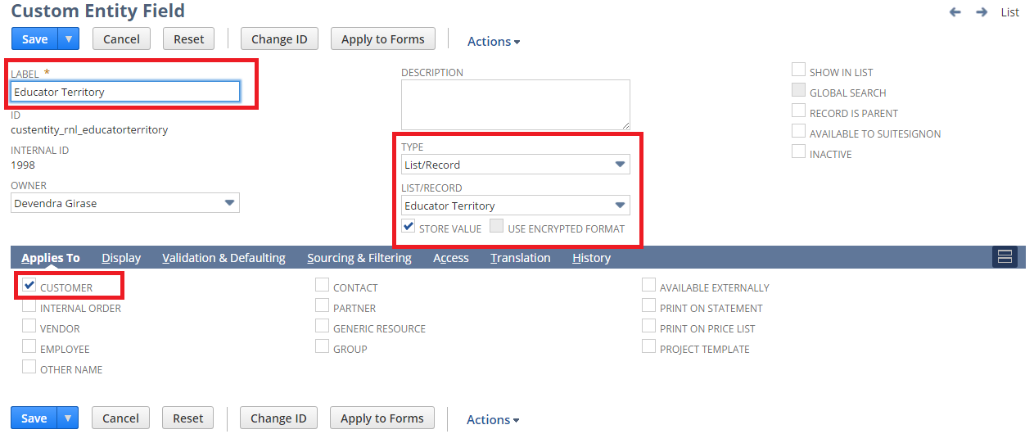

Custom Center Tab and Center Category

To create a custom Center Tab and Category follow the path mentioned below:

Customization -> Centers and Tabs -> Center Tabs -> New

Customization -> Centers and Tabs -> Center Categories -> New

Center Tab:

Hierarchy, Segment & Territory

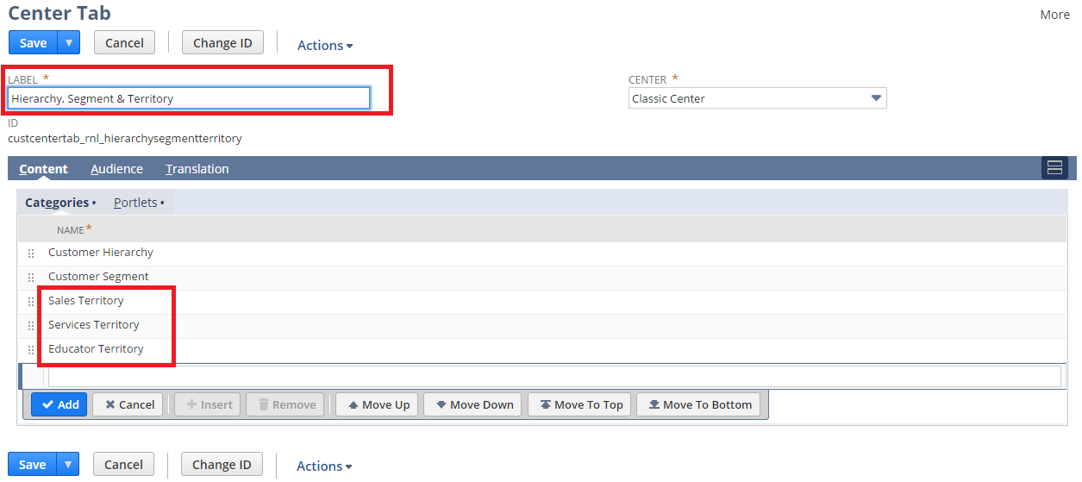

Center Category:

Sales Territory

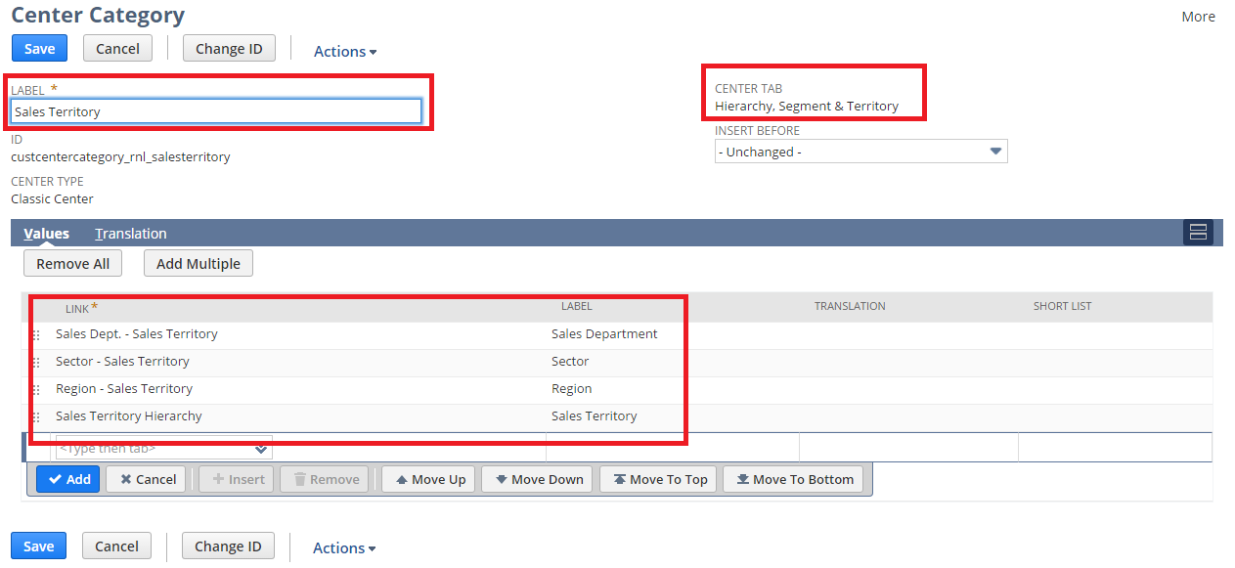

Services Territory

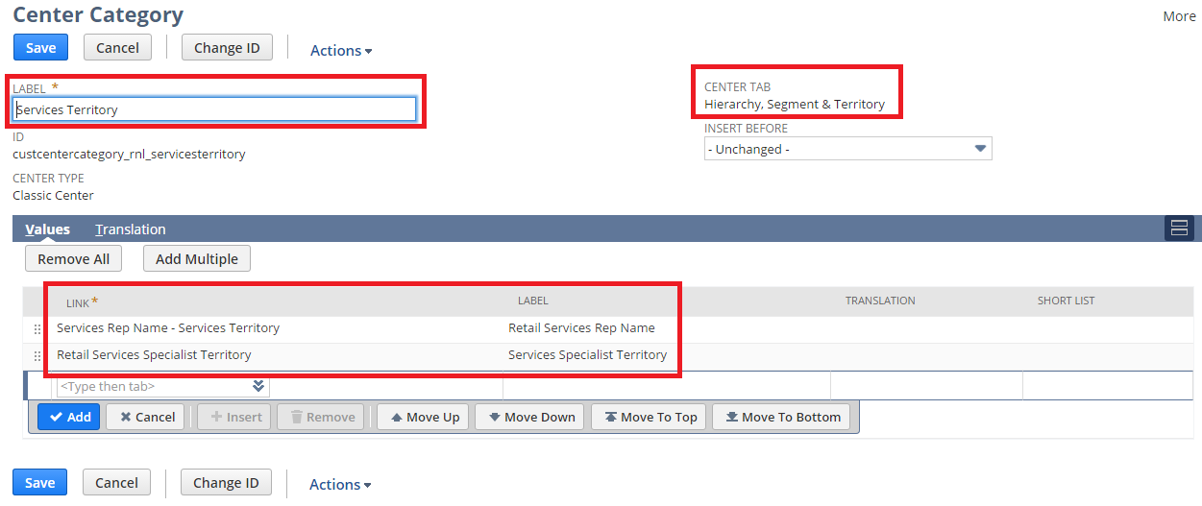

Educator Territory

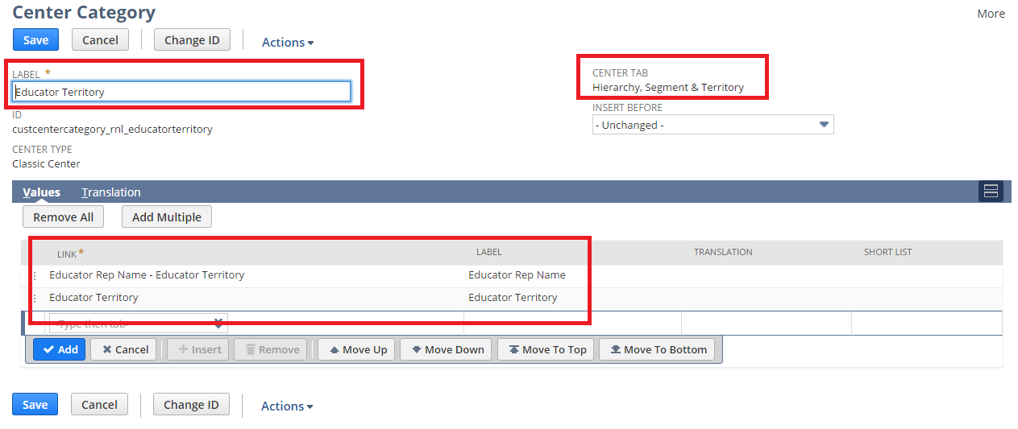

## Req-23: Need the Ability to Categorize code at the Line Item Level

Requirement is to create a new custom field “Type” on Sales Order and Invoice at Line Level consist of list value.

### ACCEPTANCE CRITERIA

1. “Type” field should be available on Sales Order record at Line Level.

2. “Type” field should be of type list record.

### USE CASES

1. Navigate to Transaction > Sales > Enter Sales Order

2. User shall be able to select “Type”.

### JEFFERSON IMPACT

No impact

### FUNCTIONAL SOLUTION

There is no functional solution for this requirement.

### TECHNICAL SOLUTION

1. A custom field will be created on Sales Order record.

Details of the custom field are given below:

|  |  |  |  |  |
| --- | --- | --- | --- | --- |
| **Record Type** | **Field** | **Description** | **Type** | **Properties** |
| RL-Sales Order | Type | This field will capture Type against Item for sale. | List Record | 1. Display Type=Normal  2. Field Type =List Record  3. Field will be displayed on line level.  4. Default value=SALE |

|  |  |  |  |
| --- | --- | --- | --- |
| **Name** | **Description** | **Values** | **Properties** |
| Discount Type | This list contains the list values on Type field on the Sales Order record | * SALE * DEMO * PROMO * TRND * CONF * LIT | This list will be available selecting Type on Sales Order Record |

### CONFIGURATION

1. Create custom Field using below path

Customization->Lists, Records & Fields >Transaction Field > New

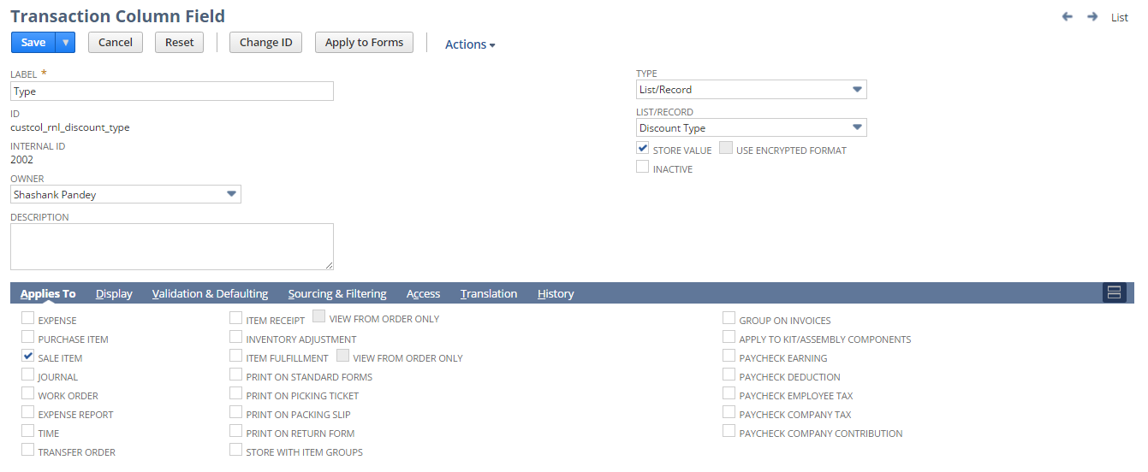

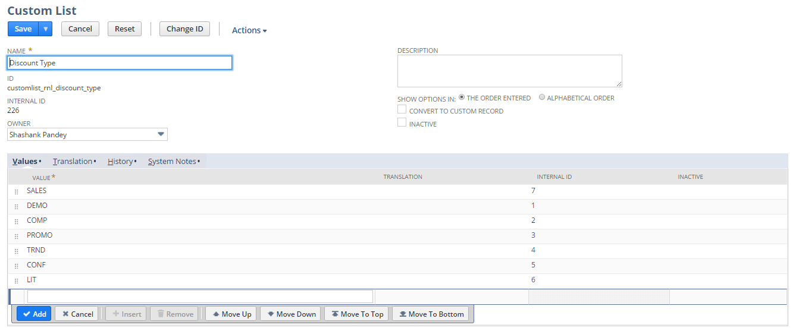

2. Click Save and Apply to forms

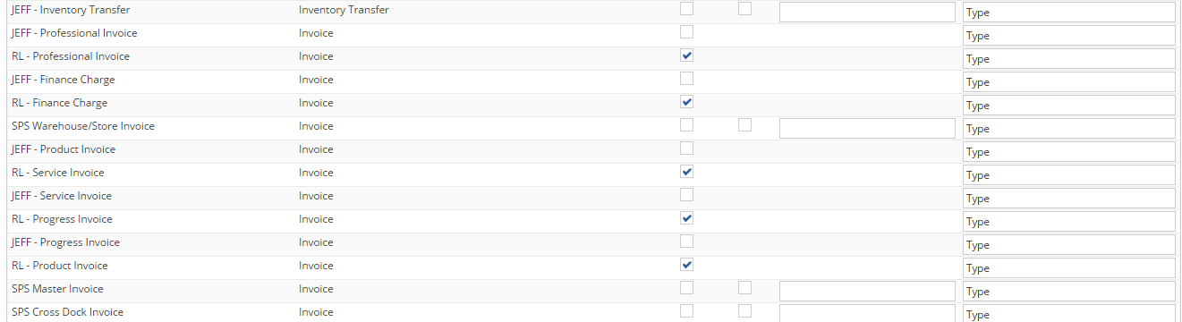

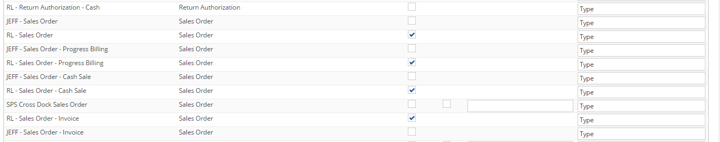

2. Open a Sales Order using below path

Transaction > Sales > Enter Sales Order

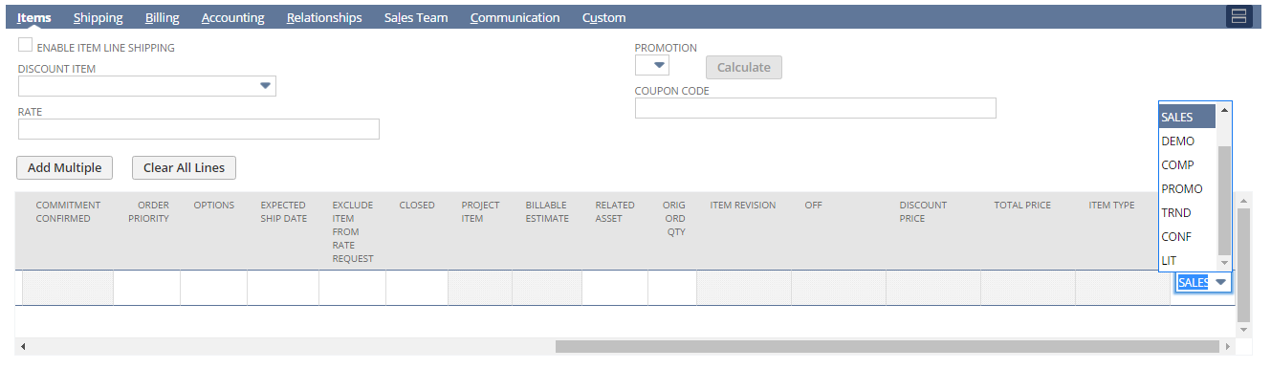

## Req-24: Need to Create a Field to Designate Customer MEI.

Need to create a field in the NetSuite Customer Master which designates whether the account should flow from NetSuite to MEI.

### ACCEPTANCE CRITERIA

1. “MEI Customer” field should be available on Customer record at Main Level.

2. “MEI Customer” field should be of type list record.

3. “MEI Vendor” field should be available on Vendor record at Main Level.

4. “MEI Vendor” field should be of type list record.

### USE CASES

1. Navigate to List > Relationship > Customer > New

2. User shall be able to select “MEI Customer”.

3. Navigate to List > Relationship > Vendors > New

4. User shall be able to select “MEI Vendor”.

### JEFFERSON IMPACT

No impact

### FUNCTIONAL SOLUTION

There is no functional solution for this requirement.

### TECHNICAL SOLUTION

1. A custom field will be created on Customer record.

Details of the custom field are given below:

|  |  |  |  |  |
| --- | --- | --- | --- | --- |
| **Record Type** | **Field** | **Description** | **Type** | **Properties** |
| RL-Customer Form | MEI Customer | This field will capture Type against Customer on Customer record. | List/Record | 1. Display Type=Normal  2. Field Type =List/Record  3. Field will be displayed on Main Level. |

2. A custom field will be created on Vendor record.

Details of the custom field are given below:

|  |  |  |  |  |
| --- | --- | --- | --- | --- |
| **Record Type** | **Field** | **Description** | **Type** | **Properties** |
| RL-Vendor Form | MEI Vendor | This field will capture type against Vendor on Vendor record. | List/Record | 1. Display Type=Normal  2. Field Type =List/Record  3. Field will be displayed on Main Level. |

3. A custom list will be created to source values into the fields created above.  
 Details of the list is given below:

|  |  |  |  |
| --- | --- | --- | --- |
| **Name** | **Description** | **Values** | **Properties** |
| MEI Customer/Vendor | This list contains the list values on MEI Vendor/Customer field on the Vendor/Customer record | * Yes * No | This list will be available selecting MEI Vendor/Customer on Vendor/Customer Record |

### CONFIGURATION

1. Create a custom field using below path

Customization->Lists, Records & Fields >Entity field > New

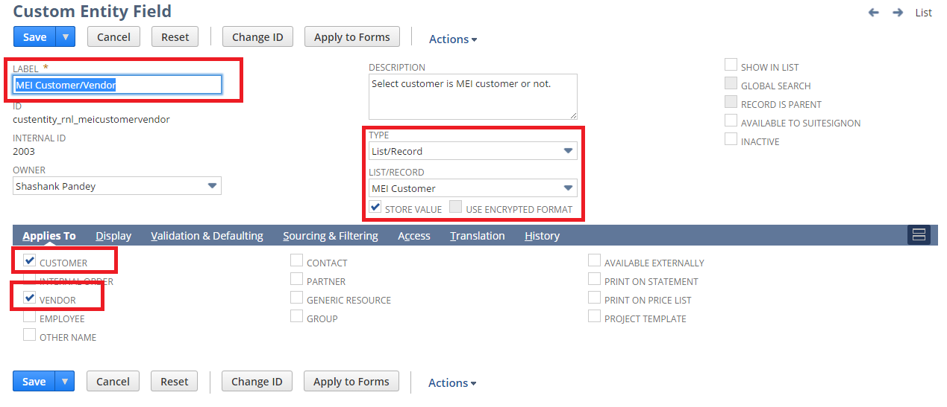

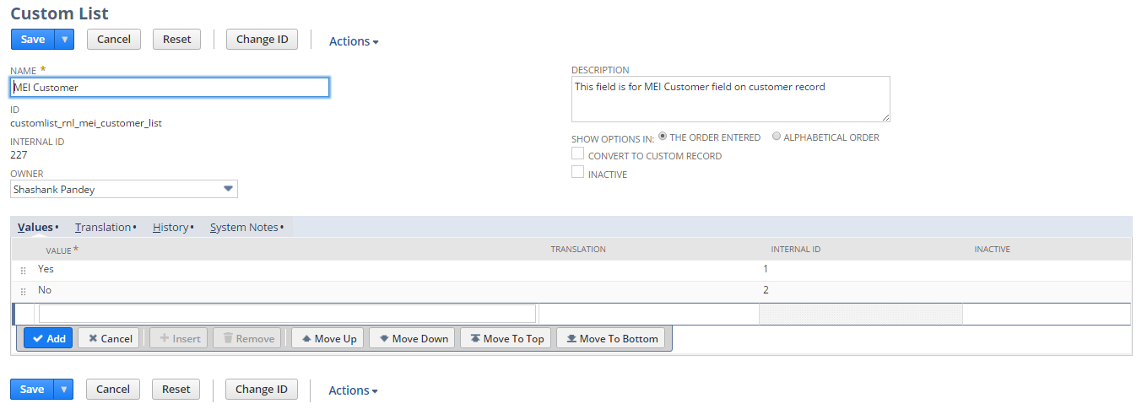

2. Click Save and Apply to forms

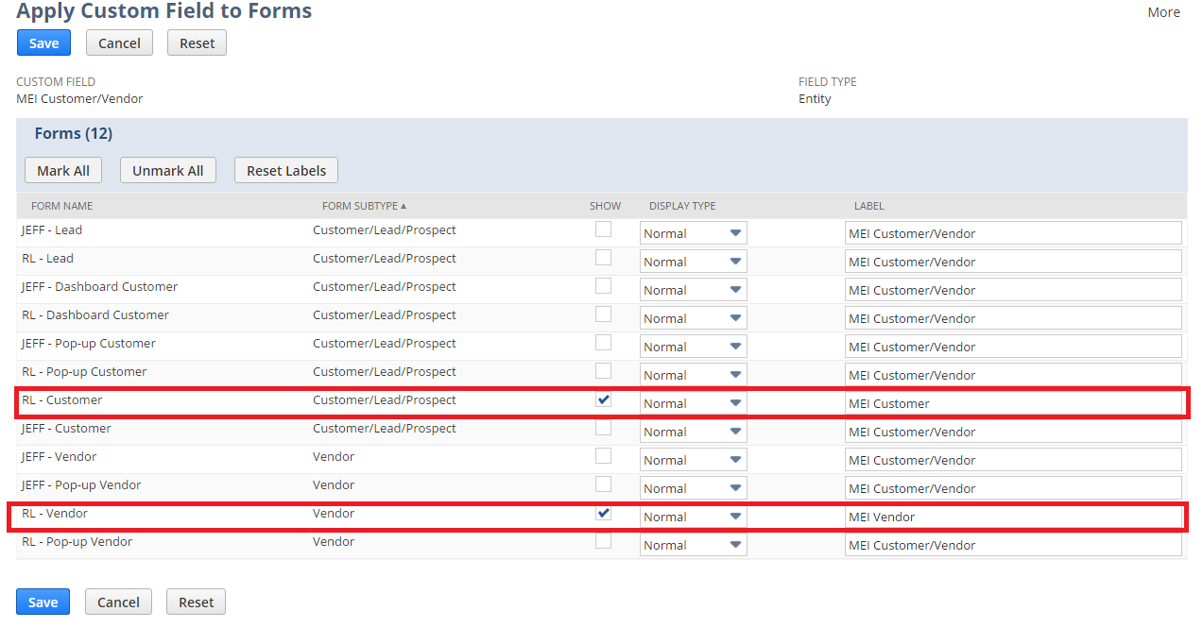

2. Open a Customer record using below path

Lists > Relationship > Customer > New

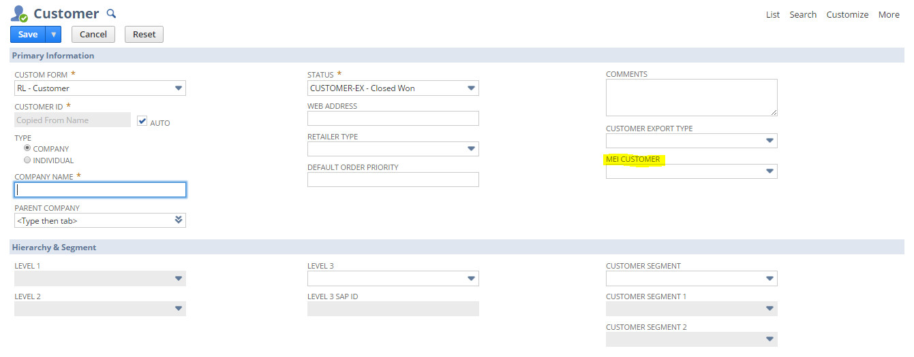

3. Open a Vendor record using the path mentioned below

Lists -> Relationships -> Vendors -> New

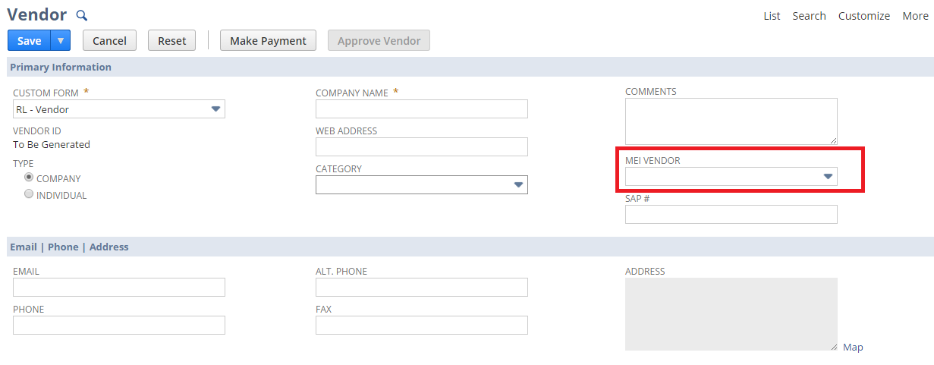

## Req-25: Ability to perform MEI Integration for vendor

Requirement is to create a checkbox “MEI Integration” on vendor.

### ACCEPTANCE CRITERIA

1. “MEI Integration” field should be available on Vendor record.
2. “MEI Integration” field should be of type checkbox.

### USE CASES

1. Navigate to Lists > Relationships > Vendor >New

### JEFFERSON IMPACT

No impact

### FUNCTIONAL SOLUTION

There is no functional solution for this requirement.

### TECHNICAL SOLUTION

1. A custom field will be created on Vendor record.

Details of the custom field are given below:

|  |  |  |  |  |
| --- | --- | --- | --- | --- |
| **Record Type** | **Field** | **Description** | **Type** | **Properties** |
| Vendor | MEI Integration | This field is used to allow flow through to MEI | Checkbox | 1. Display Type=Normal 2. Field Type =Checkbox 3. Field will be displayed on Header tab under Classification Field group. |

### CONFIGURATION

1. Create custom Field using below path

Customization->Lists, Records & Fields >Entity Fields > New

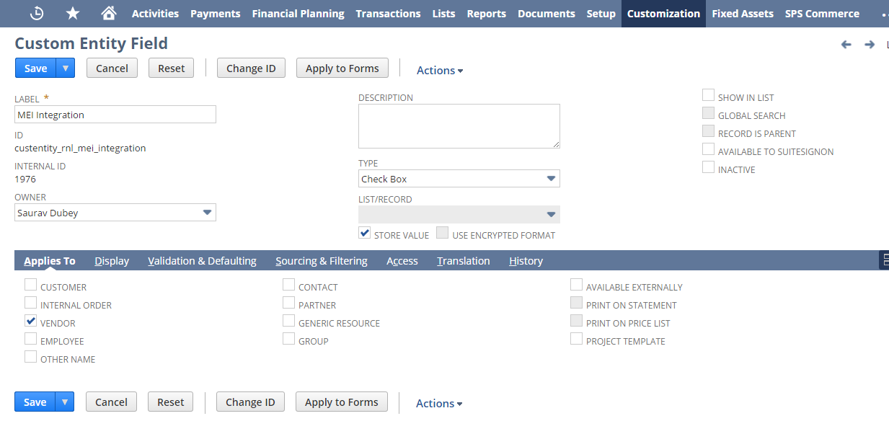

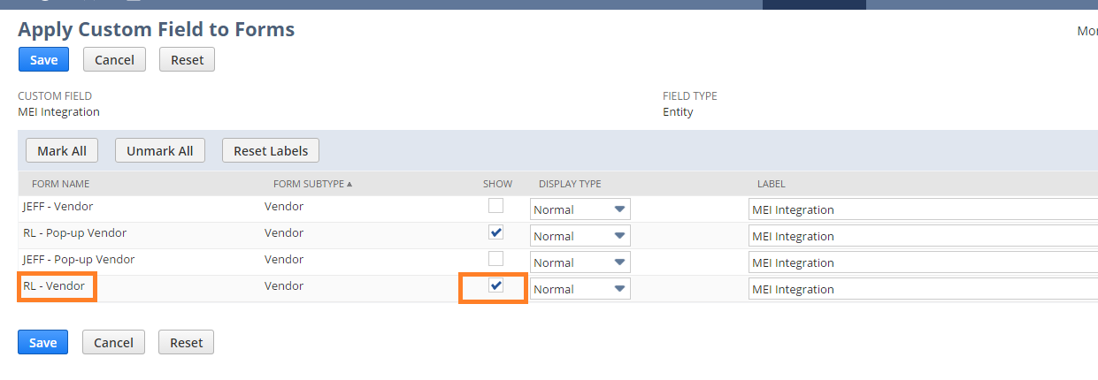

1. Open a Vendor using below path

Lists > Relationship > Vendors >New

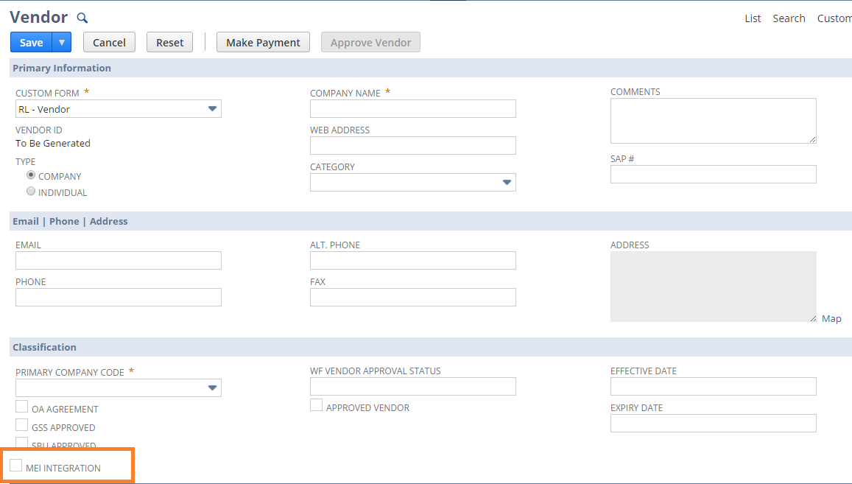

## Req-26: Ability to perform MEI Integration for Credit Memo and Vendor Bill

Requirement is to create custom forms for credit memo and vendor in order to perform MEI integration.

### ACCEPTANCE CRITERIA

1. Custom forms should be available for credit memo and vendor bill.
2. Two fields MEI Reason Code, Deduction Owner to be added on each custom forms.
3. Planning account to be added on RL-Credit Memo MEI form.

### USE CASES

1. Navigate to Customization ->Forms ->Transaction Forms
2. Select the credit memo /Vendor Bill form to customize.

### JEFFERSON IMPACT

No impact

### FUNCTIONAL SOLUTION

1. Customize the “RL-Credit Memo/Vendor Bill” form.

2. Save the Form to mark the required changes.

|  |  |  |  |
| --- | --- | --- | --- |
| **Record Type** | **Name** | **Description** | **Properties** |
| Credit Memo/Vendor Bill | RL-Credit Memo MEI/RL-Vendor Bill MEI Custom | * 1. Create new custom forms for both Credit Memos and Vendor Bills.   2. Add the custom fields “MEI Reason Code”, “Deduction Owner on these forms.   3. Planning account to be added on RL-Credit Memo MEI form | The fields created will be displayed under classification tab. |

### TECHNICAL SOLUTION

* + - 1. Three custom fields will be created on Vendor record.

Details of the custom field are given below:

|  |  |  |  |  |
| --- | --- | --- | --- | --- |
| **Record Type** | **Field** | **Description** | **Type** | **Properties** |
| Transaction(Credit Memo/Vendor Bill) | MEI Reason Code | This field is for MEI Reason Code on Vendor Bill/ Credit Memo | List/Record | 1. 1. Display Type= Normal 2. Source the custom List "MEI Reason Code" 3. Field will be displayed at Main level of the record. |
| Transaction(Credit Memo/Vendor Bill) | Deduction Owner | This field is used | List/Record | 1. 1. Display Type= Normal 2. Source the Record "Employee"   3. Field will be displayed at Main level of the record |
| Transaction(Credit Memo/Vendor Bill) | Planning Account | This field is used to Capture planning Account on Vendor Record | Free-Form Text | 1. Display Type= Normal  2. Free-Form Text. |

2. A custom list will be created with the values of deduction type .

Details of the list is given below:

|  |  |  |  |
| --- | --- | --- | --- |
| **Name** | **Description** | **Values** | **Properties** |
| Deduction Type | Deduction Type list is to be linked with MEI Reason Codes | * Non-Promotion * Promotion | Deduction Type list is to be linked with MEI Reason Codes |

3. A custom record will be created   
Details of the Custom record is given below:

|  |  |  |  |  |  |  |
| --- | --- | --- | --- | --- | --- | --- |
| **Record Type** | **Name** | **Fields** | **Description** | **Type** | **Properties** | |
| Custom | MEI Reason Code | 1. Name  2. Deduction Type | * The Record will be used to store the MEI Reason Code and Deduction type | * Free-form Text * List/ Record | | This list will be available as a dropdown in MEI Reason Code field on Credit memo and Vendor Bill record |

### CONFIGURATION

Create custom list using below path

Customization->Lists, Records & Fields >List Type > New

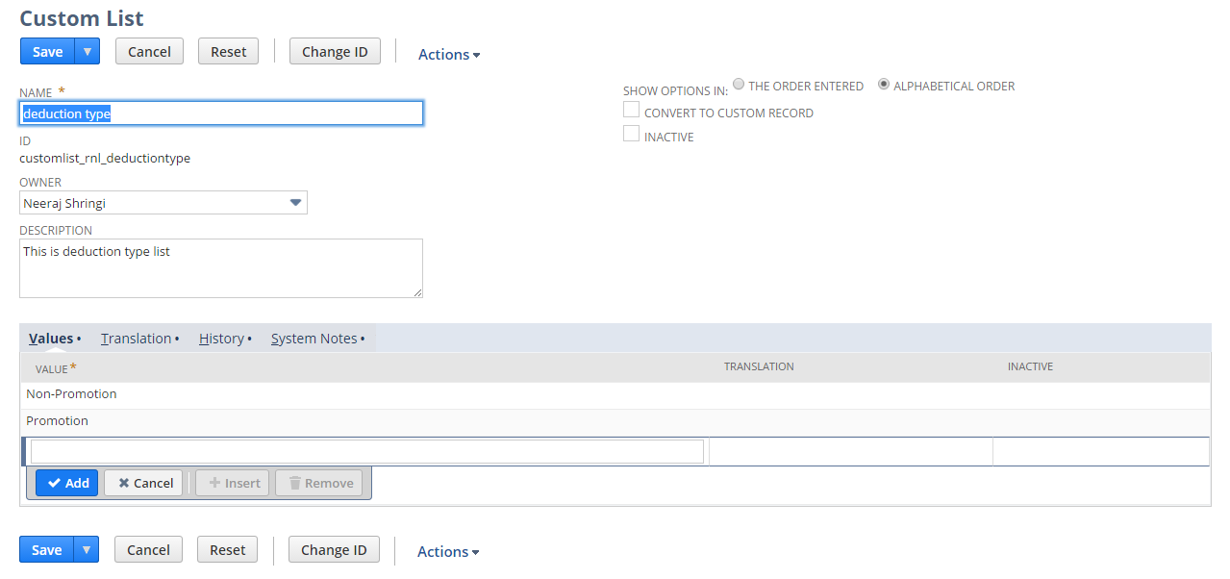

Create Custom record by using the below path

Customization->Lists, Records & Fields >Record Type > New

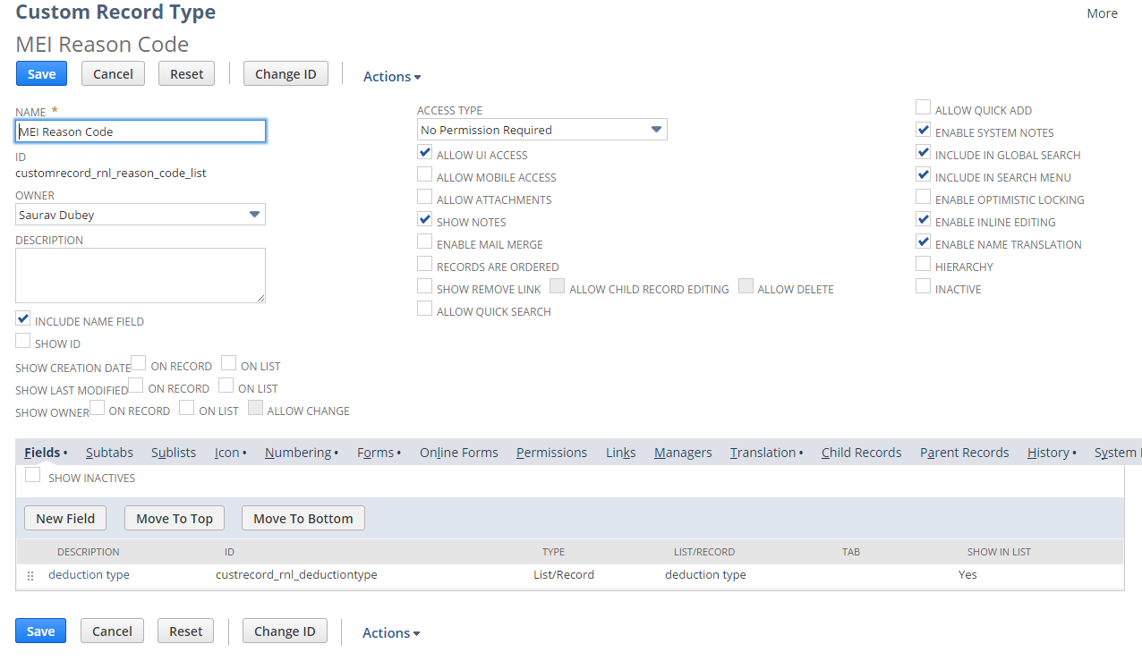  
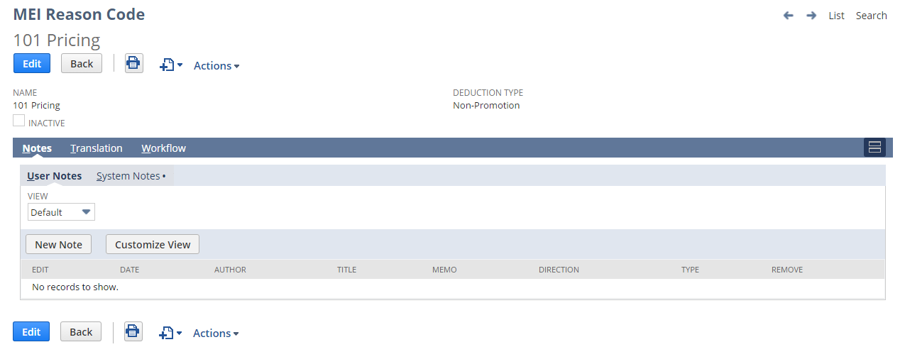

Create custom Field using below path

Customization->Lists, Records & Fields >Transaction Body Fields > New

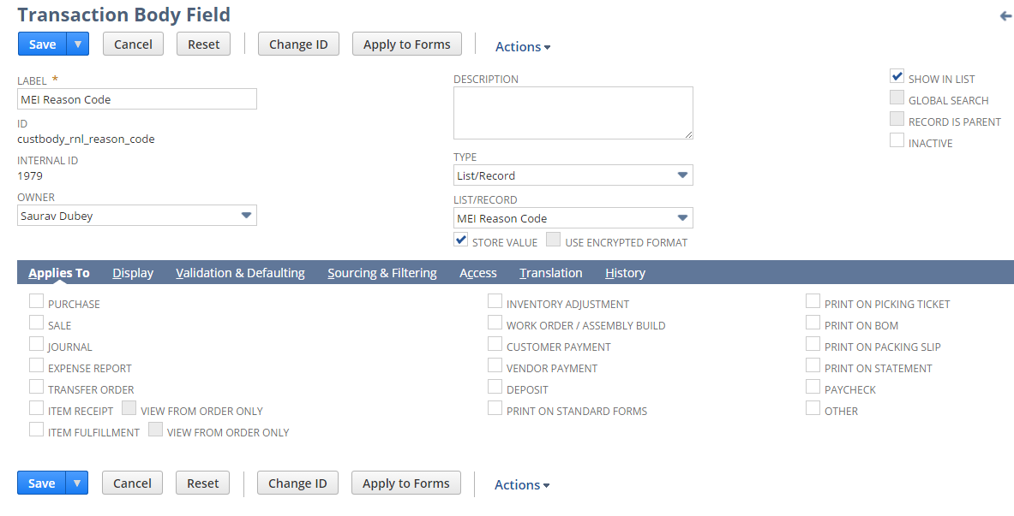

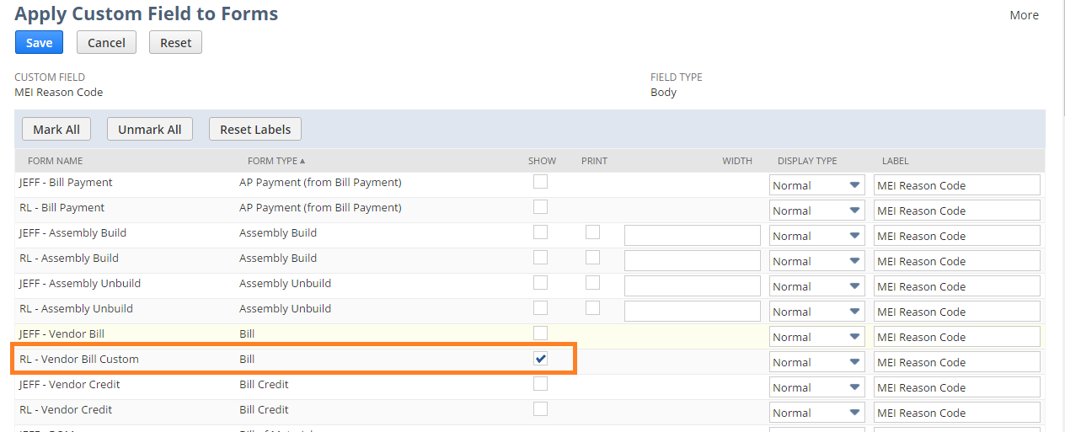

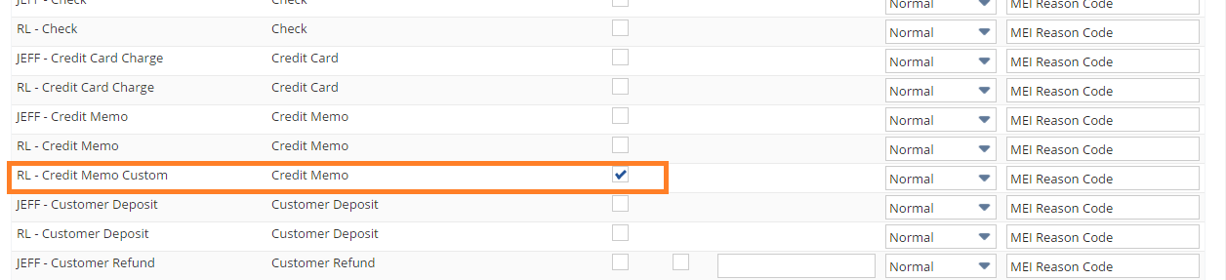

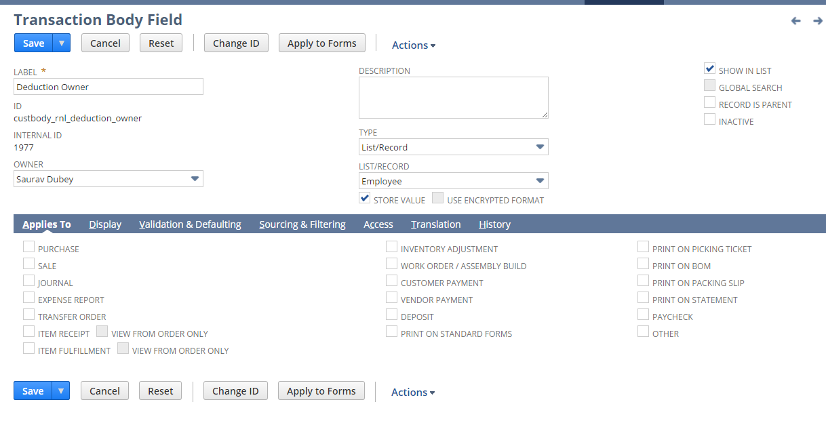

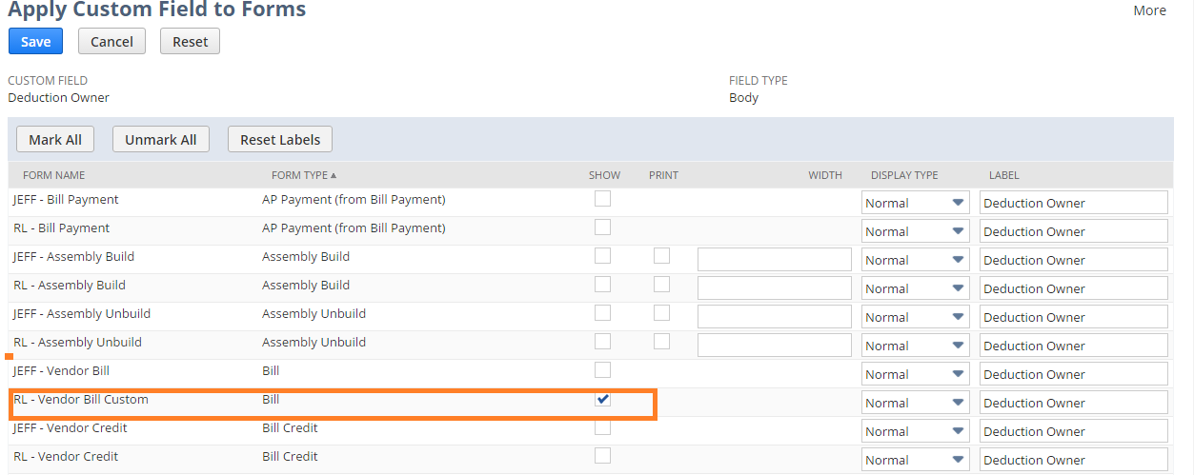

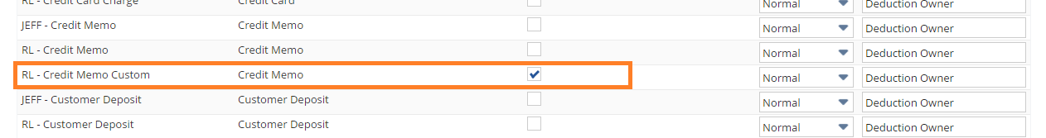

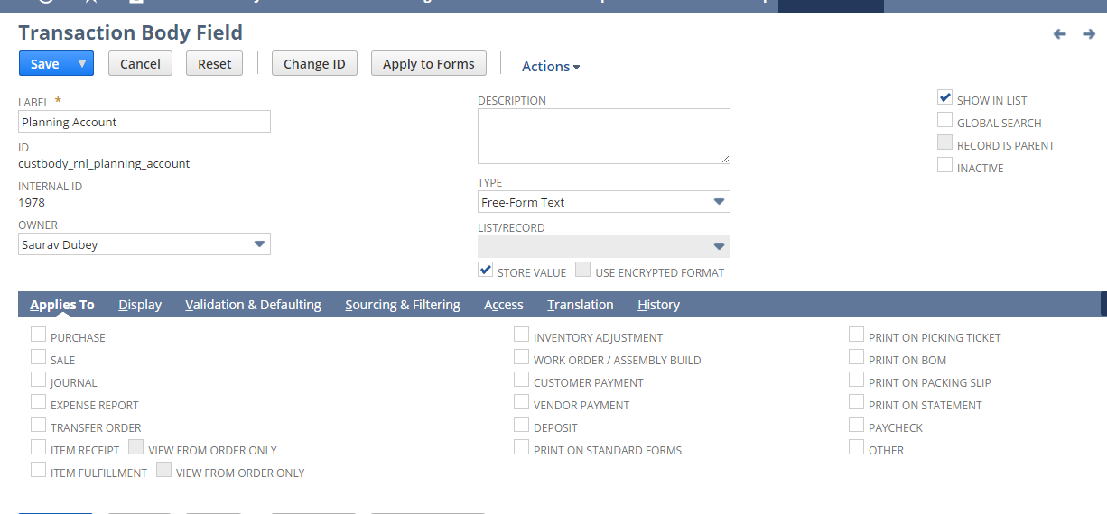

Apply to custom Form:

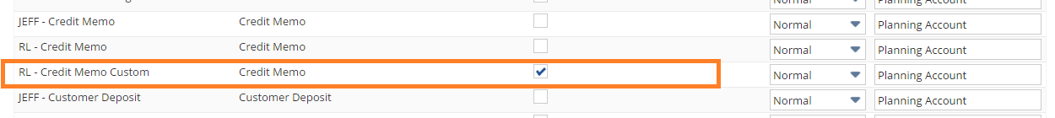

Edit the RL-Credit Memo Form using below path

Customization -> Forms -> Transaction Forms and Edit the form

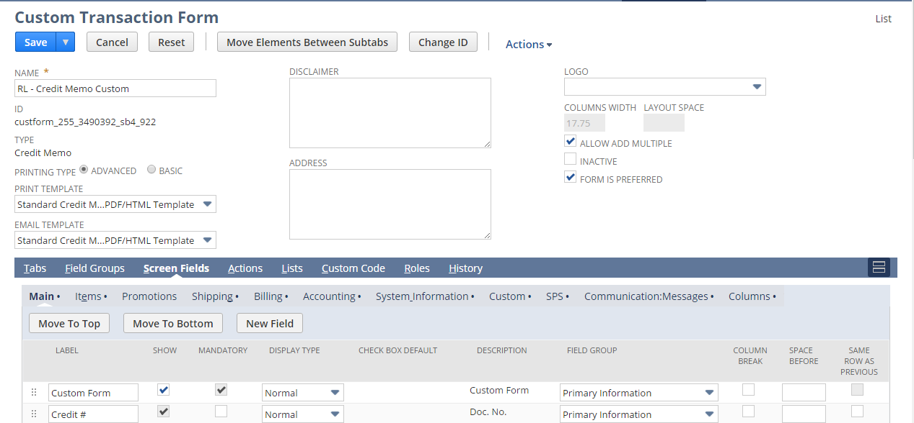

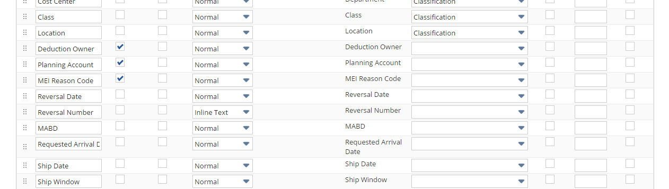

Edit the RL-Vendor Bill Form using below path

Customization -> Forms -> Transaction forms and Edit the form

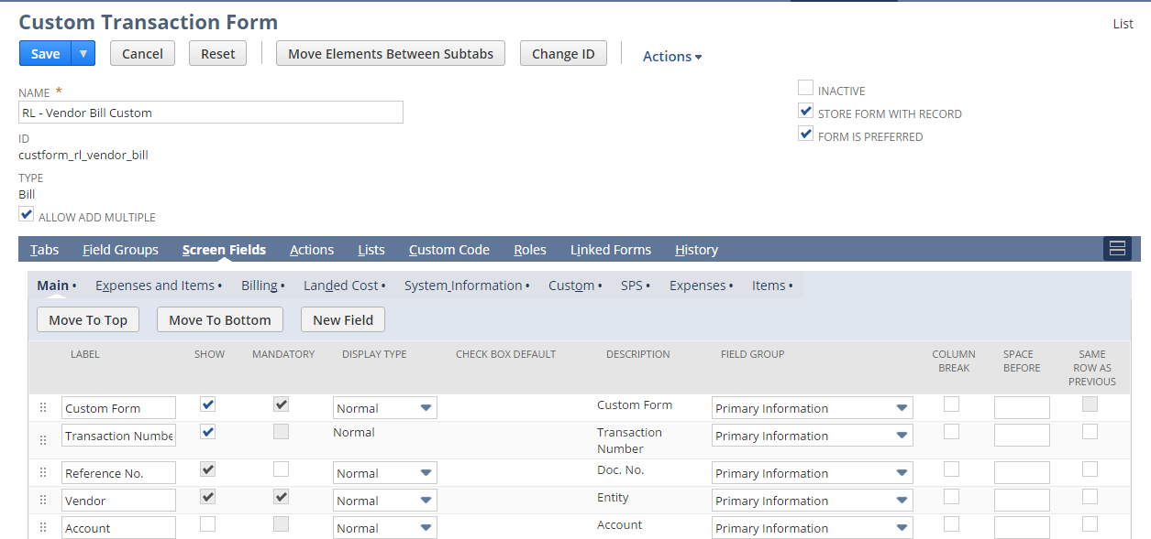

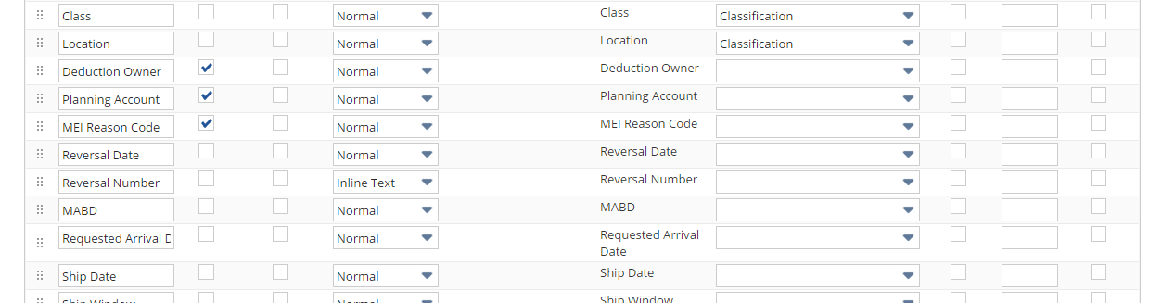

View the Credit Memo Using the below Path

Transactions -> Customers -> Issue Credit Memo -> New

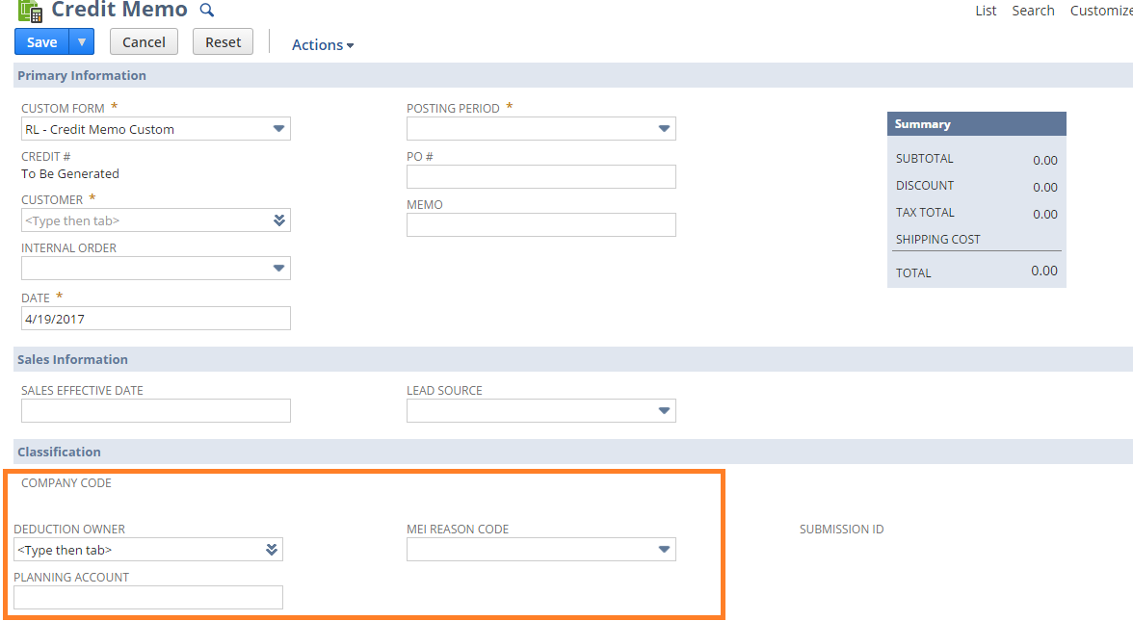

View the Vendor Bill Using the below Path

Transactions -> Payables-> Enter Bills

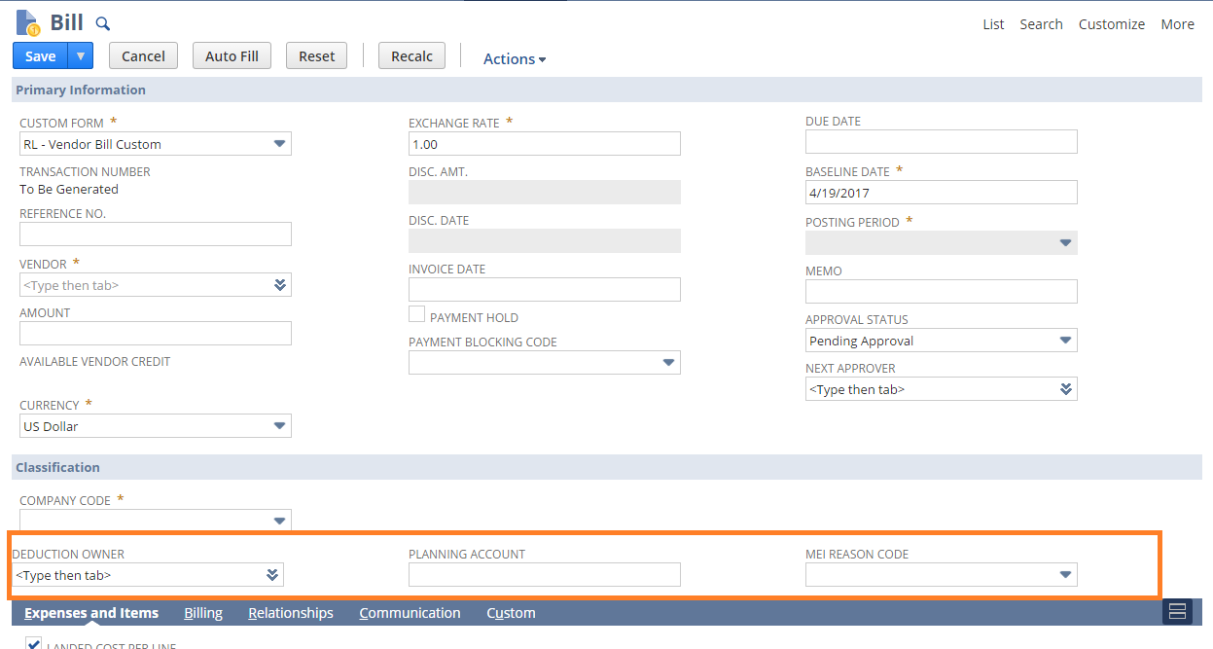

## Req-27: Global Trade Compliance Requirements for Item Master

### ACCEPTANCE CRITERIA

1. “HS Codes” field should be available on item master.
2. “ECCN” field should be available on item master.
3. “Country of Origin” field should be available on item master.

### USE CASES

1. Navigate to Lists > Accounting > Item >New

### JEFFERSON IMPACT

No impact

### FUNCTIONAL SOLUTION

There is no functional solution for this requirement.

### TECHNICAL SOLUTION

1. A custom field will be created on Vendor record.

Details of the custom field are given below:

|  |  |  |  |  |
| --- | --- | --- | --- | --- |
| **Record Type** | **Field** | **Description** | **Type** | **Properties** |
| Item | HS Codes |  | Free-text | 1. Display Type=Normal 2. Field Type =Free-text 3. Field will be displayed on Header tab under Classification Field group. |
| Item | ECCN |  | Free-text | 1. Display Type=Normal 2. Field Type =Free-text   Field will be displayed on Header tab under Classification Field group. |
| Item | Country of Origin | This field is sourced from country list. | List/Record | 1. Display Type=Normal 2. Field Type =List Record 3. Field will be displayed on Header tab under Classification Field group. |

### CONFIGURATION

1. Create custom Field using below path

Customization->Lists, Records & Fields >Item Fields > New

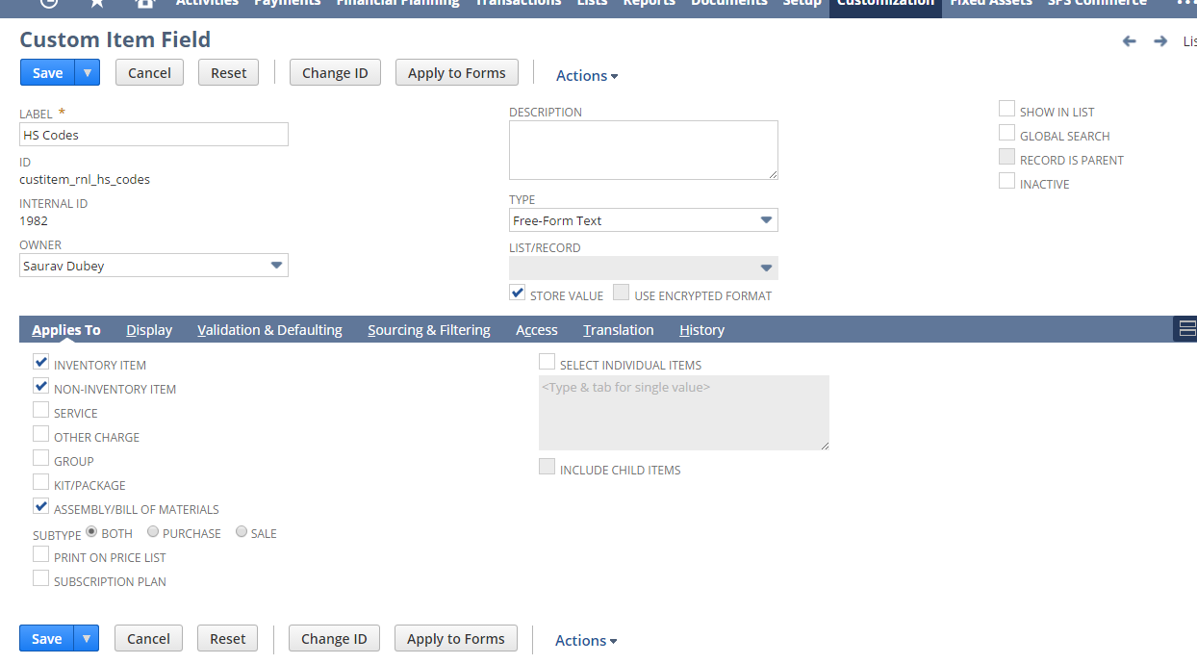

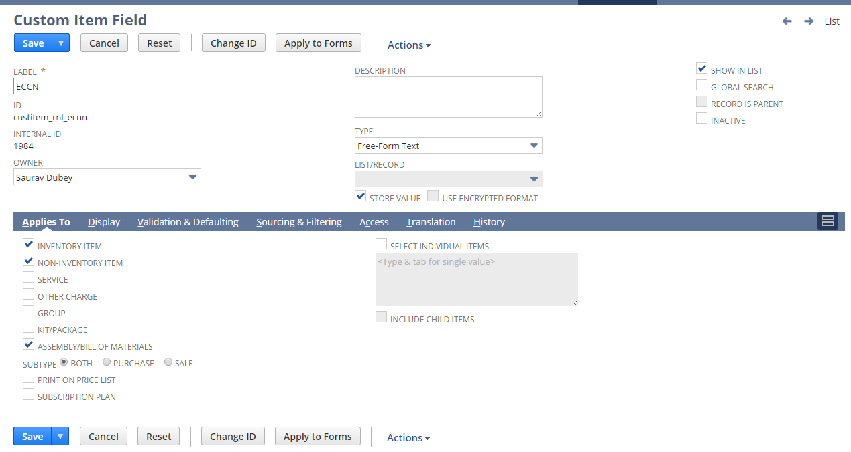

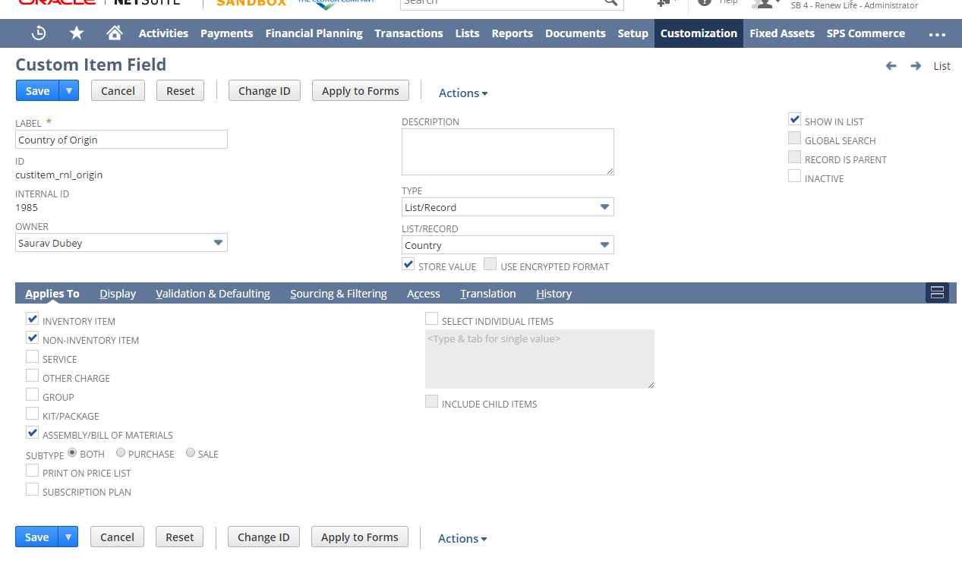

1. Open a Vendor using below path

Lists > Accounting > Items >New

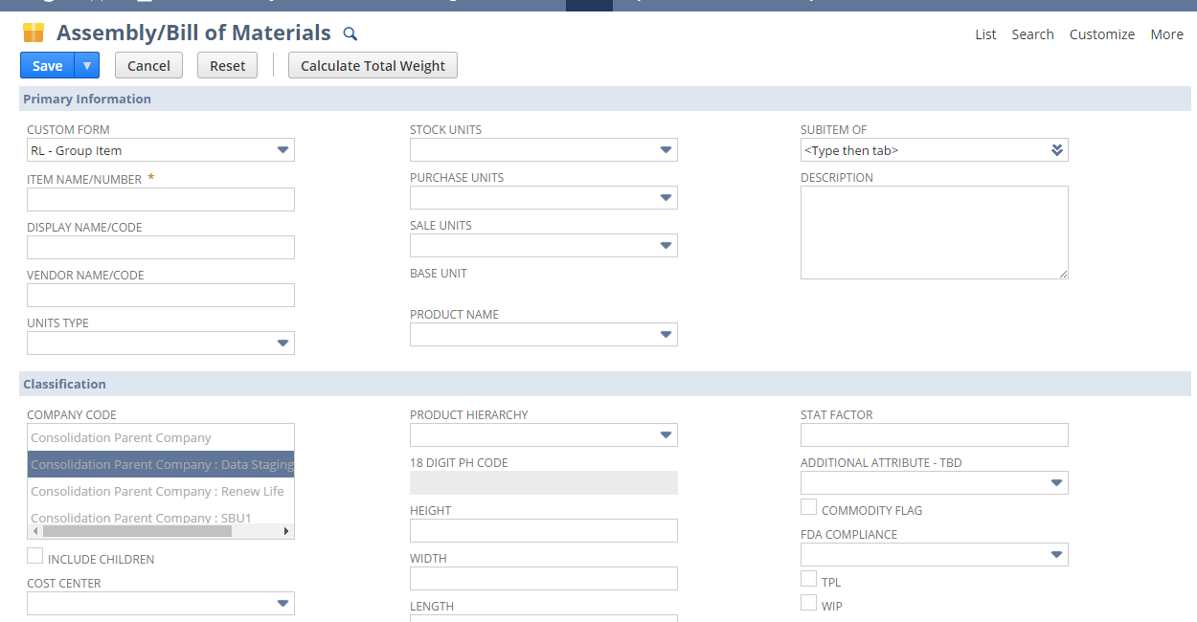

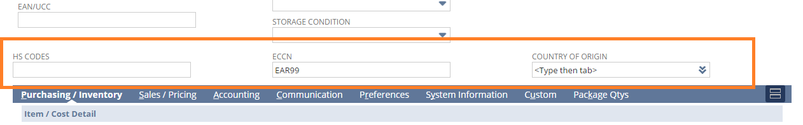

## Req-28: Global Trade Compliance Requirements for Customer Master

### ACCEPTANCE CRITERIA

1. “Export Customer” field should be available on customer master.

### USE CASES

1. Navigate to Lists > Relationships > Customers >New

### JEFFERSON IMPACT

No impact

### FUNCTIONAL SOLUTION

There is no functional solution for this requirement.

### TECHNICAL SOLUTION

1. A custom field will be created on Vendor record.

Details of the custom field are given below:

|  |  |  |  |  |
| --- | --- | --- | --- | --- |
| **Record Type** | **Field** | **Description** | **Type** | **Properties** |
| Item | Export Customer |  | Checkbox | 1. Display Type=Normal 2. Field Type =Checkbox 3. Field will be displayed on Header tab under Classification Field group. |

### CONFIGURATION

1. Create custom Field using below path

Customization->Lists, Records & Fields >Entity Fields > New

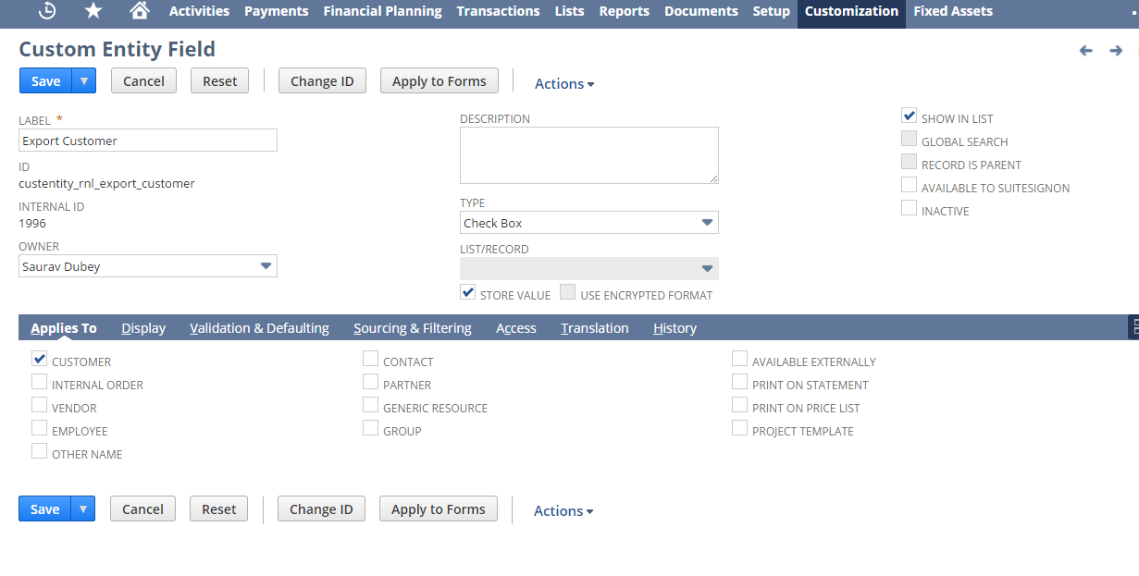

1. Open a Customer using below path

Lists > Relationships > Customers >New

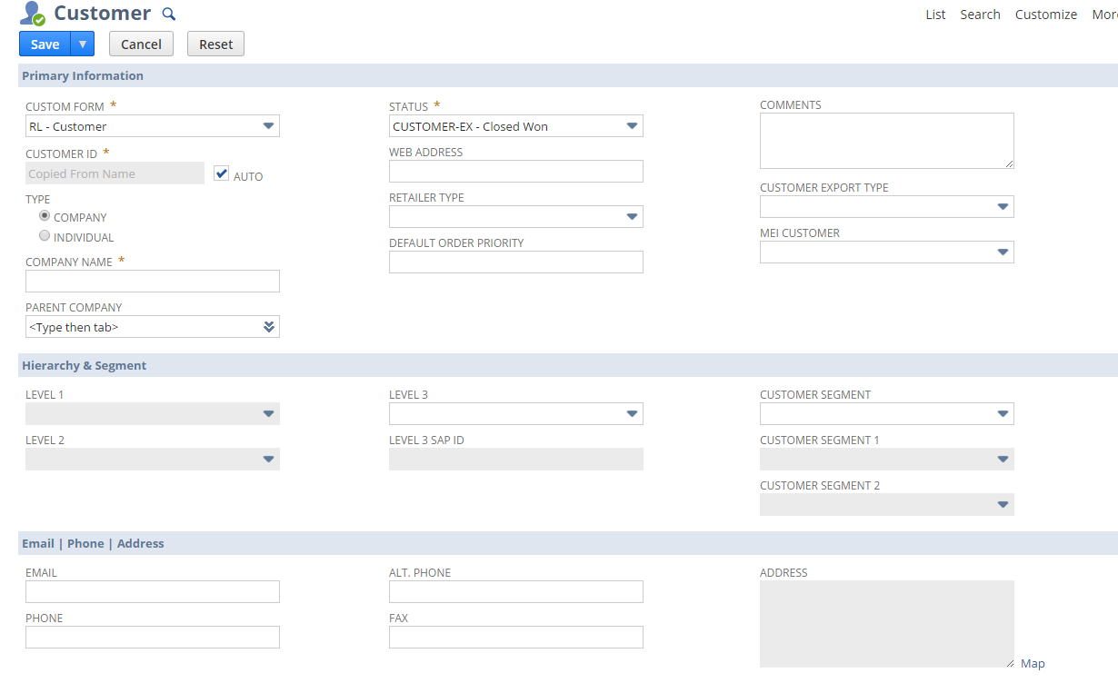

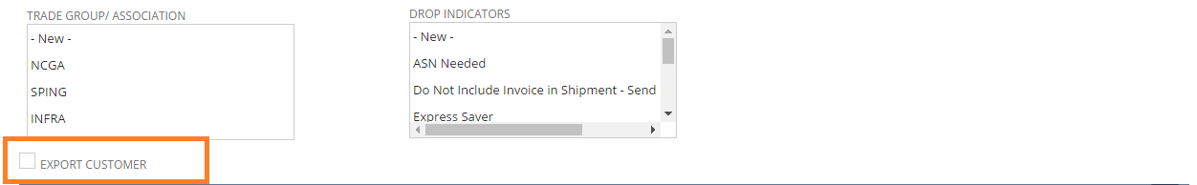

## Req-29: Capability to view all sales orders fully filled but pending billing

Business Process would be to generate invoice on the same day, and also approved on the same day. So they need a report to show all Sales Order Fulfilled but not billed

### ACCEPTANCE CRITERIA

1. Show all sales orders which are created for Renew Life subsidiary which are fulfilled but not billed

### USE CASES

1. Navigation Path for the Saved Search: Reports > Saved Searches > RNL Sales order pending billing
2. Follow above path to view all sales orders pending billing

### JEFFERSON IMPACT

No impact

### FUNCTIONAL SOLUTION

There is no functional solution for this requirement.

### TECHNICAL SOLUTION

* 1. Saved search to be created on Transaction record.  
     Details of the saved search are given in the table below:

|  |  |  |  |  |  |
| --- | --- | --- | --- | --- | --- |
| **Record Type** | **Name** | **Description** | **Filters** | **Columns** | **Properties** |
| Transaction | RNL Sales Orders Pending Billing | This saved search will display sales orders in renew life which are in fulfilled but pending billing status | * Company Code= Renew Life * Status = Sales Order:Pending Billing/Partially Fulfilled and Pending Billing * Type = Sales Order * Formula (Numeric)= {quantityshiprecv}-{quantitybilled} >0 | * Internal Id * Sales Order No. * Customer Name * Item * Quantity Ordered * Quantity Fulfilled * Quantity Billed * Quantity Unbilled * Order Amount Unbilled | * Available as menu |

### CONFIGURATION

1. Create a Custom Saved Search using the path mentioned below:
2. Reports -> Saved Searches -> All Saved Searches -> New and Select Search type as Transaction

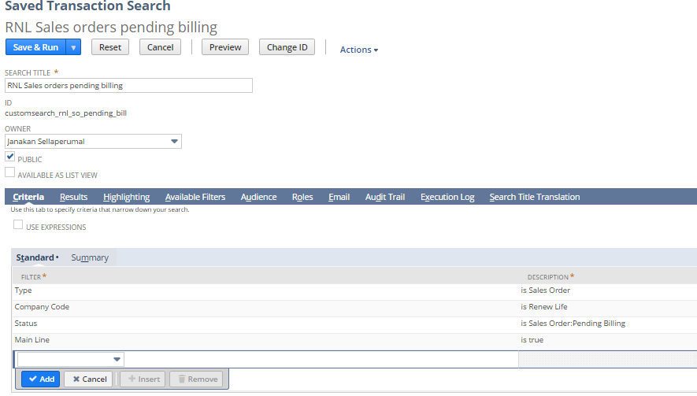

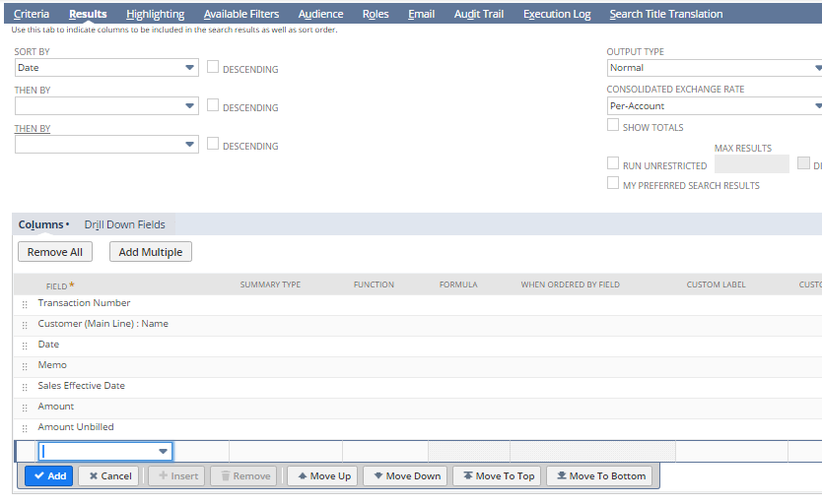

1. View the Saved Search using the path mentioned below:

Reports -> Saved Searches -> RNL Sales Order pending billing

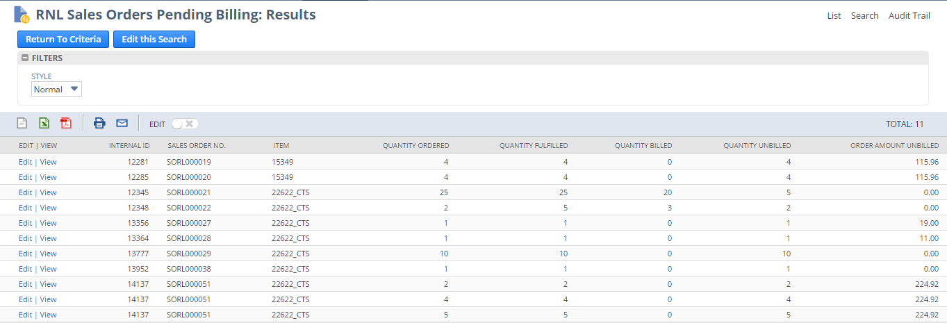

## Req-30: Capability to view all open invoices due for this week

Business wants to view all open invoices which are due for the current week with a reminder on dashboard

### ACCEPTANCE CRITERIA

1. Show all invoices which are open, created for Renew Life subsidiary and due for the current week

### USE CASES

1. Navigation Path for the Saved Search: Reports > Saved Searches > RNL Open invoices due this week
2. Follow above path to view all open invoices

### JEFFERSON IMPACT

No impact

### FUNCTIONAL SOLUTION

There is no functional solution for this requirement.

### TECHNICAL SOLUTION

* 1. Saved search to be created on Transaction record.  
     Details of the saved search are given in the table below:

|  |  |  |  |  |  |
| --- | --- | --- | --- | --- | --- |
| **Record Type** | **Name** | **Description** | **Filters** | **Columns** | **Properties** |
| Transaction | RNL open invoices due this week | This saved search will display all open invoices which are due for the current week and created for renew life | * Company Code= Renew Life * Status <> Paid in Full, Pending Approval * Main Line = True * Due Date = within this week * Payment Method | * Transaction Number * Customer Name * Date * Status * Payment Method * Reason code * Amount * Amount Remaining | * Available as menu * Available for reminders * Payment method filter is available for user selection. |

### CONFIGURATION

1. Create a Custom Saved Search using the path mentioned below:

2. Reports -> Saved Searches -> All Saved Searches -> New and Select Search type as Transaction

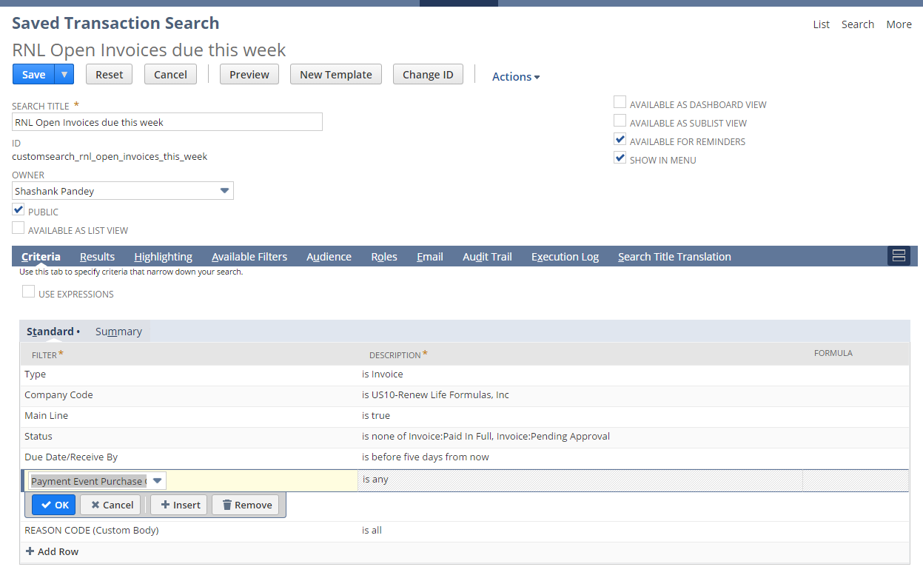

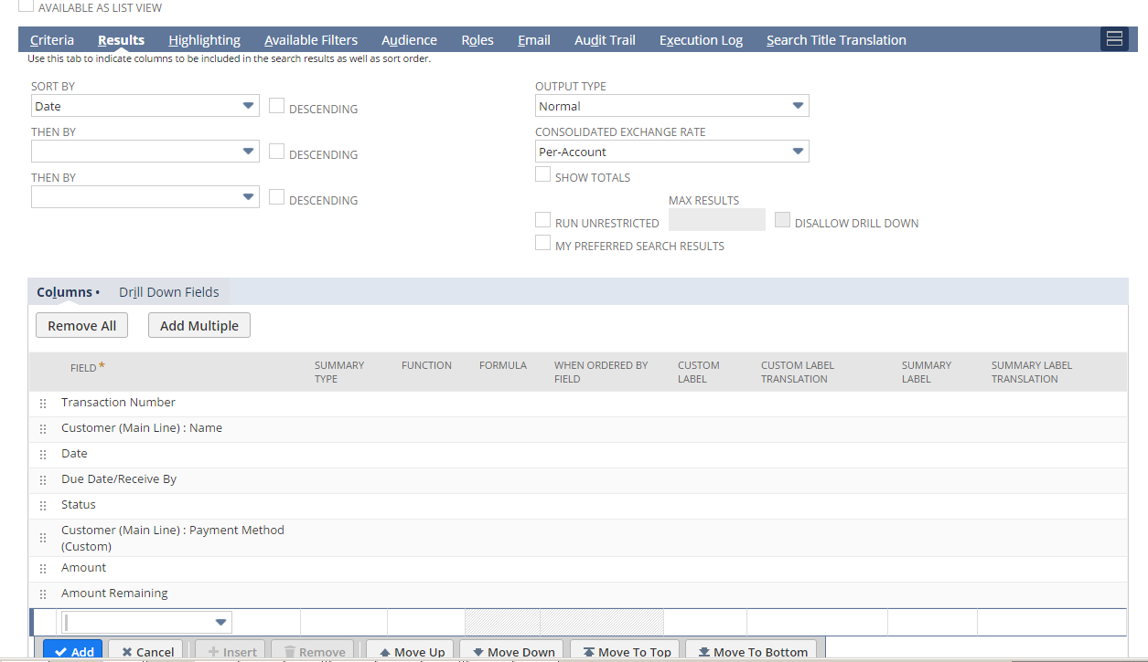

3. View the Saved Search using the path mentioned below:

Reports -> Saved Searches -> RNL Invoices due this week

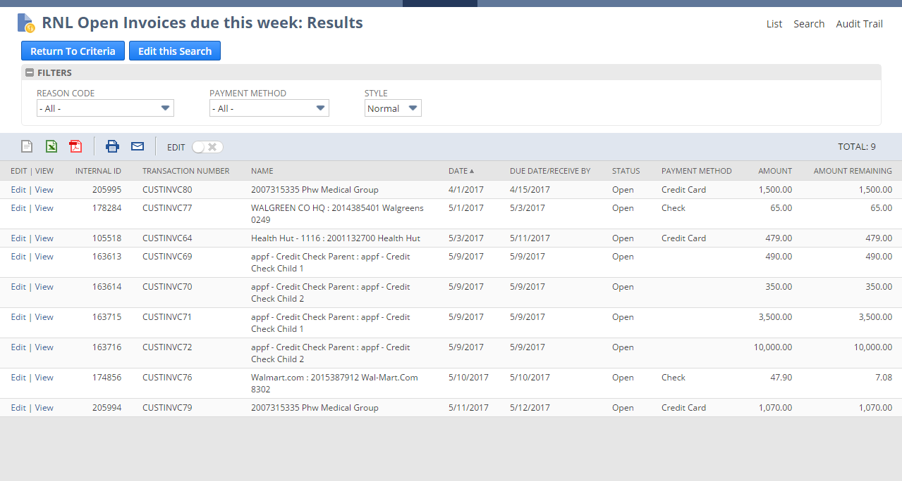

## Req-31: Capability to view all open invoices

Business wants to view all open invoices which are due and with a reminder on dashboard

### ACCEPTANCE CRITERIA

1. Show all invoices which are open, created for Renew Life subsidiary

### USE CASES

1. Navigation Path for the Saved Search: Reports > Saved Searches > RNL All Open invoices
2. Follow above path to view all open invoices

### JEFFERSON IMPACT

No impact

### FUNCTIONAL SOLUTION

There is no functional solution for this requirement.

### TECHNICAL SOLUTION

* 1. Saved search to be created on Transaction record.  
     Details of the saved search are given in the table below:

|  |  |  |  |  |  |
| --- | --- | --- | --- | --- | --- |
| **Record Type** | **Name** | **Description** | **Filters** | **Columns** | **Properties** |
| Transaction | RNL all open invoices | This saved search will display all open invoices created for renew life | * Company Code= Renew Life * Status <> Paid in Full, Pending Approval * Main Line = True | * Transaction Number * Customer Name * Date * Status * Payment Method * Reason code * Amount * Amount Remaining | * Available as menu * Available for reminders |

### CONFIGURATION

1. Create a Custom Saved Search using the path mentioned below:
2. Reports -> Saved Searches -> All Saved Searches -> New and Select Search type as Transaction

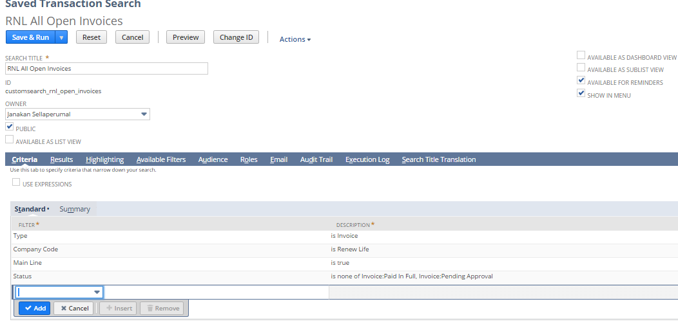

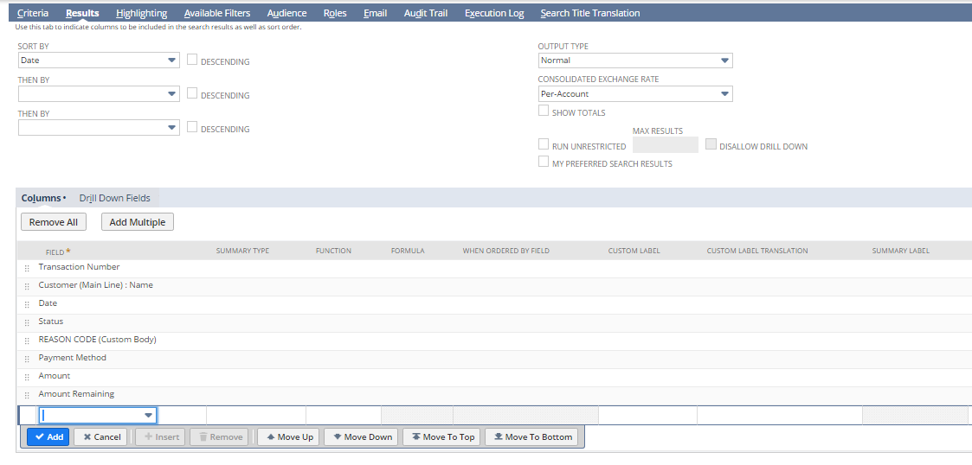

1. View the Saved Search using the path mentioned below:

Reports -> Saved Searches -> RNL Invoices due this week

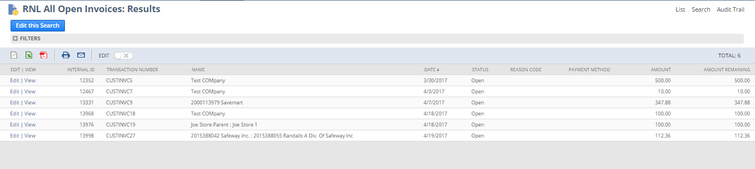

## Req-32: Need the Ability to Reason Code on customer Credit Memo

Requirement is to create a new custom field “Reason Code” on RL-Credit Memo of List/Record type.

### ACCEPTANCE CRITERIA

1. “Reason Code” field should be available on RL-Credit Memo Form.

2. “Reason Code” field should be of type list record.

### USE CASES

1. Navigate to Transaction > Customer> Issue Credit Memos

2. User shall be able to select “Reason code”.

### JEFFERSON IMPACT

No impact

### FUNCTIONAL SOLUTION

There is no functional solution for this requirement.

### TECHNICAL SOLUTION

1. A custom field will be created on Credit Memo.

Details of the custom field are given below:

|  |  |  |  |  |
| --- | --- | --- | --- | --- |
| **Record Type** | **Field** | **Description** | **Type** | **Properties** |
| Transaction  (RL-Credit Memo) | Reason Code | This field will capture reason code for the credit memo. | List Record | 1. Display Type=Normal 2. Field Type =List Record 3. Field will be displayed on Main level under classification. |

|  |  |  |  |
| --- | --- | --- | --- |
| **Name** | **Description** | **Values** | **Properties** |
| Reason Code | This list contains the list values on Reason Code type field on the credit memo | * Promo * Non-Promo | This list will be available selecting reason code on credit memo Record |

### CONFIGURATION

1. Create custom Field using below path

Customization->Lists, Records & Fields >Transaction Body Filed > New

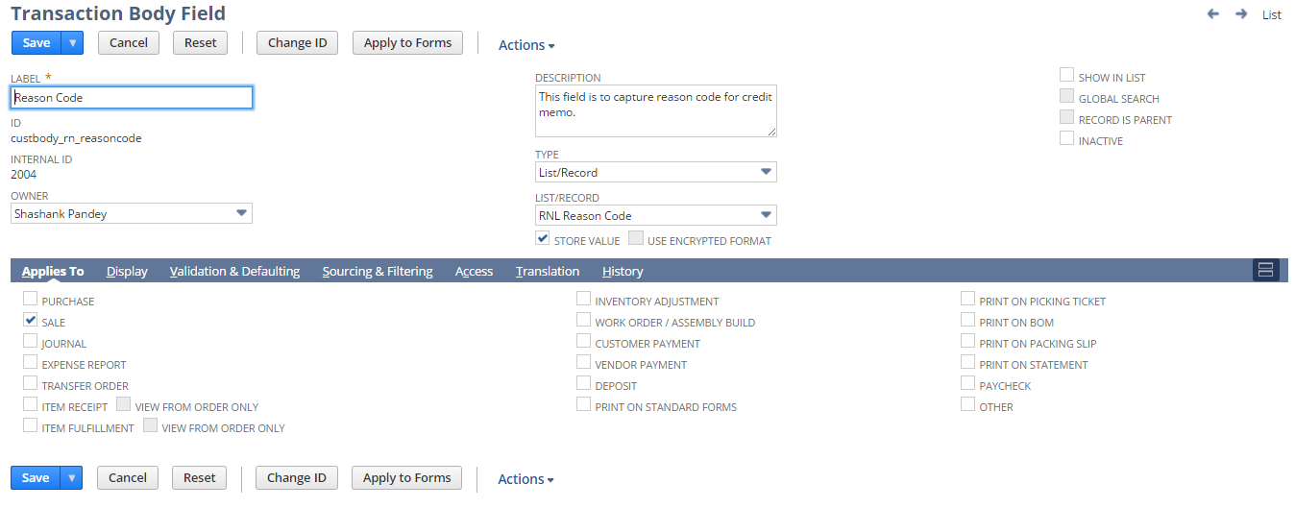

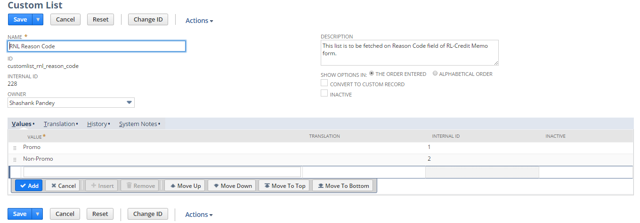

2. Click Save and Apply to forms

Apply the field to RL – Credit Memo

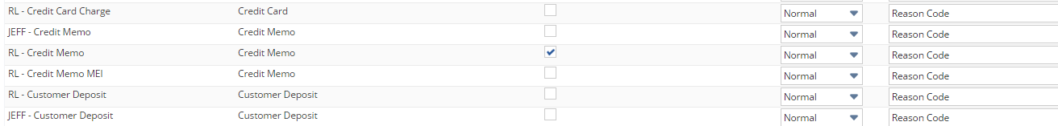

3. Open a Sales Order using below path

Transaction > Customer > Issue Credit Memo > RL-Credit Memo Form

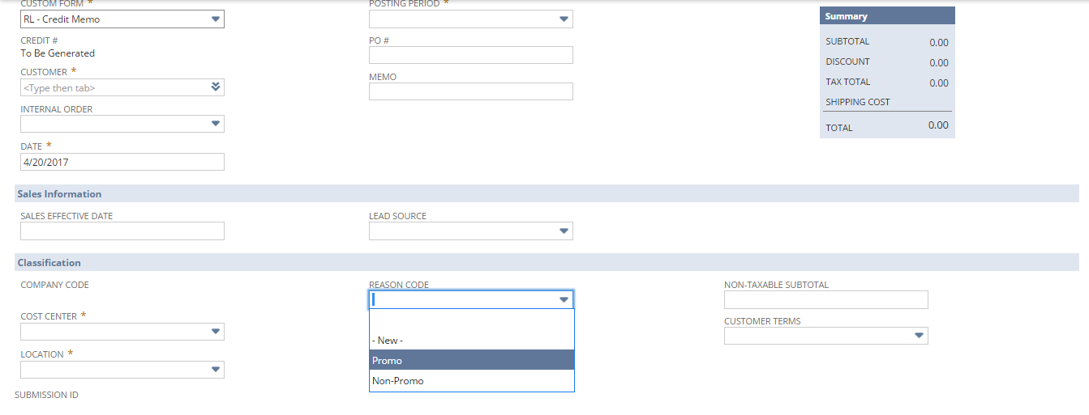

## Req-33: Ability to validate requested ship date is captured on sales order

Requirement is to validate requested ship date is captured on sales order record by sending an email to the accountable Sales Rep once the sales order is entered into NS.

### ACCEPTANCE CRITERIA

1. On Sales Order creation, a mail should be triggered to sales rep on customer record.

2. Sales rep should be able to receive the mail.

### USE CASES

1. On Sales Order creation, a mail should be triggered to customer sales rep.

2. Sales rep should be able to receive the mail.

### JEFFERSON IMPACT

No impact

### FUNCTIONAL SOLUTION

There is no functional solution for this requirement.

### TECHNICAL SOLUTION

1. Custom workflow is required to send email from sales order to sales rep in customer record. Details of the workflow are given below:

|  |  |  |  |  |
| --- | --- | --- | --- | --- |
| **Record Type** | **Name** | **Description** | **Conditions** | **Properties** |
| Sales Order | RNL-Email After SO Creation | 1. Workflow shall be initiated on Sales Order creation.  2. Workflow shall be initiated when company code is Renew Life. | Context = User event script. | 1. Email should be triggered after sales order created to customer sales rep.  2. Customer sales rep should be able to receive email. |

Details of workflow



System Change Impacts for Workflow

|  |  |  |
| --- | --- | --- |
| **#** | **Impact** | **Analysis** |
| 1 | Impact of Adding new subsidiary | 1. Current workflow executes only on below conditions    * Form selected belongs to Renew Life    * Logged in user’s subsidiary is Renew Life 2. To include a new subsidiary workflow trigger condition needs to be updated as shown in configuration section   Refer to Section 1.10.6.4 for details |
| 2 | Impact of NetSuite Product upgrades | 1. No specific maintenance needed during NetSuite upgrades as Script uses stable API’s of NetSuite. 2. A preview testing shall be needed during upgrades, as advised by NetSuite for all custom developments |
| 3 | Post Go Live maintenance | 1. No specific post go live maintenance needed and should be manageable by support organization |

### CONFIGURATION

Custom workflows

To create Custom Workflow follow path Customization->Scripting->Workflows->New

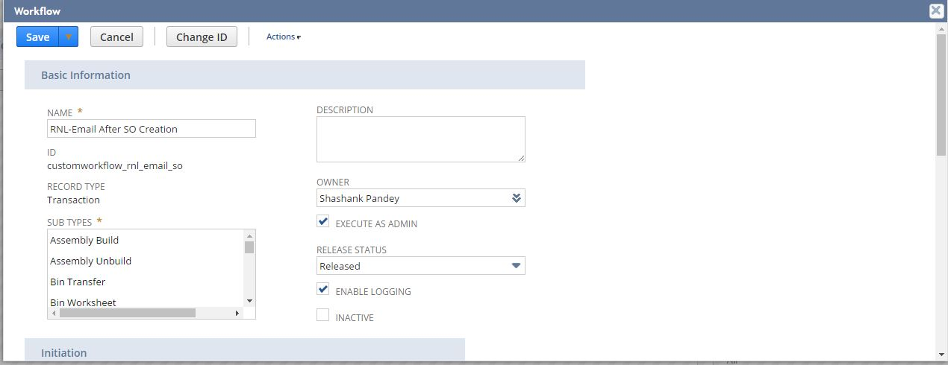

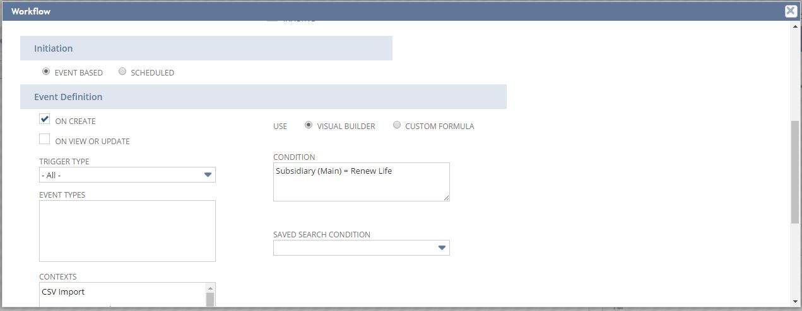

To view Custom Workflow follow path Customization->Scripting->Workflows-> [RNL-Email After SO Creation](https://system.sandbox.netsuite.com/app/common/workflow/setup/workflowmanager.nl?id=40)

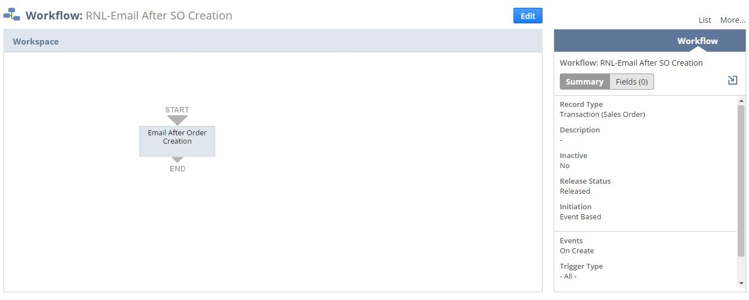

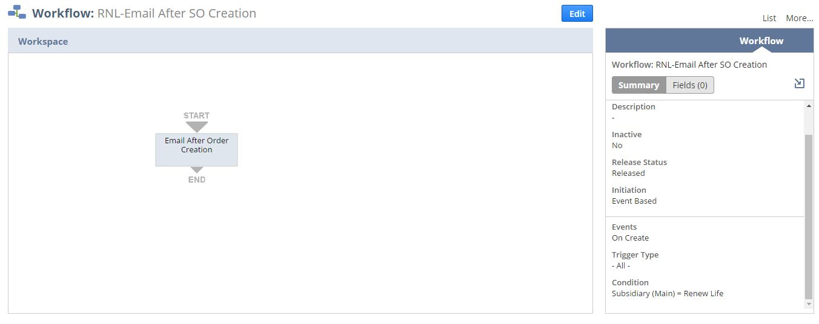

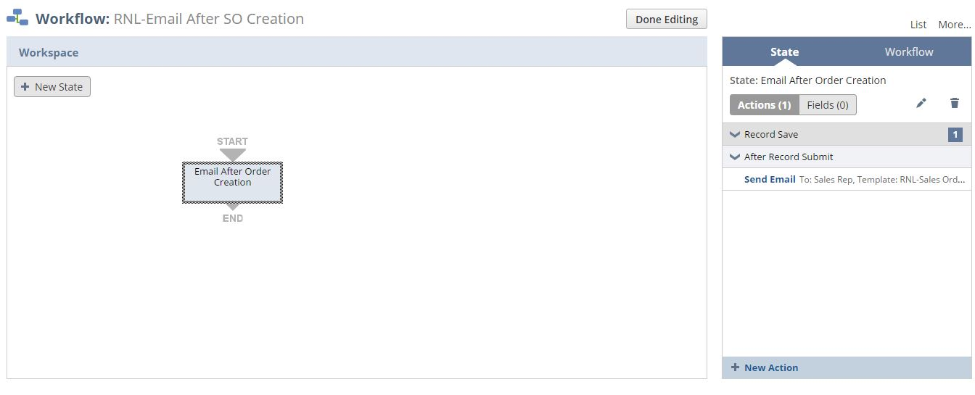

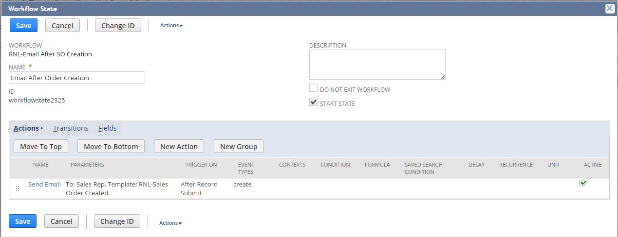

Below workflow condition needs to be changed for subsidiary addition\deletion

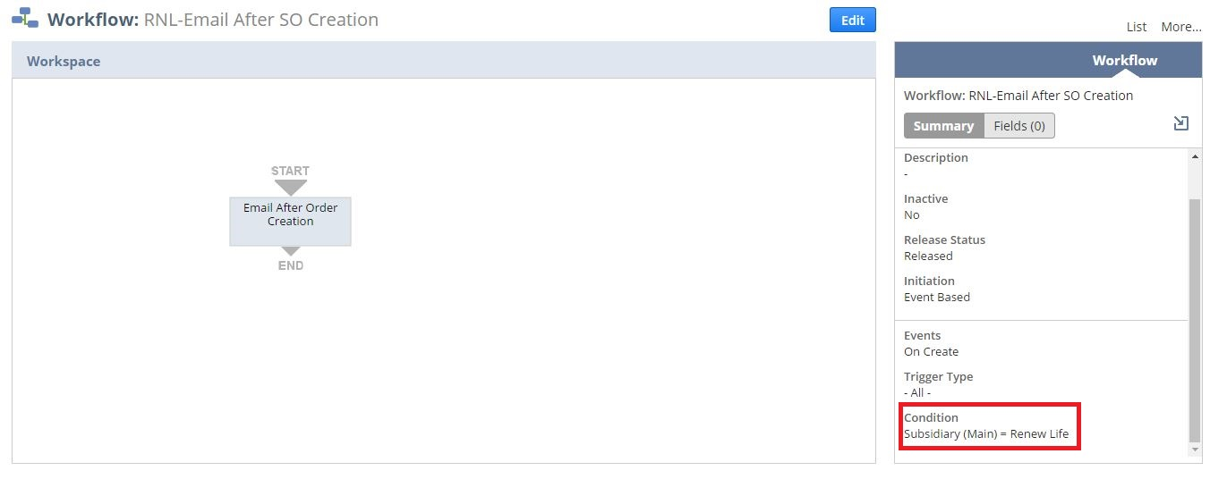

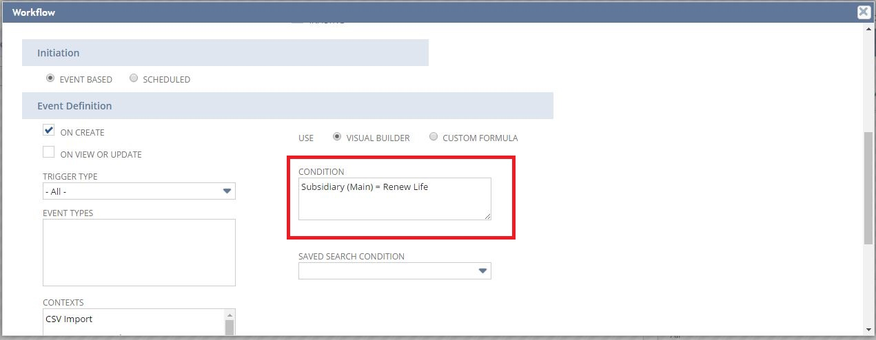

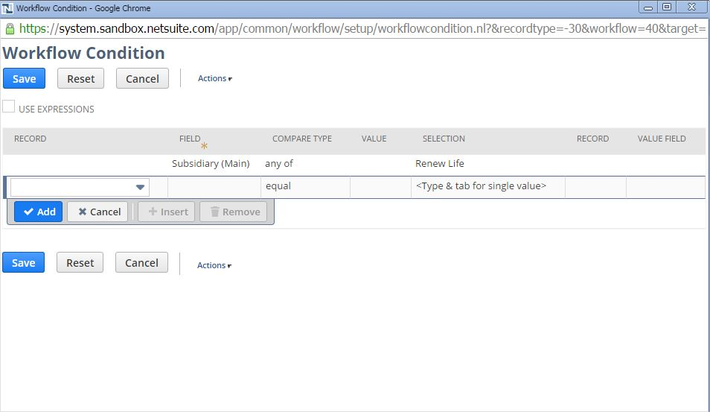

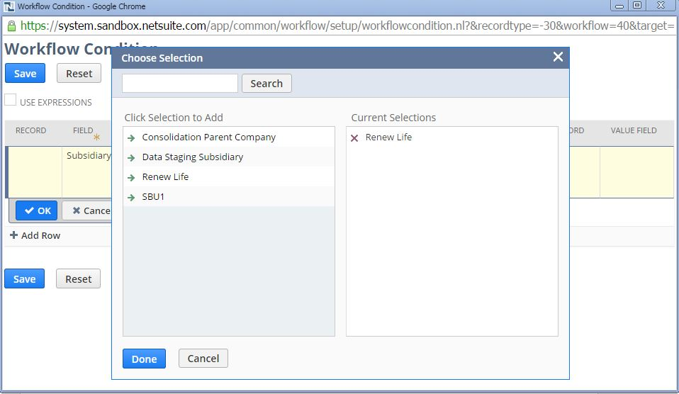

Email Templates

Email Templates for sending mail, Documents->Templates->Email Templates-> [RNL-Sales Order Created](https://system.sandbox.netsuite.com/app/crm/common/merge/emailtemplate.nl?id=10&nl=F)

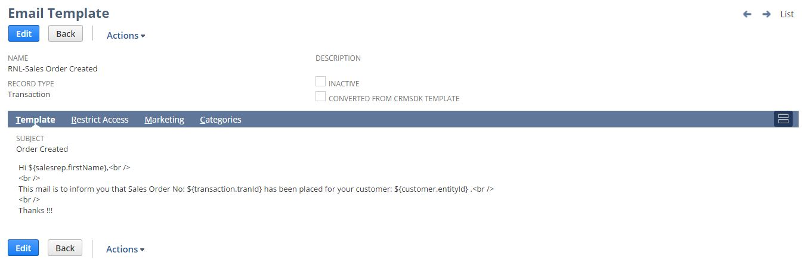

## Req-34: Ability to Send an email notification to customer when product is shipped

Requirement is that the system should be able to send an email notification to customer once an order ships.

### ACCEPTANCE CRITERIA

1. On item shipment on item fulfillment, a mail should be triggered to customer.

2. Customer should be able to receive the mail.

### USE CASES

1. On item shipment on item fulfillment, a mail should be triggered to customer.

2. Customer should be able to receive the mail.

### JEFFERSON IMPACT

No impact

### FUNCTIONAL SOLUTION

There is no functional solution for this requirement.

### TECHNICAL SOLUTION

1. Custom workflow is required to send email when item is shipped at item fulfillment to customer. Details of the workflow are given below:

|  |  |  |  |  |
| --- | --- | --- | --- | --- |
| **Record Type** | **Name** | **Description** | **Conditions** | **Properties** |
| Item Fulfillment | RNL-Email After Shipment | 1. Workflow shall be initiated on shipped status on item fulfillment.  2. Workflow shall be initiated when company code is Renew Life and customer email is not empty | Context = User event script. | 1. Email should be triggered after item shipment.  2. Customer should be able to receive email. |

Details of workflow



System Change Impacts for Workflow

|  |  |  |
| --- | --- | --- |
| **#** | **Impact** | **Analysis** |
| 1 | Impact of Adding new subsidiary | 1. Current workflow executes only on below conditions    * Form selected belongs to Renew Life    * Logged in user’s subsidiary is Renew Life.    * Customer email should not be empty |
| 2 | Impact of NetSuite Product upgrades | 1. No specific maintenance needed during NetSuite upgrades as Script uses stable API’s of NetSuite. 2. A preview testing shall be needed during upgrades, as advised by NetSuite for all custom developments |
| 3 | Post Go Live maintenance | 1. No specific post go live maintenance needed and should be manageable by support organization |

### 1.34.6 CONFIGURATION

Custom workflows

To create Custom Workflow follow path Customization->Scripting->Workflows->New

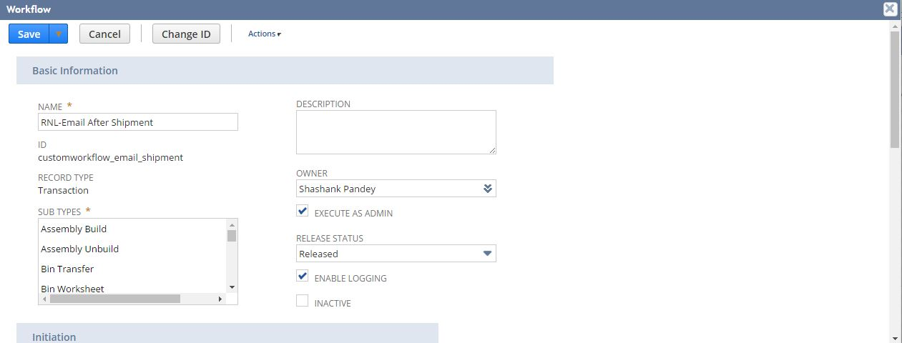

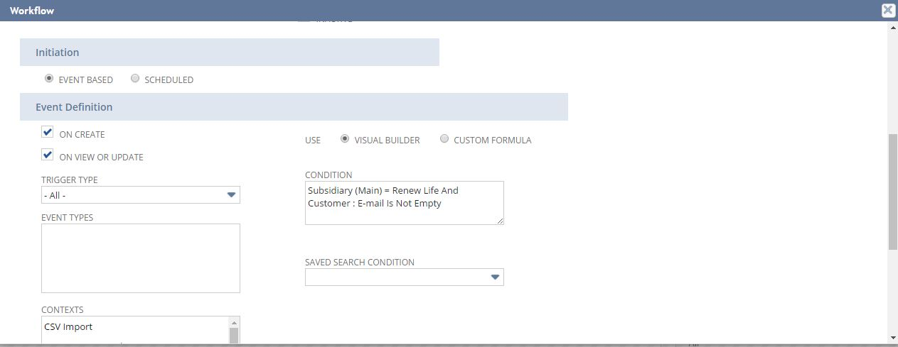

To view Custom Workflow follow path Customization->Scripting->Workflows-> [RNL-Email After](https://system.sandbox.netsuite.com/app/common/workflow/setup/workflowmanager.nl?id=40) Shipment

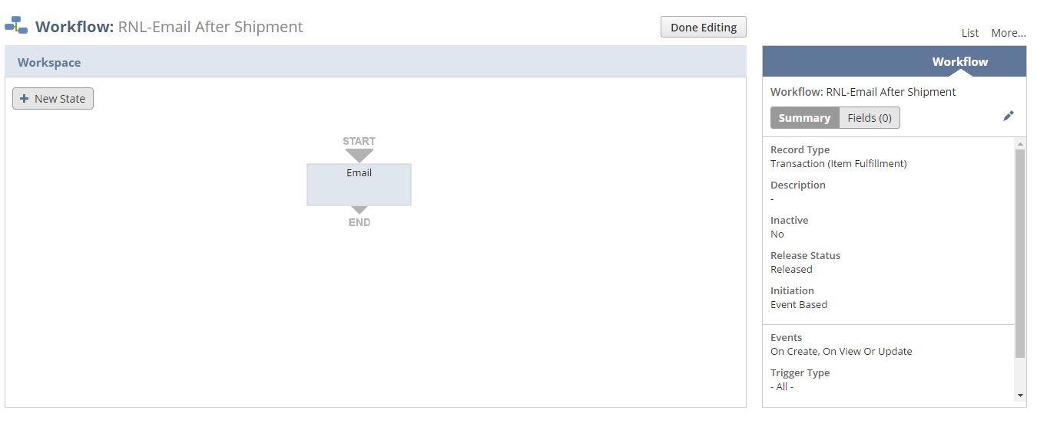

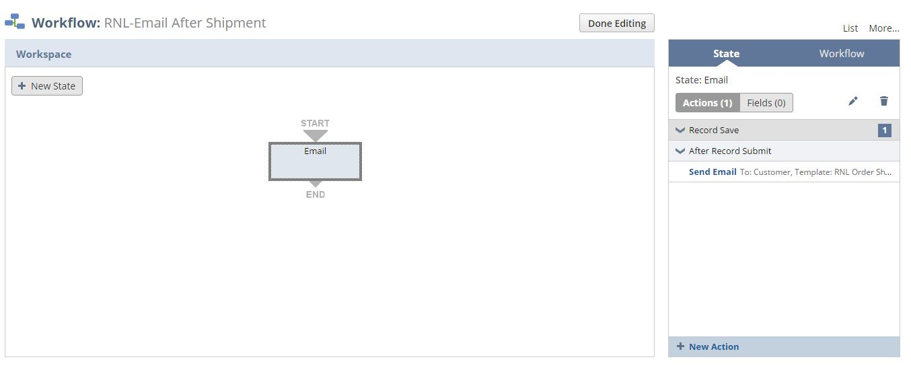

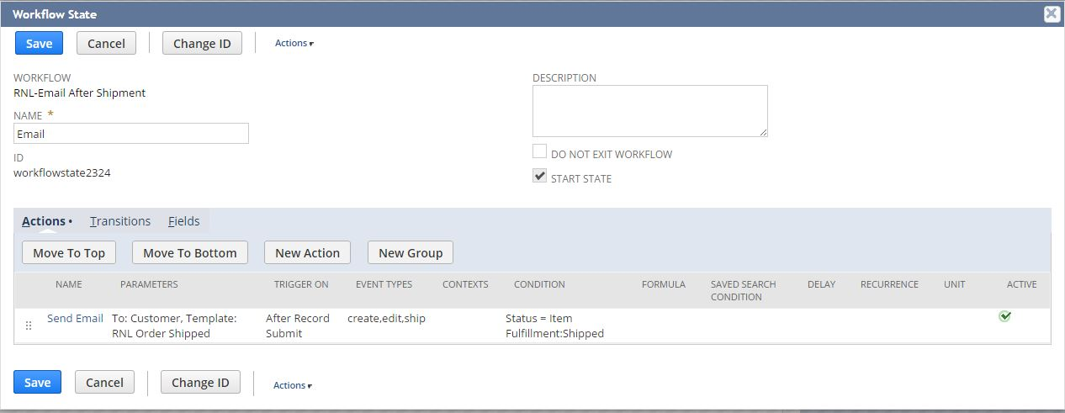

Below workflow condition needs to be changed for subsidiary addition\deletion

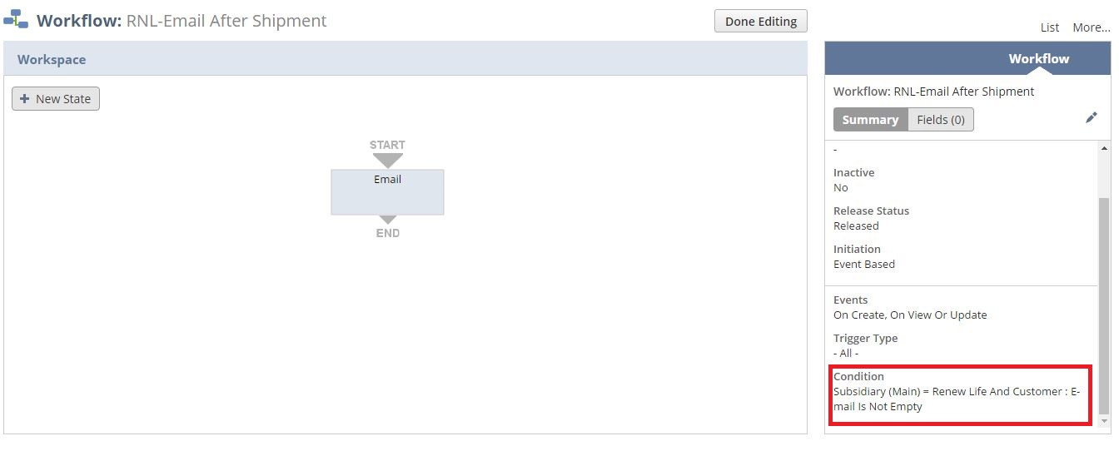



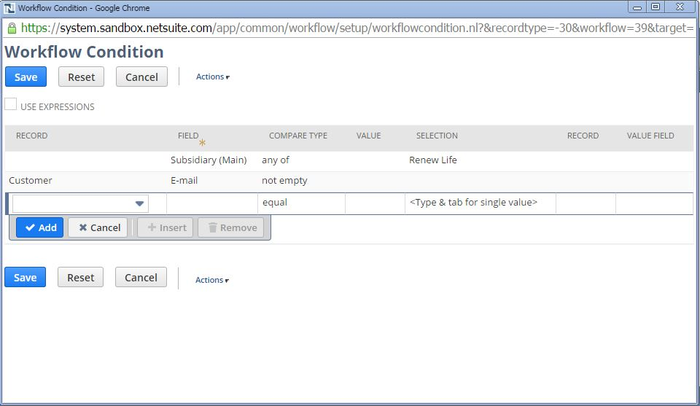



Email Templates

Email Templates for sending mail, Documents->Templates->Email Templates-> [RNL Order](https://system.sandbox.netsuite.com/app/crm/common/merge/emailtemplate.nl?id=10&nl=F) Shipped

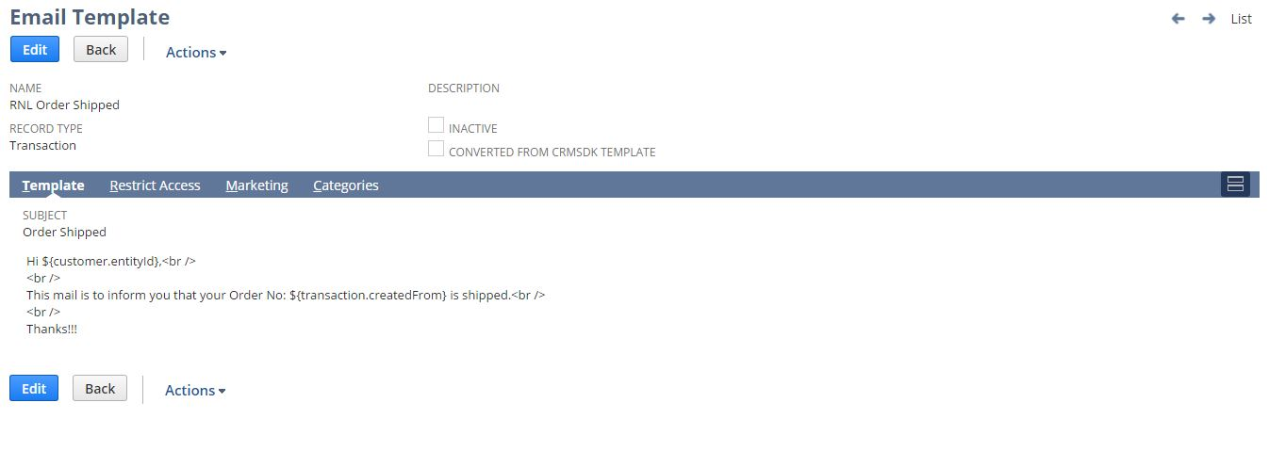

## Req-35: Ability to approve or reject the invoice

Requirement is to approve the generated customer invoice based on picked quantity in order for invoice to travel with shipment.

### ACCEPTANCE CRITERIA

1. RNL Super User should be able to approve or reject the customer invoice.

### USE CASES

1. RNL Super User should be able to approve or reject the customer invoice.

### JEFFERSON IMPACT

No impact

### FUNCTIONAL SOLUTION

There is no functional solution for this requirement.

### TECHNICAL SOLUTION

1. Custom workflow is required to approve or reject the customer invoice. Details of the workflow are given below:

|  |  |  |  |  |
| --- | --- | --- | --- | --- |
| **Record Type** | **Name** | **Description** | **Conditions** | **Properties** |
| Invoice | [RNL-](https://system.sandbox.netsuite.com/app/common/workflow/setup/workflowmanager.nl?id=39)Invoice Approval | 1. Workflow shall be initiated on Invoice record.  2. Workflow shall be initiated when company code is Renew Life. | Context = User event script. | * It will work for Renew Life Company * When approver approves,invoice is approved * When approver rejects,user can edit it and can send it again for approval by clicking mark for approval button |

Details of workflow



System Change Impacts for Workflow

|  |  |  |
| --- | --- | --- |
| **#** | **Impact** | **Analysis** |
| 1 | Impact of Adding new subsidiary | 1. Current workflow executes only on below conditions    * Form selected belongs to Renew Life    * Logged in user’s subsidiary is Renew Life 2. To include a new subsidiary workflow trigger condition needs to be updated as shown in configuration section   Refer to Section 1.10.6.4 for details |
| 2 | Impact of NetSuite Product upgrades | 1. No specific maintenance needed during NetSuite upgrades as Script uses stable API’s of NetSuite. 2. A preview testing shall be needed during upgrades, as advised by NetSuite for all custom developments |
| 3 | Post Go Live maintenance | 1. No specific post go live maintenance needed and should be manageable by support organization |

### CONFIGURATION

Custom workflows

To create Custom Workflow follow path Customization->Scripting->Workflows->New

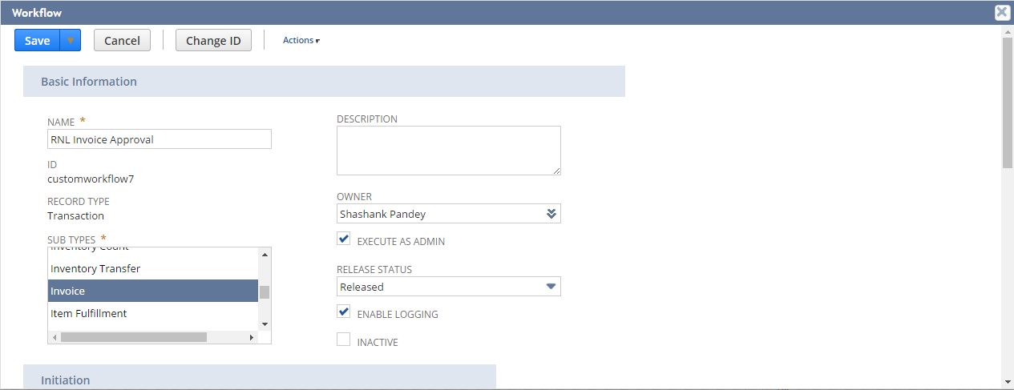

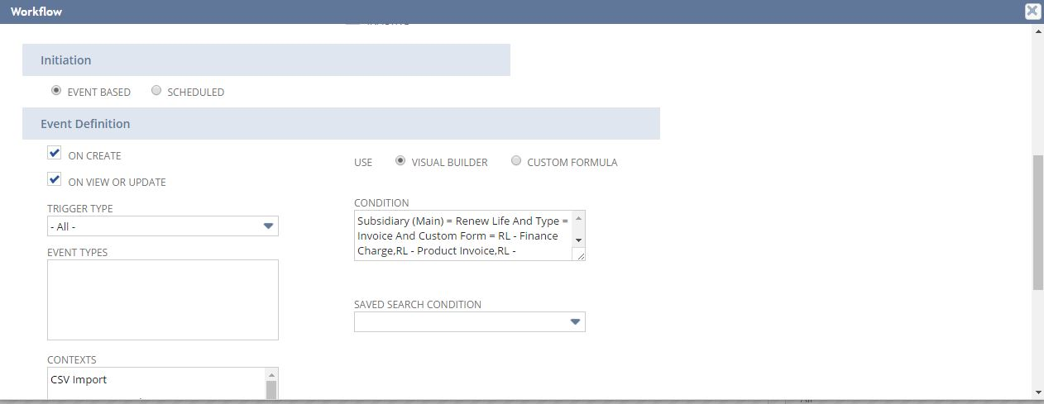

To view Custom Workflow follow path Customization->Scripting->Workflows-> [RNL](https://system.sandbox.netsuite.com/app/common/workflow/setup/workflowmanager.nl?id=40) Invoice Approval

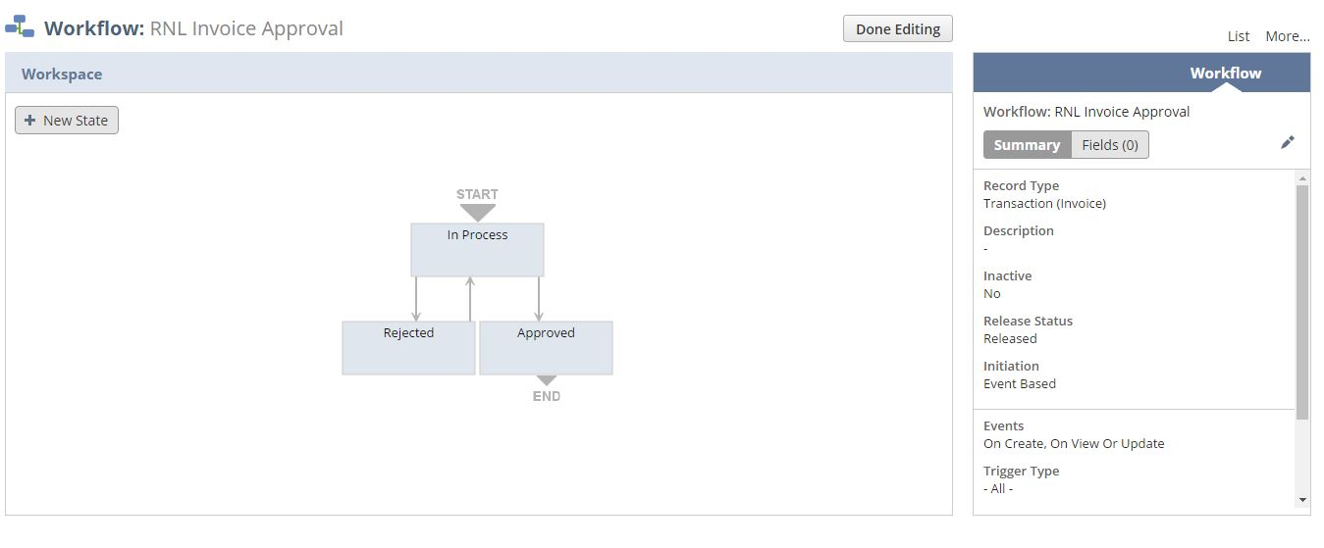

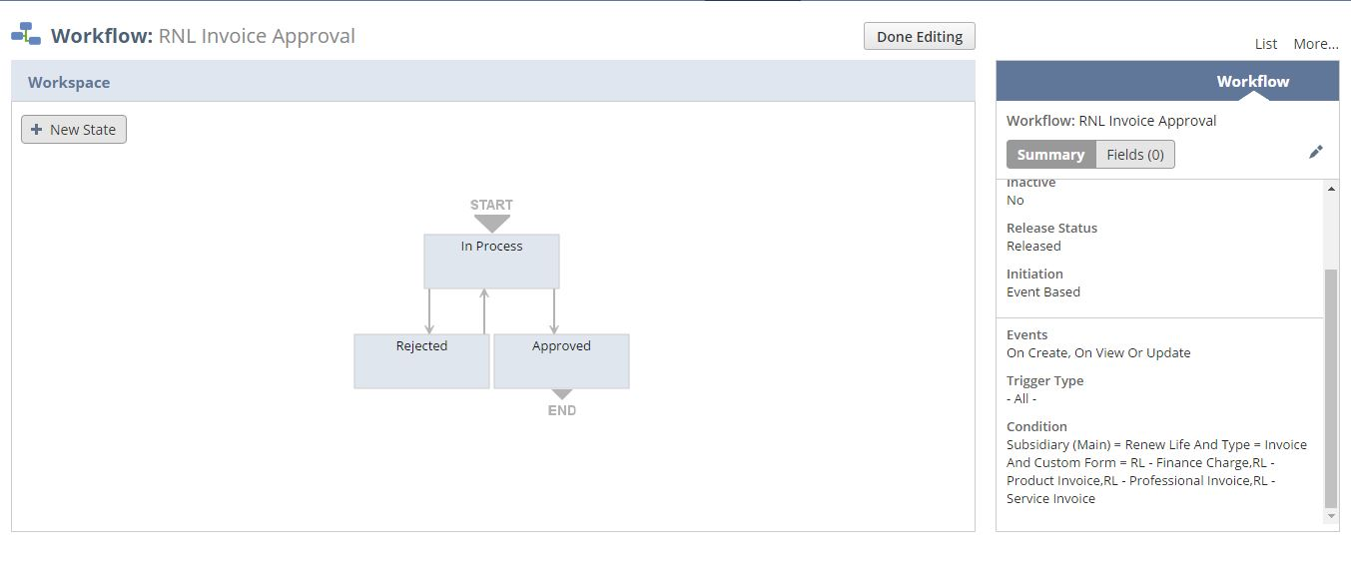

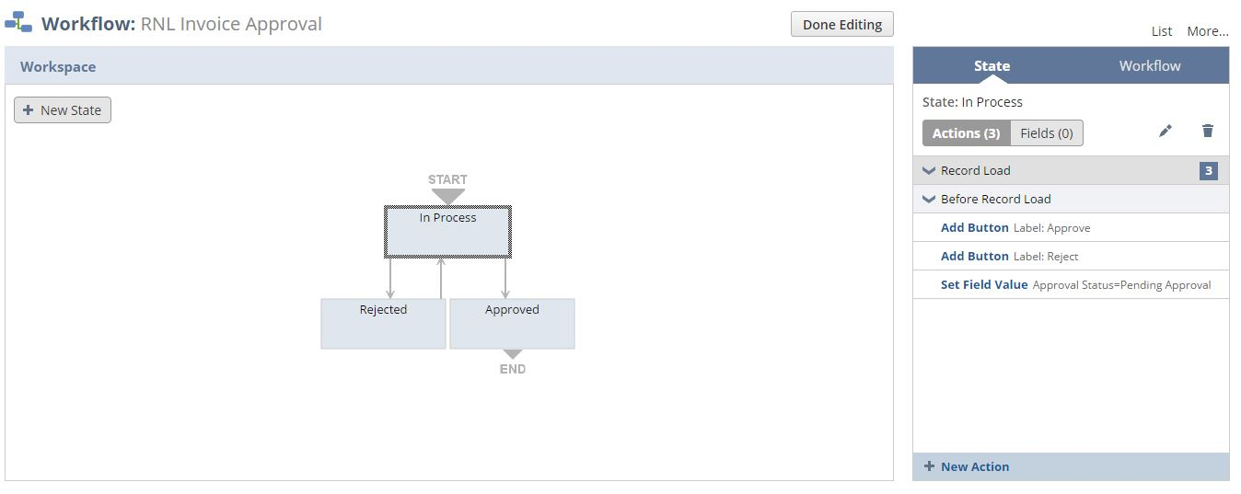

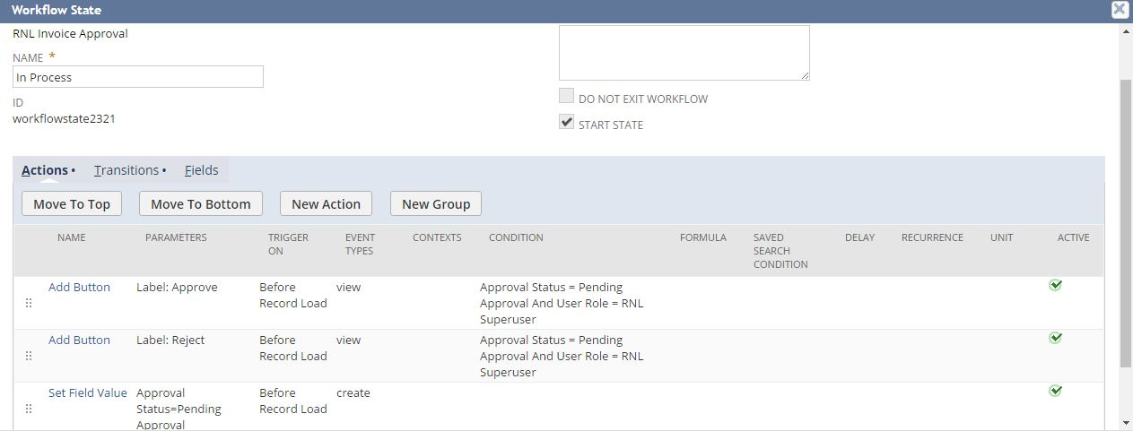

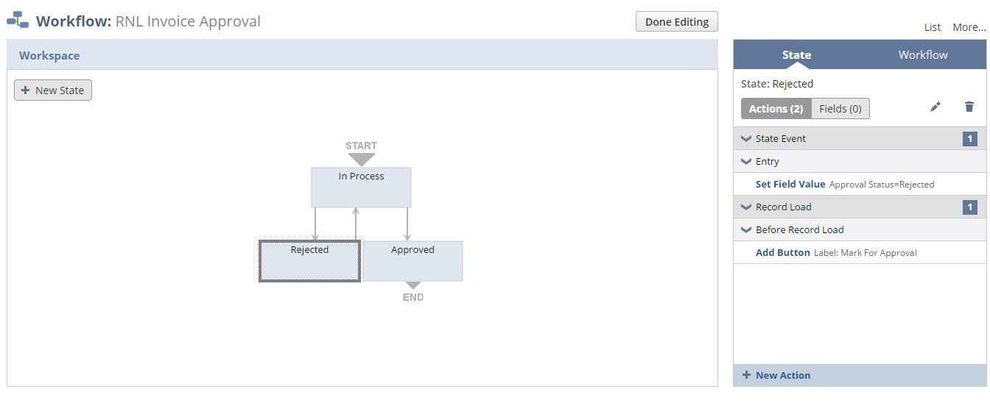

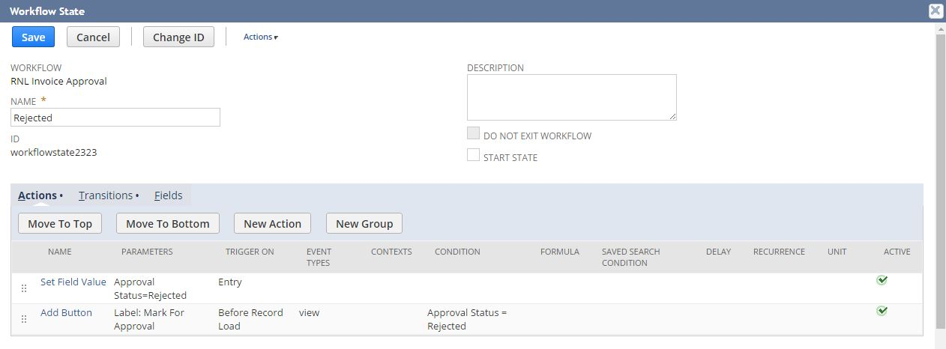

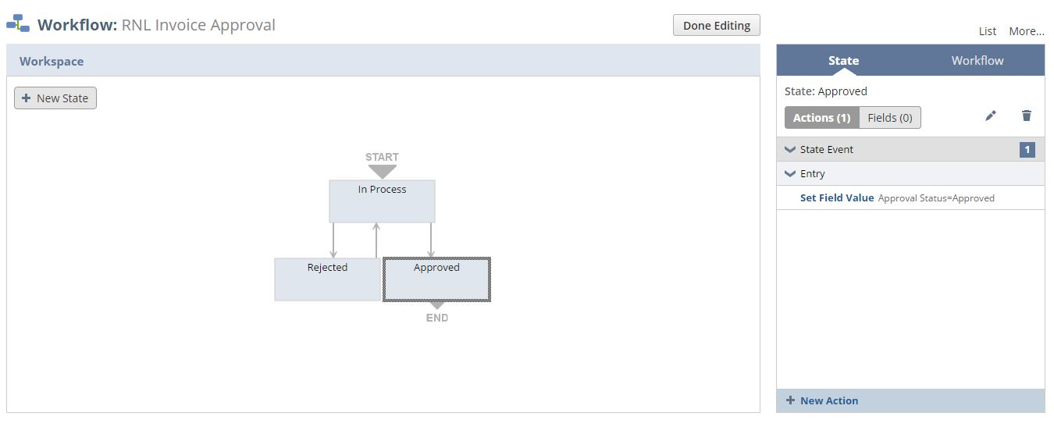

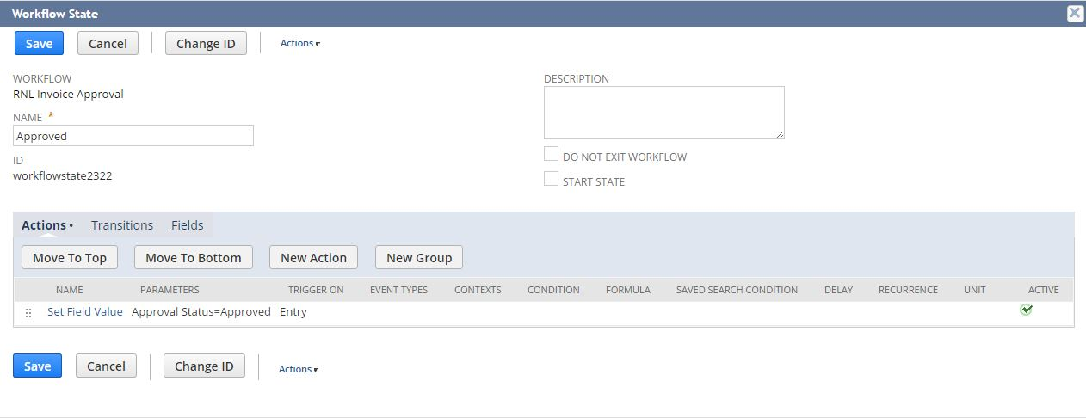

Below workflow condition needs to be changed for subsidiary addition\deletion, invoice addition\deletion and form addition\deletion.

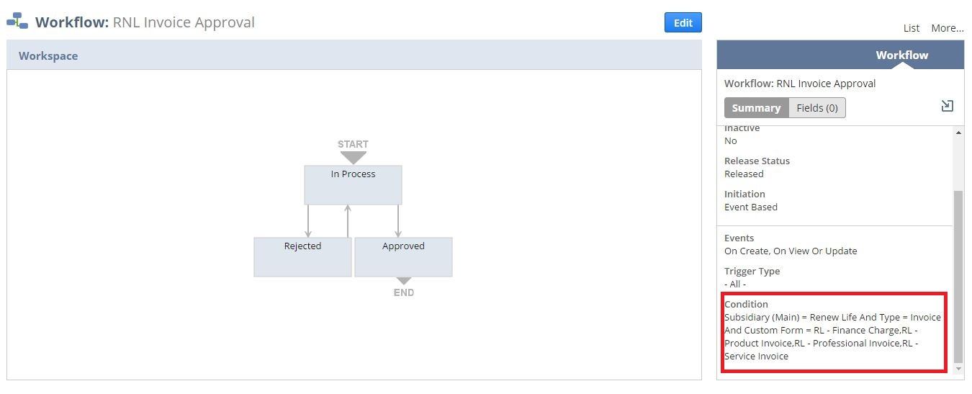

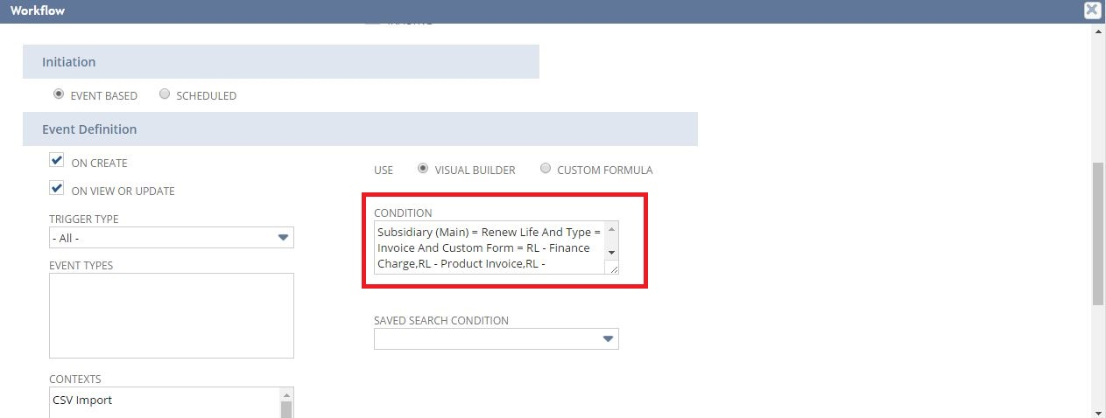

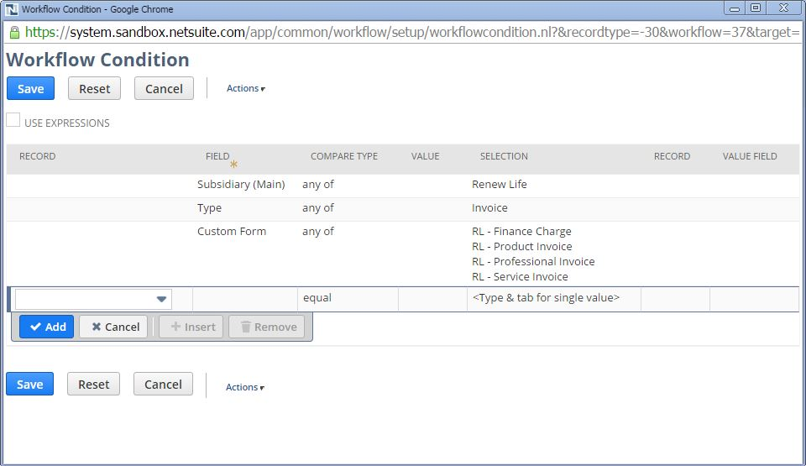

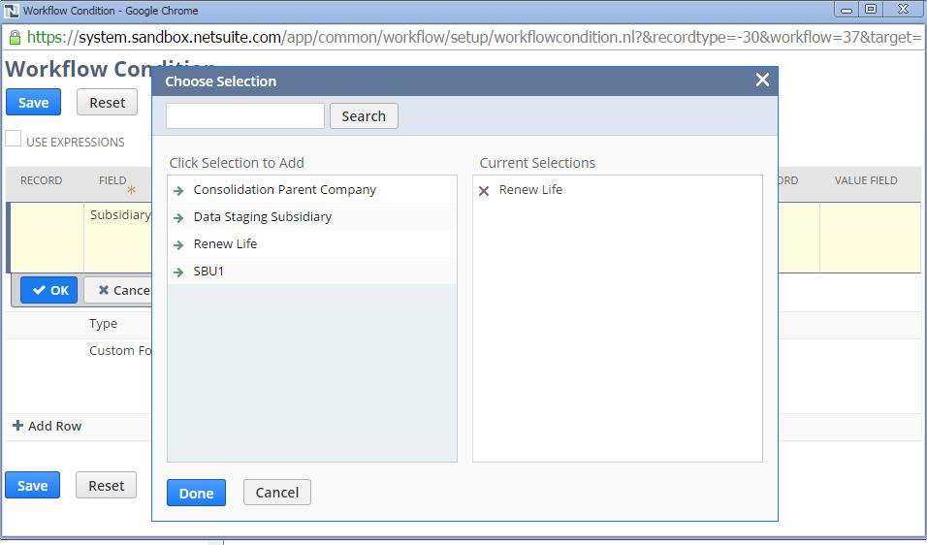

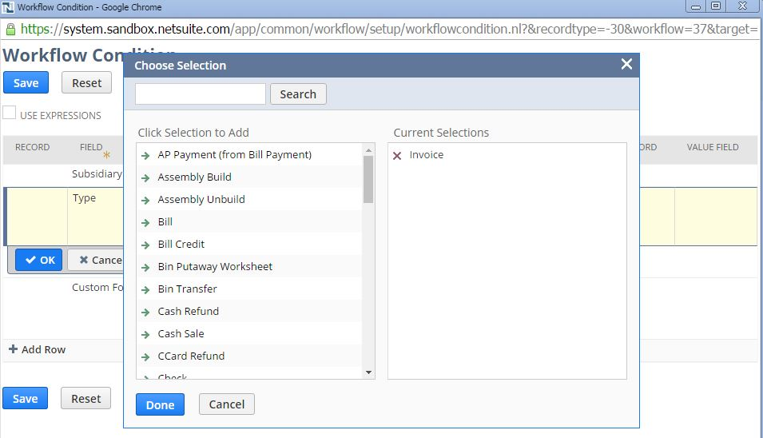

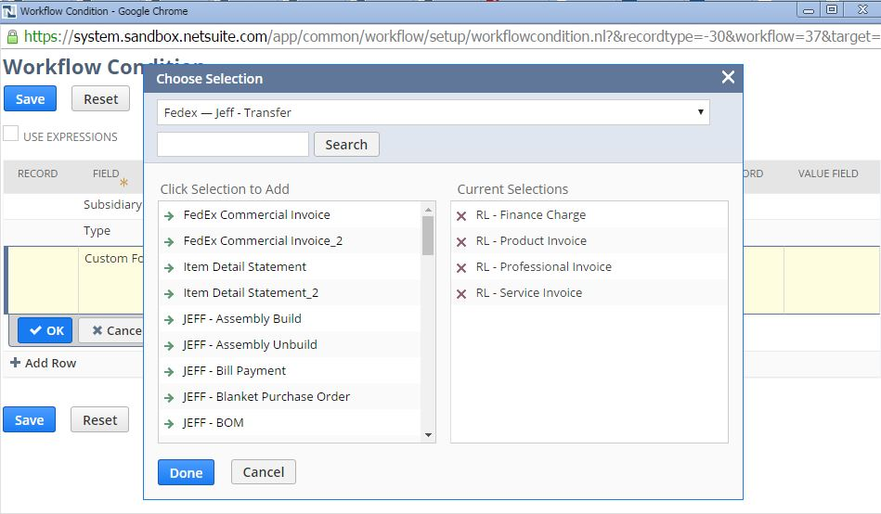

## Req-36: Report to generate Aging report for customer with sales representative

Requirement is to run a report with selection criteria to enable delination of AR line items detail by AR Detail broken out by aging buckets and sales rep.

### ACCEPTANCE CRITERIA

1. Report should display the aging report for customer with sales rep.

### USE CASES

1. Navigation Path for the Saved Search: Reports > Saved Reports > RNL A/R Aging Summary by Sales Rep

### JEFFERSON IMPACT

No impact

### FUNCTIONAL SOLUTION

There is no functional solution for this requirement.

### TECHNICAL SOLUTION

1. Saved Report to be created on Transactions record.  
   Details of the saved report are given below:

|  |  |  |  |  |  |
| --- | --- | --- | --- | --- | --- |
| **Record Type** | **Name** | **Description** | **Filters** | **Columns** | **Properties** |
| Transaction | RNL A/R Aging Summary by Sales Rep | This saved search will list all the Aging report for customer with sales rep. |  | * Customer * Transaction Number * Transaction Number * Open Balance * Sales Rep * Total | AR Detail broken out by aging buckets:  i) Current (O - 30 Days)  ii) 31 - 60 Days  iii) 61 - 90 Days  iv) 91 - 120 Days  v) >120 Days |

### CONFIGURATION

1. View the Saved Search Using the below Path

Reports -> Saved Reports -> RNL A/R Aging Summary by Sales Rep

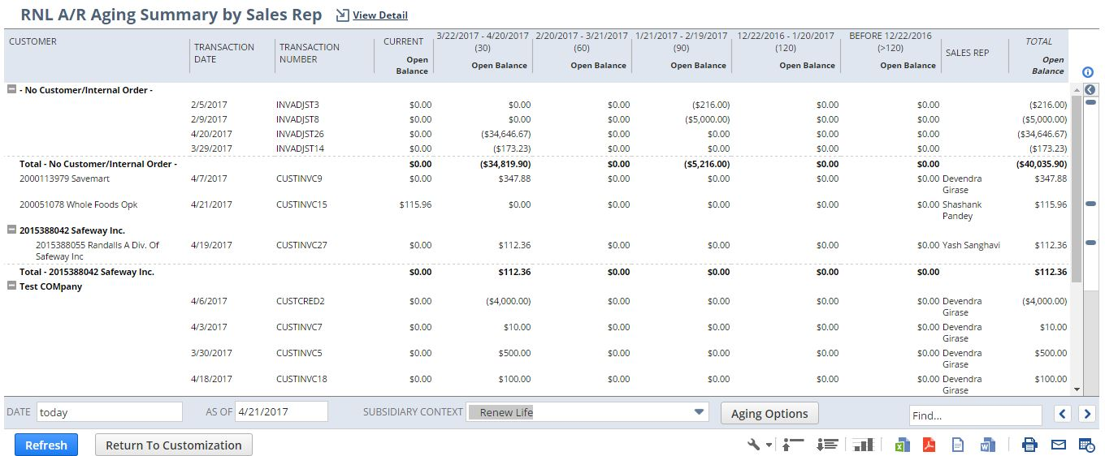

In order to export the report, Click on the export button (marked in red box) at the bottom right

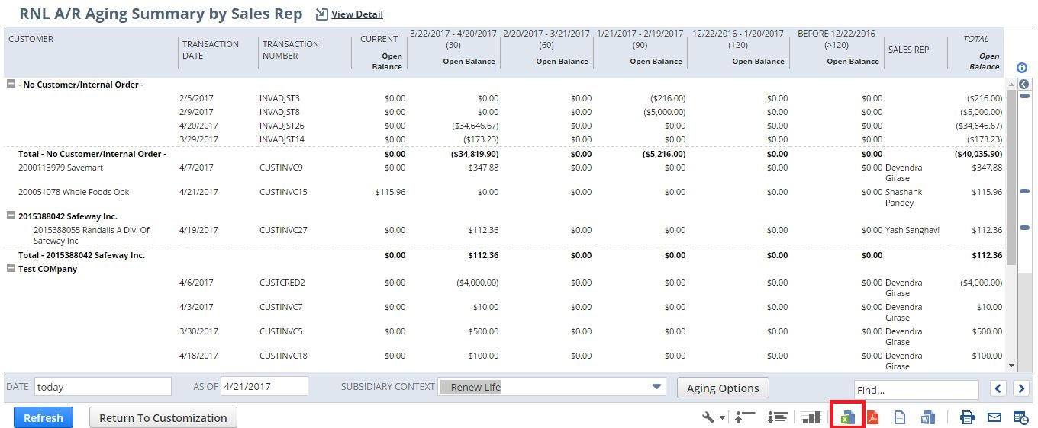

## Req-37: Create a new Customized SO Template

Requirement here is to create a new customized template printing SO.

### ACCEPTANCE CRITERIA

1. PDF has to be generated as per the new customized layout.

### USE CASES

1. To view the new SO, navigate to Transactions > Sales > Enter Sales Order >List >Print

2. To view the PDF template, navigate to Customization > Forms > Advanced PDF HTML template> RNL SO Template.

### JEFFERSON IMPACT

No impact

### FUNCTIONAL SOLUTION

There is no functional solution for this requirement.

### TECHNICAL SOLUTION

1 User Event Script needs to be created and deployed on SO.

|  |  |  |  |  |
| --- | --- | --- | --- | --- |
| **Name** | **Script Type** | **Script** | **Logic Overview** | **Properties** |
| UES_RNL_Invoice_calculation | User Event | This script will calculate the SO subtotal and percentage discounts on line item and order level. | * Script will check the line item and calculate the discount on line level as well as on order level. * Script will then store total discount and total amount in custom fields. | 1. The SO to be created.  2. A script configuration parameter shall be added which shall provide inputs to the script  Subsidiary internal id |

System Change Impacts for Script

|  |  |  |
| --- | --- | --- |
| **#** | **Impact** | **Analysis** |
| 1 | Impact of Adding new subsidiary | 1. Script configuration parameter subsidiary_internal_id shall accept multiple subsidiary id’s either seperated by “,” OR “|” symbols. So to add a new subsidiary, script configuration parameter shall be extended with new subsidiary id’s. Refer to section 1.38.6.4 for details |
| 2 | Impact of NetSuite Product upgrades | 1. No specific maintenance needed during NetSuite upgrades as Script uses stable API’s of NetSuite. 2. A preview testing shall be needed during upgrades, as advised by NetSuite for all custom developments |
| 3 | Post Go Live maintenance | 1. No specific post go live maintenance needed and should be manageable by support organization |

2. A Customized template to be created.

Details of PO template are given below:

|  |  |  |
| --- | --- | --- |
| **Record Type** | **Description** | **Columns** |
| Sales Order | A customized template to print the Sales order. | Quantity Ordered#  Quantity Shipped#  Item#  Description  Terms  Shipping method  Type  Price |

1. Eight custom fields will be created.

Details of the custom field are given in the table below:

|  |  |  |  |  |
| --- | --- | --- | --- | --- |
| **Record Type** | **Field** | **Description** | **Type** | **Properties** |
| Sales Order | Non-taxable  Subtotal | This field will be used for storing the total amount of the SO | Currency | 1.Display=Hidden  3.Mandatory=No  4.It is used to store the total amount of the SO |
| Sales Order | Total Discount | This field will be used for storing the total discount of the invoice. | Currency | 1.Display=Hidden  3.Mandatory=No  4. It is used to store the total discount of the SO. |
| Sales Order | Customer ID | This field will be used to get the customer number. | Free-Form Text | 1.Display=Hidden  3.Mandatory=No  4. It is used to fetch the customer number. |
| Sales Order | %OFF | This field will be used for storing the percentage discount on an item in the invoice. | Free-form  Text | 1.Display=Disabled  3.Mandatory=No  4. It is used to store percentage discount on an item. |
| Sales Order | Discount Price | This field will be used for storing the price after discount of a particular item. | Currency | 1.Display=Disabled  3.Mandatory=No  4. It is used to store price after discount of a particular item. |
| Sales Order | Total Price | This field will be used for storing the total price of a particular item. | Currency | 1.Display=Disabled  3.Mandatory=No  4. It is used to store the total price of the item. |
| Sales Order | Item Type | This field is used to check the item type | List/Record | 1.Display=Normal  3.Mandatory=No  4. It is used to source the value of item type. |
| Sales Order | Suggested Retail Price | This field is used to source value of suggested retail price from sales order | Currency | 1.Display=Disabled  3.Mandatory=No  4. It is used to source the value of suggested retail price. |

### CONFIGURATION

* + - 1. Go to Customization > Forms > Advanced PDF HTML template.

Click **Customize** next to the layout you want to customize.

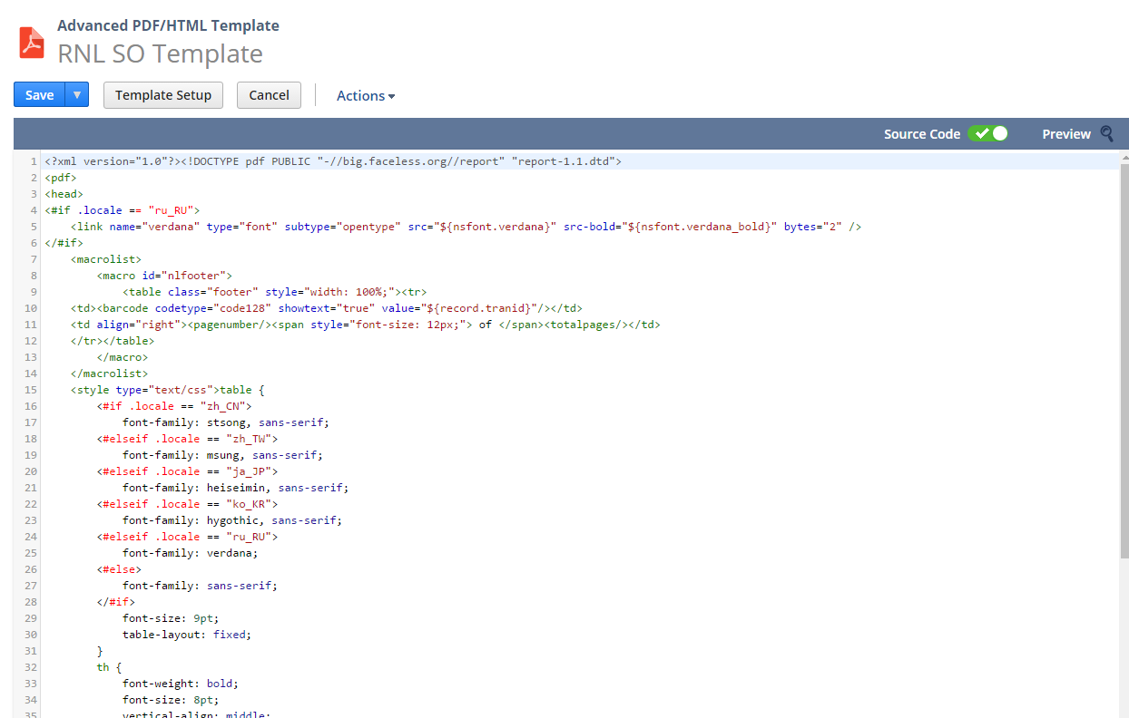



1.37.6.2 Custom Scripts

To Create Script follow the path: Customization->Scripting->Scripts->New



Upload the Script file and click on Create Script Record Button and then choose User Event Script.

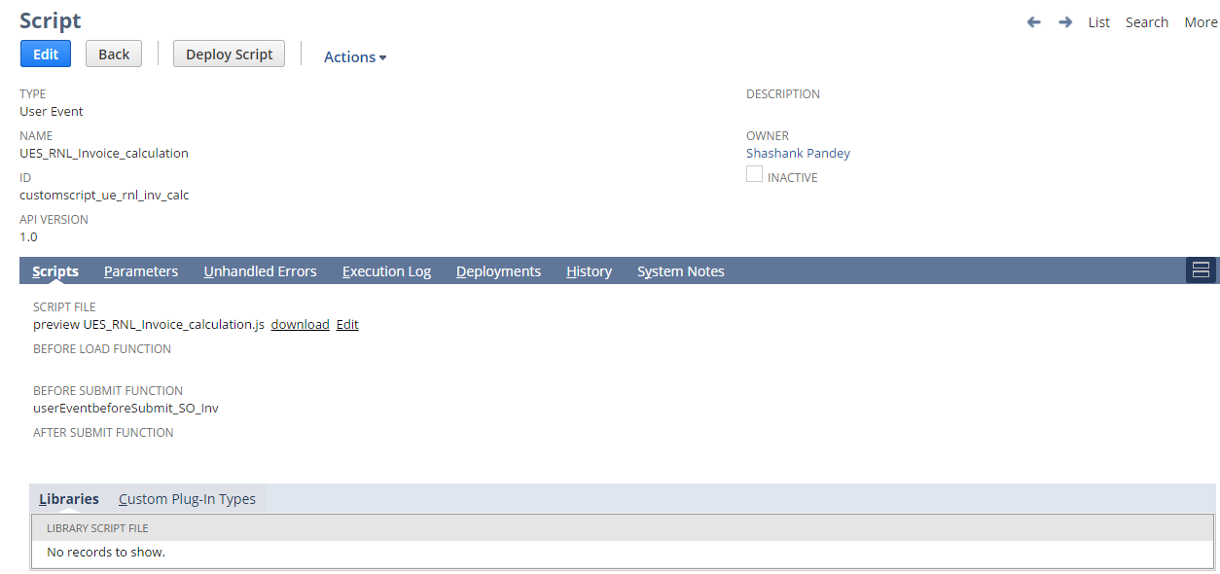

To view Script Deployment follow the path: Customization->Scripting->Scripts Deployment

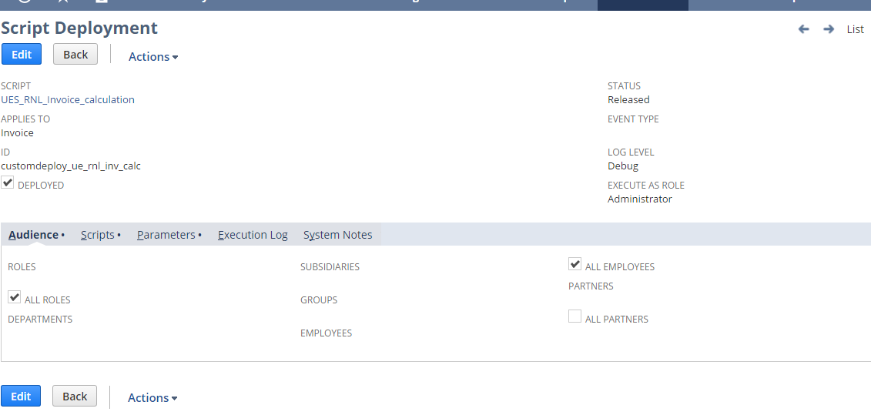

1.37.6.3 Custom fields

Go to Customization -> Lists, Records & Fields ->Transaction Body Fields -> New

Non-Taxable Subtotal:  
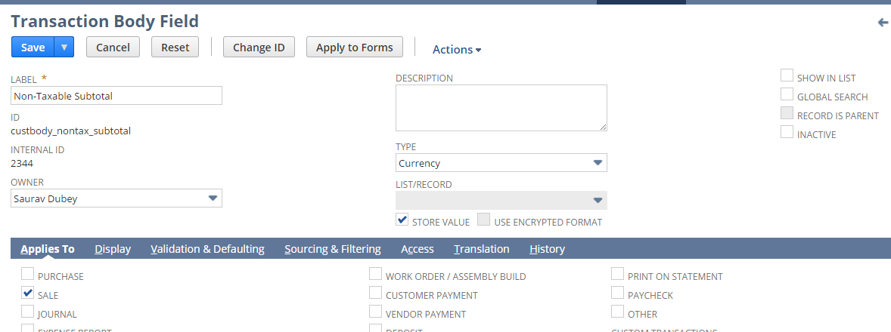

Total Discount

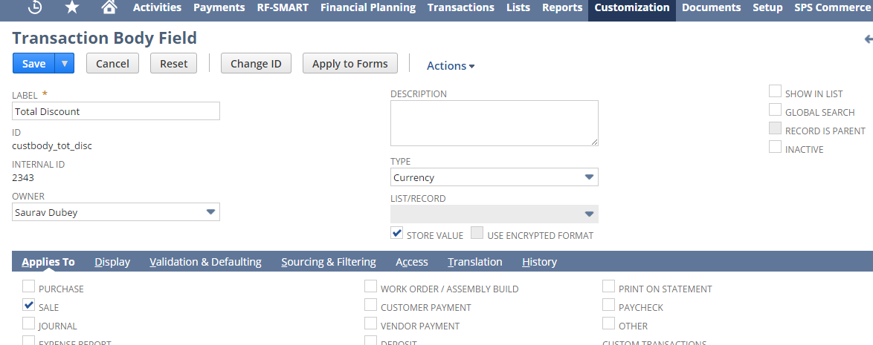

Customer ID

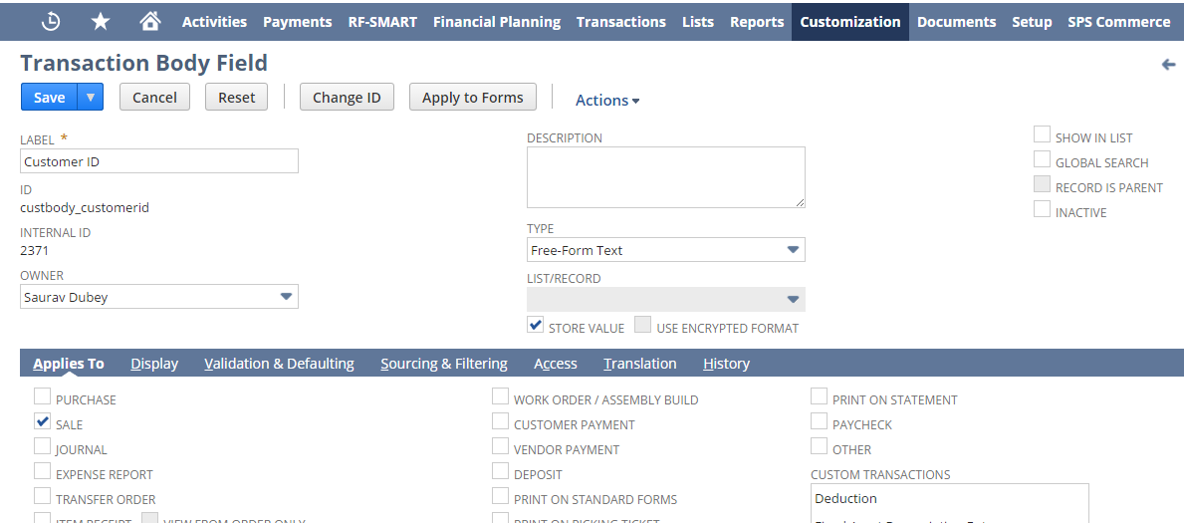

Go to Customization -> Lists, Records & Fields ->Transaction Column Fields -> New

%OFF

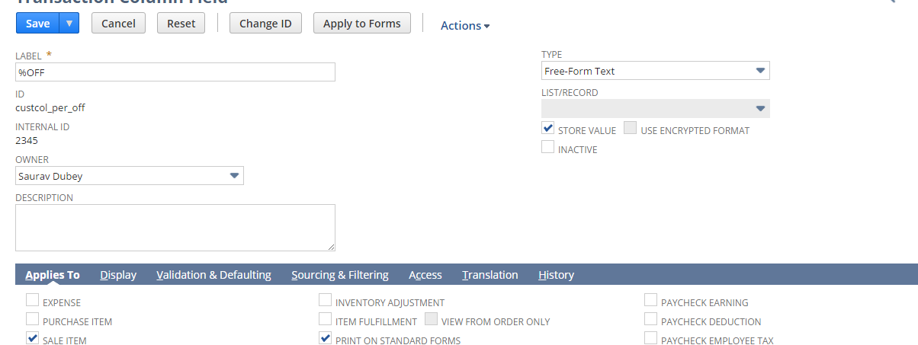

Discount Price

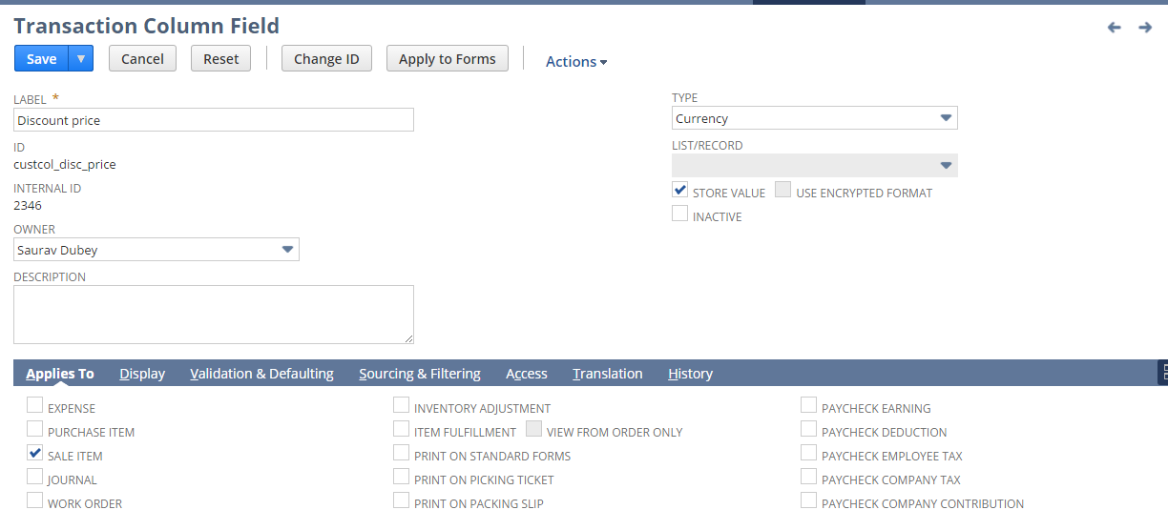

Total Price

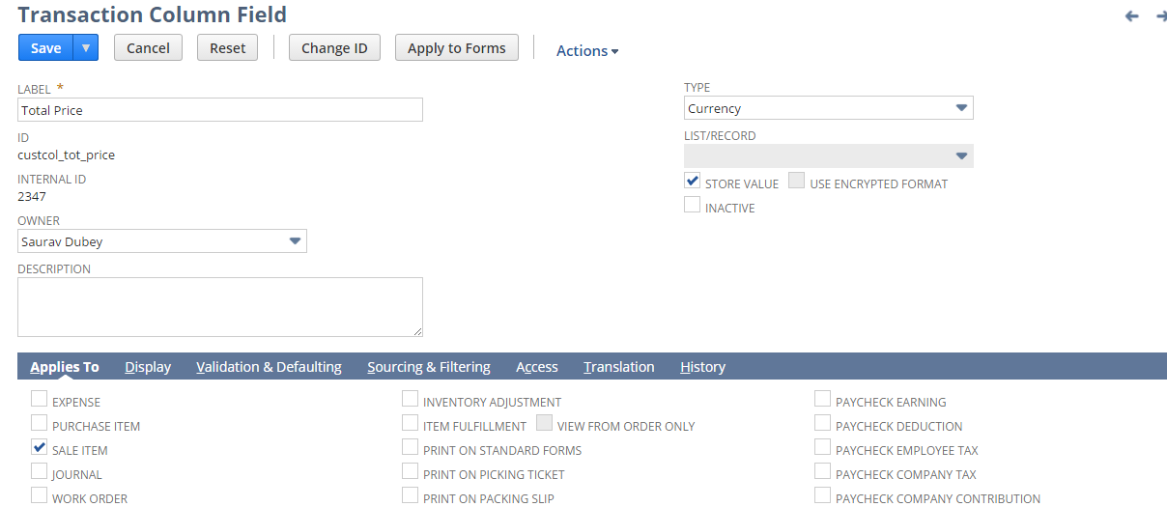

Item Type

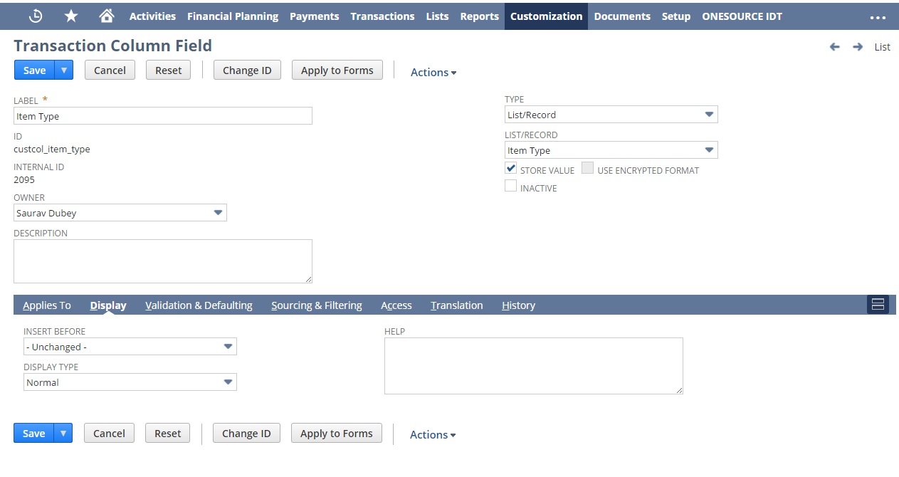

Suggested Retail Price

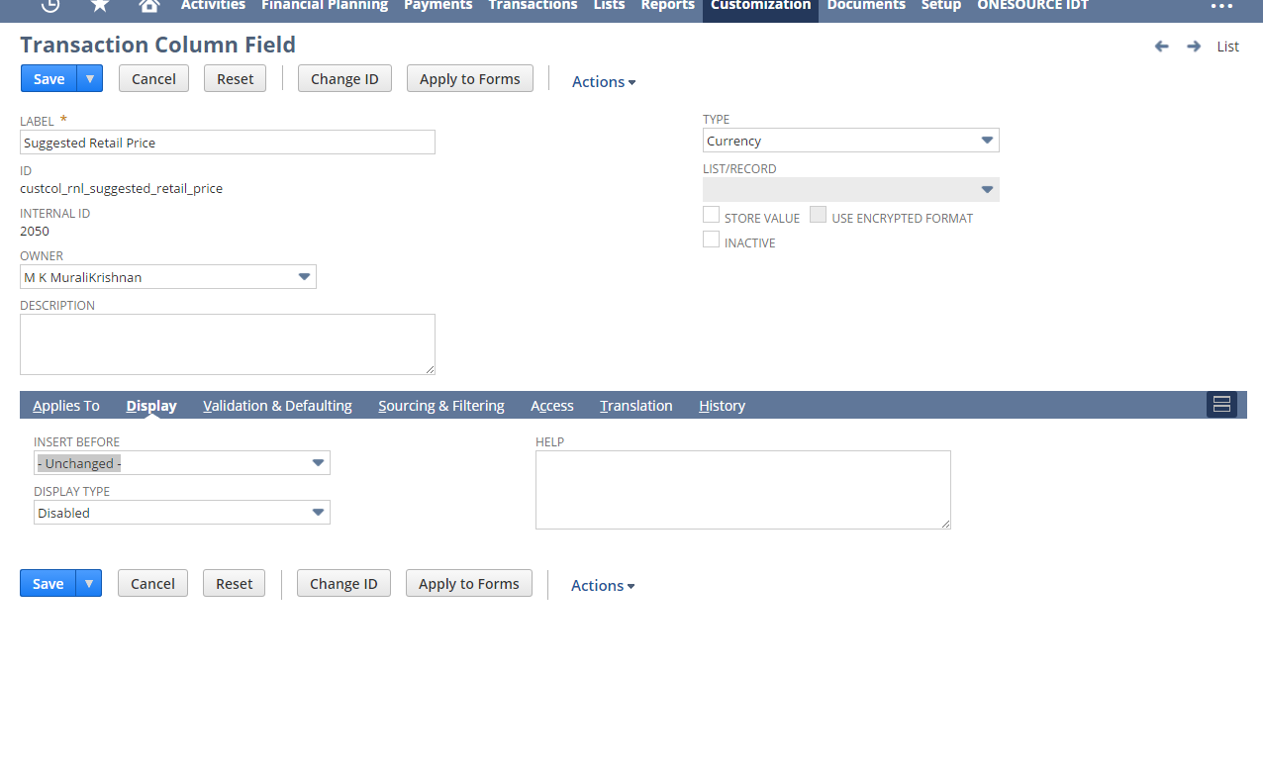

* + - 1. Updating Custom scripts for new Subsidiary additions\ deletion

Below script parameters needs to be updated either with “,” or “|” symbol for any new subsidiary

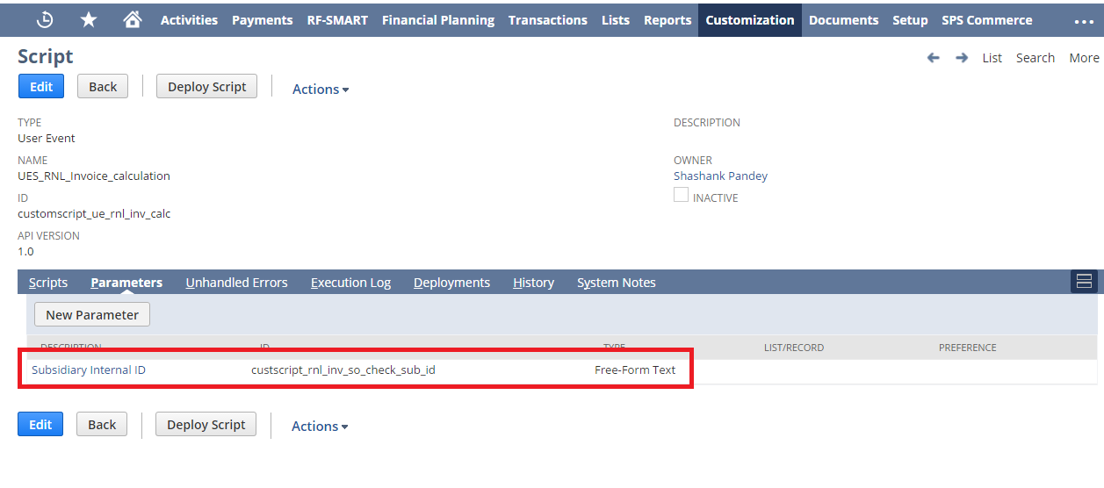

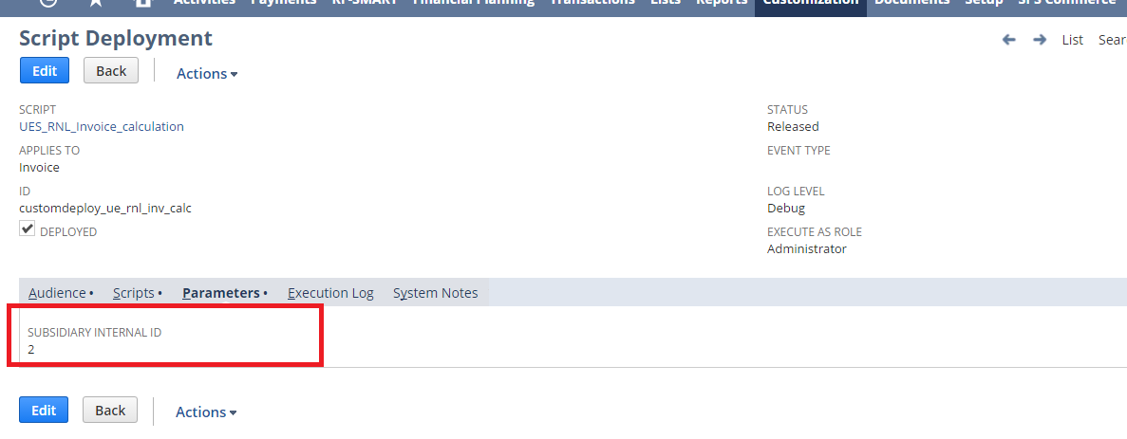

## Req-38: Customized Invoice Template

Requirement here is to create a new customized template printing Invoice.

### ACCEPTANCE CRITERIA

1. PDF has to be generated as per the new customized layout.

### USE CASES

1. To view the new Invoice, navigate to Transactions > Sales > Create Invoices >List >Print

2. To view the PDF template, navigate to Customization > Forms > Advanced PDF HTML template > RNL Invoice Template

### JEFFERSON IMPACT

No impact

### FUNCTIONAL SOLUTION

There is no functional solution for this requirement.

### TECHNICAL SOLUTION

1 User Event Script needs to be created and deployed on Invoice.

|  |  |  |  |  |
| --- | --- | --- | --- | --- |
| **Name** | **Script Type** | **Script** | **Logic Overview** | **Properties** |
| UES_RNL_Invoice_calculation | User Event | This script will calculate the Invoice subtotal and percentage discounts. | * Script will check the line item and calculate the discount on line level as well as on order level. * Script will then store total discount and total amount in custom fields. | 1. The Invoice should be created from  Sales Order  2. A script configuration parameter shall be added which shall provide inputs to the script  Subsidiary internal id |
| RNL Quantity Shipped UE | User Event | The script will calculate the total quantity shipped for the given invoice and display it at line item level on Invoice record | * Check if the logged in user subsidiary is “RL sub”, if not throw and error message and exit * Script will fetch the value of Quantity Fulfilled from the related Sales Order and will be displayed under Quantity shipped field on line items | 1. The Invoice should be created from  Sales Order  2. A script configuration parameter shall be added which shall provide inputs to the script   * Subsidiary internal id |

System Change Impacts for Script

|  |  |  |
| --- | --- | --- |
| **#** | **Impact** | **Analysis** |
| 1 | Impact of Adding new subsidiary | 1. Script configuration parameter subsidiary_internal_id shall accept multiple subsidiary id’s either seperated by “,” OR “|” symbols. So to add a new subsidiary, script configuration parameter shall be extended with new subsidiary id’s. Refer to section 1.38.6.4 for details |
| 2 | Impact of NetSuite Product upgrades | 1. No specific maintenance needed during NetSuite upgrades as Script uses stable API’s of NetSuite. 2. A preview testing shall be needed during upgrades, as advised by NetSuite for all custom developments |
| 3 | Post Go Live maintenance | 1. No specific post go live maintenance needed and should be manageable by support organization |

2. A Customized template to be created.

Details of Customized template are given below:

|  |  |  |
| --- | --- | --- |
| **Record Type** | **Description** | **Columns** |
| Invoice | A customized template to print the Invoice. | Quantity Ordered#  Quantity Shipped#  UPC  Item#  Description  Terms  Shipping method  Type  Price |

3. Ten custom fields will be created.

Details of the custom field are given in the table below:

|  |  |  |  |  |
| --- | --- | --- | --- | --- |
| **Record Type** | **Field** | **Description** | **Type** | **Properties** |
| Invoice | Quantity Shipped | This field will be used for storing the total quantity shipped for the respective item available on Invoice | Integer Number | 1.Only Integer Number data to be entered  2. It will be displayed on Items Subtab at Item Line Level besides Quantity field.  3.Mandatory=No  4.It is used to store the total quantity shipped on Invoice |
| Invoice | Non-taxable  Subtotal | This field will be used for storing the total amount of the invoice | Currency | 1.Display=Hidden  3.Mandatory=No  4.It is used to store the total amount of the Invoice |
| Invoice | Total Discount | This field will be used for storing the total discount of the invoice. | Currency | 1.Display=Hidden  3.Mandatory=No  4. It is used to store the total discount of the Invoice. |
| Invoice | Customer ID | This field will be used to get the customer number. | Free-Form Text | 1.Display=Hidden  3.Mandatory=No  4. It is used to fetch the customer number. |
| Invoice | SO Date | This field will be used to get the Sales order date from the invoice. | Date | 1.Display=Hidden  3.Mandatory=No  4. It is used to fetch the SO date to the invoice. |
| Invoice | Payment Applied | This field will be used to calculate payments applied on the invoice. | Currency | 1.Display=Hidden  3.Mandatory=No  4. It is used to calculate the payment applied. |
| Invoice | %OFF | This field will be used for storing the percentage discount on an item in the invoice. | Free-form  Text | 1.Display=Disabled  3.Mandatory=No  4. It is used to store percentage discount on an item. |
| Invoice | Discount Price | This field will be used for storing the price after discount of a particular item. | Currency | 1.Display=Disabled  3.Mandatory=No  4. It is used to store price after discount of a particular item. |
| Invoice | Total Price | This field will be used for storing the total price of a particular item. | Currency | 1.Display=Disabled  3.Mandatory=No  4. It is used to store the total price of the item. |
| Invoice | Item Type | This field is used to check the item type | List/Record | 1.Display=Normal  3.Mandatory=No  4. It is used to source the value of item type. |

### CONFIGURATION

1.38.6.1 Custom Templates  
 Go to Customization > Forms > Advanced PDF HTML template  
 Click **Customize** next to the layout you want to customize.

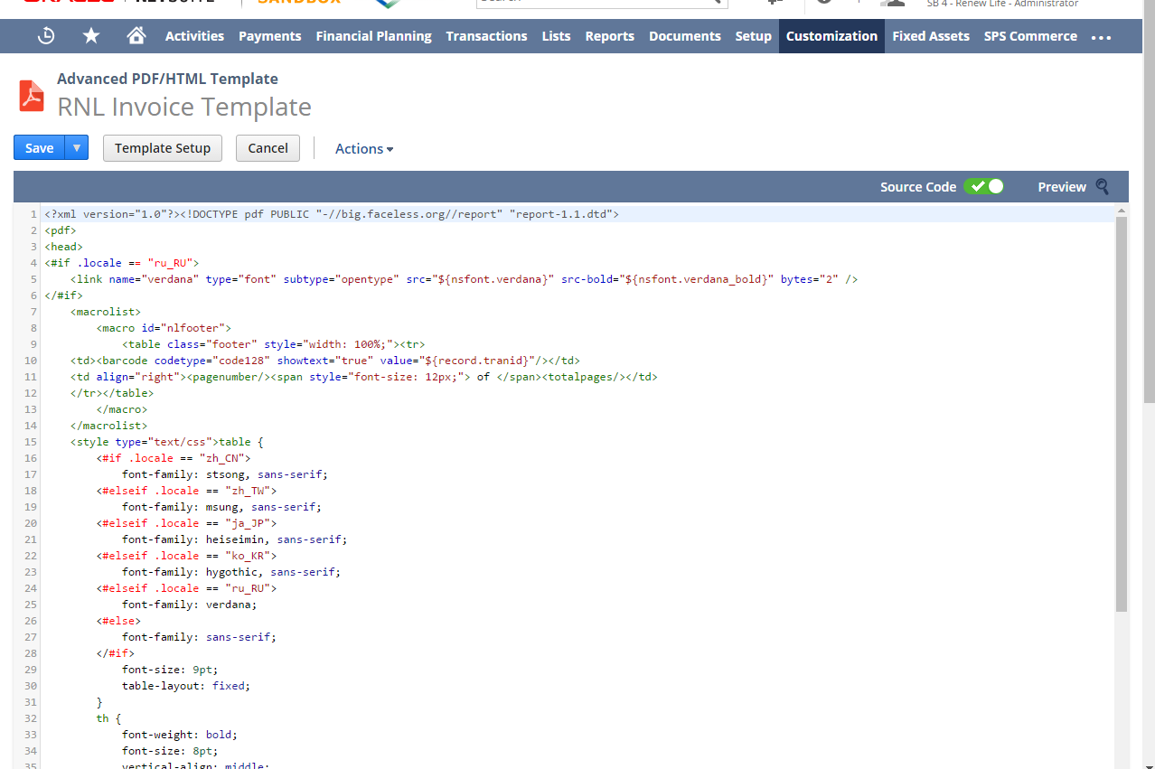



1.38.6.2 Custom Scripts

1.38.6.2.1 To Create Script follow the path: Customization->Scripting->Scripts->New



Upload the Script file and click on Create Script Record Button and then choose Suitelet Script.

To view Script Deployment follow the path: Customization->Scripting->Scripts Deployment  
  
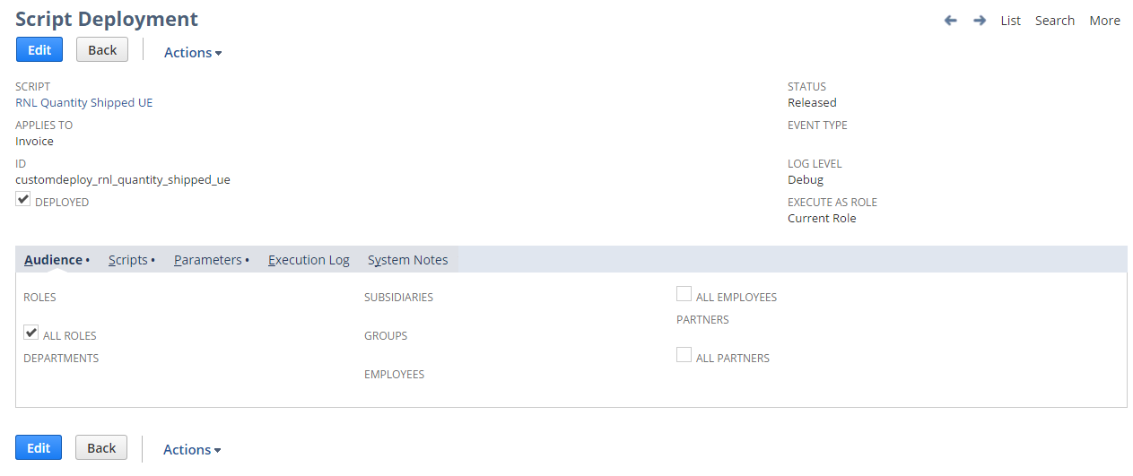

1.38.6.2.2

To Create Script follow the path: Customization->Scripting->Scripts->New



Upload the Script file and click on Create Script Record Button and then choose User Event Script.

To view Script Deployment follow the path: Customization->Scripting->Scripts Deployment



1.38.6.3 Custom fields  
Go to Customization -> Lists, Records & Fields ->Transaction Column Fields -> New  
Apply to RL- Commercial Invoice, RL – Cash Sale and RL – Product Invoice.

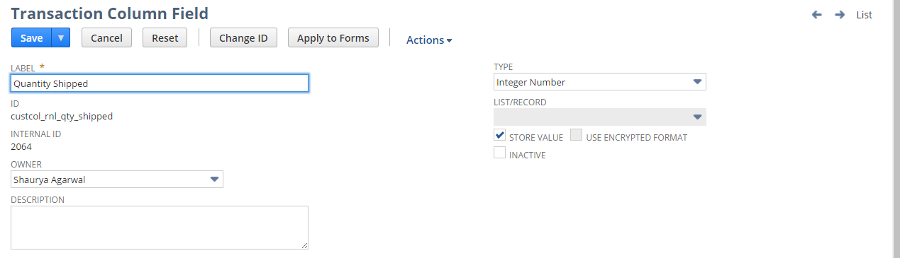

%OFF



Discount Price



Total Price



Item Type



Go to Customization -> Lists, Records & Fields ->Transaction Body Fields -> New

Non-Taxable Subtotal:  


Total Discount



SO Date

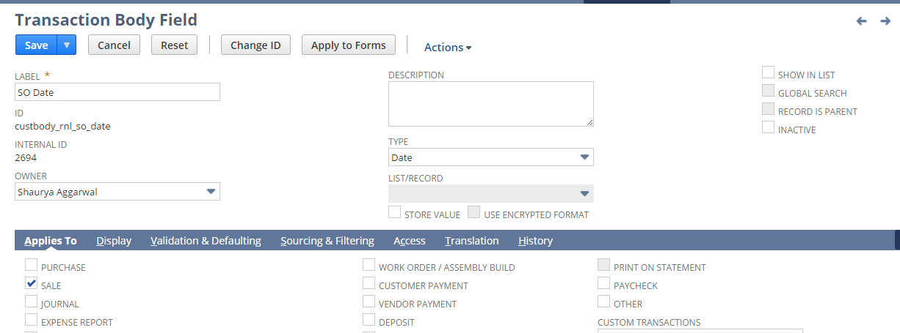

Payment Applied

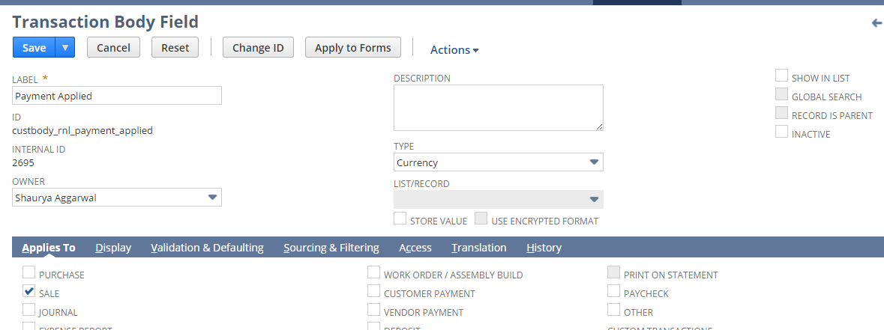

Customer ID



1.38.6.4 Updating Custom scripts for new Subsidiary additions\ deletion

Below script parameters needs to be updated either with “,” or “|” symbol for any new subsidiary





## Req-39: Capability to have further attributes on Item Record for price List

According to business needs, some additional attributes were needed to be defined on Item record. Some of the attributes given will be created.

### ACCEPTANCE CRITERIA

1. Values for the attribute fields need to be entered by the users.
2. Additional attributes will be defined as required.

### USE CASES

* 1. User will set up values for Depth, Volume, Width, Height and Weight for pallets eaches, inners and pallets respectively.
  2. SRP will be a currency field entered by the user.
  3. Tie, High, Size ,FDM Product# to be entered by user

### JEFFERSON IMPACT

Yes, Existing fields Length, Volume, Width and Height will be renamed to Depth(Eaches),Volume(Eaches), Width(Eaches) and Height(Eaches) respectively

### FUNCTIONAL SOLUTION

1. There is no functional solution for this requirement.

### TECHNICAL SOLUTION

* + 1. 19 custom fields will be created.

Details of the custom field are given in the table below:

|  |  |  |  |  |
| --- | --- | --- | --- | --- |
| **Record Type** | **Field** | **Description** | **Type** | **Properties** |
| Item | Depth(Cases) | This field will be used for volume calculation, recorded for supply chain and shipment delivery documentation. | Decimal Number | 1.Only Decimal Number data to be entered  2.It will be displayed on Header tab under Classification field group  3.Mandatory=No  4.It is used to store length of the Item |
| Item | Width(Cases) | Used for volume calculation and recording for supply chain and shipment delivery documentation | Decimal Number | 1.Only Decimal Number data to be entered  2.It will be displayed on Header tab under Classification field group  3.Mandatory=No  4.It is used to store width of the Item |
| Item | Height(Cases) | Used for volume calculation and recording for supply chain and shipment delivery documentation. | Decimal Number | 1.Only Decimal Number data to be entered  2.It will be displayed on Header tab under Classification field group  3.Mandatory=No  4.It is used to store Height of the Item |
| Item | Volume(Cases) | This field will be used for volume calculation, recorded for supply chain and shipment delivery documentation. | Decimal Number | 1.Only Decimal Number data to be entered  2.It will be displayed on Header tab under Classification field group  3.Mandatory=No  4.It is used to store Volume of the Item |
| Item | Weight(Cases) | Used for recording Weight for supply chain and shipment delivery documentation. | Decimal Number | 1.Only Decimal Number data to be entered  2.It will be displayed on Header tab under Classification field group  3.Mandatory=No  4.It is used to store weight of the Item |
| Item | Depth(Inners) | This field will be used for volume calculation, recorded for supply chain and shipment delivery documentation | Decimal Number | 1.Only Decimal Number data to be entered  2.It will be displayed on Header tab under Classification field group  3.Mandatory=No  4.It is used to store length of the Item |
| Item | Width(Inners) | Used for volume calculation and recording for supply chain and shipment delivery documentation | Decimal Number | 1.Only Decimal Number data to be entered  2.It will be displayed on Header tab under Classification field group  3.Mandatory=No  4.It is used to store width of the Item |
| Item | Height(Inners) | Used for volume calculation and recording for supply chain and shipment delivery documentation. | Decimal Number | 1.Only Decimal Number data to be entered  2.It will be displayed on Header tab under Classification field group  3.Mandatory=No  4.It is used to store Height of the Item |
| Item | Volume(Inners) | This field will be used for volume calculation, recorded for supply chain and shipment delivery documentation. | Decimal Number | 1.Only Decimal Number data to be entered  2.It will be displayed on Header tab under Classification field group  3.Mandatory=No  4.It is used to store volume of the Item |
| Item | Weight(Inners) | Used for recording Weight for supply chain and shipment delivery documentation. | Decimal Number | 1.Only Decimal Number data to be entered  2.It will be displayed on Header tab under Classification field group  3.Mandatory=No0  4.It is used to store weight of the Item |
| Item | Weight(Pallets) | Used for recording Weight for supply chain and shipment delivery documentation. | Decimal Number | 1.Only Decimal Number data to be entered  2.It will be displayed on Header tab under Classification field group  3.Mandatory=No  4.It is used to store Weight of the Item |
| Item | Volume(Pallets) | This field will be used for volume calculation, recorded for supply chain and shipment delivery documentation. | Decimal Number | 1.Only Decimal Number data to be entered  2.It will be displayed on Header tab under Classification field group  3.Mandatory=No  4.It is used to store volume of the Item |
| Item | Weight(Eaches) | Used for recording Weight for supply chain and shipment delivery documentation. | Decimal Number | 1.Only Decimal Number data to be entered  2.It will be displayed on Header tab under Classification field group  3.Mandatory=No  4.It is used to store Weight of the Item |
| Item | Pallet Height | Used for volume calculation and recording for supply chain and shipment delivery documentation. | Decimal Number | 1.Only Decimal Number data to be entered  2.It will be displayed on Header tab under Classification field group  3.Mandatory=No  4.It is used to store Height of the Item |
| Item | FDM Product# | This field will be used for supply chain and shipment delivery documentation. | Free Form Text | 1.It will be displayed on Header tab under Classification field group  2.Mandatory=No |
| Item | Size | This field will be used for supply chain and shipment delivery documentation. | Free Form Text | 1.It will be displayed on Header tab under Classification field group  2.Mandatory=No  3. It is used to store size. |
| Item | Tie | This field will be used for supply chain and shipment delivery documentation. | Decimal Number | 1.Only Decimal Number data to be entered  2.It will be displayed on Header tab under Classification field group  3.Mandatory=No |
| Item | High | This field will be used for supply chain and shipment delivery documentation. | Decimal Number | 1.Only Decimal Number data to be entered  2.It will be displayed on Header tab under Classification field group  3.Mandatory=No |

### CONFIGURATION

* + - 1. To Create a Custom Item Field follow the path mentioned below:

Customization-> Lists, Records, & Fields ->Item Fields-> New

Depth (Cases):

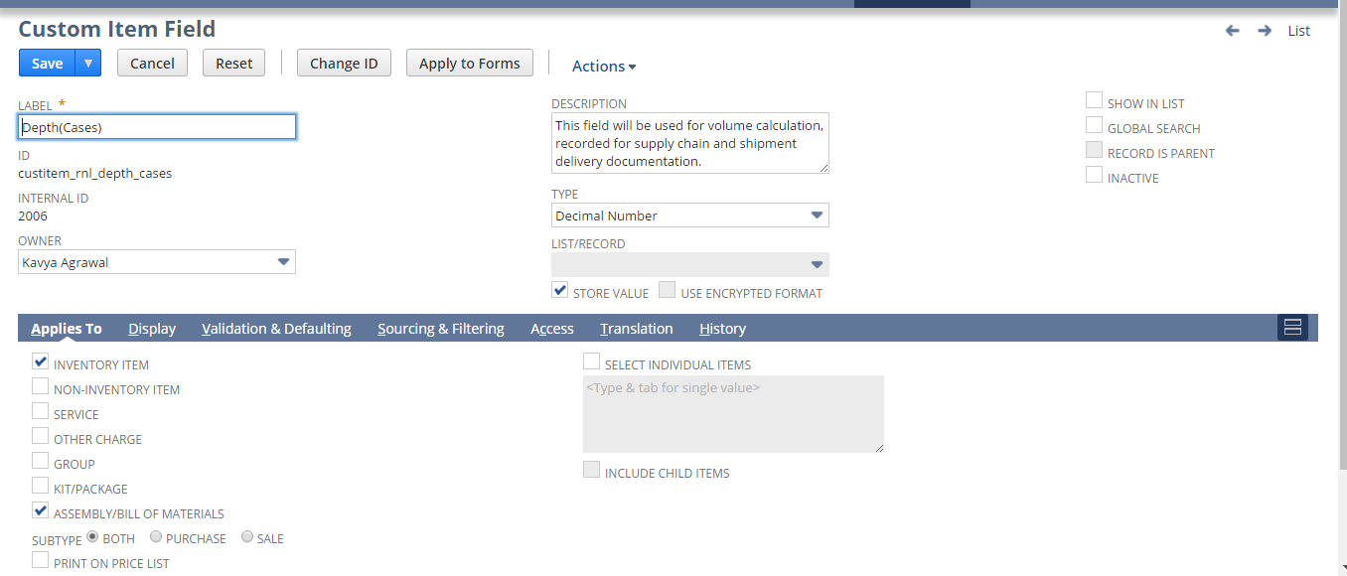

Width(Cases):

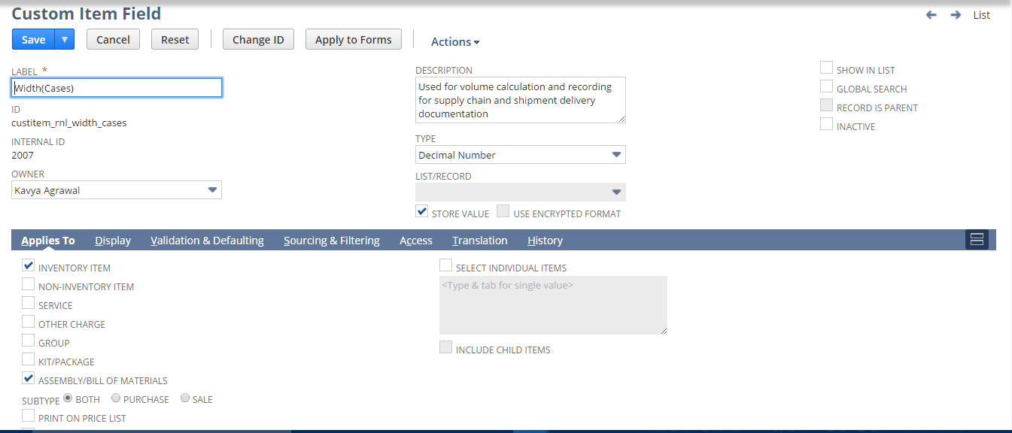

Height(Cases):

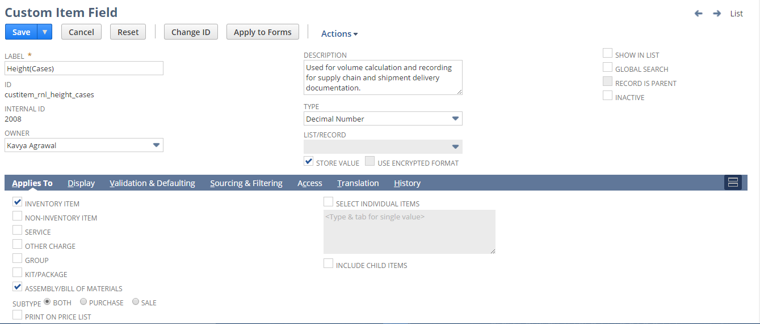

Volume(Cases):

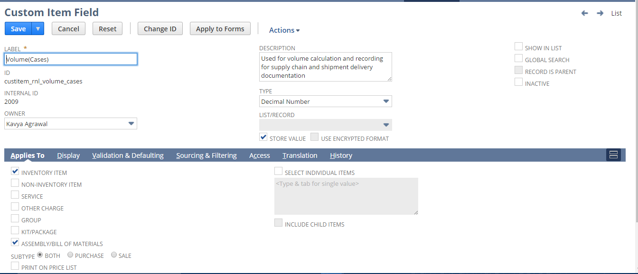

Weight(Cases):

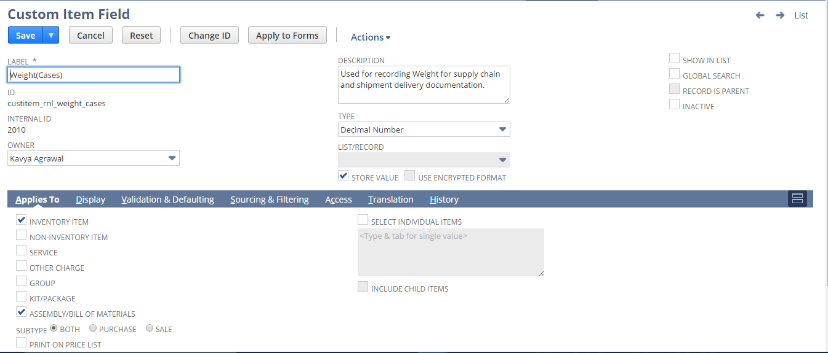

Depth(Inners):

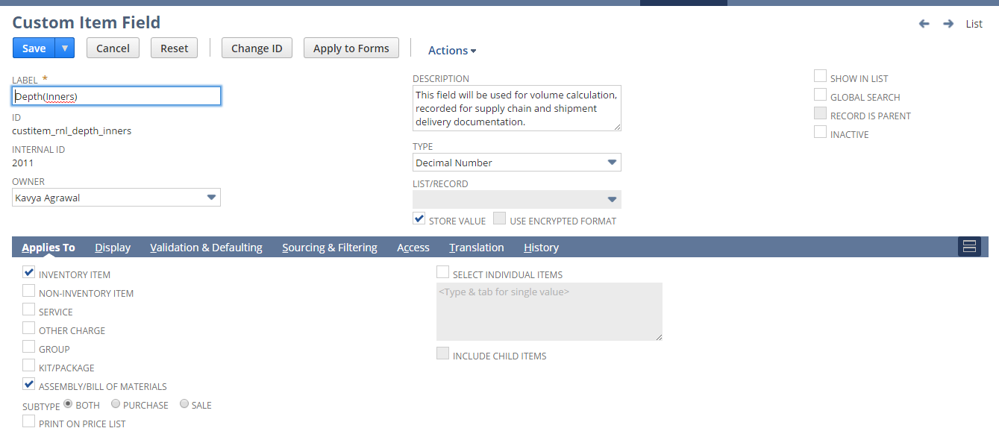

Width(Inners):

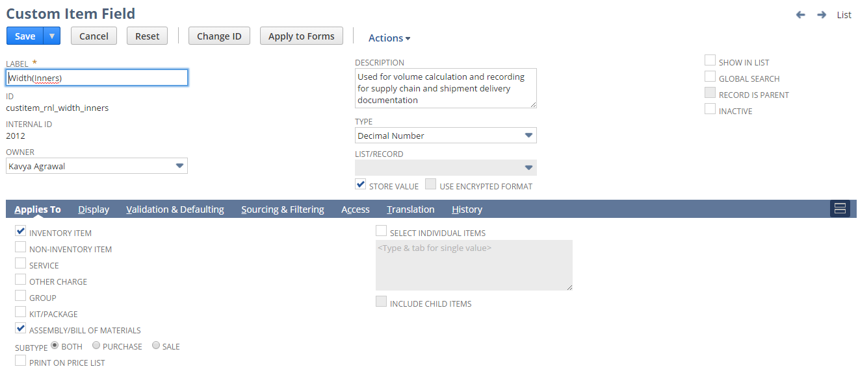

Height(Inners):

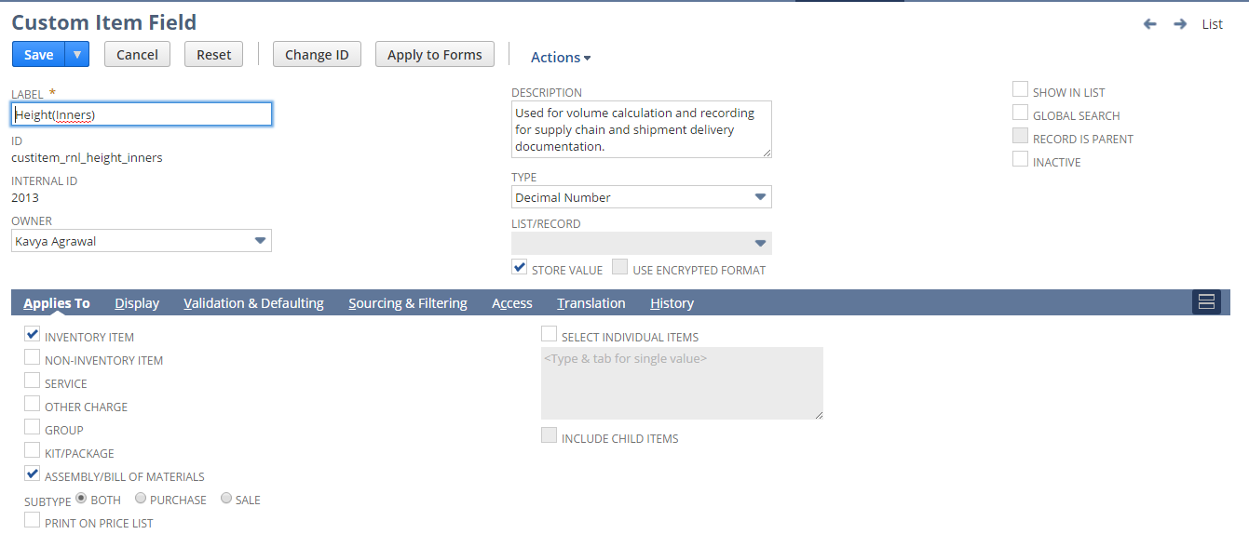

Volume(Inners):

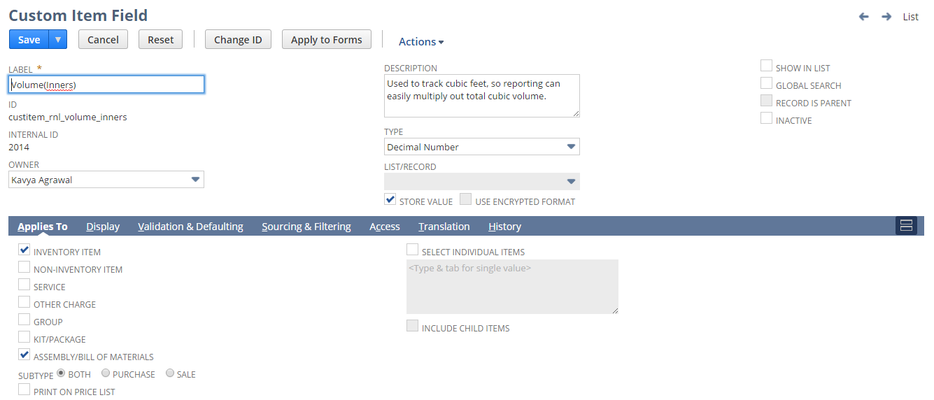

Weight(Inners):

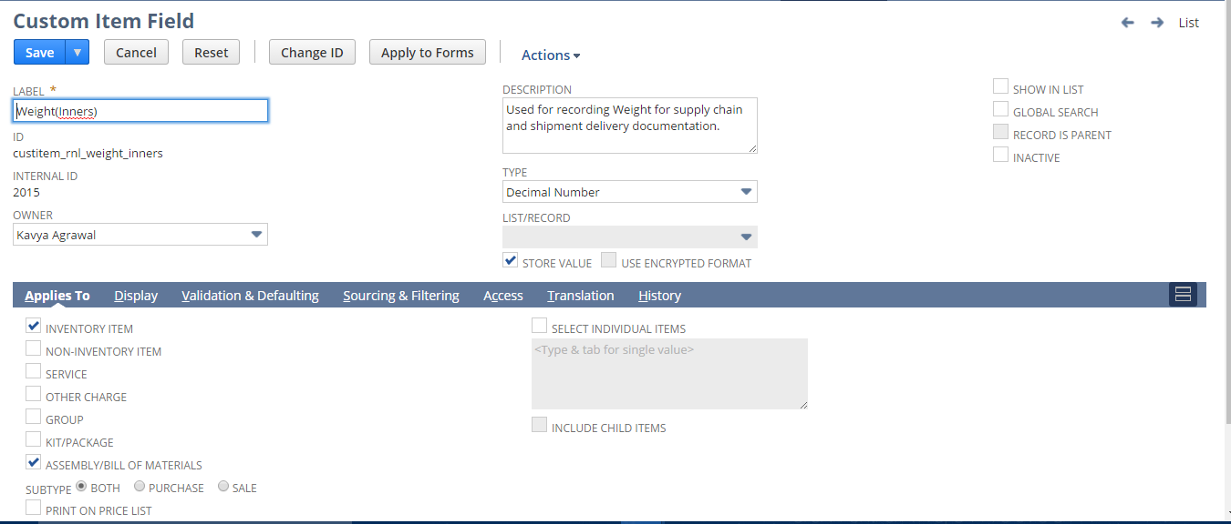

Weight(Pallets):

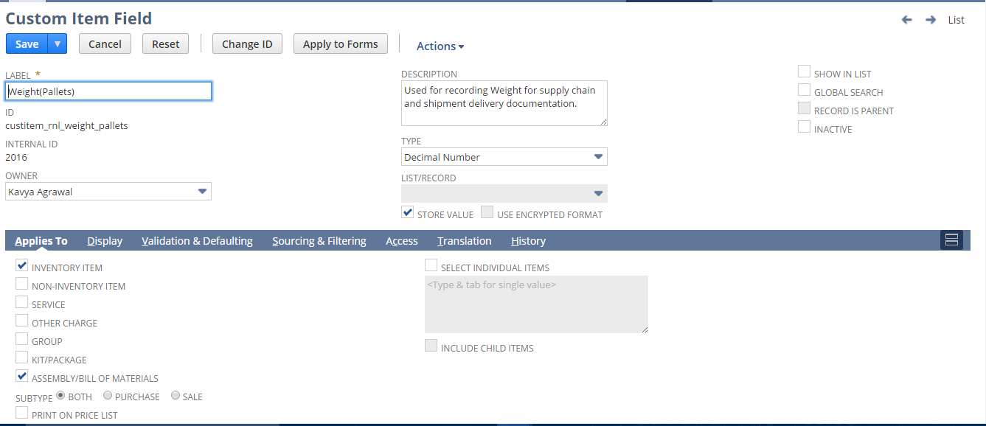

Volume(Pallets):

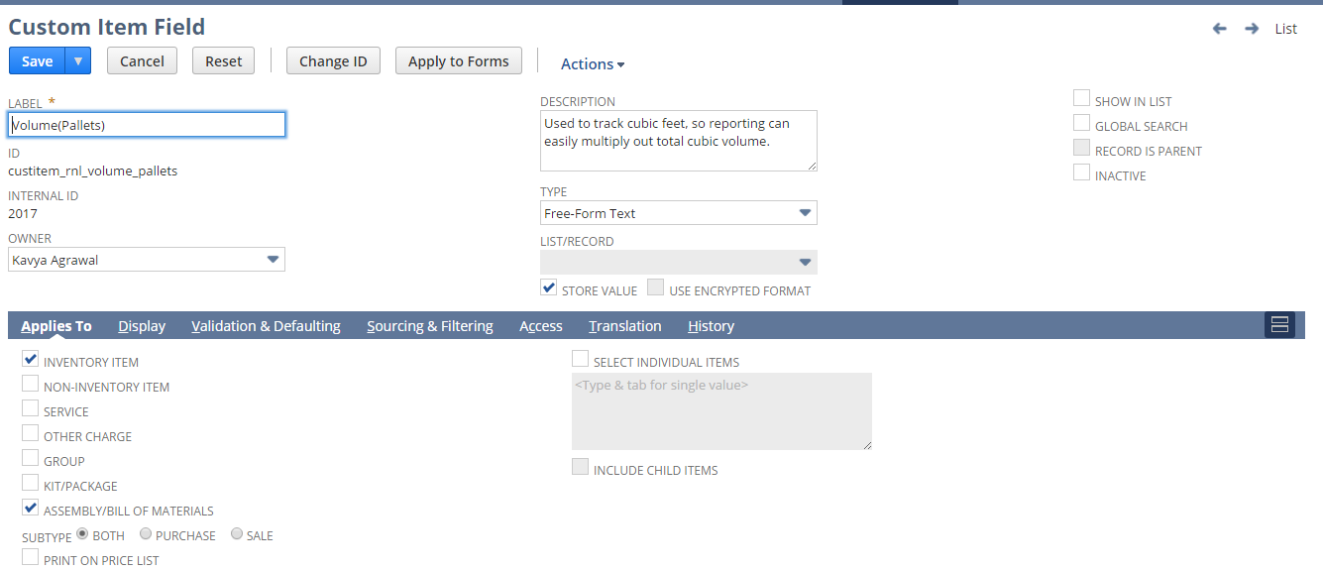

Pallet Height:

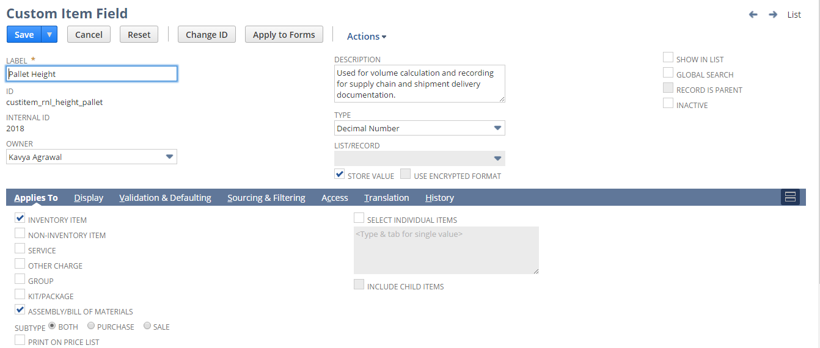

Weight(Eaches):

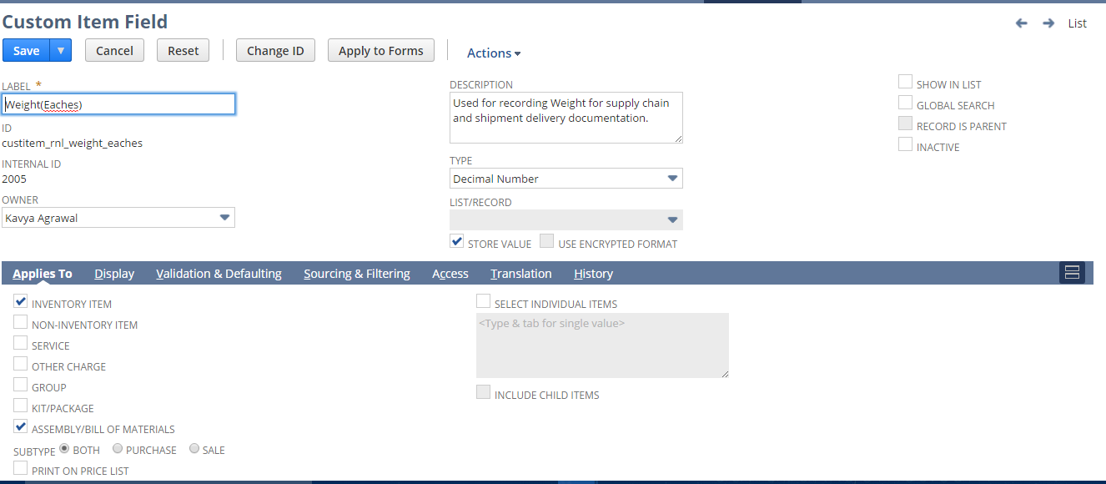

FDM Product#:

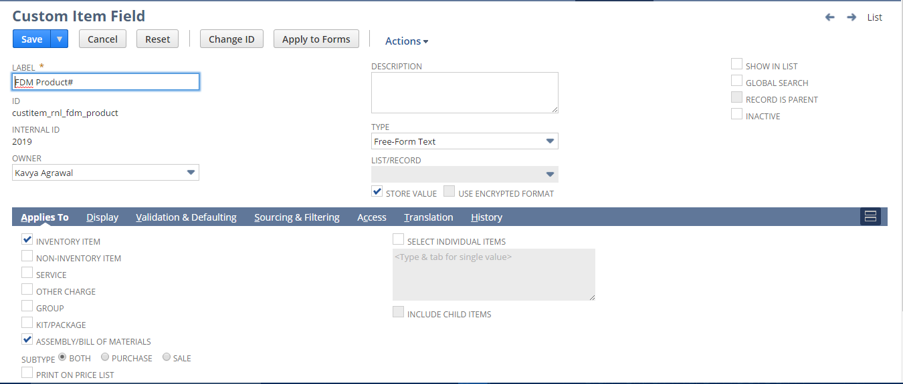

Size:

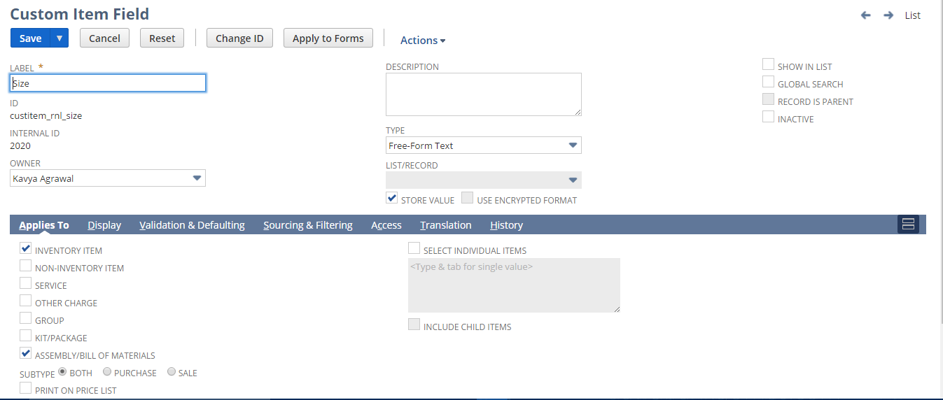

Tie :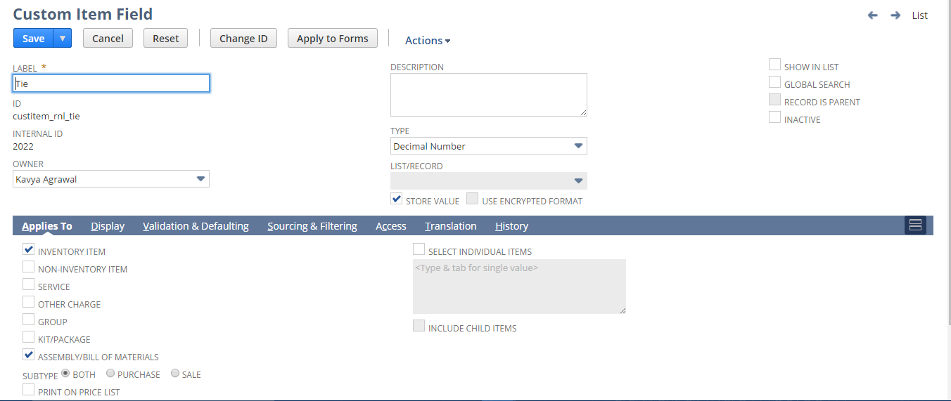

High :

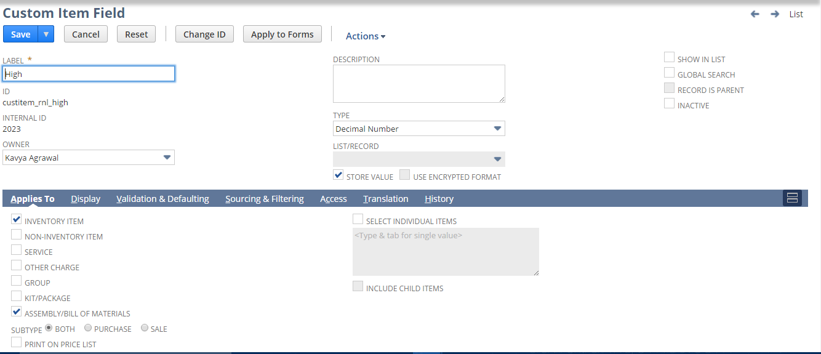

To view the item form Navigate to the following below path:

List> Accounting >Items>New

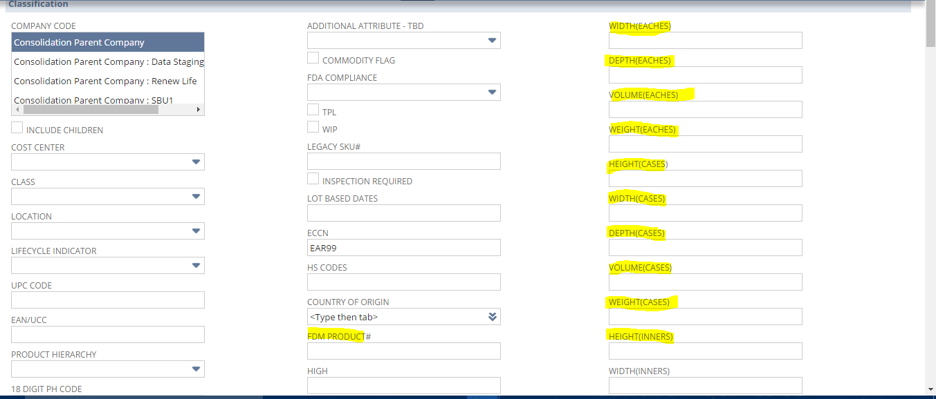

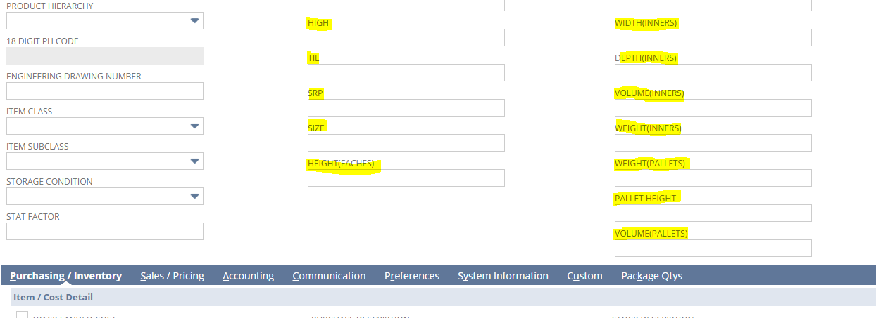

## Req-40: Customized Customer Statement Template

Requirement here is to generate and send statements to customer.

### ACCEPTANCE CRITERIA

1. PDF has to be generated as per the new customized layout.

### USE CASES

1. To view the new statement, navigate to Transactions > Customers > Individual Statement.  
 Select the Customer and set the criteria as per your requirement and Click Print.

2. To view the PDF template, navigate to Customization > Forms > Advanced PDF HTML template > RNL Customer Statement Template.

### JEFFERSON IMPACT

No impact

### FUNCTIONAL SOLUTION

There is no functional solution for this requirement.

### TECHNICAL SOLUTION

1. A Customized template to be created.

Details of the template are given below:

|  |  |  |
| --- | --- | --- |
| **Record Type** | **Description** | **Columns** |
| Customer | A customized template to print the Customer Statement of Account. | 1. Transaction Date 2. Invoice Number 3. Description 4. Charge 5. Payment 6. Balance 7. Account Number |

### CONFIGURATION

1. Go to Customization > Forms > Advanced PDF HTML template.

Click **Customize** next to the layout you want to customize.

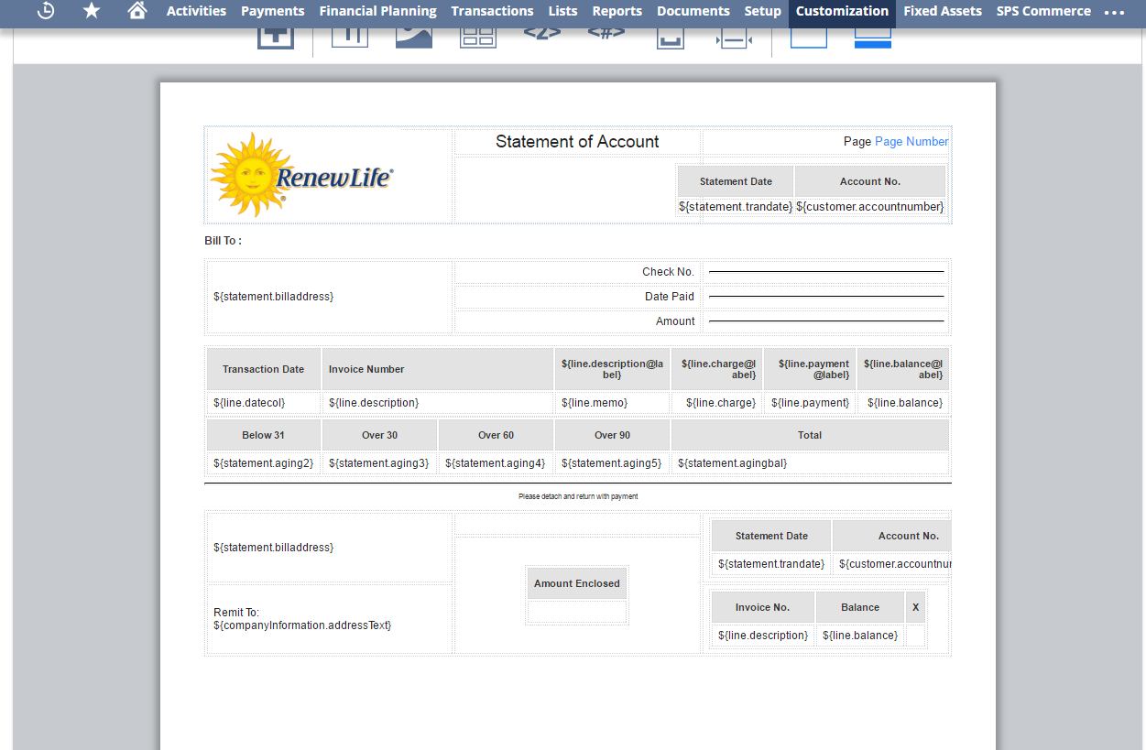



## Req-41: Ability to propose shipdate on sales order based on preferred Customer sla policy

The requirement is to propose Ship Date based on SLA policy days excluding weekends and shipping holidays.

### ACCEPTANCE CRITERIA

1. The Ship date must exclude weekends and shipping holidays

### USE CASES

* 1. User needs to Go to Lists> Relationships > Customers.
  2. User needs to Go to Transactions>Sales >Enter Sales Orders.

### JEFFERSON IMPACT

No impact

### FUNCTIONAL SOLUTION

1. There is no functional solution for this requirement.

### TECHNICAL SOLUTION

* + - * 1. A Custom record needs to be created

Details of the custom records are given in the table below:

|  |  |  |  |  |  |
| --- | --- | --- | --- | --- | --- |
| **Record Type** | **Name** | **Fields** | **Description** | **Type** | **Properties** |
| Custom | Shipping Holiday | 1. Holiday Description  2. Location  3. Holiday Date | * The Record will be used to store the Holiday description, Date and location | * Free-form Text * Date * List/ Record | Holiday Date and Location are mandatory. |

* + 1. A Center Tab will be created.  
       Details of the Center Tab are given in the table below:

|  |  |  |  |
| --- | --- | --- | --- |
| **Center Type** | **Name** | **Description** | **Categories** |
| Classic Center | Shipping Holidays | This Center tab will be available on the Dashboard under more options (…). | * Shipping Holidays |

1. A Center Category will be created  
   Details of the Center Category is mentioned below

|  |  |  |  |  |
| --- | --- | --- | --- | --- |
| **Center Tab** | **Name** | **Description** | **Links to Record** | **Label** |
| Shipping Holidays | Shipping Holidays | This Center Category will contain the links to record Shipping Holiday. | * Shipping Holidays | * Shipping Holiday |

1. A custom field will be created on Customer Record.  
    Details of the custom field are given in the table below:

|  |  |  |  |  |
| --- | --- | --- | --- | --- |
| **Record Type** | **Field** | **Description** | **Type** | **Properties** |
| Customer | Preferred SLA Policy (Days) | This field will be used to Store customer SLA policy Days | Integer | * 1. Default Value =’1’   2. Minimum Value =’1’ |

1. Script will be defined to Propose shipdate on sales order based on Preferred SLA Policy defined on customer record

|  |  |  |  |  |
| --- | --- | --- | --- | --- |
| **Name** | **Type** | **Description** | **Logic Overview** | **Properties** |
| UES RNL OrdertoShip-Date | User Event | While Creating Sales Order, Ship Date Will Proposed based on Preferred SLA Policy.  While Editing the Sales order if the user Changes the Location then again the Shipdate will be re-calculated based on location holidays and weekends. | 1. Check if the logged in user subsidiary is “RL sub”, if not exit 2. Ship date will be calculated based on Preferred SLA days and excluding weekends and customer holidays. 3. Order to ship Days= Preferred SLA Days.   A Loop will be run from 1 to order to ship days and each date will be checked if it is a weekend or a holiday(Holi day Date to be sourced from Shipping Holiday Record) .If it is a holiday then Order to ship=order to ship +1.  Hence the Ship date will be calculated by adding Order to ship days to the Date created. | * + 1. Script will be triggered only when Sales order is created or edited.     2. It will fetch the values for Preferred SLA Days then using the formula, set the result on Ship Date.   This field value will automatically get displayed in Shipping subtab record on the Sales Order.   1. A script configuration parameters shall be added which shall provide inputs to the script    * Subsidiary internal id |
|  |  |  |  |  |
|  |  |  |  |  |

System Change Impacts for Script

|  |  |  |
| --- | --- | --- |
| **#** | **Impact** | **Analysis** |
| 1 | Impact of Adding new subsidiary | 1. Script configuration parameter subsidiary_internal_id shall accept multiple subsidiary ids either separated by “,” OR “|” symbols. So to add a new subsidiary, script configuration parameter shall be extended with new subsidiary ids. |
| 2 | Impact of NetSuite Product upgrades | 1. No specific maintenance needed during NetSuite upgrades as Script uses stable API’s of NetSuite.  2.A preview testing shall be needed during upgrades, as advised by NetSuite for all custom developments |
| 3 | Post Go Live maintenance | 1.No specific post go live maintenance needed and should be manageable by support organization |

### CONFIGURATION

1.41.6.1 To Create a Custom Record follow the path mentioned below:

Customization-> Lists, Records, & Fields ->Record Types-> New

Shipping Holiday:

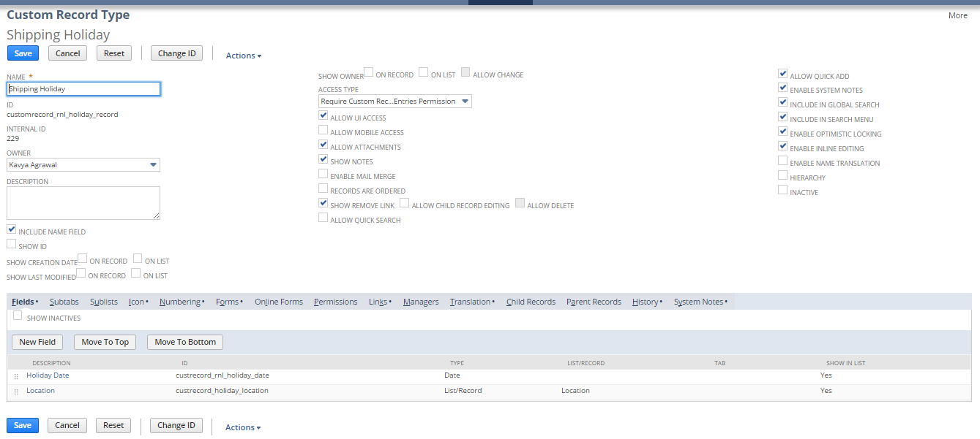

Custom Center Tab and Center Category

To create a custom Center Tab and Category follow the path mentioned below:

Customization -> Centers and Tabs -> Center Tabs -> New

Customization -> Centers and Tabs -> Center Categories -> New

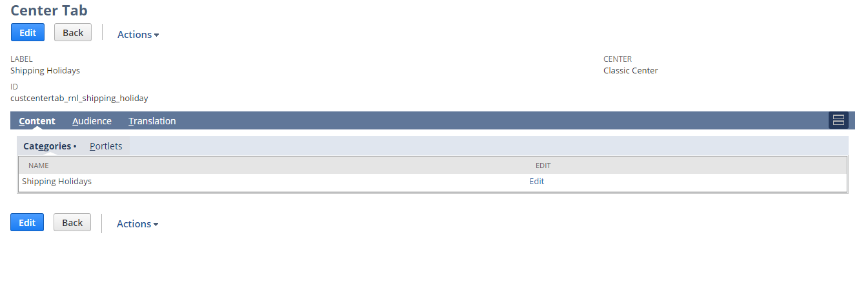

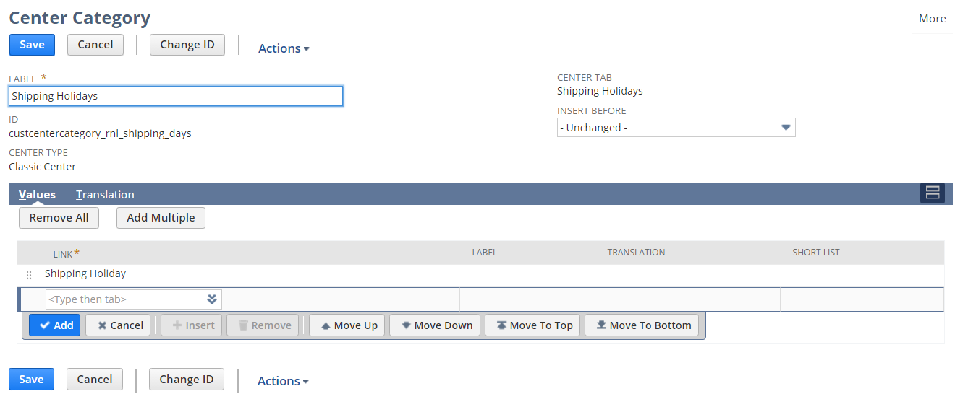

1.41.6.3 Create custom Field using below path

Customization->Lists, Records & Fields >Entity Field > New

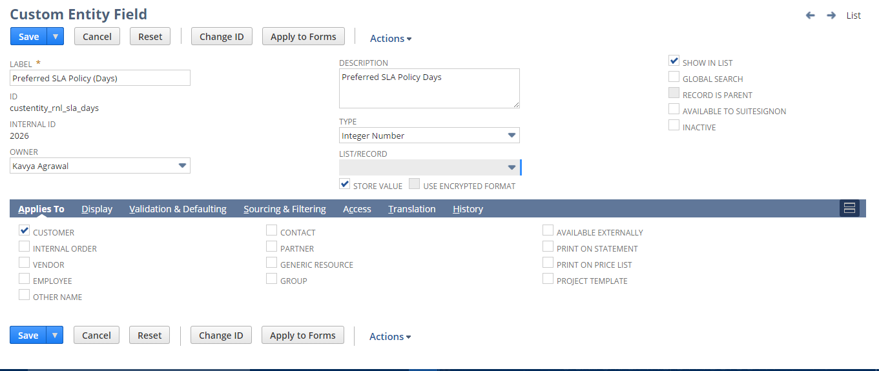

View the customer Record:

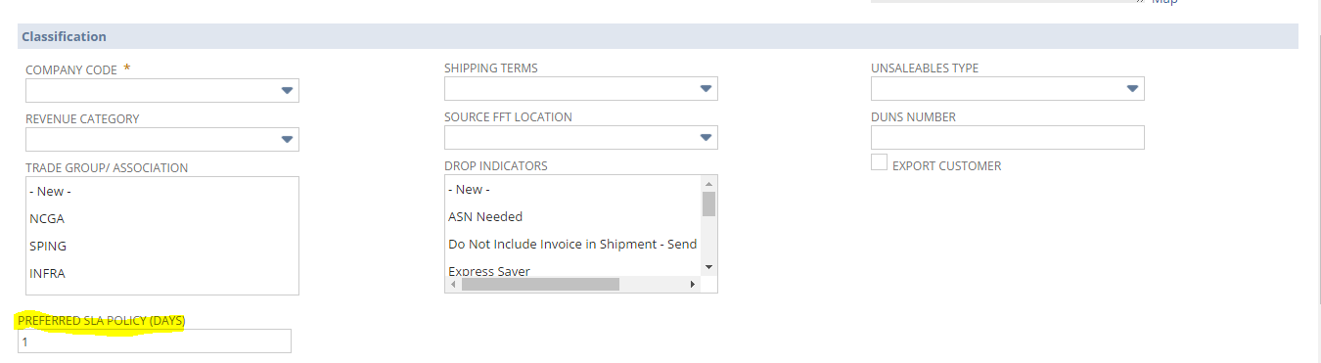

1.41.6.4 Custom Script Custom Scripts

To Create Script follow the path mentioned below:

Customization->Scripting->Scripts->New



To view Script Deployment follow the path mentioned below:

Customization->Scripting->Scripts Deployment

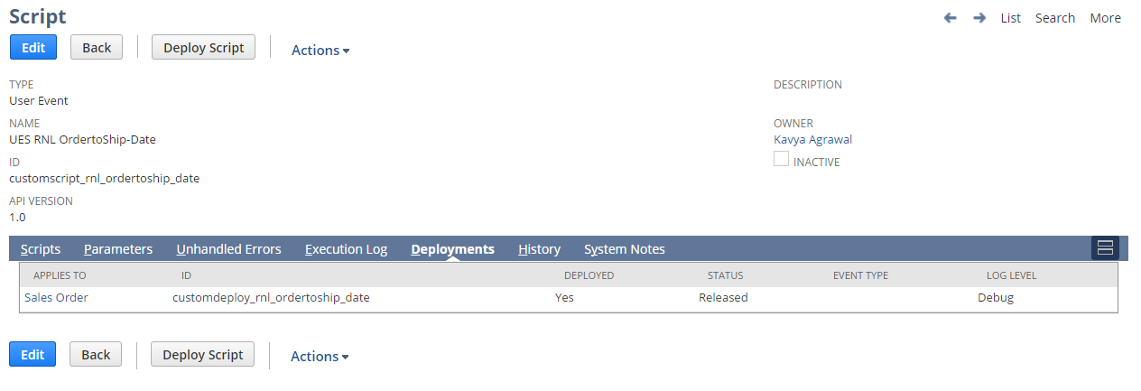

Script configuration parameters for role id and subsidiary id  
  
The script fields mentioned below needs to be changed for new quality roles addition and deletion.

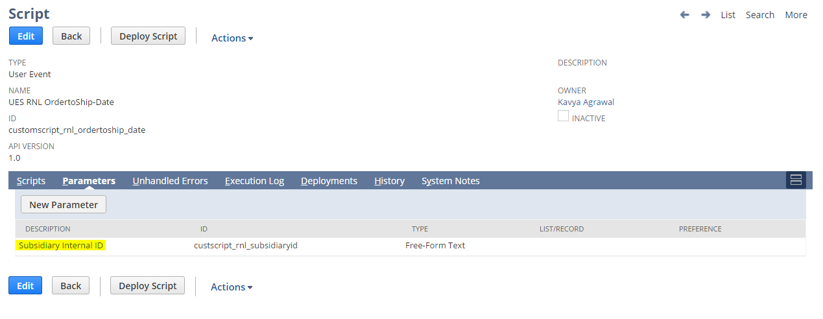

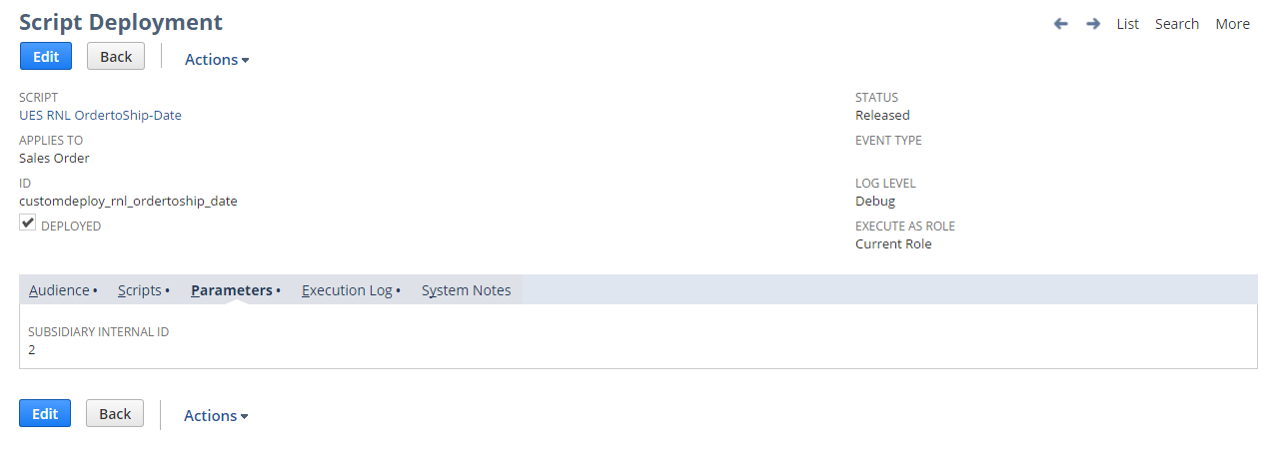

## Req-42: Ability to flag a customer active or inactive

The requirement is to identify the customers and flag them with different status on basis of their last transaction duration.

### ACCEPTANCE CRITERIA

1. All the Customers for whom transactions are done to be listed in the search.
2. Customers will be highlighted with different colors on the basis of last transaction dates.
3. If transactions are within 1-60 days then flag as Active, if 61-120 days then flag as Inactive, if 121-365 days then flag as Dormant and if over 365 days then flag as Revitalize.

### USE CASES

1. User needs to Go to Reports> Saved Searches > RNL Customer Activity Status
2. User needs to run the report

### JEFFERSON IMPACT

No impact

### FUNCTIONAL SOLUTION

There is no functional solution for this requirement.

### TECHNICAL SOLUTION

1. Saved search to be created on Customer record
2. In the result columns all required fields will be added  
   Details of the saved search are given in the table below:

|  |  |  |  |  |  |
| --- | --- | --- | --- | --- | --- |
| **Record Type** | **Name** | **Description** | **Filters** | **Columns** | **Properties** |
| Customer | RNL Customer Activity Status | This saved search will show the customers with their last transaction date and flag them with different colors for status | Criteria to be added in Standard tab:   * Company Code = Renew Life   Criteria to be added in Summary tab:   * Maximum Transaction Date is not empty * Name/ID | * Name (Group) * Transaction : Date (Maximum) * Transaction : Type | * Company Code & Transaction field criteria will be defined as default * Customer Name filter will be given for user selection * Highlighting Summary will be defined as below for color flags:   a. 1-60-Active-Green  b. 61-120 Inactive Yellow  c. 121-365 Dormant Grey  d. Over-365 Revitalize Red  e. Transactions after today Active Green |

### CONFIGURATION

1. To Create Saved Search follow the path mentioned below:

Reports->Saved Search->All Saved Searches->New

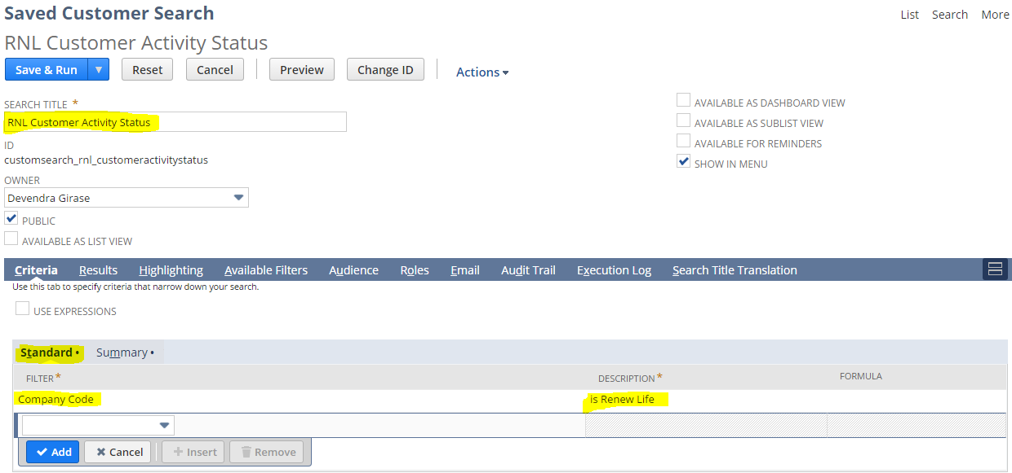

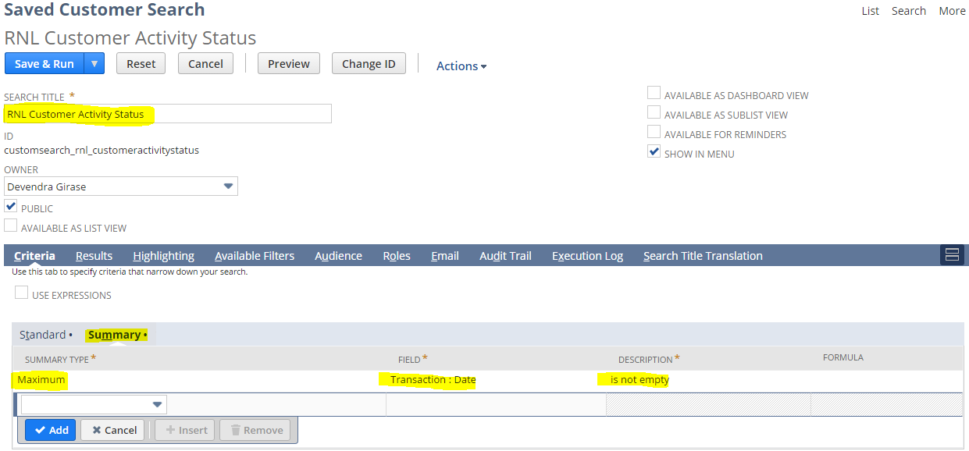

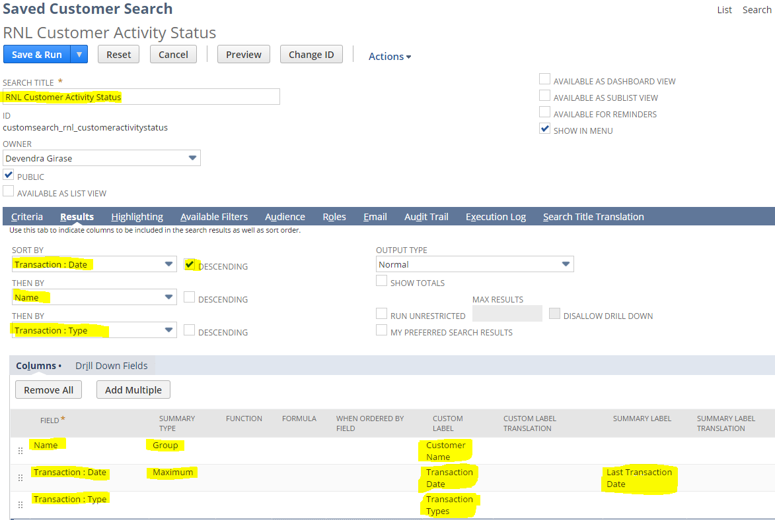

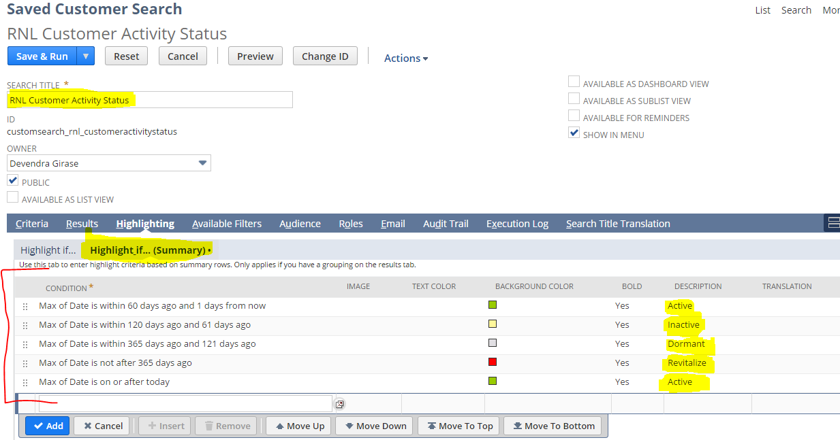

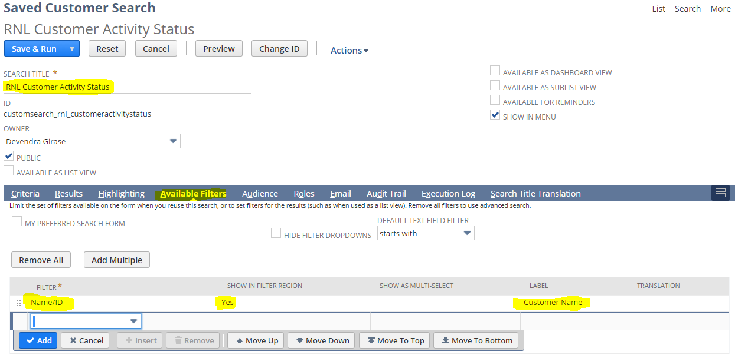

1. To view Saved Search follow the path mentioned below:

Reports->Saved Search->RNL Customer Activity Status

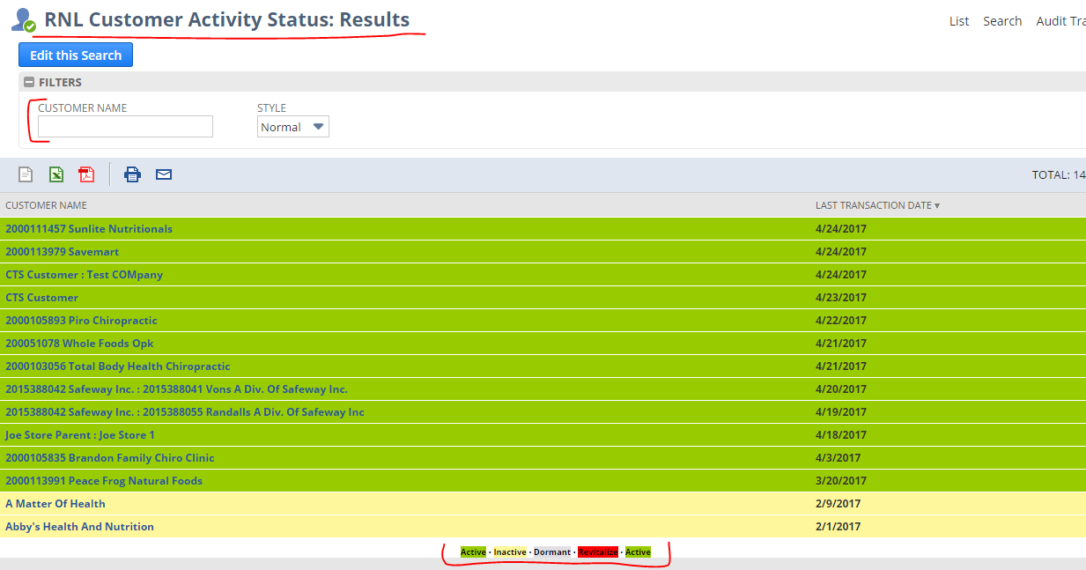

## Req-43: Ability for NetSuite to set up payees as with Planning, Non-Planning (indirect of wholesaler) or Vendor (3rd party) - MEI to include payee type

The requirement is to update the Planning Account field on Credit Memo based on the availability of Customer Level 3 field present on the Customer Record.

### ACCEPTANCE CRITERIA

1. A value should be set for Planning Account on Credit Memo depending upon the presence of Customer Level 3 on customer Record

### USE CASES

1. Users need to go to Transactions -> Customers -> Issue Credit Memos

2. After entering all the required fields on the Credit Memo, Click Save.

3. On Save, the value should get automatically populated on Planning Account field on the Credit Memo Record

### JEFFERSON IMPACT

No impact

### FUNCTIONAL SOLUTION

There is no functional solution for this requirement.

### TECHNICAL SOLUTION

1. Custom workflow is required to set the value for Planning Account field on the Credit Memo record based on the availability of the Customer Level 3 field present on the Customer Record.  
   Details of the workflow are given below:

|  |  |  |  |  |
| --- | --- | --- | --- | --- |
| **Record Type** | **Name** | **Description** | **Conditions** | **Properties** |
| Transaction(Credit Memo) | RNL Set PlanningAccount on CreditMemoMEI | 1. Workflow shall be initiated on create, view or update of the Credit memo.  2. Workflow shall be initiated when company code is Renew Life and Custom form is RL – Credit Memo MEI | 1. Subsidiary(Main) = Renew Life 2. Custom Form = RL – Credit Memo MEI | 1. A value will be set on Planning Account field on Credit Memo MEI form. |

Details of workflow



System Change Impacts for Workflow

|  |  |  |
| --- | --- | --- |
| **#** | **Impact** | **Analysis** |
| 1 | Impact of Adding new subsidiary | Current workflow executes only on below conditions   * + Logged in user’s subsidiary is Renew Life   + Form is RL - Credit Memo MEI   To include a new subsidiary workflow trigger condition needs to be updated as shown in configuration section  Refer to Section 1.43.6.2 for details |
| 2 | Impact of NetSuite Product upgrades | No specific maintenance needed during NetSuite upgrades as Script uses stable API’s of NetSuite.  A preview testing shall be needed during upgrades, as advised by NetSuite for all custom developments |
| 3 | Post Go Live maintenance | No specific post go live maintenance needed and should be manageable by support organization |

### CONFIGURATION

1.43.6.1 Custom Workflows

To create Custom Workflow follow path Customization->Scripting->Workflows->New

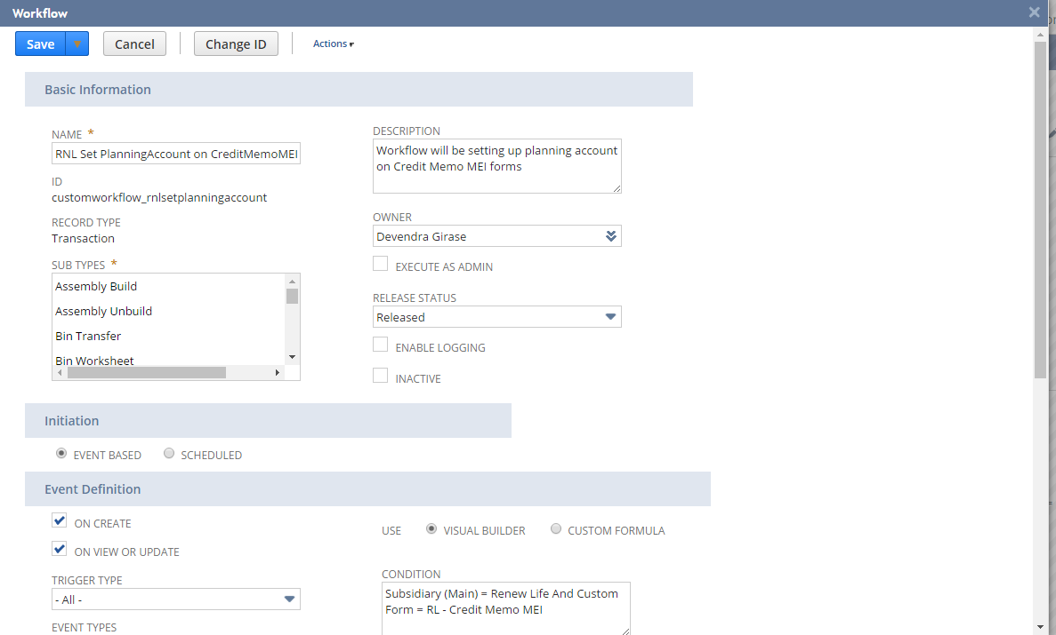

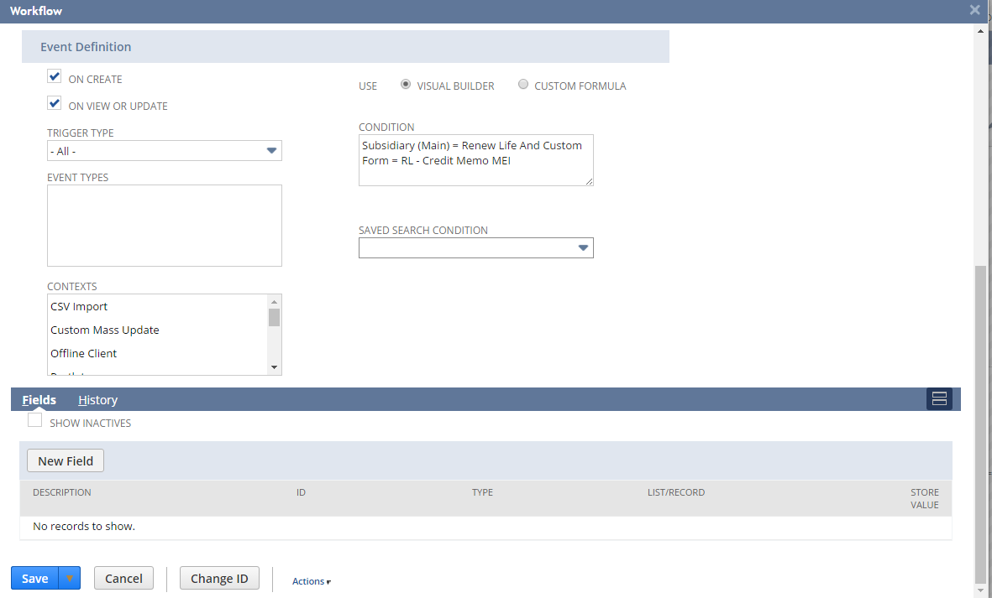

To view Custom Workflow follow path Customization->Scripting->Workflows-> RNL Set PlanningAccount on CreditMemoMEI

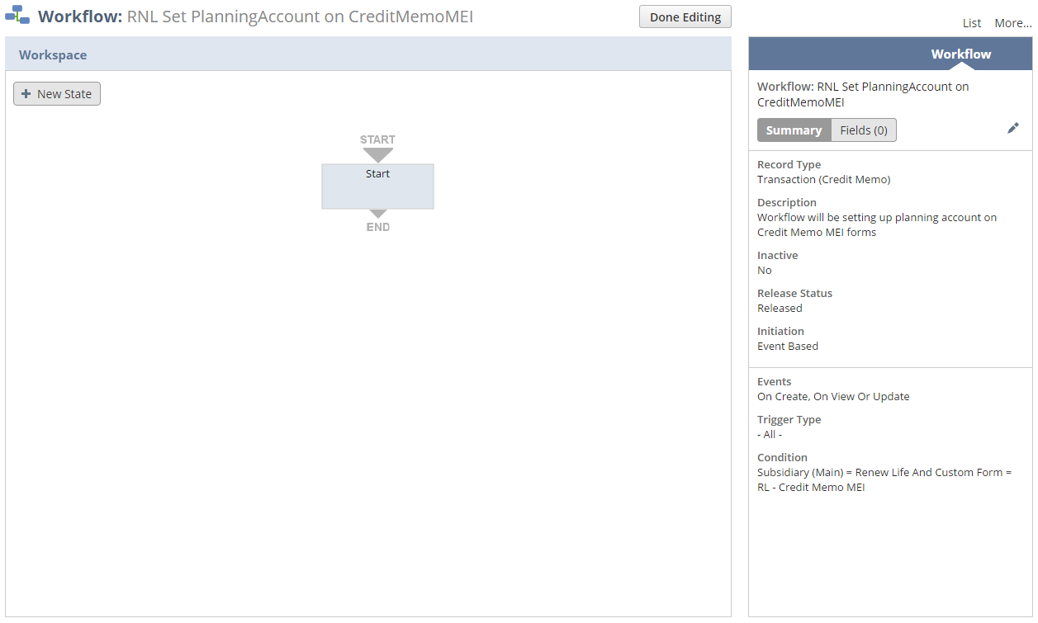

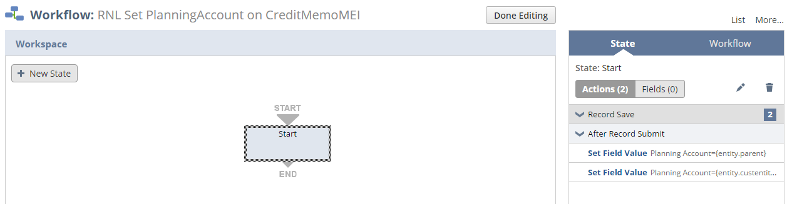

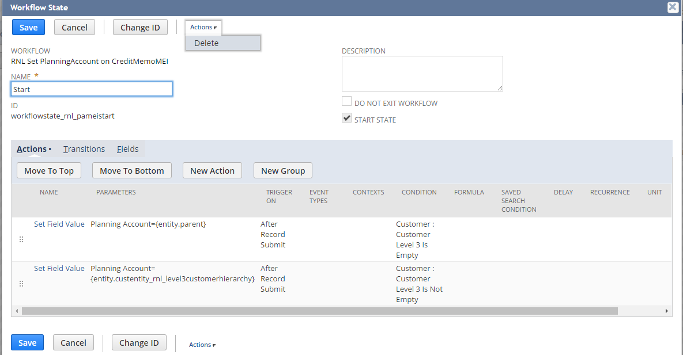

1.43.6.2 Below workflow condition needs to be changed for subsidiary addition\deletion

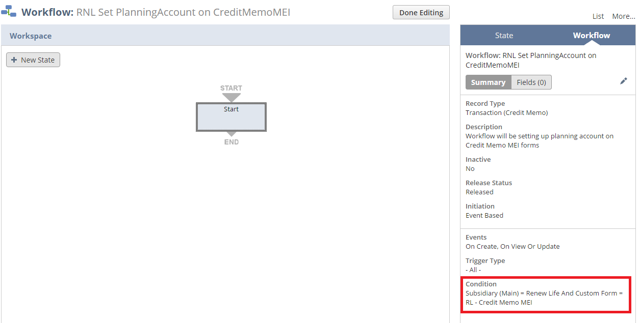

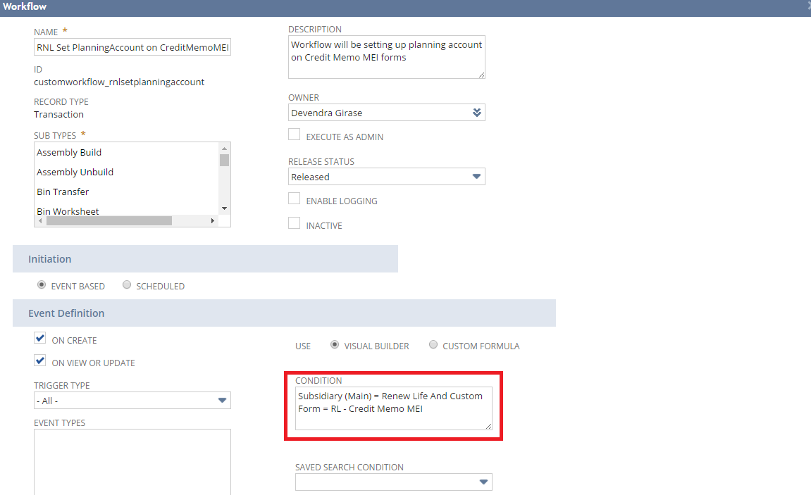

## Req-44: Commercial Invoice template for Invoice Record

Requirement here is to create a new customized commercial invoice template in invoice record.

### ACCEPTANCE CRITERIA

1. A button should available in the invoice record to print the pdf form

2. PDF has to be generated as per the new customized layout.

### USE CASES

1. To view the new commercial invoice template, navigate to Transactions > Sales > Create invoices >List. Select the invoice and click the print invoice button

2. To view the PDF template, navigate to Customization > Forms > Advanced PDF HTML template> RNL Commercial Invoice PDF/HTML template.

### JEFFERSON IMPACT

No impact

### FUNCTIONAL SOLUTION

There is no functional solution for this requirement.

### TECHNICAL SOLUTION

1. Custom Transaction Column fields will be created on Invoice Record.

Details of the custom fields are given below:

|  |  |  |  |  |
| --- | --- | --- | --- | --- |
| **Record Type** | **Field** | **Description** | **Type** | **Properties** |
| Invoice | HS Code | This field will source the HS Code field from Item record | Free-Form Text | * Display Type=Hidden * It will be a hidden field on Item line level  under Items subtab * Field must be hidden on Invoice Line level. |
| Invoice | ECCN | This field will source the ECCN field from Item record | Free-Form Text | * Display Type=Hidden * It will be a hidden field on Item line level  under Items subtab * Field must be hidden on Invoice Line level. |
| Invoice | Volume(Cases) | This field will source the Volume (Cases) field from Item record. The value is entered in ft. | Decimal Number | * Display Type=Hidden * It will be a hidden field on Item line level  under Items subtab * Value entered will be in ft. * Field must be hidden on Invoice Line level. |
| Invoice | Volume(Eaches) | This field will source the Volume (Eaches) field from Item record. The value is entered in ft. | Decimal Number | * Display Type=Hidden * It will be a hidden field on Item line level  under Items subtab * Value entered will be in ft. * Field must be hidden on Invoice Line level. |
| Invoice | Weight(Cases) | This field will source the Weight (Cases) field from Item record. The value is entered in pounds. | Decimal Number | * Display Type=Hidden * It will be a hidden field on Item line level  under Items subtab * Value entered will be in pounds. * Field must be hidden on Invoice Line level. |
| Invoice | Weight(Eaches) | This field will source the Weight (Eaches) field from Item record. The value is entered in pounds. | Decimal Number | * Display Type=Hidden * It will be a hidden field on Item line level  under Items subtab * Value entered will be in pounds. * Field must be hidden on Invoice Line level. |

2. Custom Transaction body field will be created on Invoice Record.

Details of the custom field is given below:

|  |  |  |  |  |
| --- | --- | --- | --- | --- |
| **Record Type** | **Field** | **Description** | **Type** | **Properties** |
| Invoice | Shipping Carrier Custom | This field will show the shipping carrier on invoice record | Free-Form Text | * Display Type=Hidden * It will be a hidden field on main subtab * Field must be hidden on Invoice record. |

3. Custom Form will be created for invoice to set the printing option for commercial invoice.

Details of the custom form is given below:

|  |  |  |  |
| --- | --- | --- | --- |
| **Record Type** | **Name** | **Description** | **Properties** |
| Invoice | RL – Commercial Invoice | Printing Template should be “RNL Commercial Invoice PDF/HTML Template” |  |

2. A Customized template to be created.

Details of template are given below:

|  |  |  |
| --- | --- | --- |
| **Record Type** | **Description** | **Columns** |
| Invoice | A customized template to print the commercial invoice. | * Product Code Number * Product Description * C/O * HS Code * ECCN * Units Shipped * No of Packages * Gross Weight * Cubic * Price Per Package * Total Price USD |

1. Script will be defined to create button on invoice and generate the commercial invoice on invoice record

|  |  |  |  |  |
| --- | --- | --- | --- | --- |
| **Name** | **Type** | **Description** | **Logic Overview** | **Properties** |
| RNL Print Commercial Invoice UE | User Event | This script will create a button on invoice record called “Print Invoice”. Also it will set the shipping carrier value to “Shipping Carrier Custom” custom Field. | 1. Check if the logged in user subsidiary is “RL sub”, if not exit  2. A button will be created on Invoice record on before load function on View mode.  3. The value for shipping carrier will be set to “Shipping Carrier custom” custom field on invoice record on Afterload function. | 1. Script will be triggered only when invoice is in view mode.  2.A script configuration parameters shall be added which shall provide inputs to the script   * + Subsidiary internal id |
| RNL Commercial Invoice CS | Client | This script will create the button action for “Print Invoice” button. | 1. It will check for the environment. i.e., sandbox or production environment.  2.It will create button action .i.e., it will load the suitelet script to print invoice | 1. Script will be triggered only when button is clicked.  2.Load the suitelet script |
| RNL Commercial Invoice SL | Suitelet | This script will load the PDF template form from the NetSuite system using the custom form id. | 1. Check if the logged in user subsidiary is “RL sub”, if not exit  2. Retrieve the form internal id given as script parameter in script deployment page.  2. Print the invoice form using the form id for which the invoice template is created. | 1. Script will be triggered only when client script is triggered.  2.A script configuration parameters shall be added which shall provide inputs to the script   * + Subsidiary internal id   + Form Internal ID   3. Script will retrieve the PDF form from System using form id. |

System Change Impacts for Script

|  |  |  |
| --- | --- | --- |
| **#** | **Impact** | **Analysis** |
| 1 | Impact of Adding new subsidiary | 1. Script configuration parameter subsidiary_internal_id shall accept multiple subsidiary ids either separated by “,” OR “|” symbols. So to add a new subsidiary, script configuration parameter shall be extended with new subsidiary ids. |
| 2 | Impact of NetSuite Product upgrades | 1. No specific maintenance needed during NetSuite upgrades as Script uses stable API’s of NetSuite.  2.A preview testing shall be needed during upgrades, as advised by NetSuite for all custom developments |
| 3 | Post Go Live maintenance | 1.No specific post go live maintenance needed and should be manageable by support organization |

### CONFIGURATION

1. Go to Customization > Forms > Advanced PDF HTML template.

Click **Customize** next to the layout you want to customize

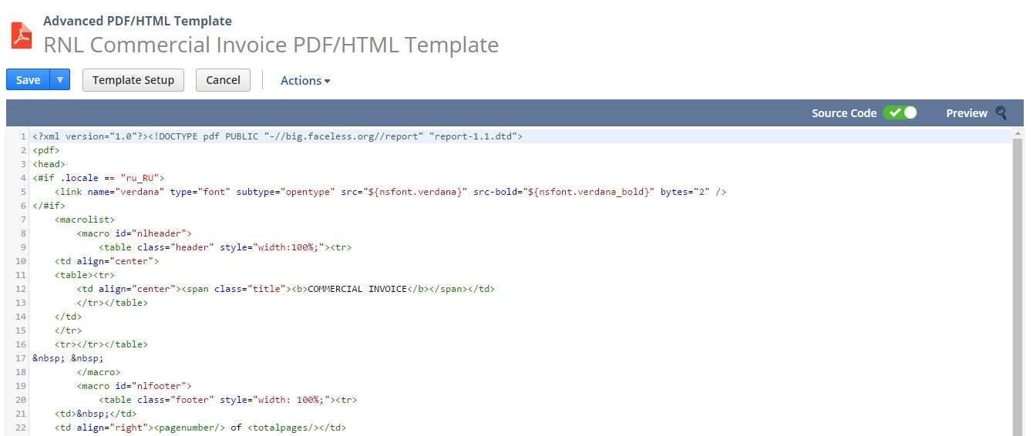



2. Create custom Field using below path

Customization->Lists, Records & Fields >Transaction Body Field > Shipping Carrier Custom

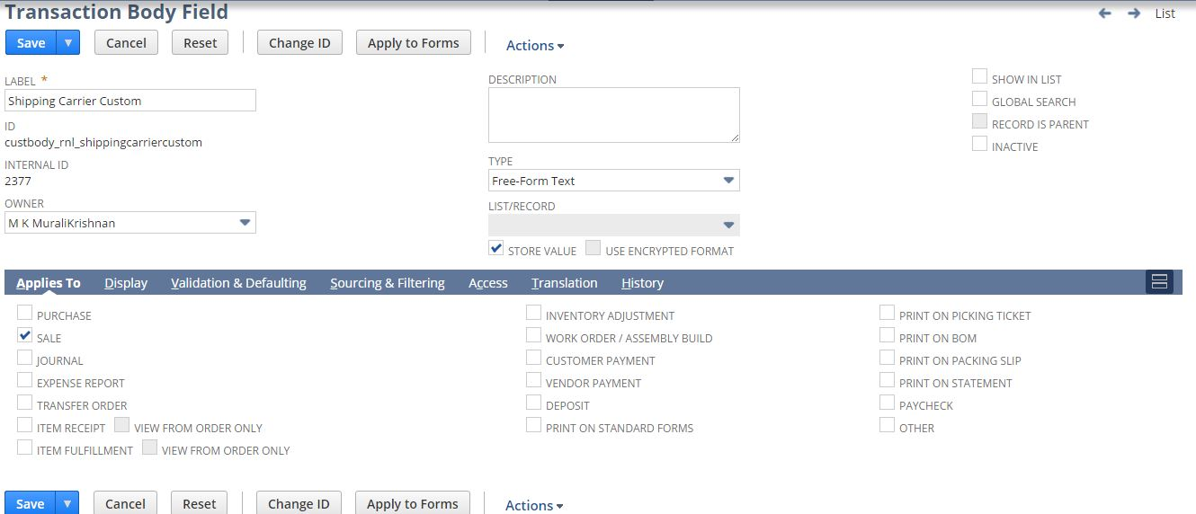

3. Create custom Field using below path

Customization->Lists, Records & Fields >Transaction Column Field > HS Code

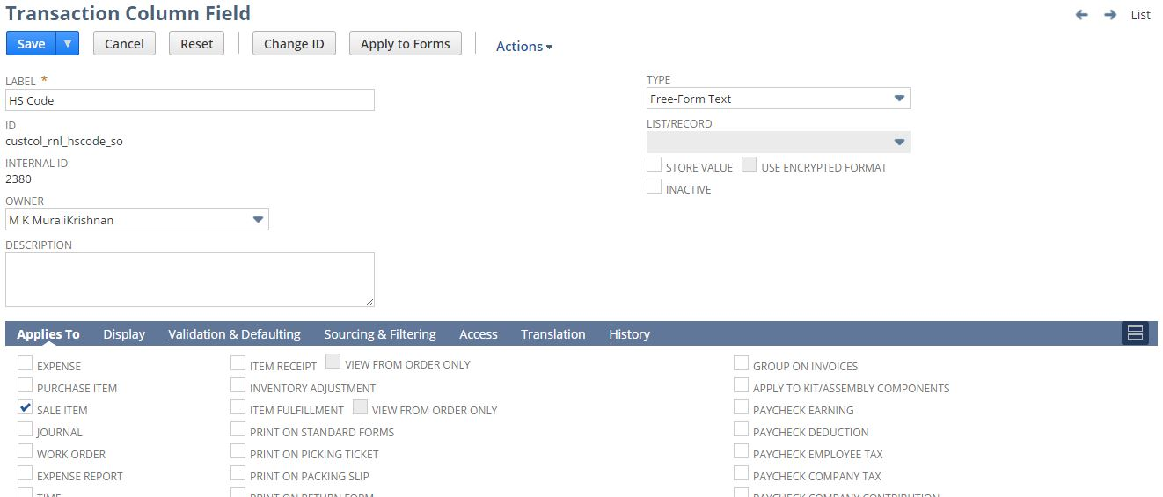

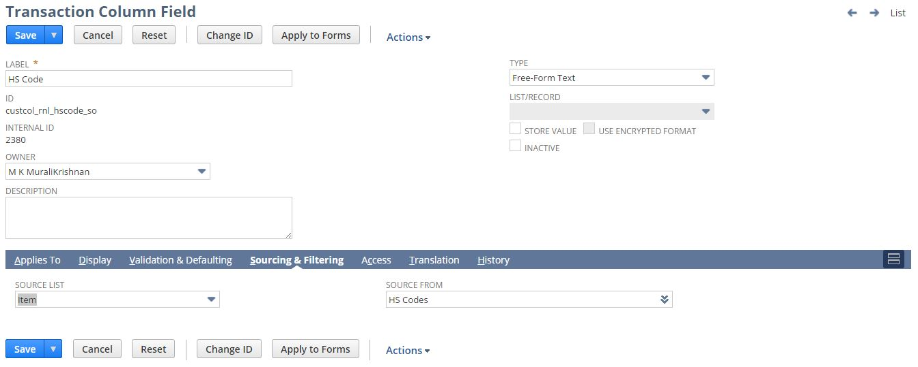

4. Create custom Field using below path

Customization->Lists, Records & Fields >Transaction Column Field > Volume(cases)

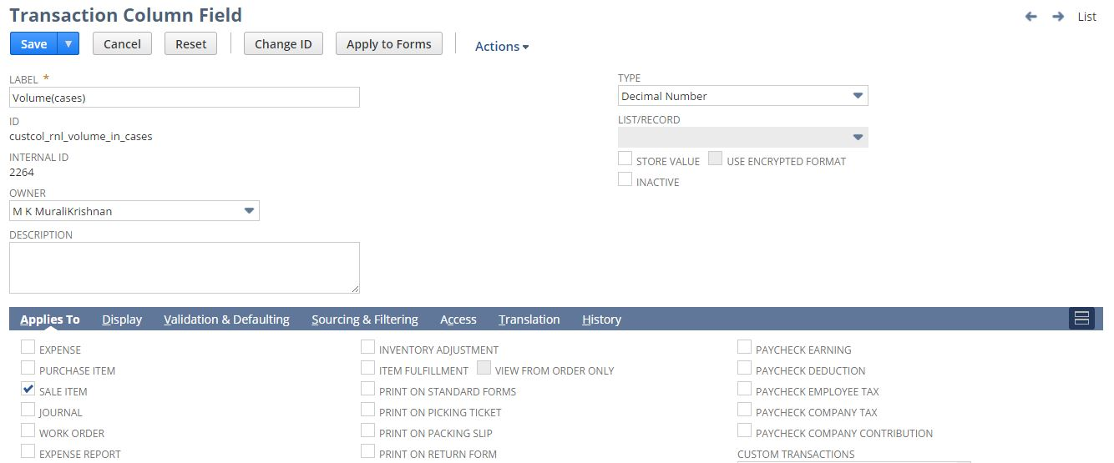

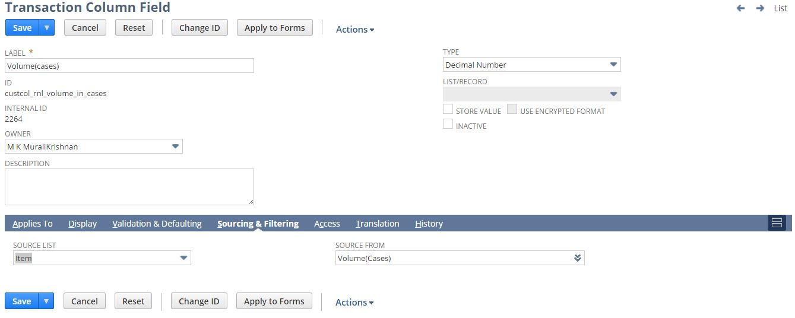

5. Create custom Field using below path

Customization->Lists, Records & Fields >Transaction Column Field > ECCN

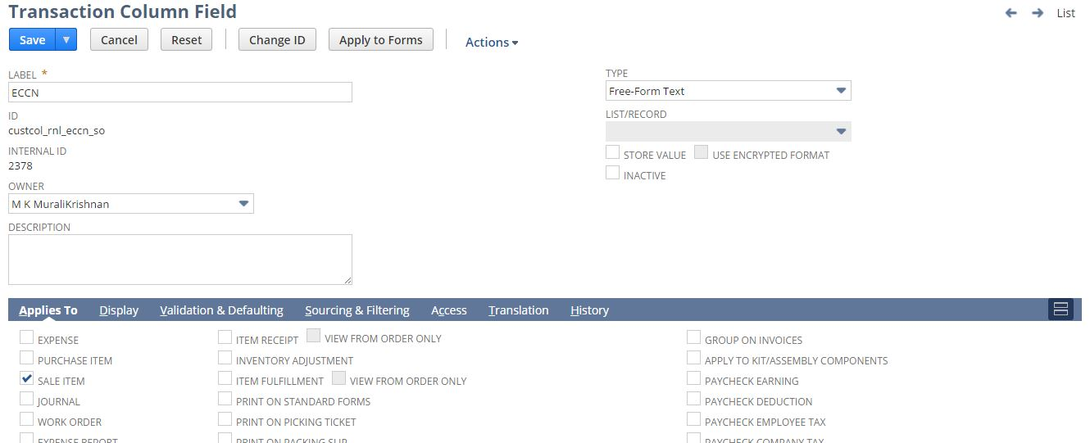

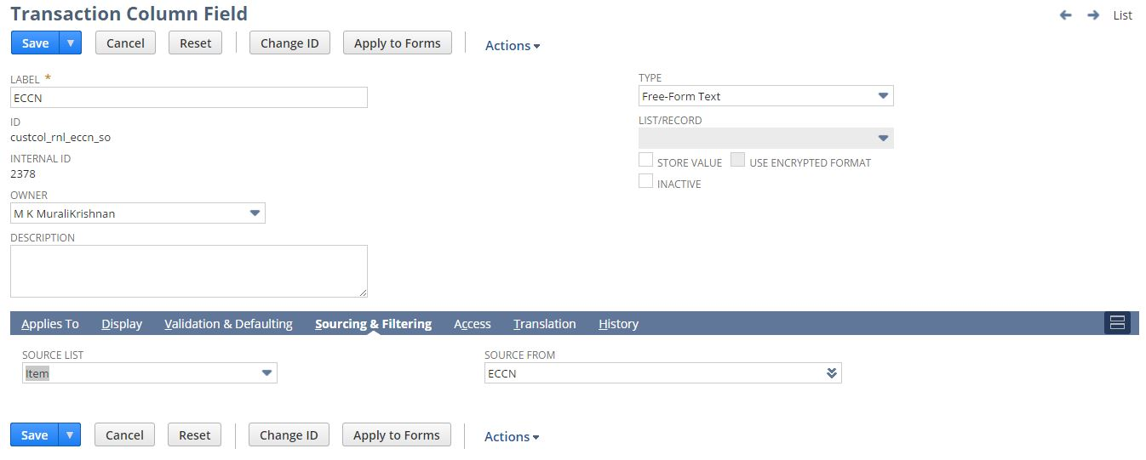

6. Create custom Field using below path

Customization->Lists, Records & Fields >Transaction Column Field > Volume (eaches)

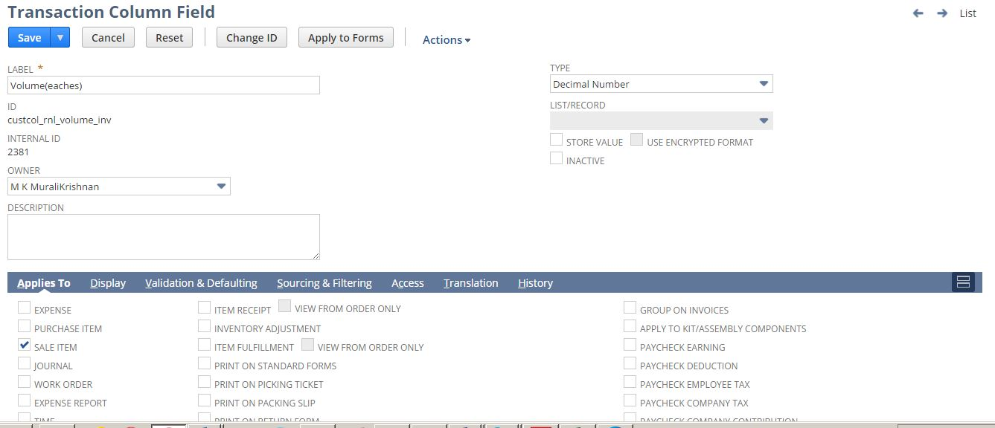

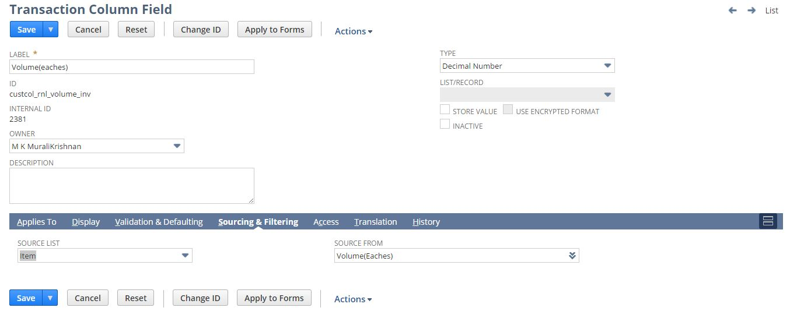

7. Create custom Field using below path

Customization->Lists, Records & Fields >Transaction Column Field > Weight(cases)

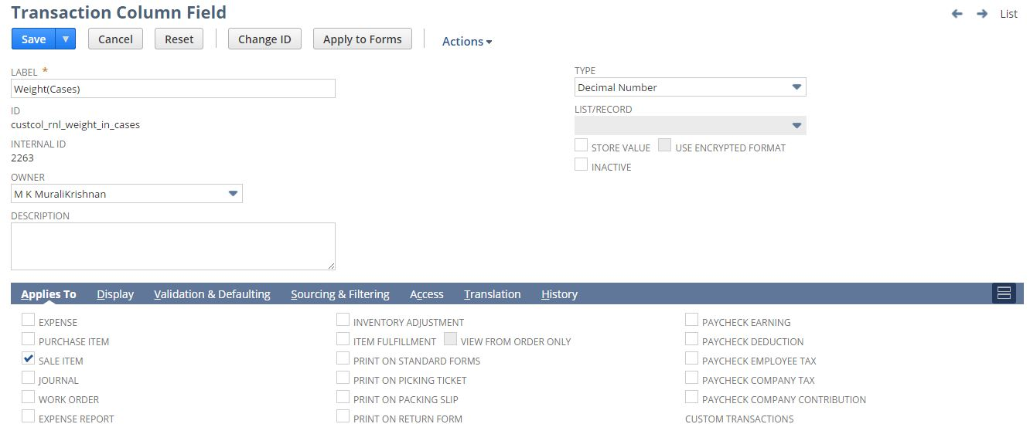

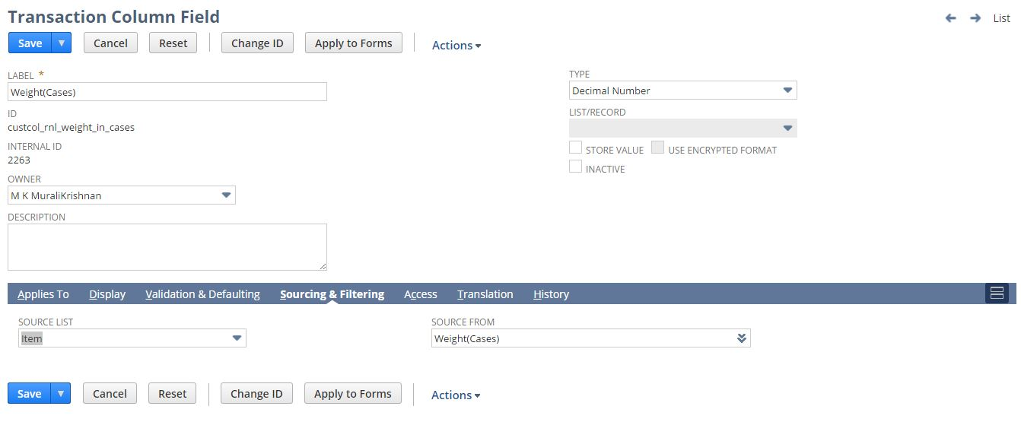

8. Create custom Field using below path

Customization->Lists, Records & Fields >Transaction Column Field > Weight(Eaches)

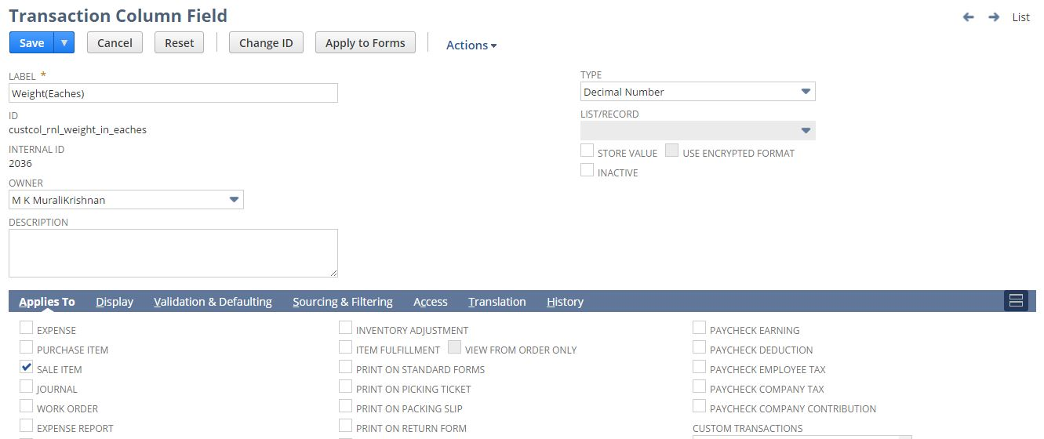

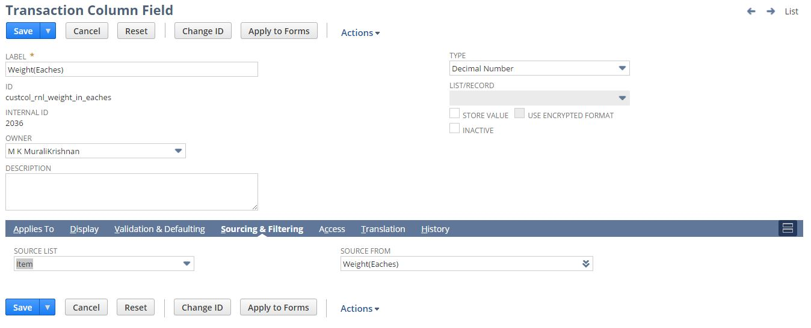

9. Create custom Form using below path

Customization->Forms >Transaction Forms

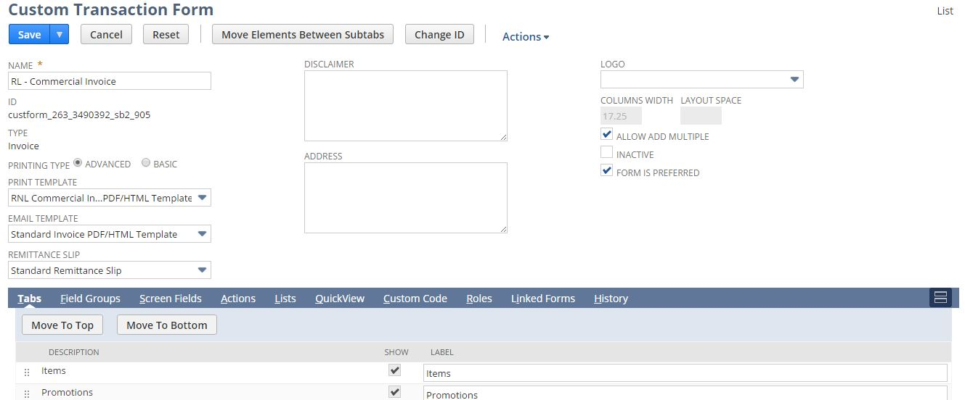

10. Custom Script Custom Scripts

To Create Script follow the path mentioned below:

Customization->Scripting->Scripts->New

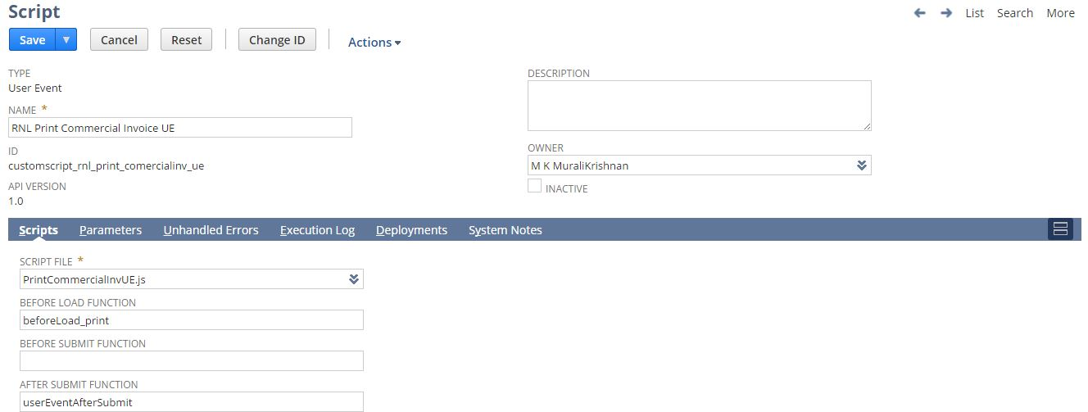

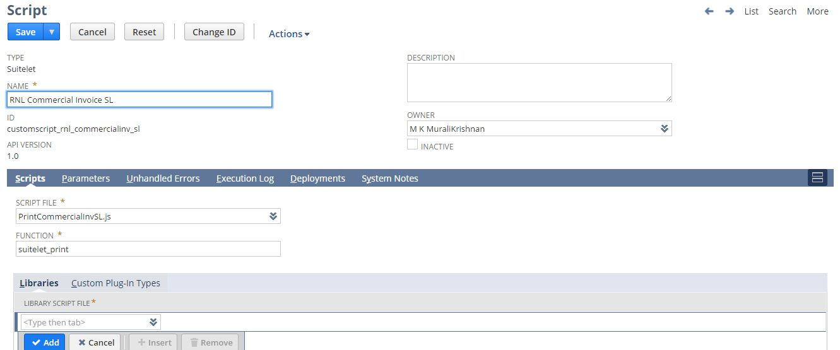

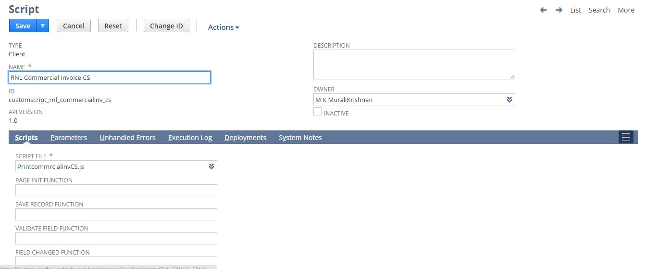

11. To View the deployment, follow the path mentioned below:

Customization->Scripting->Script Deployments

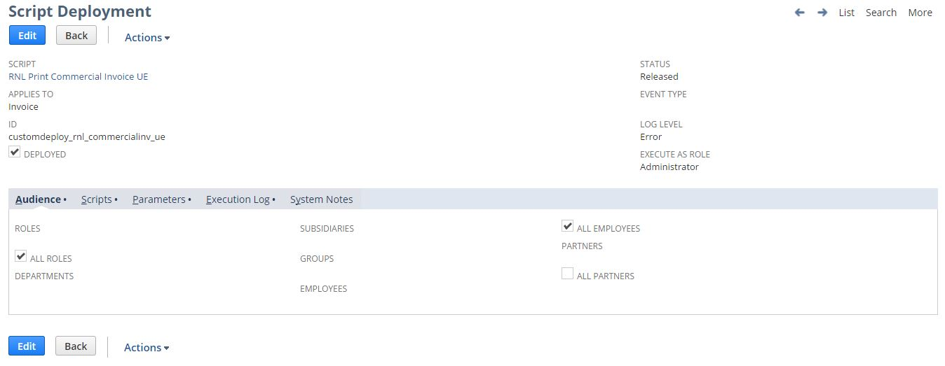

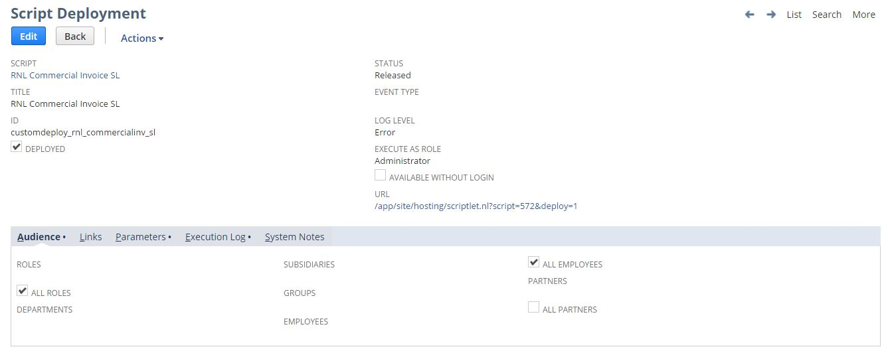

12. Script configuration parameters for subsidiary id

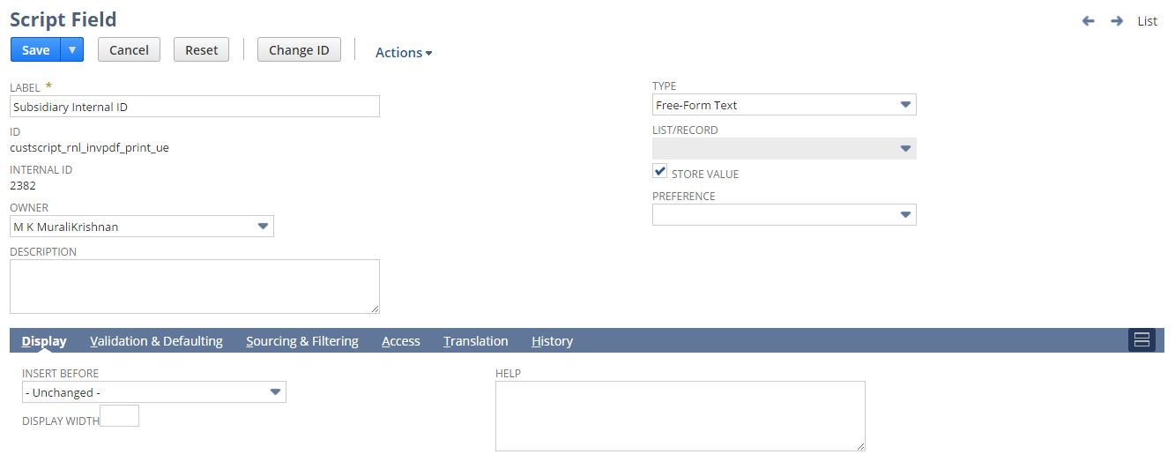

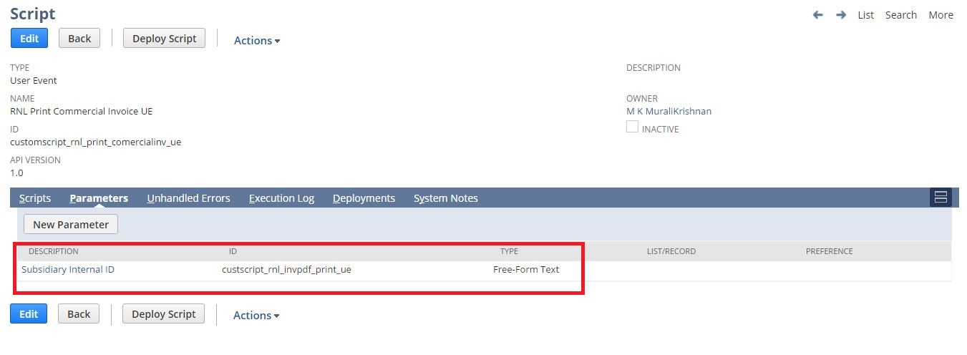

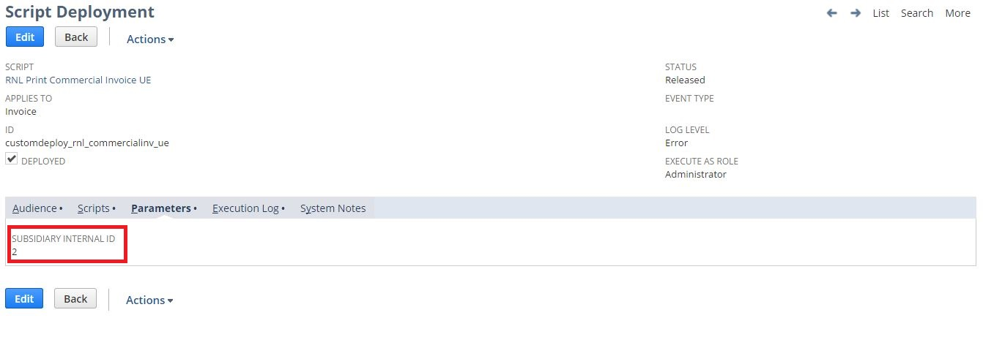

12. Script configuration parameters for form id

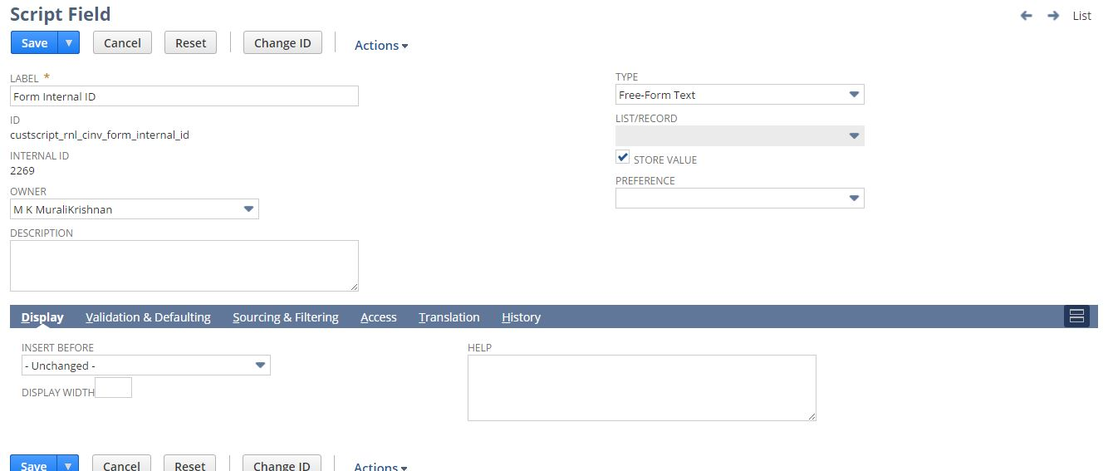

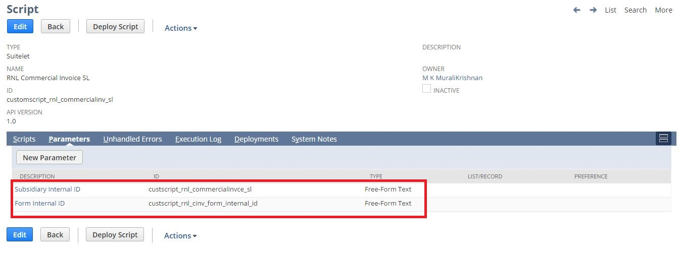

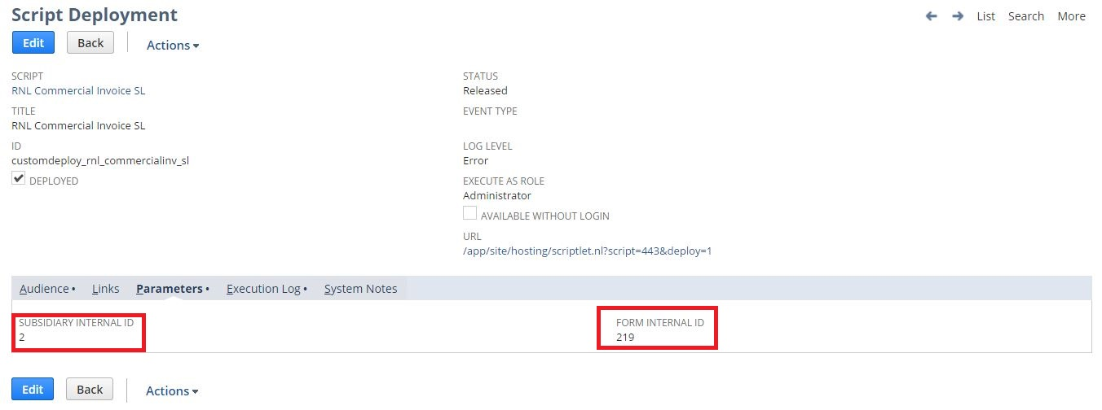

## Req-45: Ability to track MEI Transaction on Check Transaction

Requirement is to create a new custom form named RL - Check MEI, from which need to remove some fields from Header and also from Expenses & Items subtab. Rename memo field, add 2 fields on Header and 3 fields on column level.

### ACCEPTANCE CRITERIA

1. Memo field should be renamed to Memo/Promo Code and should be mandatory

2. MEI Payment No & Customer Invoice Number fields should be available on Classification tab

3. MEI Promotion ID, Promotion Rebate ID and Payment Detail ID field should be available on column level under Expenses and Items subtab

4. All above changes to be available only on RL – Check MEI form

### USE CASES

1. Navigate to Transactions > Bank > Write Checks

### JEFFERSON IMPACT

No impact

### FUNCTIONAL SOLUTION

There is no functional solution for this requirement.

### TECHNICAL SOLUTION

1. A custom fields will be created on RL- Check Form

Details of the custom field are given below:

|  |  |  |  |  |
| --- | --- | --- | --- | --- |
| **Record Type** | **Field** | **Description** | **Type** | **Properties** |
| Transaction  (RL – Write Check) | MEI Payment No | Enter MEI Payment Number | Free-Form Text | 1. Display Type=Normal 2. Field Type = Free-Form Text 3. Field will be displayed on Main level under classification. |
| Transaction  (RL – Write Check) | Customer Invoice No | Enter Customer Invoice Number for which Check issued | Free-Form Text | 1. Display Type=Normal 2. Field Type = Free-Form Text   3. Field will be displayed on Main level under classification. |
| Transaction  (RL – Write Check) | MEI Promotion ID | MEI Promotion Transaction ID to be entered | Free-Form Text | 1. Display Type=Normal 2. Field Type = Free-Form Text 3. Field will be displayed on column level of Items and Expenses |
| Transaction  (RL – Write Check) | Promotion Rebate ID | Promotion Rebate ID to be entered | Free-Form Text | 1. Display Type=Normal 2. Field Type = Free-Form Text 3. Field will be displayed on column level of Items and Expenses |
| Transaction  (RL – Write Check) | Payment Detail ID | Payment Detail ID to be entered | Free-Form Text | 1. Display Type=Normal 2. Field Type = Free-Form Text 3. Field will be displayed on column level of Items and Expenses |

### CONFIGURATION

1. Create custom Transaction Body Field using below path

Customization->Lists, Records & Fields >Transaction Body Filed > New

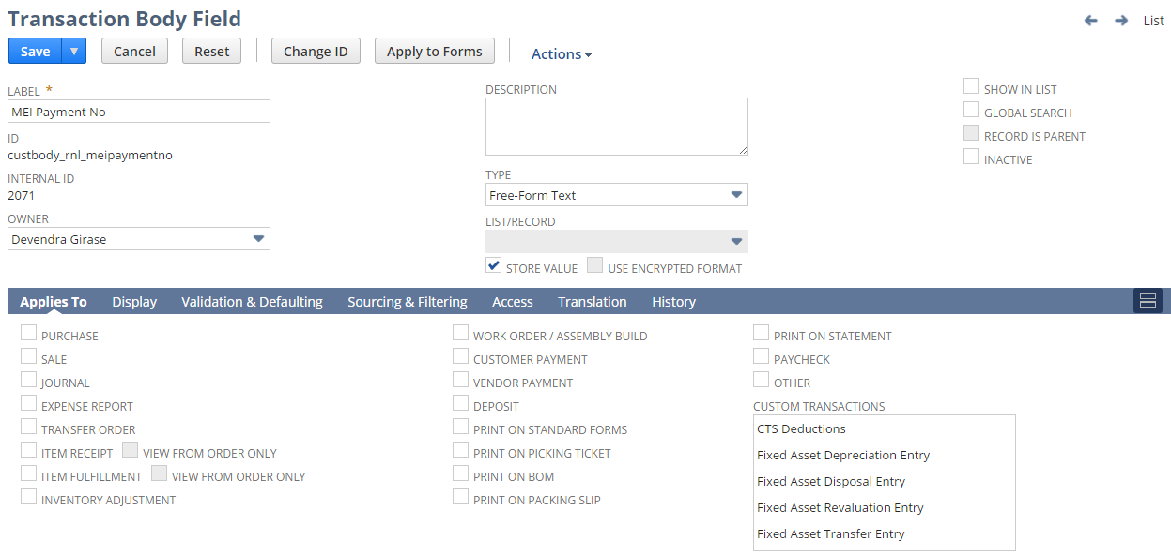

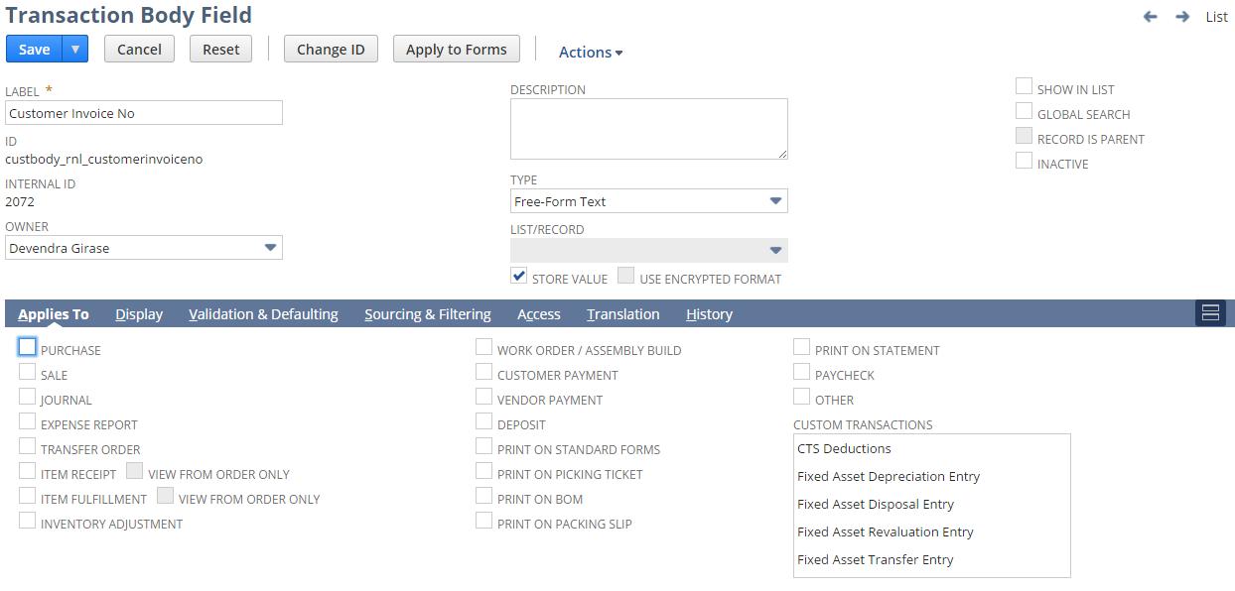

2. Create custom Transaction Column Field using below path

Customization->Lists, Records & Fields >Transaction Column Filed > New

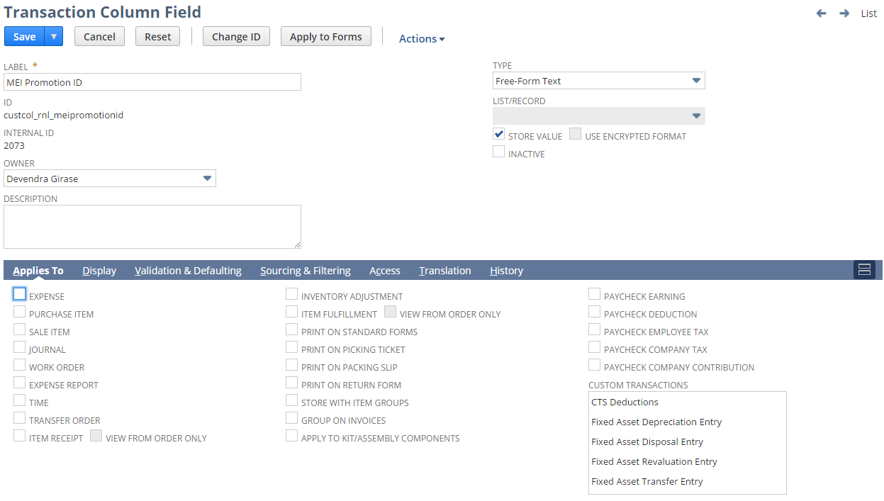

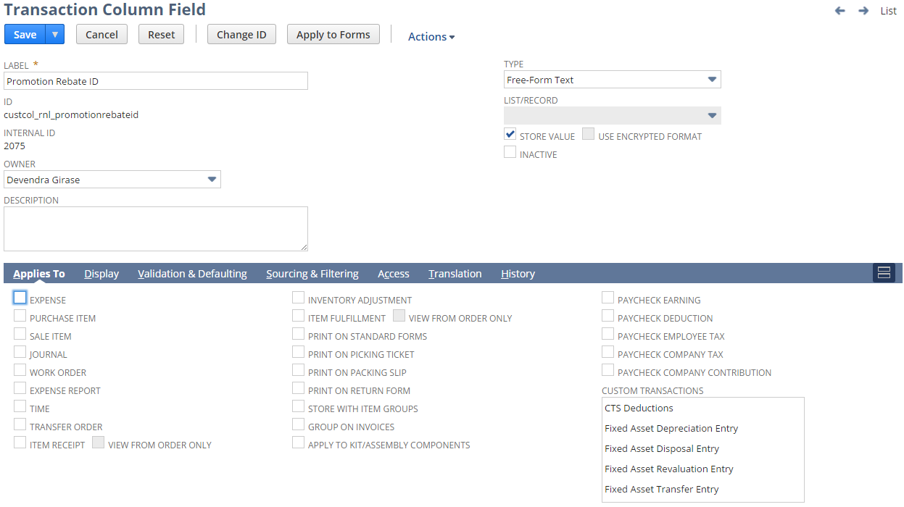

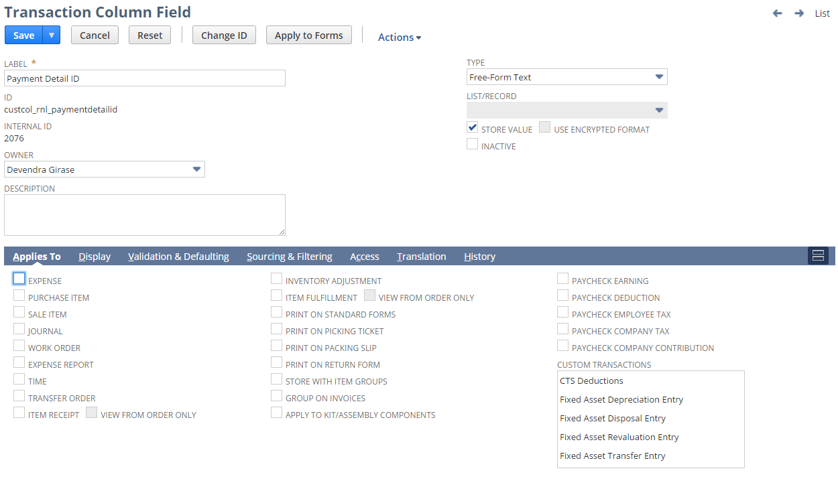

3. Click Save and Apply to forms and Apply the field to RL – Check MEI

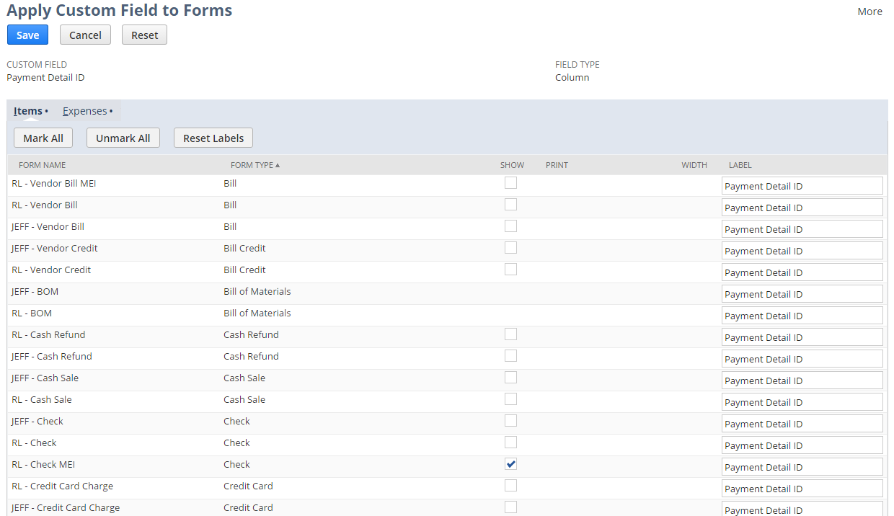

4. Open a Write Check Transaction using below path

Transactions > Bank > Write Check > RL – Check MEI form in custom forms

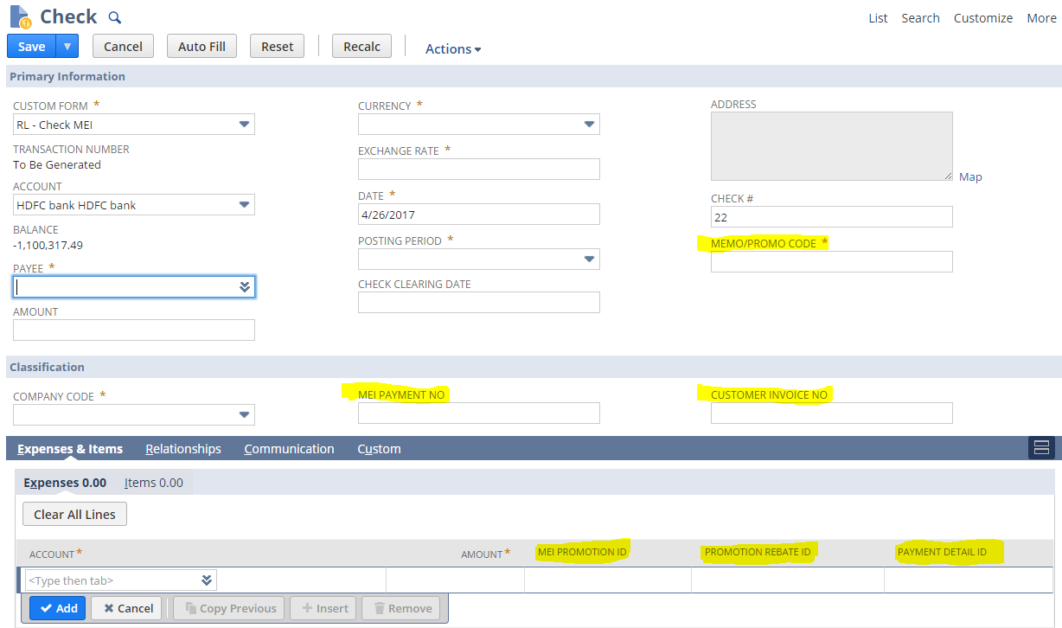

## Req-46: Ability to List out all Items with Wholesale Price and Suggested Retail Price.

The requirement is to extract data from “RNL Price List” with Wholesale Price and Suggested retail Price for each Items.

### ACCEPTANCE CRITERIA

1. All the Item for which minimum quantity is equal to or greater than 0 and maximum quantity is infinite should be listed along with their respective Name, Description, UPC Code, Wholesale Price and Suggested Retail Price.

### USE CASES

* + 1. User needs to Go to Reports> Saved Searches > RNL Price List.
    2. User needs to select/run the report.

### JEFFERSON IMPACT

No impact

### FUNCTIONAL SOLUTION

1. There is no functional solution for this requirement. We are using NetSuite’s out-of-box functionality of custom field and Saved Search to fetch data for reporting.

### TECHNICAL SOLUTION

1. Custom Fields need to be created on Item Master.
2. Custom List for Price List Category need to be created.

Details of Custom List is given below in the table.

|  |  |  |  |
| --- | --- | --- | --- |
| **Name** | **Description** | **Values** | **Properties** |
| Price List Category | This list will store the value of price list category | FDM  HFS AN  FDM-WMT  CLUB | List is sorted as the order entered. |

Details of the custom fields is given in the table below.

|  |  |  |  |  |
| --- | --- | --- | --- | --- |
| **Record Type** | **Field** | **Description** | **Type** | **Properties** |
| Item | Suggested Retail Price | This field will show the suggested retail price for the Item | Currency | * Display Type=Normal * Field must be available under Sales/Pricing tab |
| Item | PH L5 | This Field source the “Size” Value from PH Record | Free-Form Text | * Display Type= Normal * Field is disabled on Item master and hidden |
| Item | PH L3 | This Field source the “Category” Value from PH Record | Free-Form Text | * Display Type= Normal   Field is disabled on Item master and hidden |
| Item | Case Count | This is entered by user to calculate the list price value | Decimal Number | * Display Type= Normal * Field is visible under “Dimensional” Field Group |
| Item | Price List Category | This Field Source the custom list value from price List Category list | Multiple Select | * Display Type= Normal * Field is visible under “Classification” Field Group |

3. Saved search to be created on Pricing Level

4. In the result columns all required fields will be added.  
5. Details of the saved search are given in the table below:

|  |  |  |  |  |  |
| --- | --- | --- | --- | --- | --- |
| **Record Type** | **Name** | **Description** | **Filters** | **Columns** | **Properties** |
| Item  (Price Level) | RNL Price List | This saved search will fetch the data of the required columns from the ‘RNL Price List’. | * Company Code = Renew Life * Price Level= Wholesale Price * Minimum Quality>=0 * Maximum Quality = Empty * Lifecycle Indicator | * Item * Description * Price List Category * Size (PH L5) * Category(PH L3) * List Case Price * Wholesale Price * Suggested Retail Price * UPC Code * Width(Eaches) * Depth(Eaches) * Height(Eaches) * Volume(Eaches) * Weight(Eaches) * EAN/UCC * Case Count * Depth(Cases) * Width(Cases) * Height(Cases) * Volume(Cases) * Weight(Cases) * Case per Pallet * TI * HI * Pallet Height * Volume(Pallets) * Weight(Pallets) | * Company Code field will be defaulted in criteria for search. |

### CONFIGURATION

1. To create the custom field in item record go to:

Customization > List, Record & Field> Item Field New

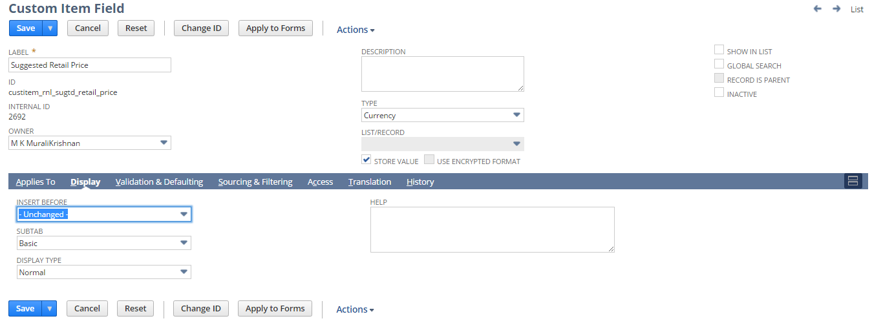

2. To view the custom field in item record go to

List> Accounting > Item > Lists> Select and Edit

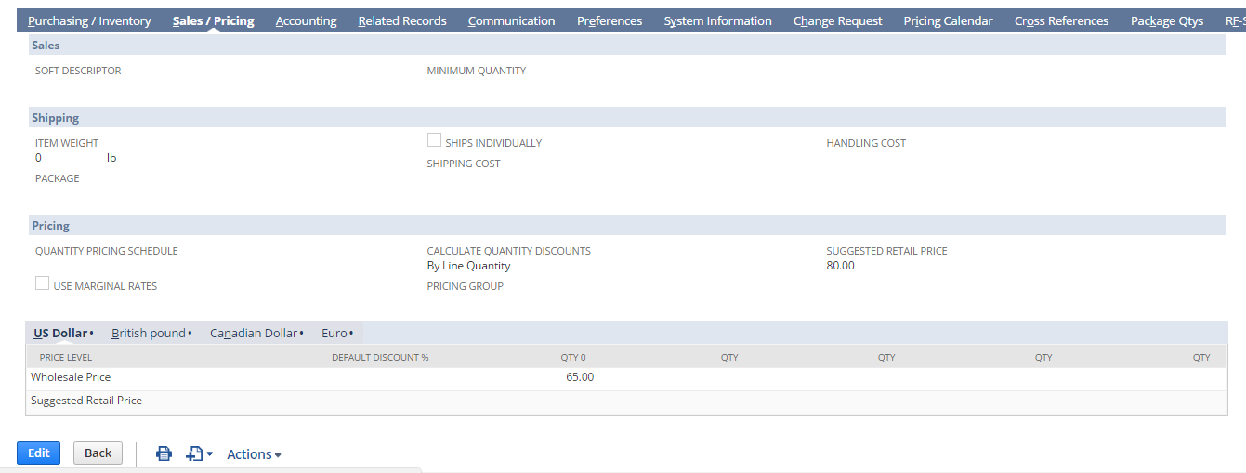

3. To create a saved search report on Price level go to:

List > Search > Saved Search > New

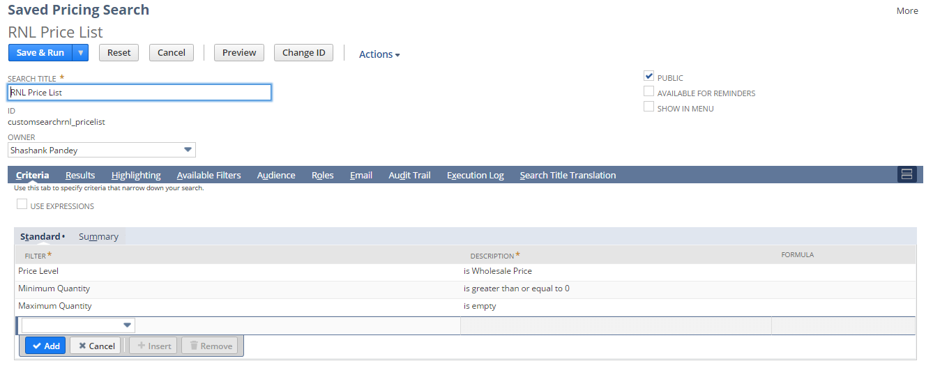

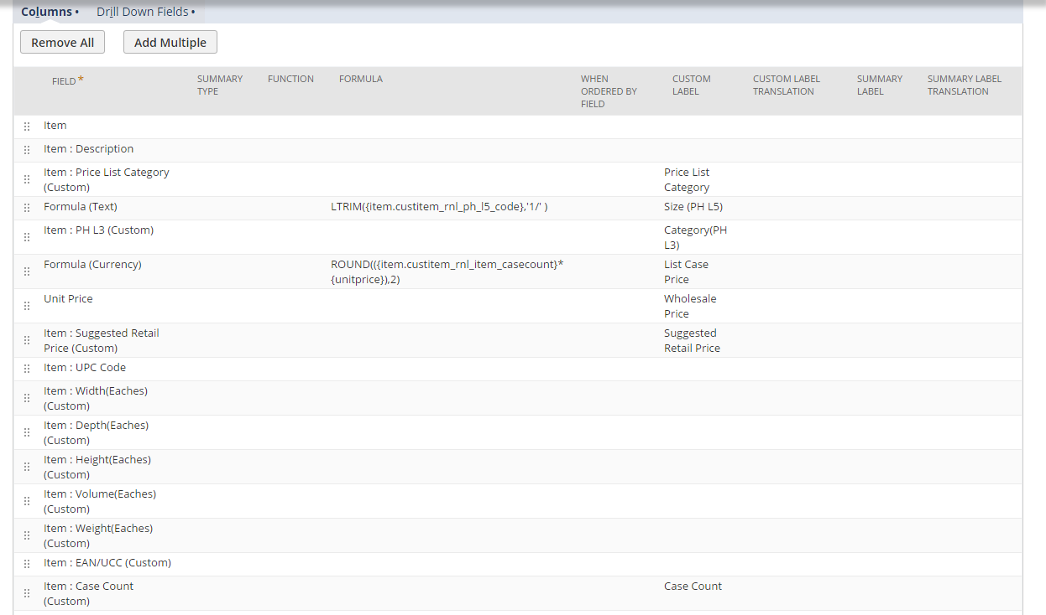

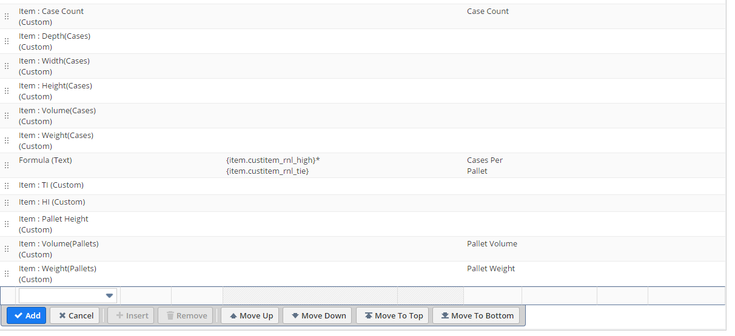

4. To view the saved search report go to:

Report > Saved Search > RNL Price List

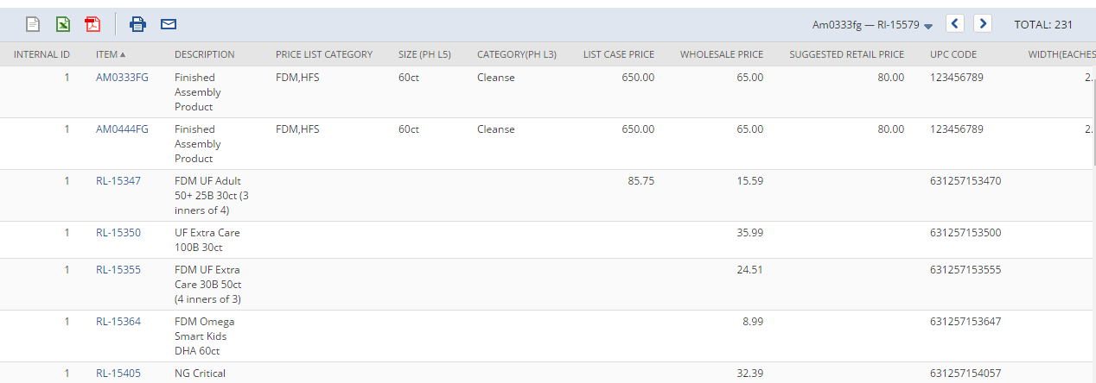

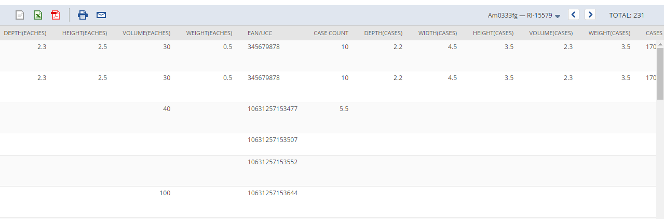

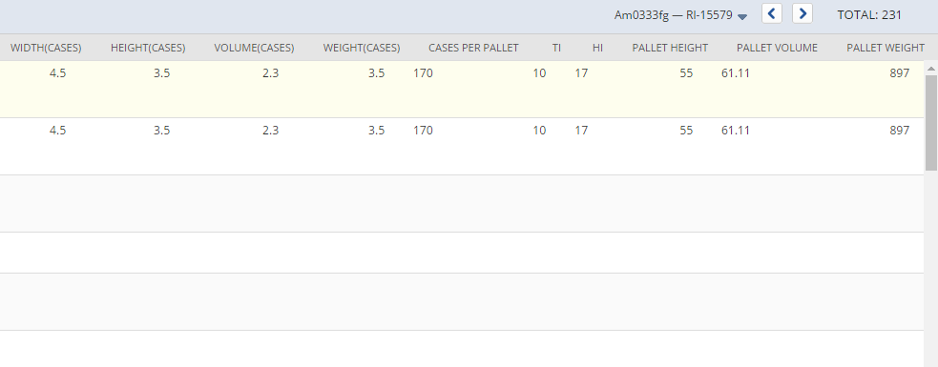

## Req-47: Ability to hold suggested retail price on sales order,invoice and cash sale record

Requirement is to hold suggested retail price on Sales order and invoice record sourced from item record.

### ACCEPTANCE CRITERIA

1. “Suggested Retail Price” field should be available on item record.

2. “Suggested Retail Price” field should be available on sales order record.

3. “Suggested Retail Price” field should be available on invoice record.

4. “Suggested Retail Price” field should be of type currency.

### USE CASES

1. Navigate to Lists > Accounting > Items >New

2. User can add currency value can the “Suggested Retail Price” field.

3. Navigate to Transaction > Sales > Enter Sales Order

4. Navigate to Transaction > Sales > Create Invoices >New

### JEFFERSON IMPACT

No impact

### FUNCTIONAL SOLUTION

There is no functional solution for this requirement.

### TECHNICAL SOLUTION

1. A Custom body field is created. (Refer to req-46)

Details of the custom field is given below:

|  |  |  |  |  |
| --- | --- | --- | --- | --- |
| **Record Type** | **Field** | **Description** | **Type** | **Properties** |
| Item | Suggested Retail Price | This field will have the suggested retail price for price level. | Currency | 1. Display Type=Normal 2. Field Type =Currency 3. Field will be displayed on pricing tab under Sales/Pricing subtab. |

2. Custom transaction column field are created.

Details of the custom fields are given below:

|  |  |  |  |  |
| --- | --- | --- | --- | --- |
| **Record Type** | **Field** | **Description** | **Type** | **Properties** |
| Sales Order | Suggested Retail Price | This column field will be sourced from the suggested retail price field on item record | Currency | 1.Display Type=Disabled  2.Field Type =Currency  3.Form =RL-Sales Order  4. Field will be displayed on line item level under items subtab on sales order record. |
| Invoice | Suggested Retail Price | This column field will be sourced from the suggested retail price field on item record | Currency | 1.Display Type=Disabled  2.Field Type =Currency  3.Form =RL-Product Invoice  4. Field will be displayed on line item level under items subtab on sales order record. |
| Cash Sale | Suggested Retail Price | This column field will be sourced from the suggested retail price field on item record | Currency | 1.Display Type=Disabled  2.Field Type =Currency  3.Form =RL-Cash Sale  4. Field will be displayed on line item level under items subtab on sales order record. |

### CONFIGURATION

1. Create custom Field using below path

Customization->Lists, Records & Fields >Item Fields > New

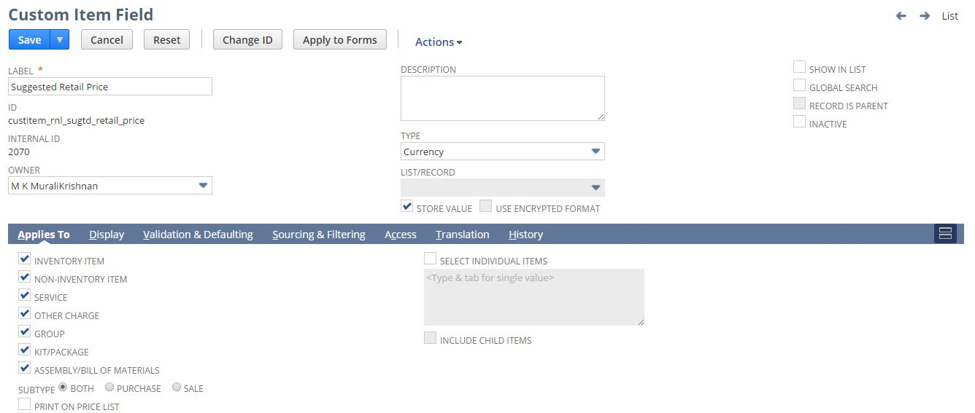

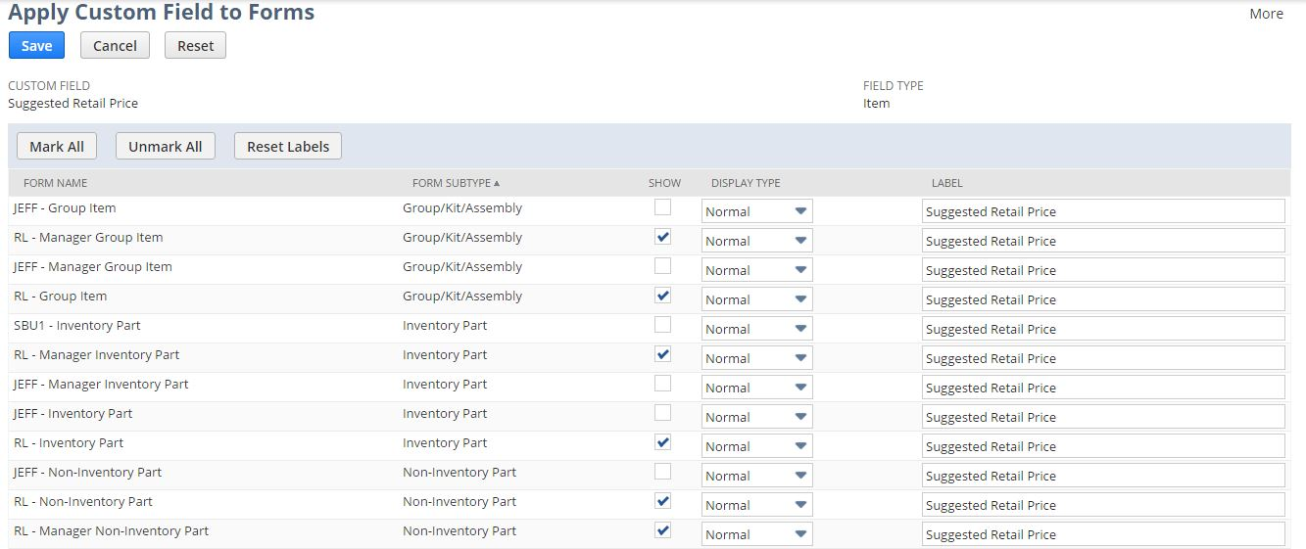

2. Create custom column field using below path

Customization->Lists, Records & Fields >Transaction Column Field > New

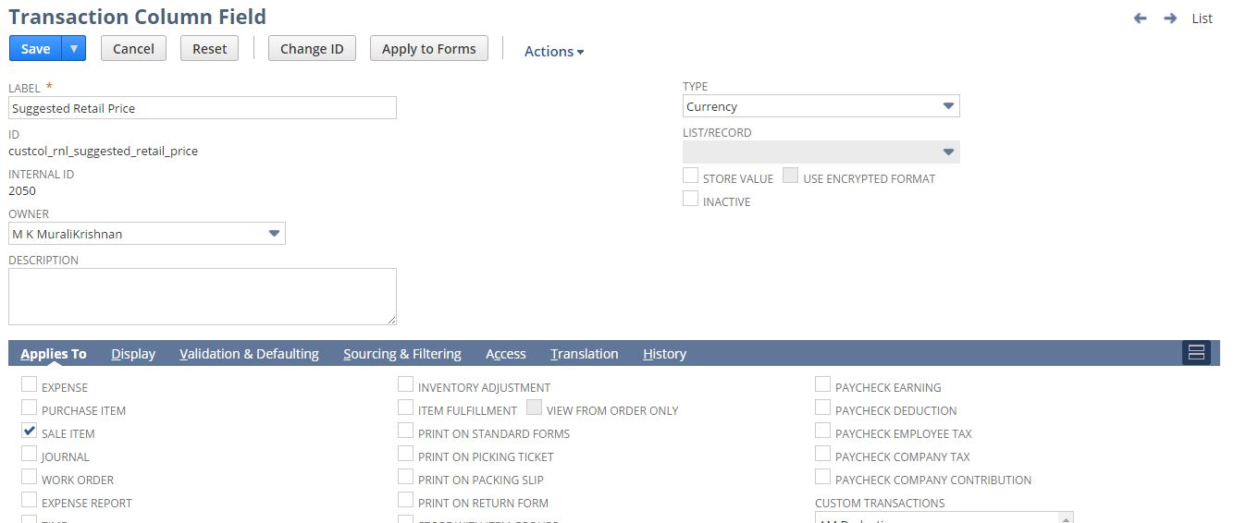

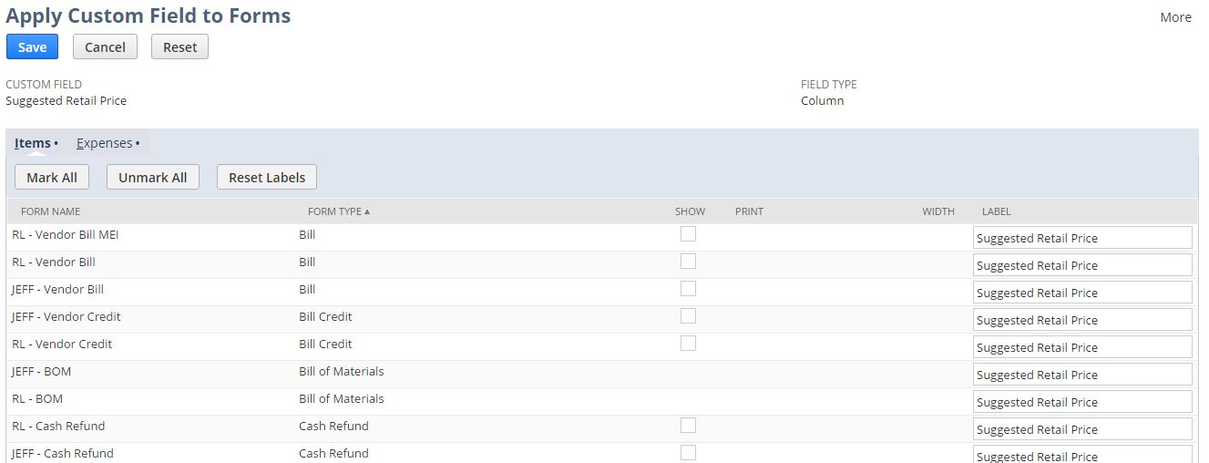

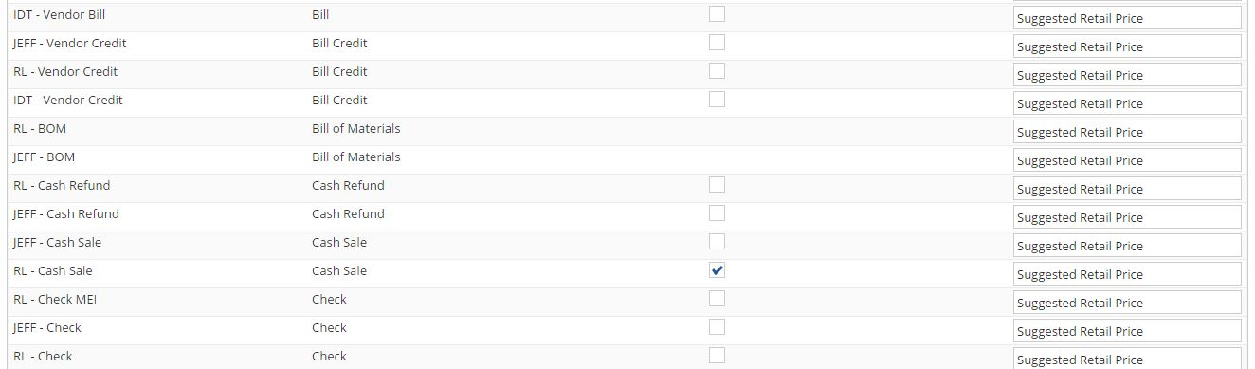

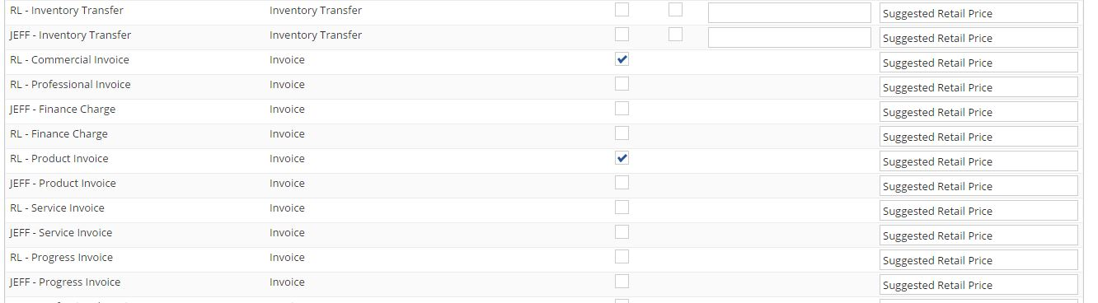

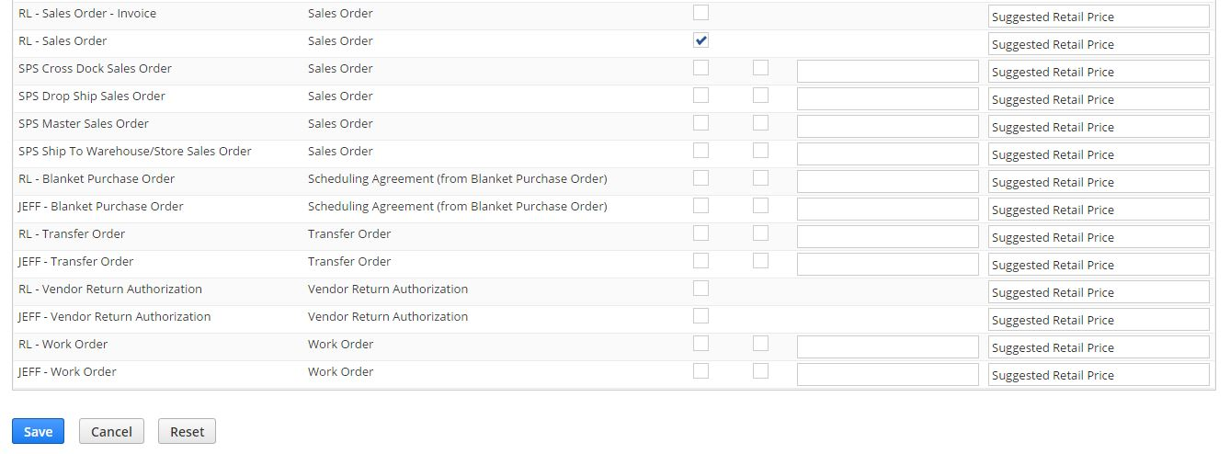

3. To view the custom field in item record go to

Lists-> Accounting > Items > New, Open an item

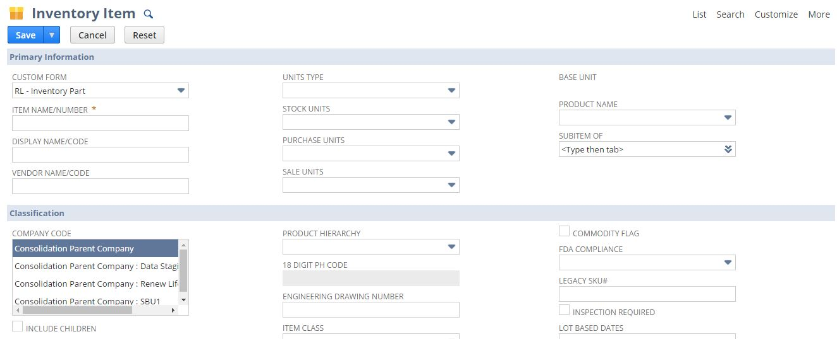

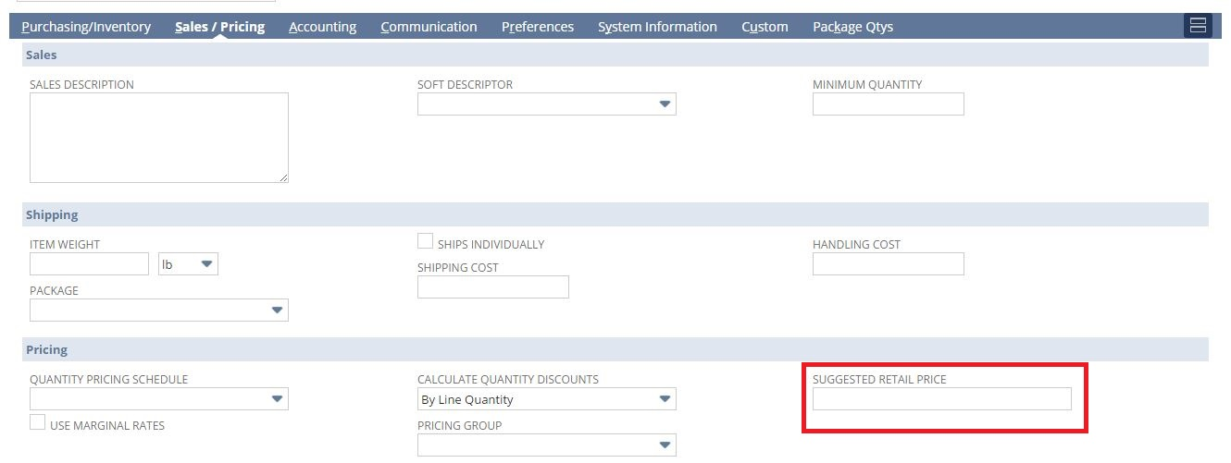

4. To view the custom column field in Sales order record go to

Transaction-> Sales > Enter Sales Order

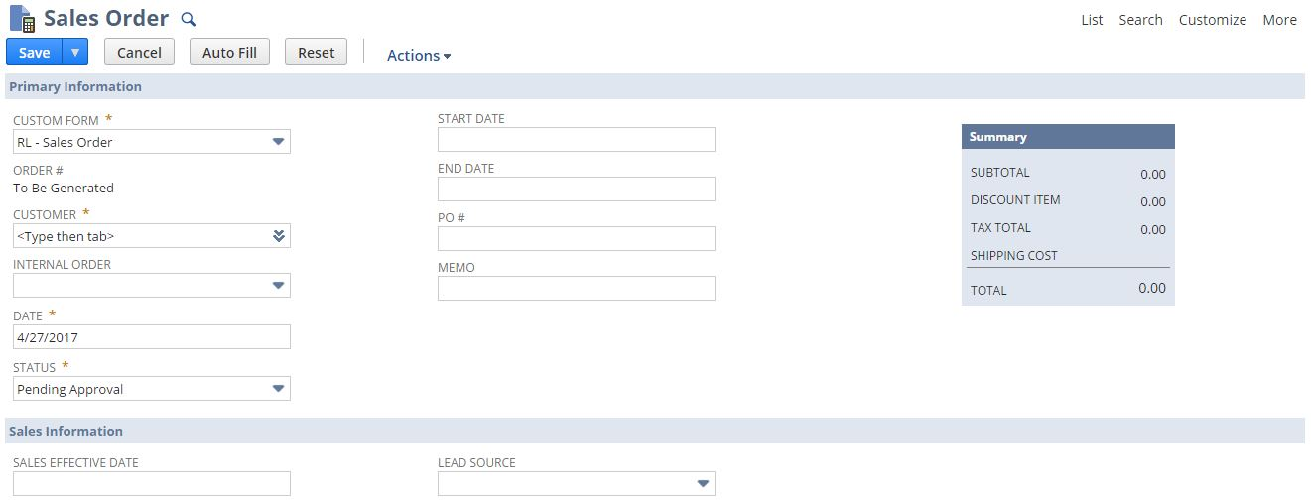

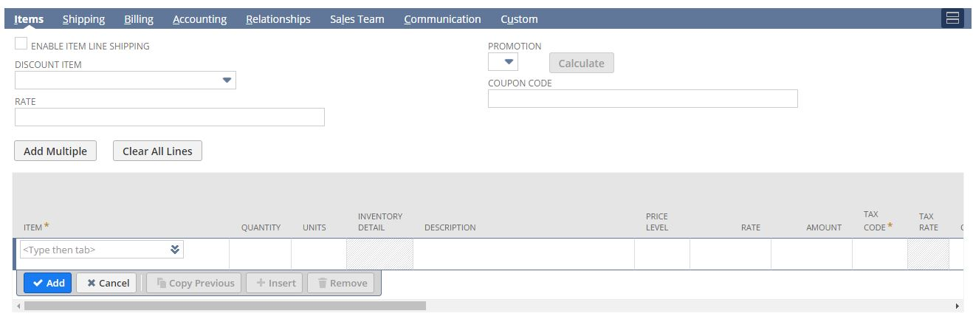

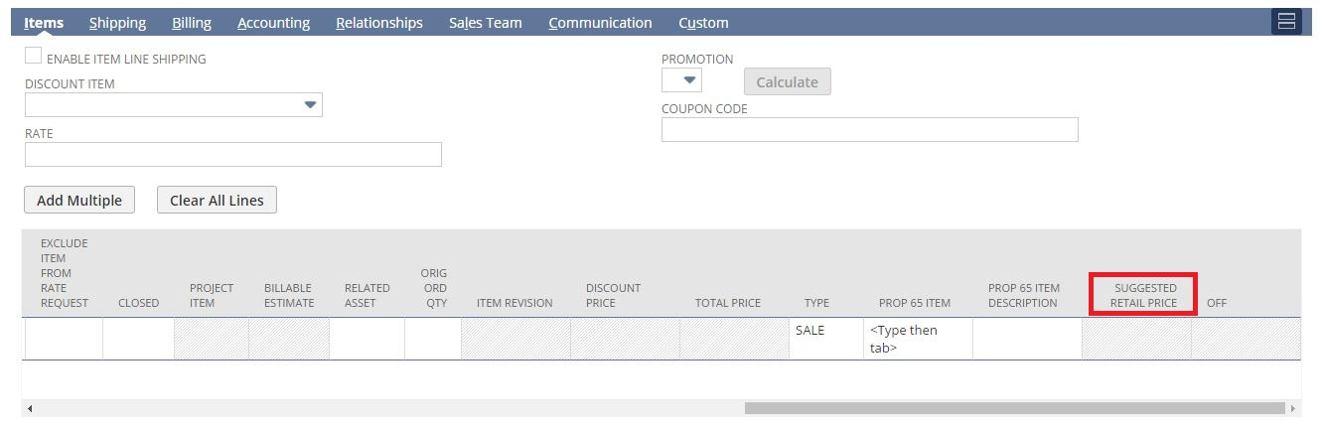

5. To view the custom column field in Invoice record go to

Transaction-> Sales > Create Invoices

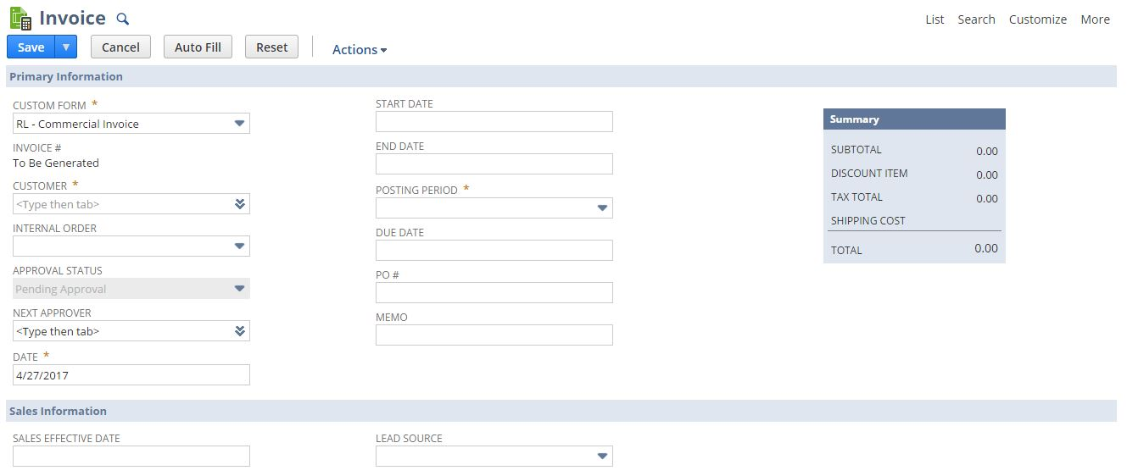

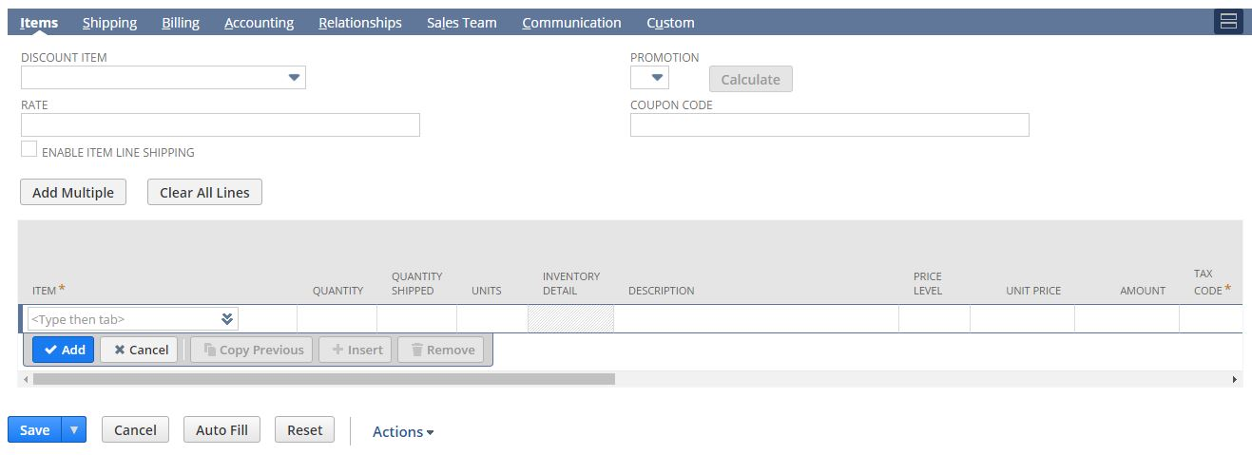

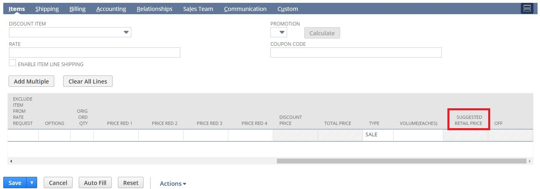

6.To view the custom column field in Cash Sale record go to

Transaction-> Sales > Enter Cash Sales

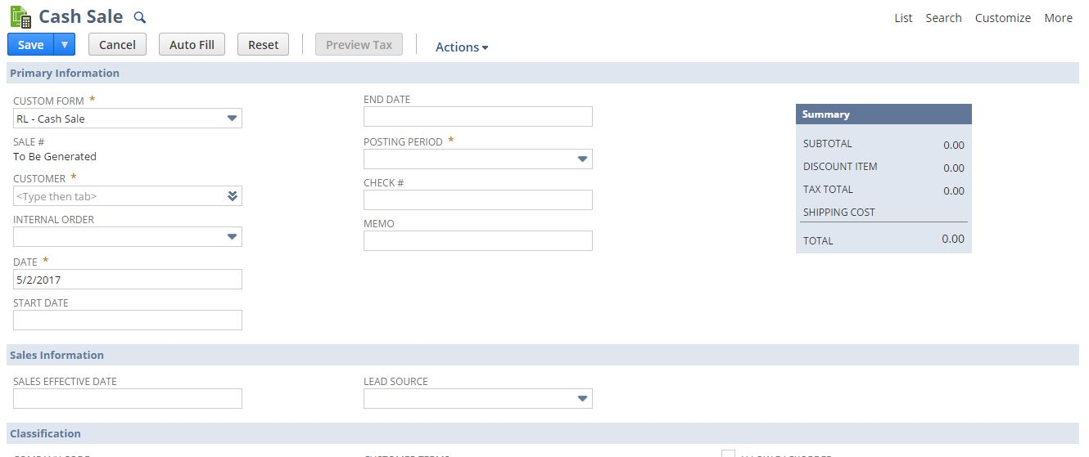

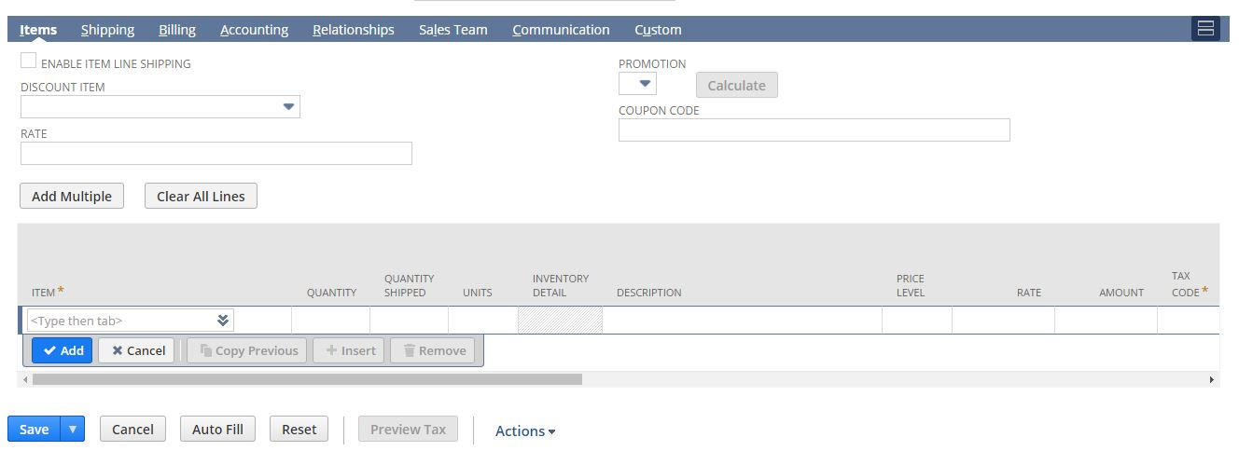

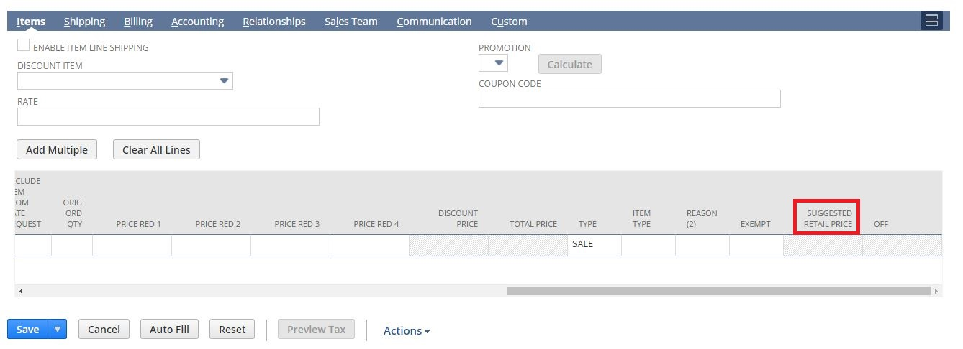

## Req-48: Customized Credit Card Invoice Template

Requirement here is to create a new customized template printing credit card invoice.

### ACCEPTANCE CRITERIA

1. PDF has to be generated as per the new customized layout.

### USE CASES

1. To view the new Invoice, navigate to Transactions > Sales > Cash Sales >List >Print

2. To view the PDF template, navigate to Customization > Forms > Advanced PDF HTML template > RNL Credit card cash sale.

### JEFFERSON IMPACT

No impact

### FUNCTIONAL SOLUTION

There is no functional solution for this requirement.

### TECHNICAL SOLUTION

1 User Event Script needs to be created and deployed on Cash Sale.

|  |  |  |  |  |
| --- | --- | --- | --- | --- |
| **Name** | **Script Type** | **Script** | **Logic Overview** | **Properties** |
| UES_RNL_Invoice_calculation | User Event | This script will calculate the credit card Invoice subtotal and percentage discounts. | * Script will check the line item and calculate the discount on line level as well as on order level. * Script will then store total discount and total amount in custom fields. | 1. The Invoice should be created from  Cash sale  2. A script configuration parameter shall be added which shall provide inputs to the script  Subsidiary internal id |

System Change Impacts for Script

|  |  |  |
| --- | --- | --- |
| **#** | **Impact** | **Analysis** |
| 1 | Impact of Adding new subsidiary | 1. Script configuration parameter subsidiary_internal_id shall accept multiple subsidiary id’s either seperated by “,” OR “|” symbols. So to add a new subsidiary, script configuration parameter shall be extended with new subsidiary id’s. Refer to section 1.38.6.4 for details |
| 2 | Impact of NetSuite Product upgrades | 1. No specific maintenance needed during NetSuite upgrades as Script uses stable API’s of NetSuite. 2. A preview testing shall be needed during upgrades, as advised by NetSuite for all custom developments |
| 3 | Post Go Live maintenance | 1. No specific post go live maintenance needed and should be manageable by support organization |

2. A Customized template to be created.

Details of Customized template are given below:

|  |  |  |
| --- | --- | --- |
| **Record Type** | **Description** | **Columns** |
| Cash Sale | A customized template to print the credit card Invoice. | Quantity Ordered#  Quantity Shipped#  UPC  Item#  Description  Terms  Shipping method  Type  Price |

1. Nine custom fields will be created.

Details of the custom field are given in the table below:

|  |  |  |  |  |
| --- | --- | --- | --- | --- |
| **Record Type** | **Field** | **Description** | **Type** | **Properties** |
| Cash Sale | Quantity Shipped | This field will be used for storing the total quantity shipped for the respective item available on Invoice | Integer Number | 1.Only Integer Number data to be entered  2. It will be displayed on Items Subtab at Item Line Level besides Quantity field.  3.Mandatory=No  4.It is used to store the total quantity shipped on Invoice |
| Cash Sale | Non-taxable  Subtotal | This field will be used for storing the total amount of the invoice | Currency | 1.Display=Hidden  3.Mandatory=No  4.It is used to store the total amount of the Invoice |
| Cash Sale | Total Discount | This field will be used for storing the total discount of the invoice. | Currency | 1.Display=Hidden  3.Mandatory=No  4. It is used to store the total discount of the Invoice. |
| Cash Sale | Customer ID | This field will be used to get the customer number. | Free-Form Text | 1.Display=Hidden  3.Mandatory=No  4. It is used to fetch the customer number. |
| Cash Sale | SO Date | This field will be used to get the Sales order date from the invoice. | Date | 1.Display=Hidden  3.Mandatory=No  4. It is used to fetch the SO date to the invoice. |
| Cash Sale | %OFF | This field will be used for storing the percentage discount on an item in the invoice. | Free-form  Text | 1.Display=Disabled  3.Mandatory=No  4. It is used to store percentage discount on an item. |
| Cash Sale | Discount Price | This field will be used for storing the price after discount of a particular item. | Currency | 1.Display=Disabled  3.Mandatory=No  4. It is used to store price after discount of a particular item. |
| Cash Sale | Total Price | This field will be used for storing the total price of a particular item. | Currency | 1.Display=Disabled  3.Mandatory=No  4. It is used to store the total price of the item. |
| Cash Sale | Item Type | This field is used to source the type of item | List/Record | 1.Display=Normal  3.Mandatory=No  4. It is used to source the value of item type. |

### CONFIGURATION

1.48.6.1 Custom Templates  
 Go to Customization > Forms > Advanced PDF HTML template  
 Click **Customize** next to the layout you want to customize.

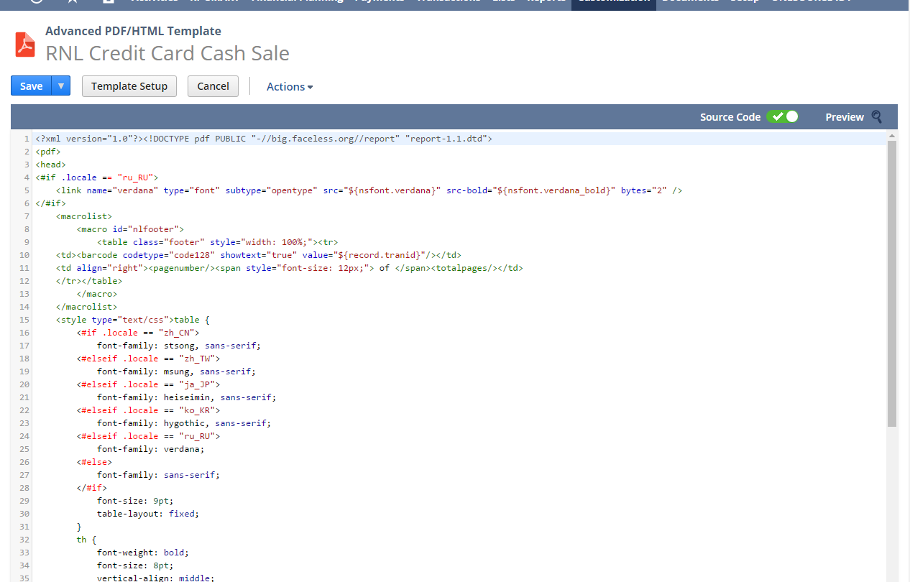



1.48.6.2 Custom Scripts

To Create Script follow the path: Customization->Scripting->Scripts->New



Upload the Script file and click on Create Script Record Button and then choose User Event Script.

To view Script Deployment follow the path: Customization->Scripting->Scripts Deployment



1.48.6.3 Custom fields  
Go to Customization -> Lists, Records & Fields ->Transaction Column Fields -> New  
Apply to RL- Commercial Invoice, RL – Cash Sale and RL – Product Invoice.

Quantity Shipped



%OFF



Discount Price



Total Price



Item Type



Go to Customization -> Lists, Records & Fields ->Transaction Body Fields -> New

Non-Taxable Subtotal:  


Total Discount



SO Date



Customer ID



1.48.6.4 Updating Custom scripts for new Subsidiary additions\ deletion

Below script parameters needs to be updated either with “,” or “|” symbol for any new subsidiary





## Req-49: Ability to create a new Journal Entry form for MEI

Requirement is to create custom form for Journal Entry in order to perform MEI transaction .

### ACCEPTANCE CRITERIA

1.Custom form should be available for Journal Entry

2.Two fields Customer Level 3 and Product Hierarchy Level 3 to be added to custom form.

### USE CASES

1. Navigate to Customization ->Forms ->Transaction Forms

2. Select the RL - Journal Entry MEI.

### JEFFERSON IMPACT

No impact

### FUNCTIONAL SOLUTION

1. Customize the Journal Entry form.

2. Save the Form to mark the required changes.

|  |  |  |  |
| --- | --- | --- | --- |
| **Record Type** | **Name** | **Description** | **Properties** |
| Journal Entry | RL - Journal Entry MEI | 1.Create new custom forms for Journal Entry  2. Add the custom fields “Customer Level 3” ,”Product Hierarchy Level 3” | The fields created will be displayed under Lines tab. |

### TECHNICAL SOLUTION

1. Custom fields will be created on Journal Entry record.

Details of the custom field are given below:

|  |  |  |  |  |
| --- | --- | --- | --- | --- |
| **Record Type** | **Field** | **Description** | **Type** | **Properties** |
| Transaction (Journal Entry) | Customer Level 3 | This field is for Level 3 Customer Hierarchy List | List/Record | 1. Display Type= Normal 2.Source the custom List " Level 3 Customer Hierarchy"  3.Field will be displayed at the Column level of the record. |
| Transaction (Journal Entry) | Product Hierarchy Level 3 | This field is for show product Hierarchy Level 3 lists value | List/Record | 1. Display Type= Normal  2. Source the custom List “PH5 L3 Purpose“  3.Field will be displayed at the Column level of the record. |

### CONFIGURATION

Create custom Field using below path

Customization->Lists, Records & Fields >Transaction Column Fields > New

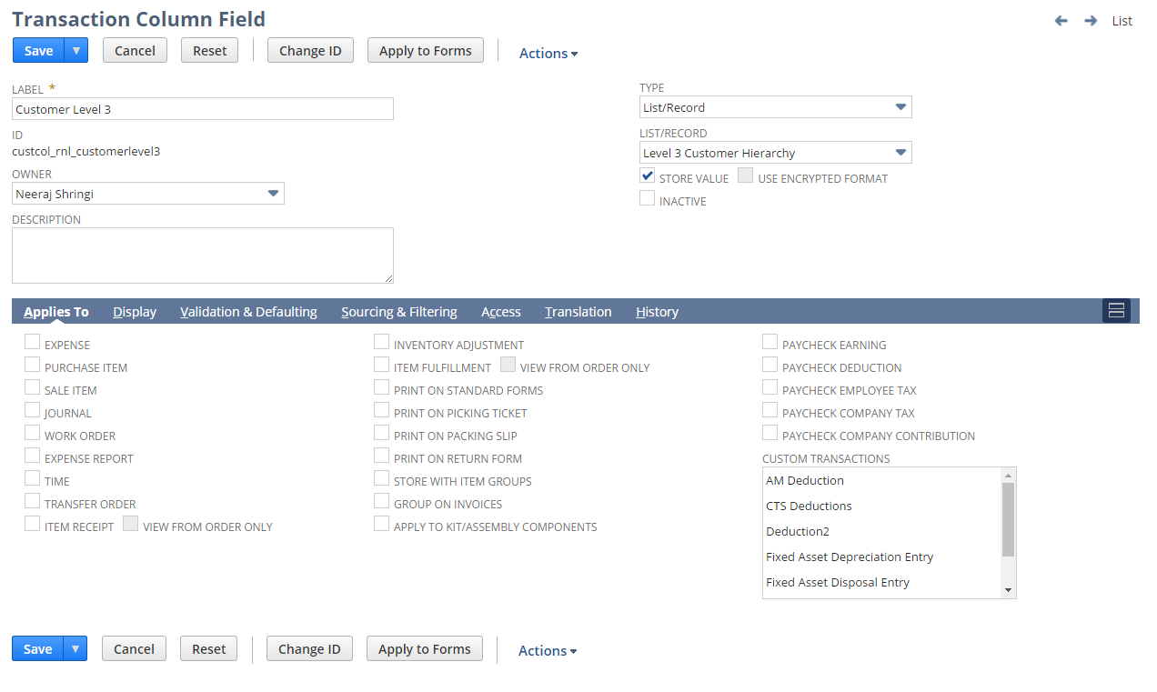

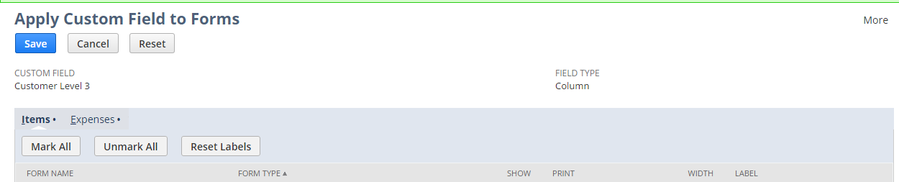



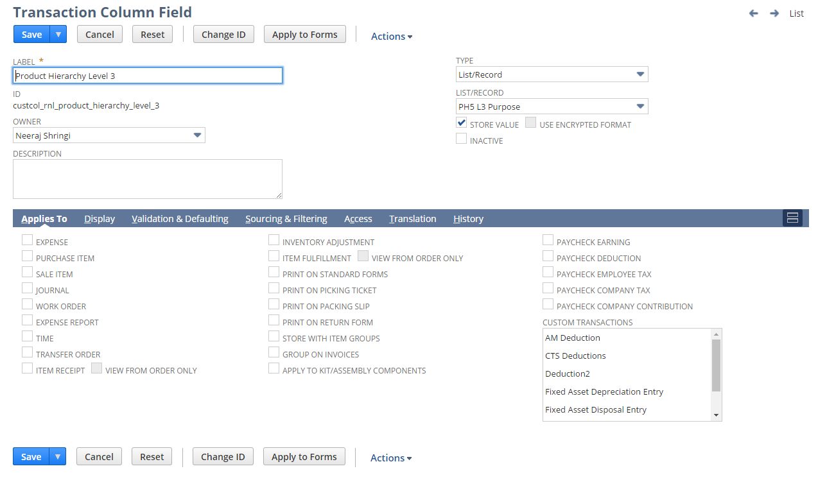

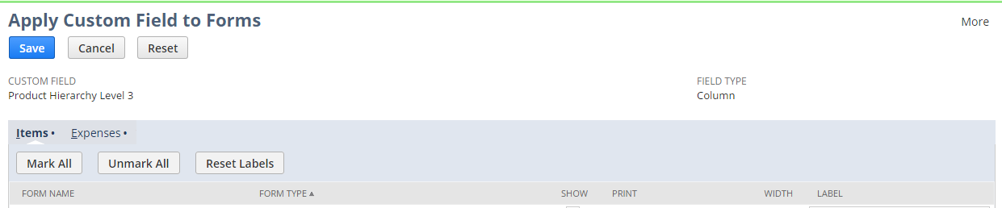



Create the RL - Journal Entry MEI Form using below path

Customization -> Forms -> Transaction Forms and Edit the form

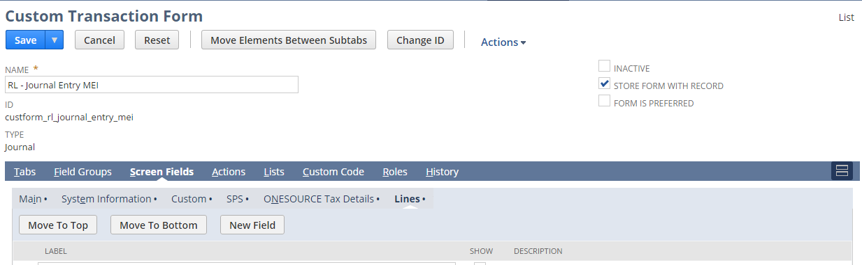

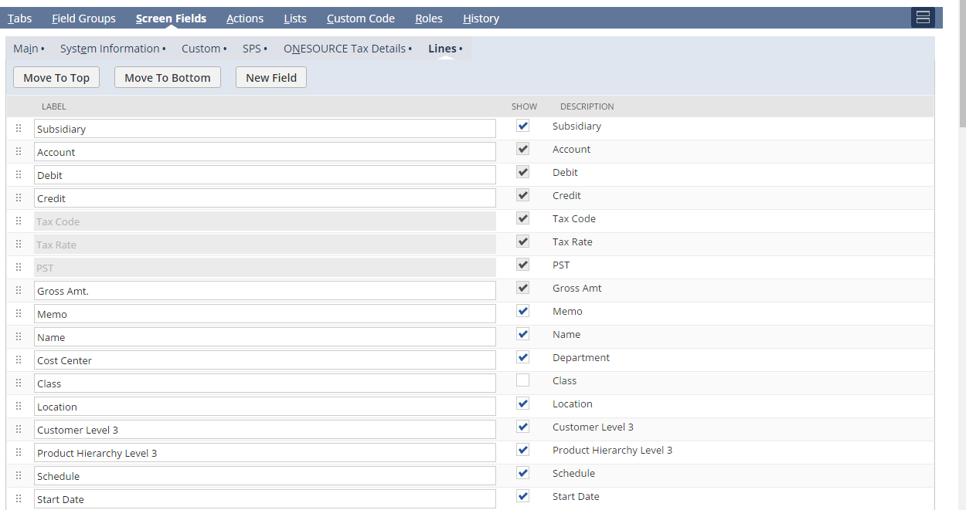

View the RL - Journal Entry MEI Form Using the below Path

Transactions -> Financial -> Make Journal Entry >New and select the Custom Form :RL - Journal Entry MEI

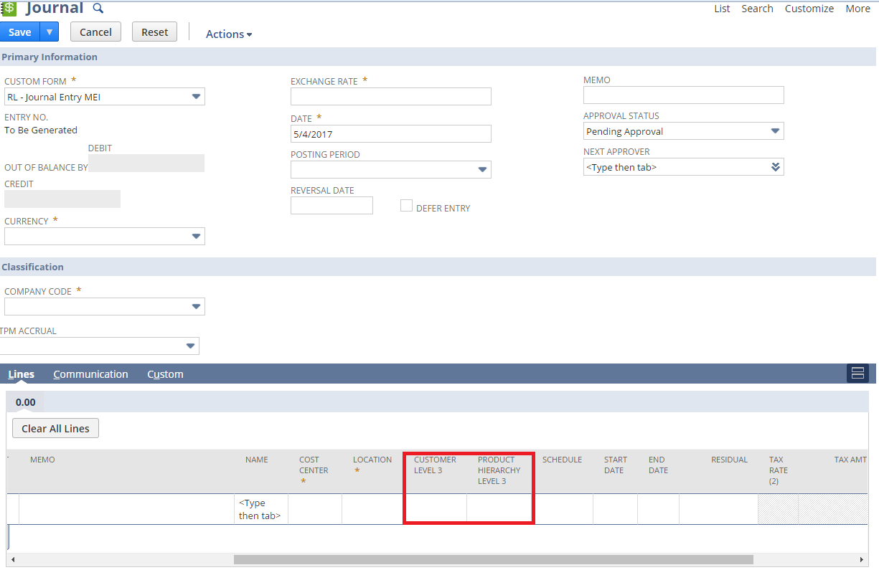

## Req-50: Ability to Group the Locations

Requirement is to support reporting on location additional custom list field to be created named as Location Group on Location record.

### ACCEPTANCE CRITERIA

1. Location Group field should be available on Location record.

2. Location Group should be list field

### USE CASES

1. Navigate to Setup > Company > Locations> New

2. Enter all Location relevant details

3. User shall be able to select Location Group for that Location

### JEFFERSON IMPACT

Yes, this field will be shown on Location record and it does not have any restriction for Jefferson or Madison.

### FUNCTIONAL SOLUTION

There is no functional solution for this requirement.

### TECHNICAL SOLUTION

1. A custom field will be created on location record.

Details of the custom field are given below:

|  |  |  |  |  |
| --- | --- | --- | --- | --- |
| **Record Type** | **Field** | **Description** | **Type** | **Properties** |
| Location | Location Group | Custom Location Group List for Locations. | List Record | 1. Display Type=Normal 2. Field Type =List/Record 3. Field will be displayed on Location record only 4. Field to be sourced from Location Group list |

2. A custom list will be created on location record.

Details of the custom list are given below:

|  |  |  |  |
| --- | --- | --- | --- |
| **Name** | **Description** | **Values** | **Properties** |
| Location Group | Custom Location Group List for Locations. | * East Coast DC * West Coast DC * CoPacker-All * CoPacker * Tax Location | 1. Custom Location Group List for Locations. |

### CONFIGURATION

1. Create custom list using below path

Customization > Lists, Records & Fields > Lists > New

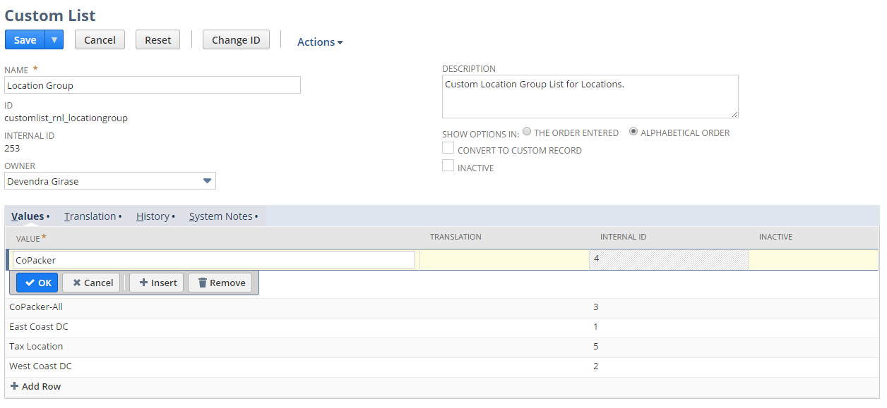

2. Create custom Field using below path

Customization->Lists, Records & Fields >Other Custom Fields > New

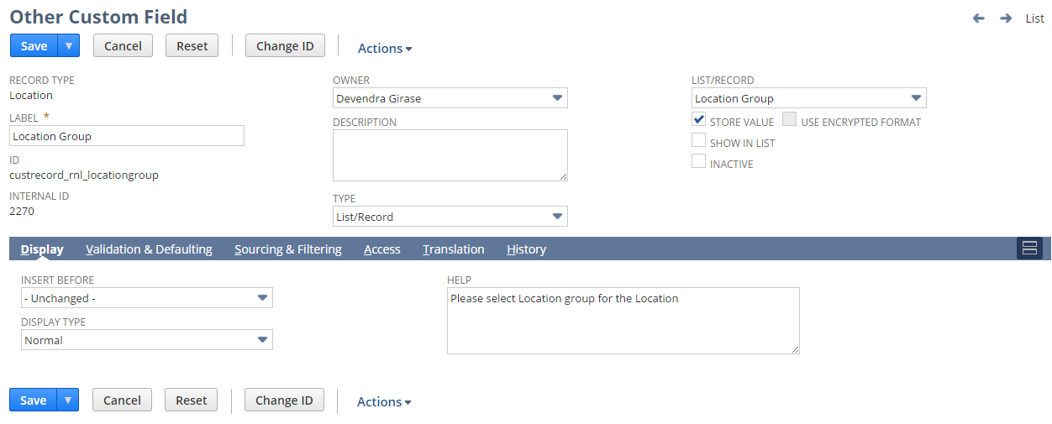

3. Create Location using below path

Setup > Company > Locations > New

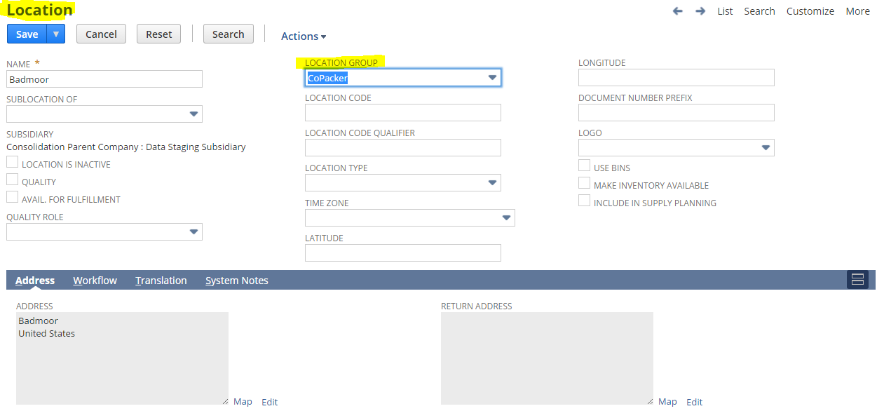

## Req-51: Ability to add Credit Approve Date for Customer

Requirement is to hold credit approve date on Customer record.

### ACCEPTANCE CRITERIA

1. “Credit Approve Date” field should be available on Customer record.

2. “Credit Approve Date” field should be of type date.

### USE CASES

1. Navigate to Lists > Relationship > Customers >New

2. User shall be able to select date value from the “Credit Approve Date” field.

### JEFFERSON IMPACT

No impact

### FUNCTIONAL SOLUTION

There is no functional solution for this requirement.

### TECHNICAL SOLUTION

1. A custom field will be created on Customer record.

Details of the custom field are given below:

|  |  |  |  |  |
| --- | --- | --- | --- | --- |
| **Record Type** | **Field** | **Description** | **Type** | **Properties** |
| Customer | Credit Approve Date | This field on the customer record will hold credit approve date. | Date | 1. Display Type=Normal 2. Field Type =Date 3. Field will be displayed on financial tab under Account Information Field group. |

### CONFIGURATION

1. Create custom Field using below path

Customization->Lists, Records & Fields >Entity Fields > New

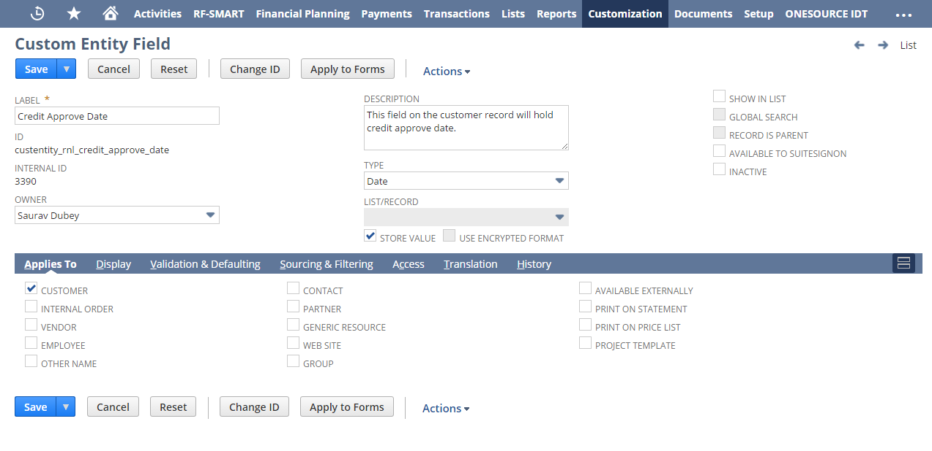

## Req-52: Ability to add Legacy customer id for Customer

Requirement is to create the field on customer where the Sage legacy customer ID

will be hosted.

### ACCEPTANCE CRITERIA

1. “Legacy customer ID” field should be available on Customer record.

2. “Legacy customer ID” field should be of type free-form text.

### USE CASES

1. Navigate to Lists > Relationship > Customers >New

2. User shall be able to see value of legacy Customer ID on main tab under classification

### JEFFERSON IMPACT

No impact

### FUNCTIONAL SOLUTION

There is no functional solution for this requirement.

### TECHNICAL SOLUTION

1. A custom field will be created on Customer record.

Details of the custom field are given below:

|  |  |  |  |  |
| --- | --- | --- | --- | --- |
| **Record Type** | **Field** | **Description** | **Type** | **Properties** |
| Customer | Legacy customer ID | This is the field on customer where the Sage legacy customer ID will be hosted. | Free-Form Text | 1. Display Type=Normal 2. Field Type = Free-Form Text 3. Field will be displayed on main tab under classification. |

### CONFIGURATION

1. Create custom Field using below path

Customization->Lists, Records & Fields >Entity Fields > New

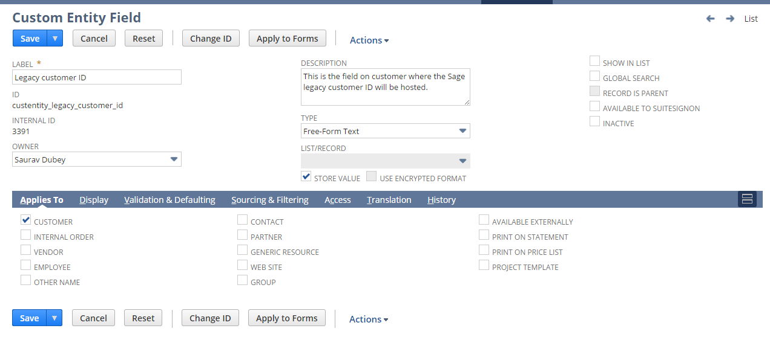

## Req-53: Ability to display remaining credit available and place a check on Credit Limit and Credit Days Limit

Requirement is to display the remaining credit available and based on those credits determine if the Sales Order can be further processed or not. If not, then trigger an email to its respective approver for approval

### ACCEPTANCE CRITERIA

1. Location Group field should be available on Location record.

2. Location Group should be list field

### USE CASES

1. Navigate to Transaction > Sales > Enter Sales Order
2. Create a Sales Order.
3. When the condition is met where either Credit Limit is greater than Allocated Amount OR Days overdue > Credit Limit Days, NetSuite displays credit warning.
4. User can click OK and Save the Sales Order.
5. When Approve button is Clicked, the SO should not get approved if the condition = True as mentioned in Step 3.
6. Only a specific role RNL Credit Limit Approver should be allowed to approve the orders.
7. A Saved search and dashboard reminder on the role’s dashboard.
8. Two checkboxes are added on the Approve Sales Order screen to mark the Sales Order that are in CREDIT HOLD.
9. If a SO goes into HOLD for the authorized user, an email will be triggered.
10. If SO is on hold due to Credit Limit then it will go to one email address.
11. If SO is on hold due to Past Due – then it will be triggered to another address.

12.A Saved Search is created to display SO with custom fields.

### JEFFERSON IMPACT

No impact

### FUNCTIONAL SOLUTION

There is no functional solution for this requirement.

### TECHNICAL SOLUTION

1. Custom fields will be created on Sales record and Customer Record.

Details of the custom fields are given below:

|  |  |  |  |  |
| --- | --- | --- | --- | --- |
| **Record Type** | **Field** | **Description** | **Type** | **Properties** |
| Sales Order | CR Hold | This field will store the value sourced from the Hold field present on the Customer Record. | Free-Form Text | 1. Display Type=Hidden 2. Field Type =Free-Form Text 3. Field will not be displayed on the Sales Order 4. Field to be sourced from Customer Record (Credit Hold field). |
| Sales Order | Days over due | This field would be present on the Sales Order record and would denote if the Sales Order is in Hold state or not. This checkbox will marked true if the Due days for a customer is greater than the Available  Credit Limit Days and credit hold is Auto | Checkbox | 1. Display Type=Normal 2. Field Type = Checkbox 3. Field will be displayed on the Sales Order under Primary Information Field Group.   Field will be set to true if the Due days for a customer is greater than the Available Credit Limit Days and credit hold is Auto, conditions given in the script “RNL Credit Hold Check UE” is fulfilled. |
| Sales Order | Over Credit Limit | This field would be present on the Sales Order record and would denote if the Sales Order is in Hold state or not. This checkbox will marked true if the Credit Limit for a customer is greater than the zero and credit hold is Auto | Checkbox | 1. Display Type=Normal 2. Field Type = Checkbox 3. Field will be displayed on the Sales Order under Primary Information Field Group. 4. Field will be set to true if the credit limit remaining for a customer is greater than the zero and credit hold is zero, conditions given in the script “RNL Credit Hold Check UE” is fulfilled. |
| Customer | Remaining Credit Limit | * This field would be present under financial subtab and would display the value which can be utilized by the Customer. * If present in negative then that much amount is left with the Customer from his Credit Limit. * If Positive then the customer has exceeded the limit by that much amount. | Currency | 1. Display Type=Normal 2. Field Type = Currency 3. Field will be displayed on the Customer under Financial Subtab 4. Field would be set by the formula : (Balance + Unbilled Orders – Credit Limit) |

2. Custom Saved Search will be created on Sales Order.

Details of the Saved Search is given below:

|  |  |  |  |  |  |
| --- | --- | --- | --- | --- | --- |
| **Record Type** | **Name** | **Description** | **Filters** | **Columns** | **Properties** |
| Sales Order | RNL SO Pending For Approval (Credit Limit) | This saved search will show the sales orders with days overdue and over credit limit checkbox values. | In Standard Tab:   * Type=Sales Order * Mainline=True * Days overdue = True OR Over credit limit =True | * Document Number * Name * Days overdue * Over credit limit * Amount | * Company Code field will be defaulted in criteria for search. |

3. Custom Scripts will be created on Sales Order.

Details of the custom scripts are given below:

|  |  |  |  |  |
| --- | --- | --- | --- | --- |
| **Name** | **Type** | **Description** | **Logic Overview** | **Properties** |
| RNL Accounting Preference | Workflow Action Script | Workflow action script will be used to check whether the Due days for a customer is greater than the Available  Credit Limit Days wherever the Credit hold is set to Auto. If yes, then throw an error to the user and stop the sales order from getting approved. The Sales Order then can only be approved by the RNL Credit Limit Approver. | * Check if the logged in user subsidiary is “RL sub”, if not exit * Check if Credit hold is Auto or not * Check if Days Overdue is greater than Credit Limit days or not. * Check if role is RNL Credit Limit Approver * The script will fetch values of fields ‘[Days](javascript:void(%22help%22)) Overdue For Warning/Hold’. | 1. The script will be executed on Approve button click of Sales Order.  2. It will fetch the values for [Days](javascript:void(%22help%22)) Overdue For Warning/Hold from Customer record and then using the fields to validate the Credit limit check.  3. A script configuration parameter shall be added which shall provide inputs to the script   * Subsidiary Internal id * Credit Limit Approver |
| RNL Credit Hold Check UE | User Event Script | This script will be triggered on the save of Sales Order and will set the Credit Hold Check checkbox to true if Credit Limit Days is less than the Due days or the Credit Limit available is exceeded by the Customer in the script are true and trigger the mail accordingly. | * Check if the logged in user subsidiary is “RL sub”, if not exit * Check if Credit hold is Auto or not * Check if Credit limit is exceeded or not * Check if Days Overdue is greater than Credit Limit days or not. * Check if role is RNL Credit Limit Approver * The script will trigger the email as per the condition fulfilled i.e. whether the Credit limit is exceeded or the Credit linit days are exceeded to the respective approver | 1. The script will be executed on Save of Sales Order.  2. It will fetch the values for [Days](javascript:void(%22help%22)) Overdue For Warning/Hold from Customer record and then using the fields to validate the Credit limit check.  3. A script configuration parameter shall be added which shall provide inputs to the script   * Subsidiary Internal id * Credit Limit Approver |

System Change Impacts for Script

|  |  |  |
| --- | --- | --- |
| **#** | **Impact** | **Analysis** |
| 1 | Impact of Adding a new Credit Limit Approver Role | 1. Script configuration parameter Credit limit Approver shall accept multiple role ids either separated by “,” OR “|” symbols. So to add a new credit limit approver role, script configuration parameter shall be extended with new role ids. Refer to section 1.53.6.4 for details |
| 2 | Impact of Adding new subsidiary | 1. Script configuration parameter subsidiary_internal_id shall accept multiple subsidiary ids either separated by “,” OR “|” symbols. So to add a new subsidiary, script configuration parameter shall be extended with new subsidiary ids. Refer to section 1.53.6.4 for details |
| 3 | Impact of NetSuite Product upgrades | 1. No specific maintenance needed during NetSuite upgrades as Script uses stable API’s of NetSuite. 2. A preview testing shall be needed during upgrades, as advised by NetSuite for all custom developments |
| 4 | Post Go Live maintenance | 1. No specific post go live maintenance needed and should be manageable by support organization |

3. A custom workflow needs to be defined to check the credit limit and Credit hold value on Sales Order. Details of the custom workflow are given in the below table:

|  |  |  |  |  |
| --- | --- | --- | --- | --- |
| **Record Type** | **Name** | **Description** | **States & Transitions** | **Properties** |
| Transaction(Sales Order) | RNL SO Approval based on Credit Limit | This workflow will be used for approval process of Sales Order based on Credit Limit and Customer overdue days. | Approval | Workflow will be triggered only if the logged in user is assigned to RL subsidiary and Approve button is clicked on Sales Order record |

Details of the workflow



System Change Impacts for Workflow

|  |  |  |
| --- | --- | --- |
| **#** | **Impact** | **Analysis** |
| 1 | Impact of Adding new subsidiary | 1. Current workflow executes only on below conditions    * Logged in user’s subsidiary is Renew Life 2. To include a new subsidiary workflow trigger condition needs to be updated as shown in configuration section   Refer to Section 1.53.6.5 for details |
| 2 | Impact of NetSuite Product upgrades | 1. No specific maintenance needed during NetSuite upgrades as Script uses stable API’s of NetSuite. 2. A preview testing shall be needed during upgrades, as advised by NetSuite for all custom developments |
| 3 | Post Go Live maintenance | 1. No specific post go live maintenance needed and should be manageable by support organization |

### CONFIGURATION

1.53.6.1 Custom Transaction Body Fields  
To create follow path Customization->Lists, Records & Fields-> Transaction Body Fields->New

CR Hold

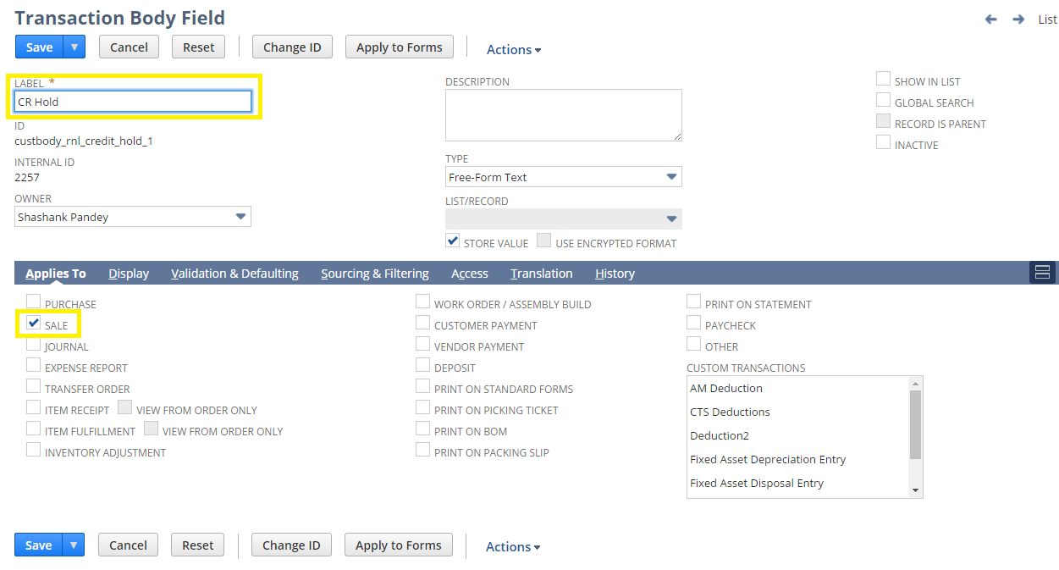

Days over due

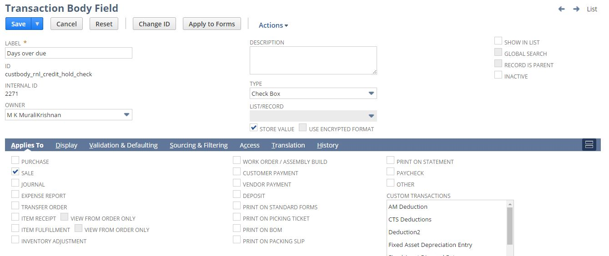

Over Credit Limit

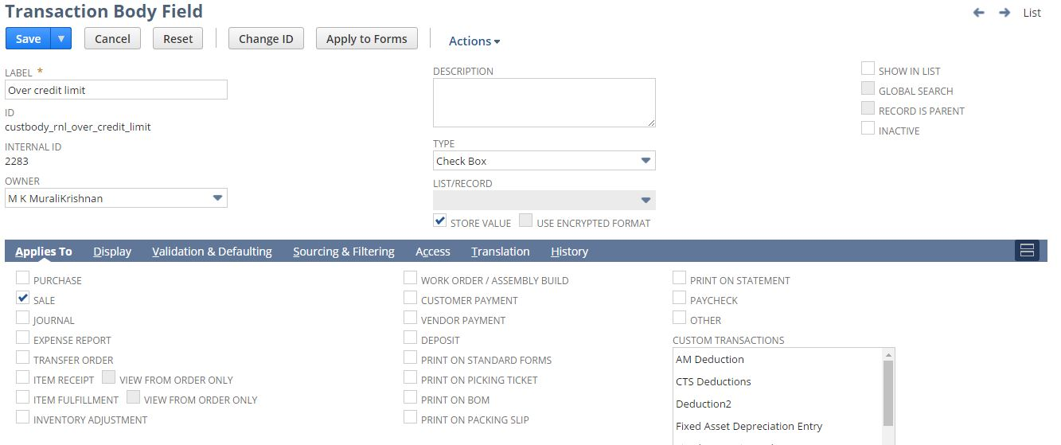

1.53.6.2 Custom Entity Fields

To create follow path Customization->Lists, Records & Fields-> Entity Fields->New  
  
Remaining Credit Limit

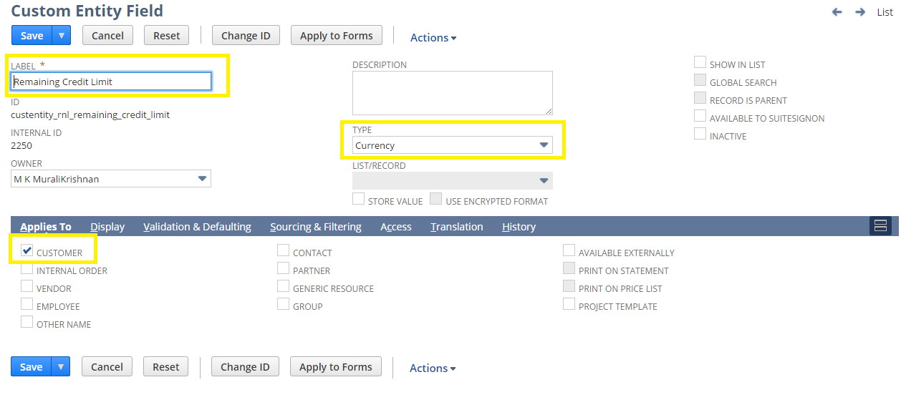

1.53.6.3 Custom Saved Search

To create Custom Saved Search follow path Lists->Search->Saved Searches->New

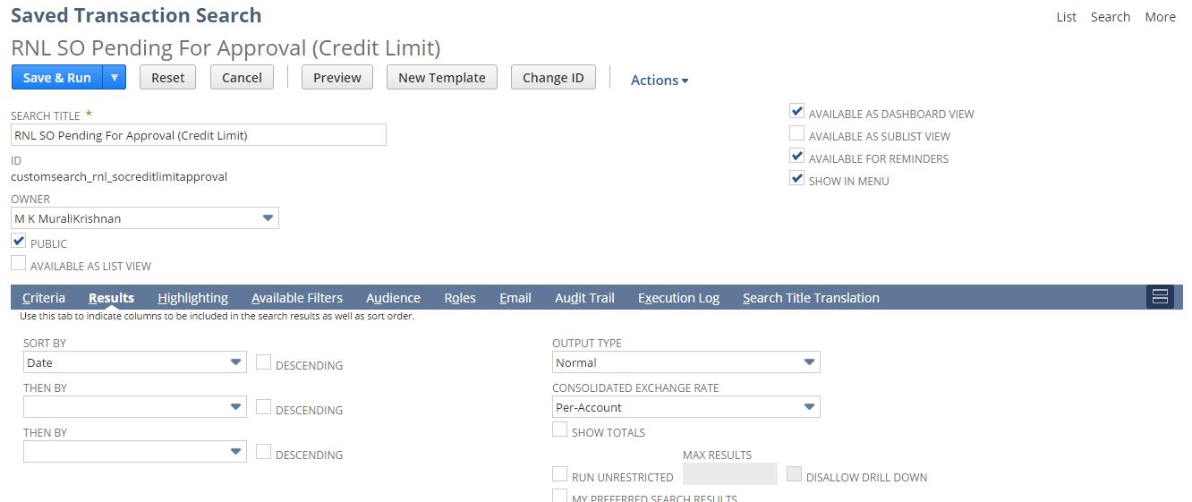

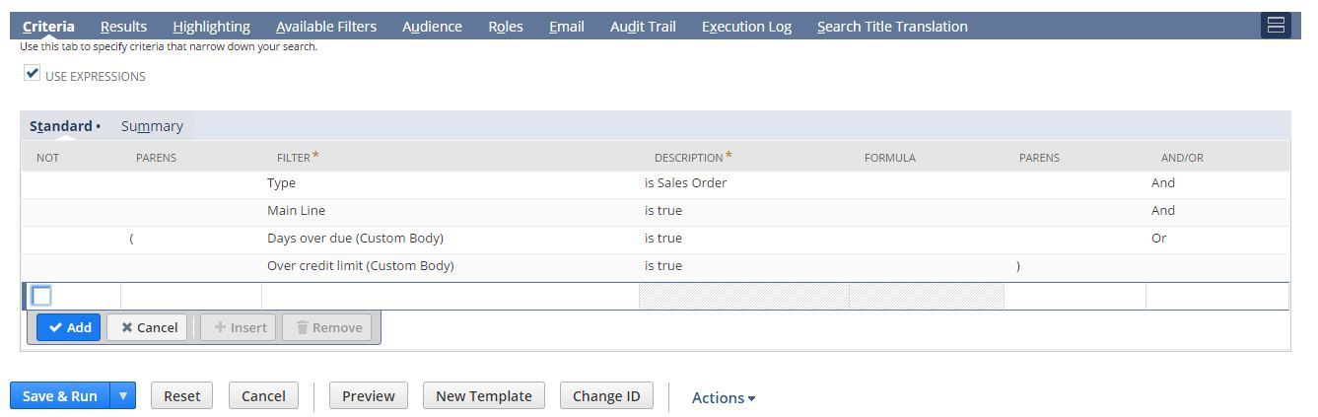

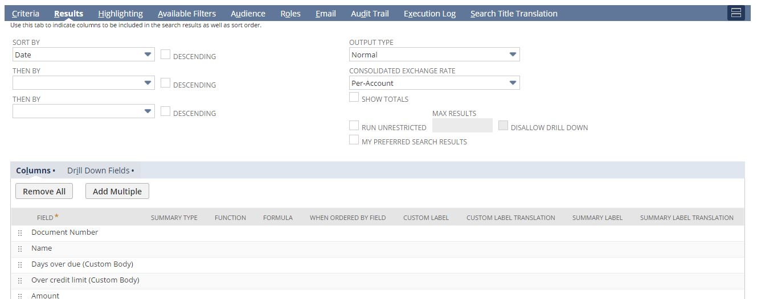

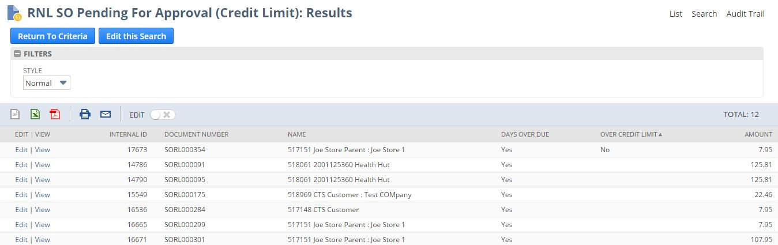

#### 1.53.6.4 Custom scripts

To create Custom Script follow path Customization->Scripting->Script->New



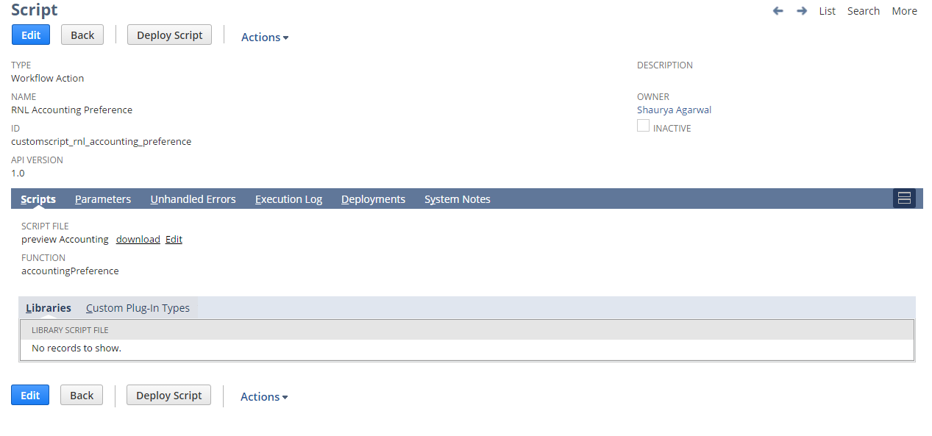

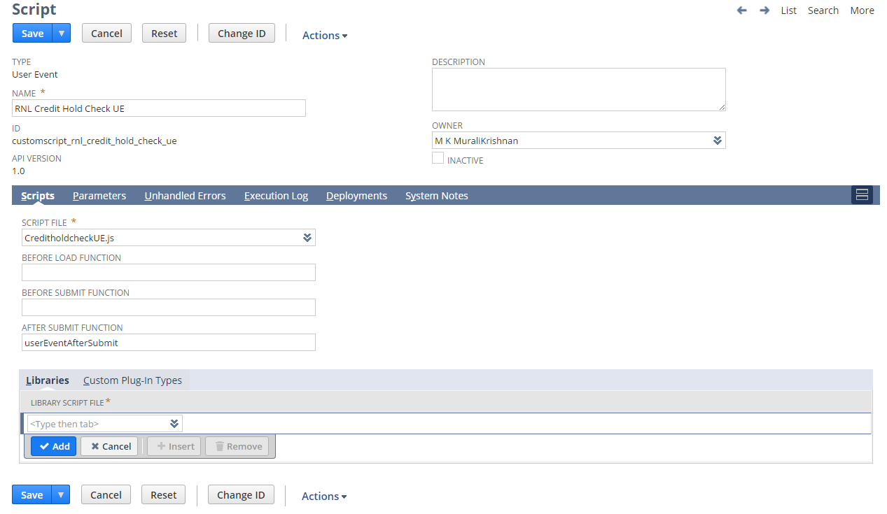

To view Script Deployment follow below path customization->Scripting->Scripts Deployment

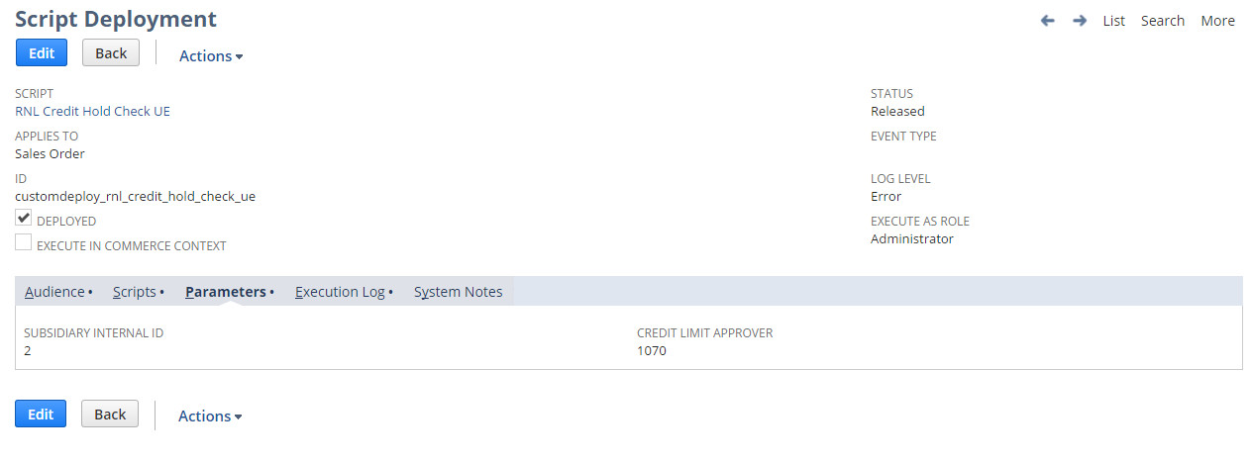

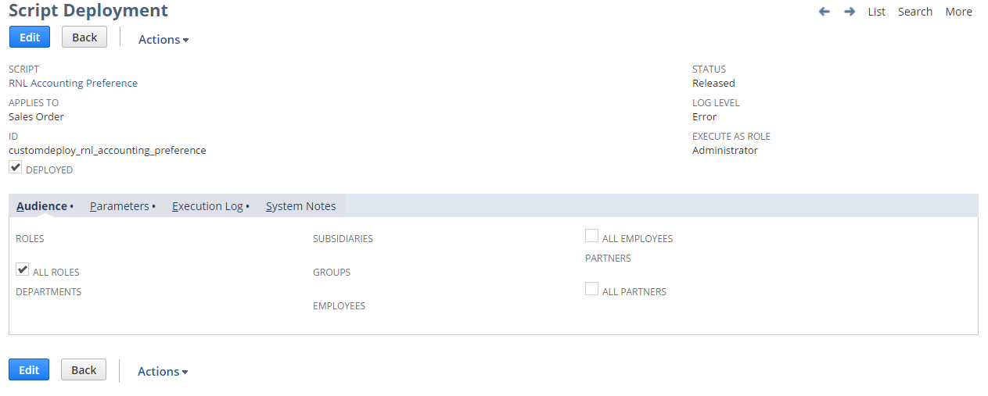

#### 1.53.6.5 Updating Custom scripts for new Credit Limit Approver and Subsidiary additions\ deletion

#### Below script parameters needs to be updated either with “,” or “|” symbol for any new subsidiary or Credit Limit Approver Role

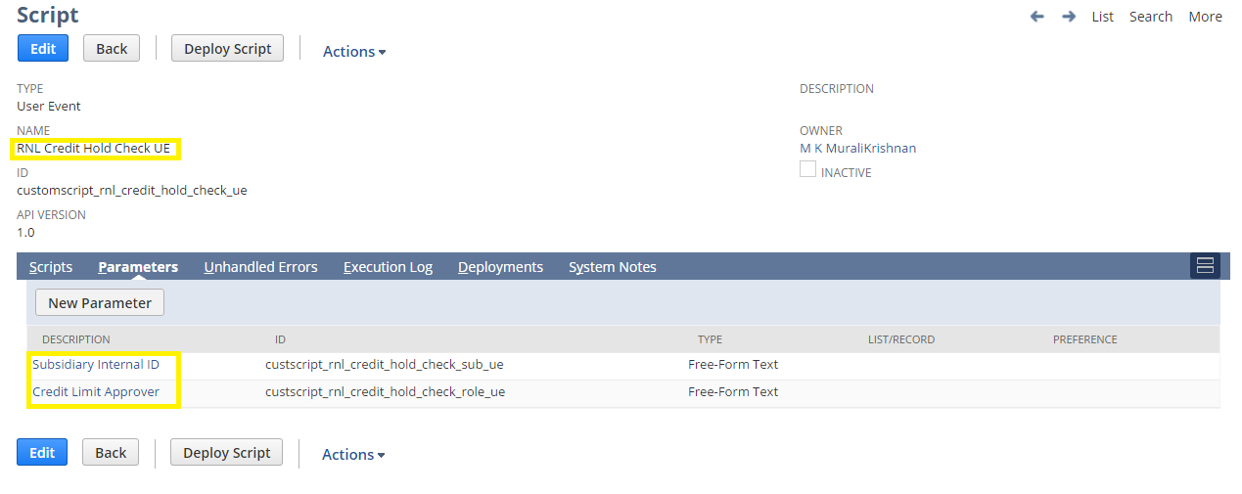

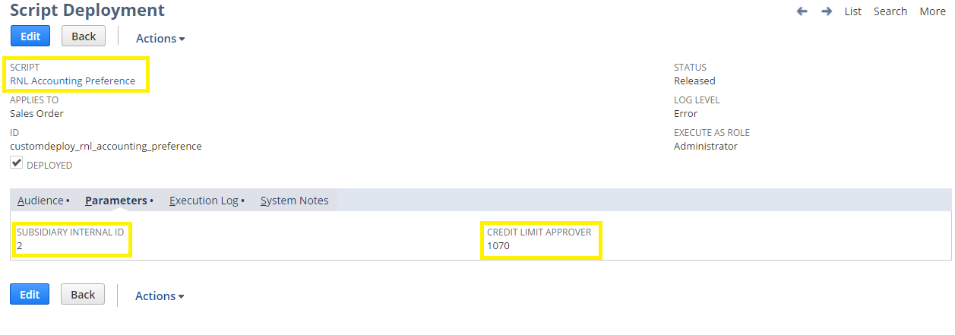

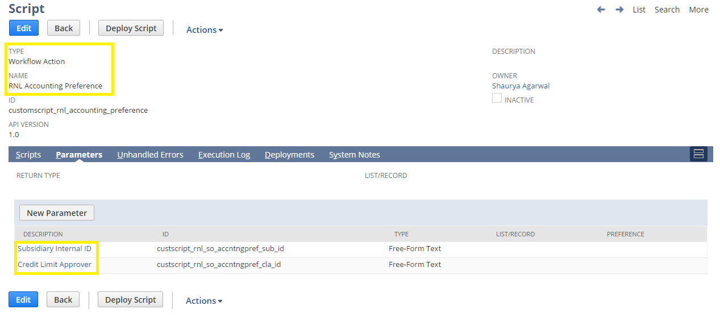

1.53.6.6 Custom Workflows

To create Custom Workflow follow path Customization->Scripting->Workflows->New

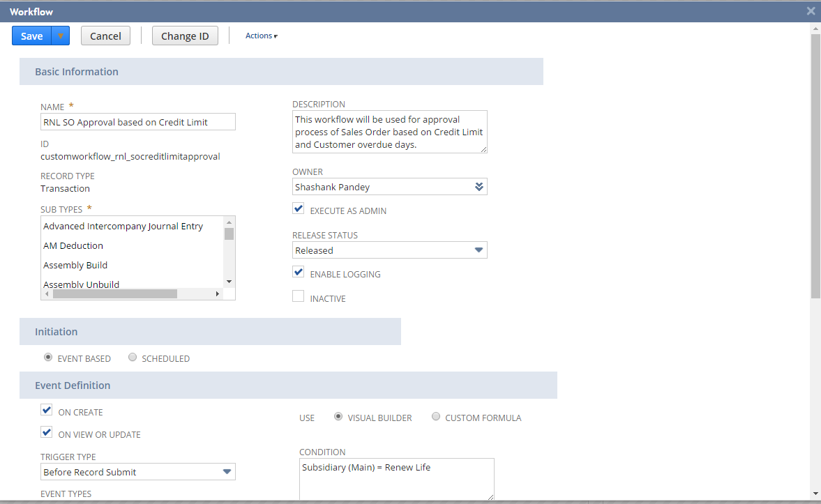

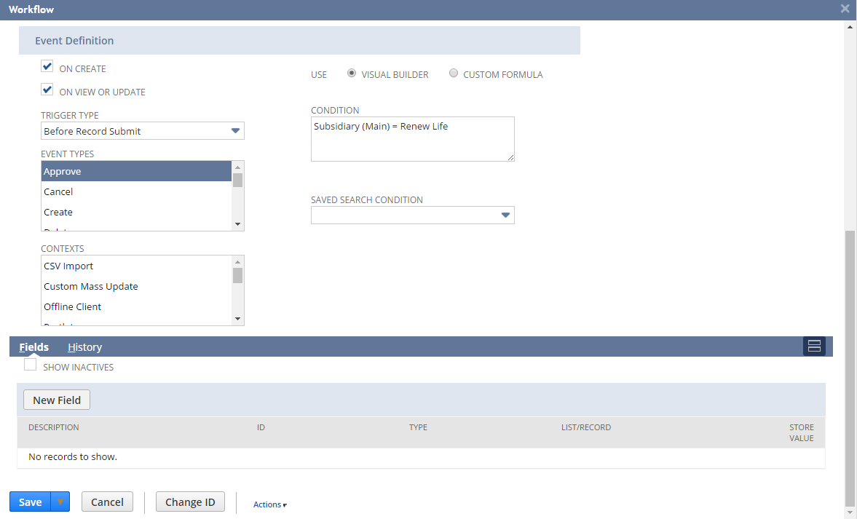

To view Custom Workflow follow path Customization->Scripting->Workflows-> [RNL](https://system.sandbox.netsuite.com/app/common/workflow/setup/workflowmanager.nl?id=40) SO Approval based on Credit Limit

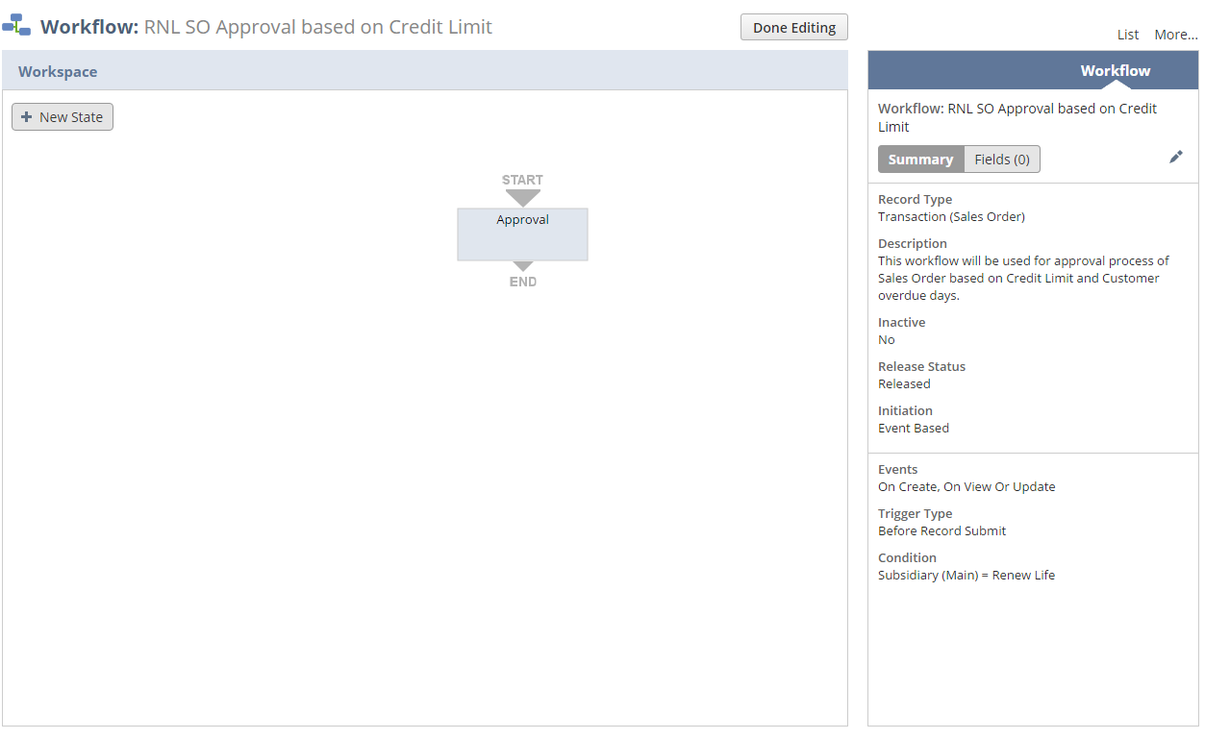

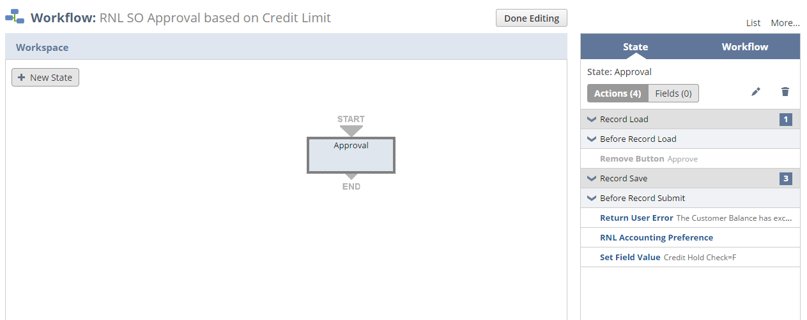

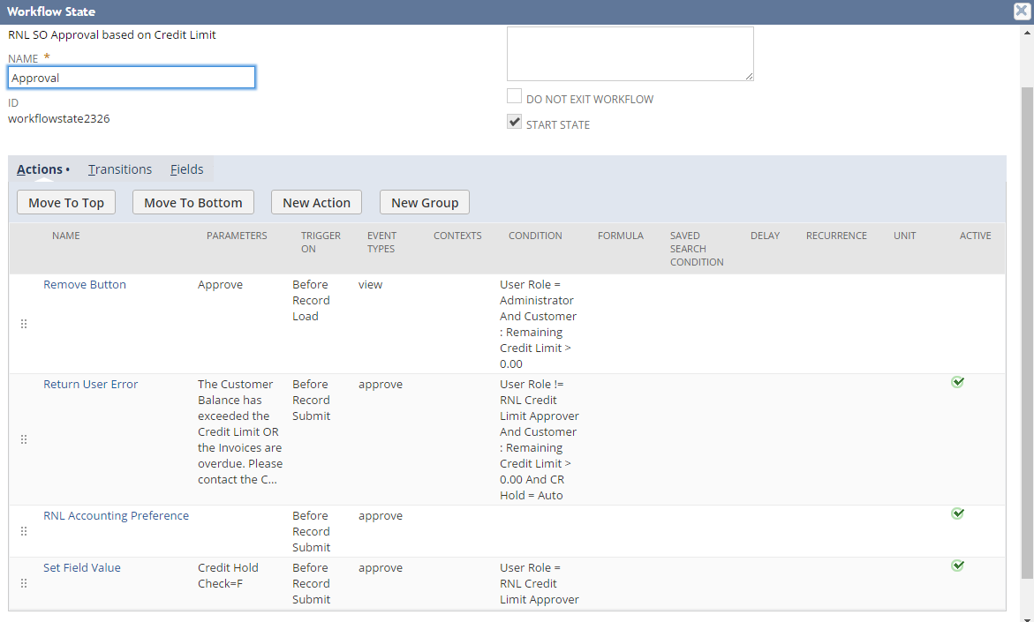

Below workflow condition needs to be changed for subsidiary addition\deletion

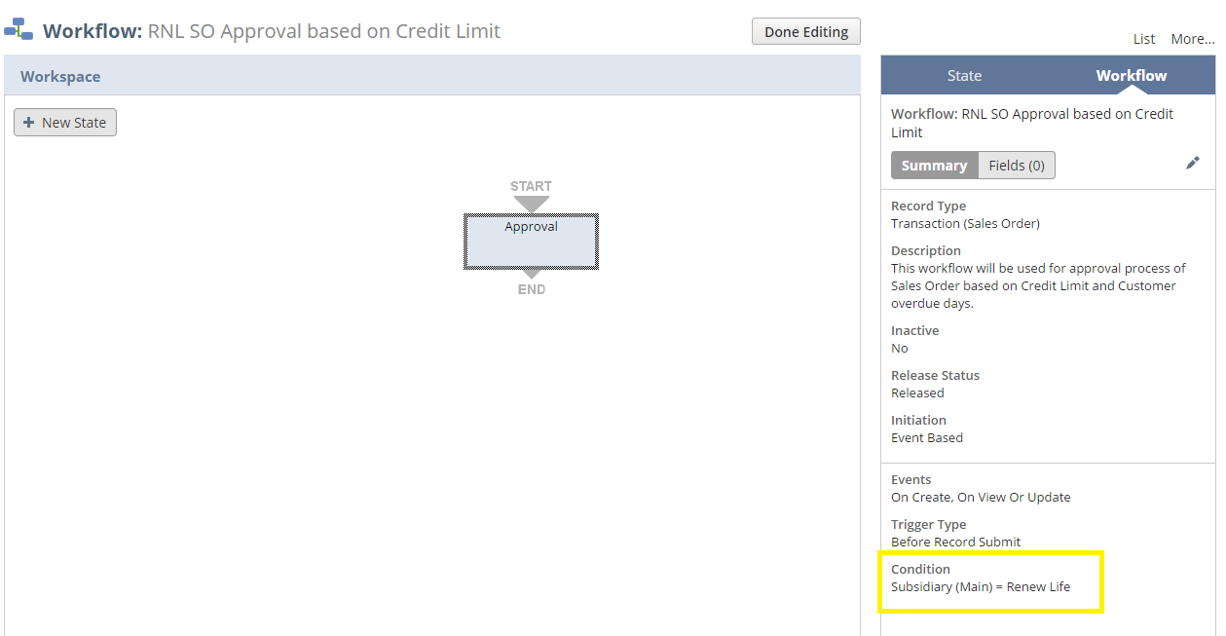

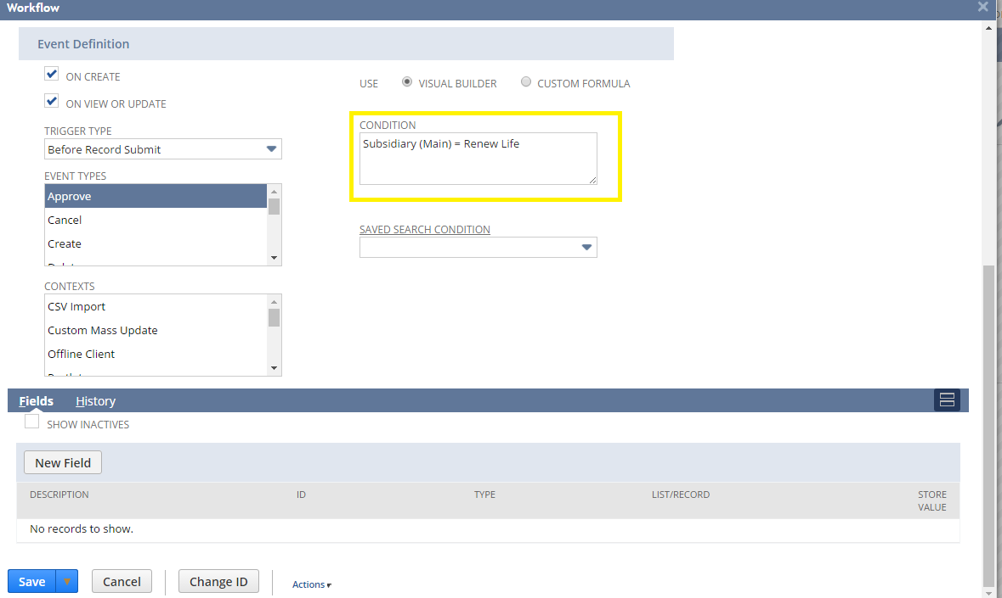

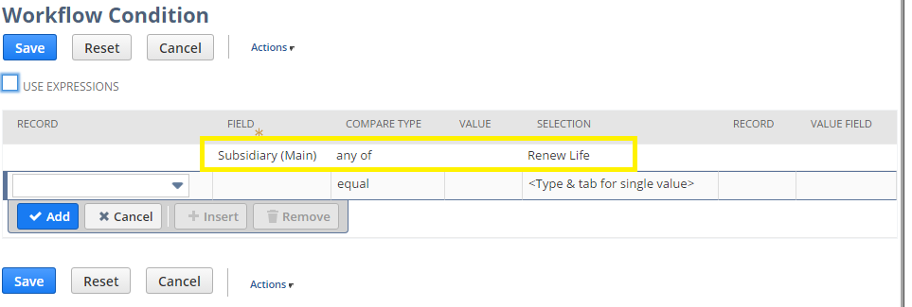

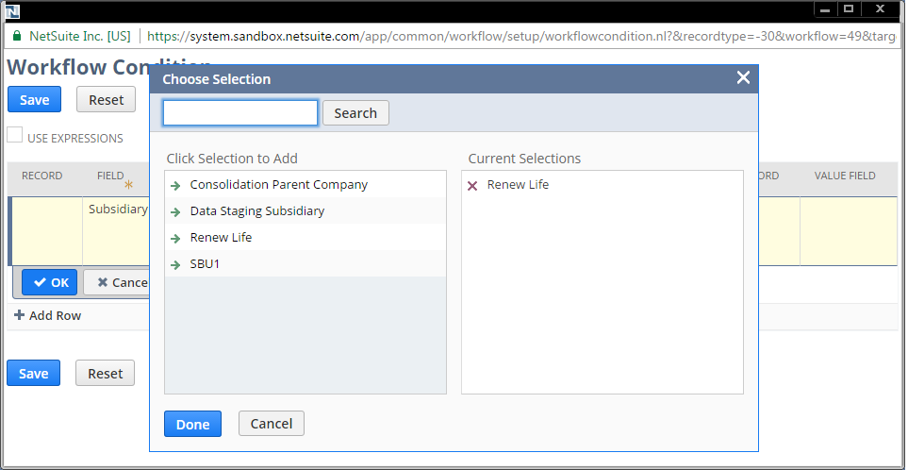

# TESTING INSTRUCTIONS & QA TEST CASES

The attached spreadsheet contains the test scenarios and specific test cases for the Sprint 3 requirements

<<attach test case excel>>

# APPENDIX

## Customization list

# ACCEPTANCE

Cognizant Professional Services and Clorox are in agreement that the functional requirements of the project, detailed within this document are considered appropriate for development.

|  |  |  |
| --- | --- | --- |
| **Clorox** |  | **Project Manager** |
| **Name:** |  | **Name:** Suzanne Little |
| **Title:** |  | **Title:** Project Manager |
| **Signature:** |  | **Signature:** |
| **Date:** |  | **Date:** |